**Interview Test**

Please note, this test requires you to build a single page application so make sure all the calls back to the server after the initial page load are done via AJAX.

1. Restore the attached database into SQL server which should contain the following 3 tables:

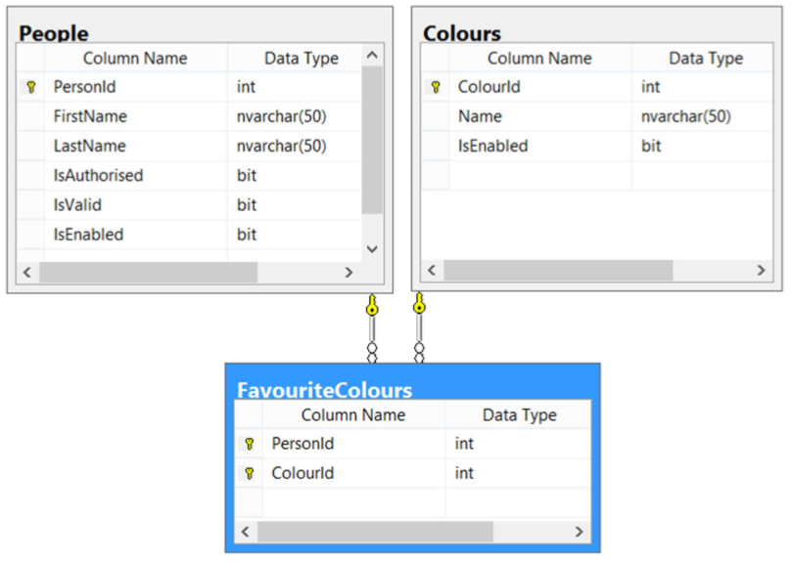

2. Create a blank ASP.NET MVC project in Visual Studio.

3. Add a controller to the home route and render a blank view.

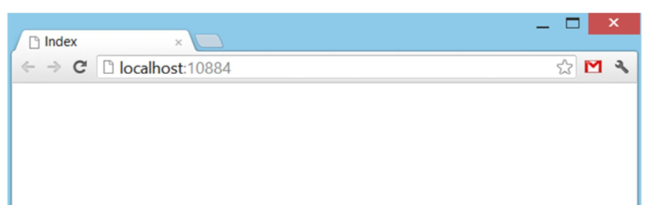

4. In the web project add an Entity Framework EDMX and point it to the database.

5. Using javascript, make an AJAX request back to the web server and access the database. The response from the server should be in JSON and you need to reproduce the following HTML table. You’re free to use any of the following javascript frameworks - jQuery, Backbone, Angular or Knockout.

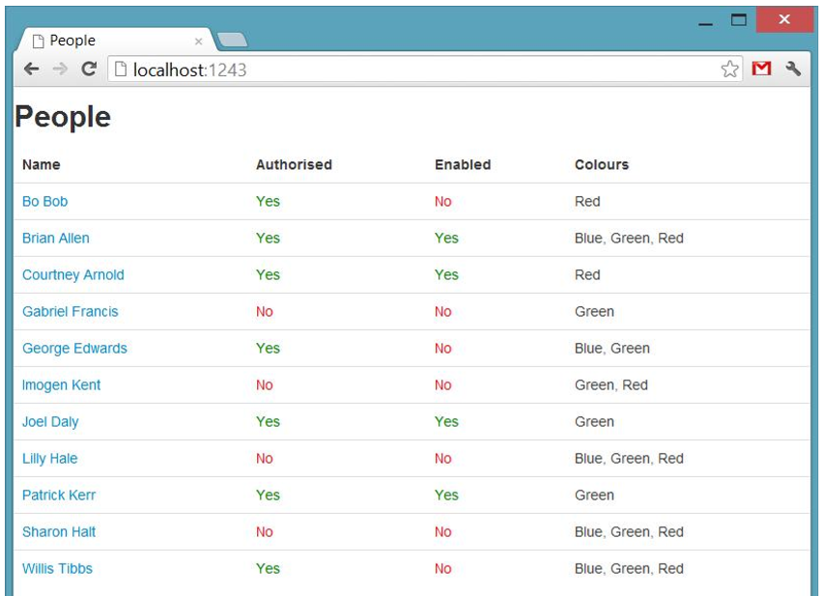

6. Hook up a click event to the anchor link in the first column of the table. This should make another AJAX call back to the web server and return JSON. With the resulting data reproduce the following HTML form for updating the Person’s details.

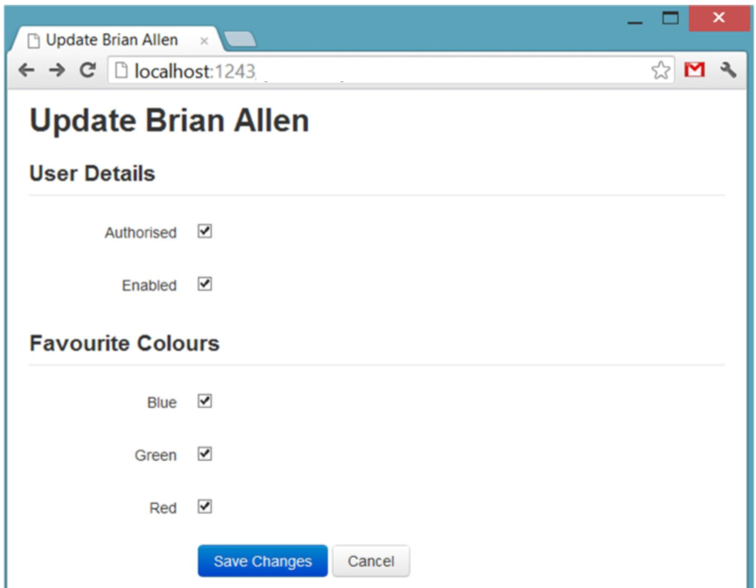

7. Wire up a javascript event so whenever a label next to a checkbox is clicked the corresponding checkbox disappears. Clicking the label again should make the checkbox reappear.

8. Add the javascript and web server endpoints so you can submit the form changes via AJAX and update the database. Upon a success response the form should now be destroyed and the initial HTML table should be rendered.

9. Finally, add a column displaying Yes or No depending on whether the FullName is spelt the same forwards as it is backwards. The match should not take spaces into account and should also be case insensitive.

