**LEARNING MANAGEMENT SYSTEM**

**Mentric Technologies Pvt Ltd**

# 105, 4th Floor, Near Amruth Maruthi Temple, Dasarahalli

Main Road, Hebbal, Bengaluru - 560024

[www.mentrctech.in](http://www.mentrctech.in)

[info@mentrictech.in](mailto:info@mentrictech.in) / [jithin@mentrictech.in](mailto:jithin@mentrictech.in)

+91 63639 01661

A learning management system (LMS) is a software application for the administration, documentation, tracking, reporting, and delivery of educational courses, training programs, or learning and development programs.

An LMS delivers and manages all types of content, including video, courses, and documents.  
An LMS will also include a variety of functionalities such as teacher and instructor facilitated learning, discussion board etc.

**Purpose of the Project**

The purpose of the project is to develop a cloud based LMS platform to carry out online classes and training programmes. The application will facilitates the students to attend classes and training programmes from anywhere in the world. The students will also have access to all the course database present in the system, which includes course materials, videos, pictures and other documents.

The application will have primarily three modules: Admin, Student and Faculty.

**Phase - I**

* **Admin Module ( 20 -25 days,** Functional testing included**)**

1. **Create Verticals**: Admin has the option to create Training Blocks.
2. **In hospital/Institution/Companies**: Admin has the option to integrate Institution companies under each vertical. (First Responder – Existing Module)
3. **Create Streams:** The admin will have the option to create Streams Subjects/Departments (i.e Medical, Surgical, Emergencies etc.]
4. **Create/Manage Courses:** The admin or designee will have the option to modify/create existing courses or multiple courses under each stream.
5. **Add Course Materials:** The admin or designee will have the privilege to add course materials (course materials, videos, pictures and other documents) under each course.
6. **Create Library Materials:** The admin or the designee will have an option to add data relevant to the users of LMS in the library area which will be available to everyone.
7. **Create Users (Students):** The admin or the designee will have an option to add students although the students can directly register with the LMS
8. **Create Faculty:** Admin or the designee will have the option to create faculty profiles, while the designated faculty can directly register & manage with the LMS **[Admin, Chair, Co-chair, Secretary]**
9. **Create customers:** Admins can create National/International/Regional customers(will have view of the entire Course materials which the customers can access for their training purposes contents)
10. **Create Tests/Publish Results:** Admin or the designee will have privilege to create Pre & post-test by email and publish the results under each stream along with the faculties.
11. **Create Online Class Schedules:** Admin or the designee has an option to create schedule the online classes and timing.
12. **Assign Faculty to Class Schedules:** Admin or the designee will have an option to assign the Faculty to the schedules.

* **Student Module (15-20 days,** Functional testing included**)**

1. **Login/Sign up:** Thestudent login will have an option login / sign up with the system. At the time of signup basic details of the students will be gathered.
2. **View Course Materials:** The students will have access to all the course materials available in the system under the course & he/she will have an option to choose the courses of his/her choice
3. **View Class Schedules:** The student window will display the schedules of classes as per the course opted by the student.
4. **Attend Test:** The tests created by the admin/faculty for the course opted by the students will be displayed in the student login, the students can attend the test from the student window.
5. **View Test Results:**  Result of the tests will be available in student window along with the given answers and the answer keys.
6. **View Library Data:** Students will have an access to the complete library data.
7. **Upload Own Data to Library:** They can upload own data, make comments on presentations etc., Students will have option to delete and edit their own data and manage comments under their posts**.**
8. **Edit Profile:** The students will also have an option to Edit their respective profiles (Courses and Streams can be added and edited)
9. **Subscription:** course details and payment track [Payment track/history will be implemented only if the payment gateway integration]
10. Users will have an option to follow particular companies ( Users will get notifications of the announcements and posts published by the companies that they are following)

* **Faculty Module (15- 20 days,** Functional testing included**)**

1. **Login:** The faculty will have an option to login/signup to the application with the username and password after approval from the admin.
2. **Upload/ Edit Course Materials:** The faculty will have the option to update the course materials and edit their respective data.
3. **View/Join Online Class Schedules:** The Faculty window will display the schedules to which the faculty has been assigned by the admin. The faculties will have an option to join the schedules and interact with the students from here
4. The faculty will also have an option to make their availability for an courses, the students will have an option to choose the classes of desired faculty depending on the ratings and reviews
5. **Create Test:** The faculties along with the admin has an option to create the tests for the particular course to which they belong.
6. **View Complete Data Related To Respective Stream:** The faculty will have access to the complete data under their respective streams.
7. **View/Update Library:** The faculties will have to access to the complete library data, can upload own data, make comments on presentations etc., will have option to delete and edit their own data and mange comments under their respective posts.
8. Faculty will have an option to enrol to the courses offered by the LMS

Note: Additional 20- 30days will be required for testing and bug fixing

Data Flow Diagram of LMS

* Managing all the students
* Managing all Activity logs
* Managing all Assignment
* Managing all the Files
* Managing all Teachers / Faculty
* Managing all the Subjects/courses
* Managing all the system users
* Processing student records and generating report of all student
* Processing activity log records and generating report of all activity log
* Processing assignment records and generate report of all assignment
* Processing files records and generate report of all Files
* Processing Teacher records and generate report of all teacher
* Processing Subject records and generate report of all subject
* Processing assignment records and generate report of all assignment

**Flow Chart**

Check Login Report

Login Management

Student Management

Generate Student Report

Generate Activity Log Report

Activity Log Management

Faculty Management

Generate Faculty Report

Generate Assignment Report

Assignment Management

Generate System User Report

System User Management

**Admin**

* Admin logins to the system and manage all the functionalities of E-learning management system
* Admin can add, edit, delete and view the records of student, assignment, teacher, system users
* Admin can manage all the details of Activity log, files, subject
* Admin can generate reports of students, activity log, assignment, files, teacher, subject
* Admin can search the details of activity log, teacher, student

**Manage Student Details**

Admin

**Manage Course Details**

**Manage Files / content Details**

**Manage Reports**

**Manage Teacher Profiles**

**Manage Activity Log Details**

**Manage Assignment Details**

**Manage Roles of users**

**Manage user permission**

**Manage system Admins**

**Basic wireframe of the web app**

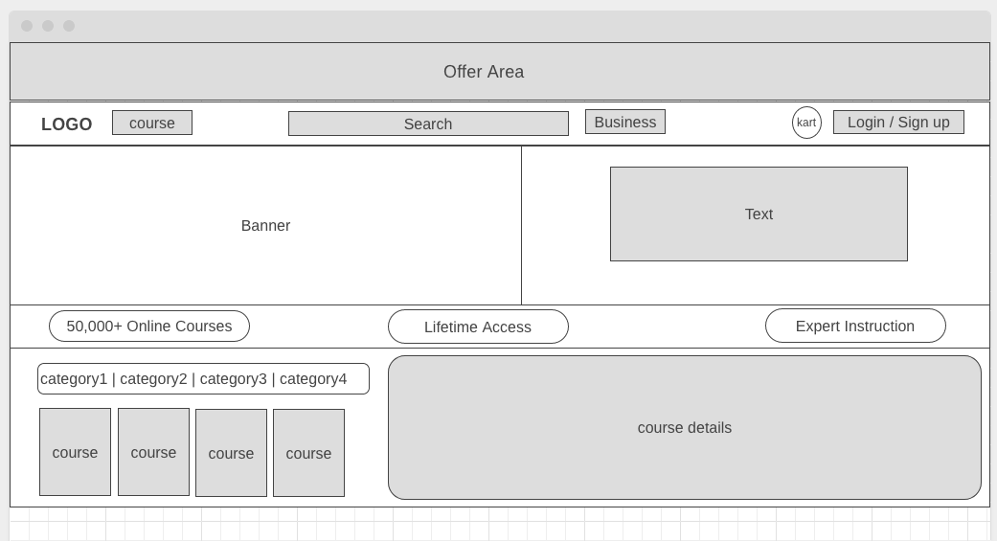

**Basic Mobile Application [android]**

* Login page
* Signup page
* User registration
* View courses
* Apply courses [enrolment form]
* List approved courses

**Technology**

**Timeline**

**Note:**

* The platform is available on both web and android interface
* Domain has to be provided by the client. [if required]
* Development and Deployment Server [Live server] has to be provided by the client
* 30 days free support post launch for handling any issues or bug fixes
* For any new development / changes / updates post production, it will be mutually defined and agreed for cost & timeline.
* AWS / Firebase account needs to be registered and provided by the client [optional]
* Any additional API integration [google, LinkedIn, SMS, whatsapp etc] needs to be registered and provided by the client [optional]

**Scope for 30 days free support:**

* To support bug fixes in the overall application
* Server review & maintenance

**Out of Scope:**

* New Feature Development or Feature Enhancements

|  |  |
| --- | --- |
| **Phase - 2** | 1. **Adding Multiple Institutes** 2. **Adding Multiple Companies** 3. **Online Classroom** 4. **Mobile application live class** 5. **Payment gateway integration** |