# Gfex website installation guide on AWS

This is the guideline to install GFeX website on Amazon Web Service. You can host this GFeX website on any kind of website hosting services.

## Configure aws instance

You have to configure and launch a Windows Server Amazon EC2 instance. To do this, you have an account on Amazon Web Service.

* 1. create a new AWS account

You can follow the below link to create and activate a new AWS account.

<https://aws.amazon.com/premiumsupport/knowledge-center/create-and-activate-aws-account/>

* 1. Launch a Windows Server Amazon EC2 Instance

You can follow the below link to launch a Windows Server Amazon EC2 instance.

<https://docs.aws.amazon.com/codedeploy/latest/userguide/tutorials-windows-launch-instance.html>

Here you can get Remote Desktop file and connect to Amazon EC2 instance. Also you can add inbound rules for Http (port 80) and Https (port 443), SSH (port 22).

* 1. Allow connection in Windows Firewall

After you connected to your Windows Server via Remote Desktop connection, you have to add Inbound Rules for Windows Defender Firewall, because it is not allowed by default.

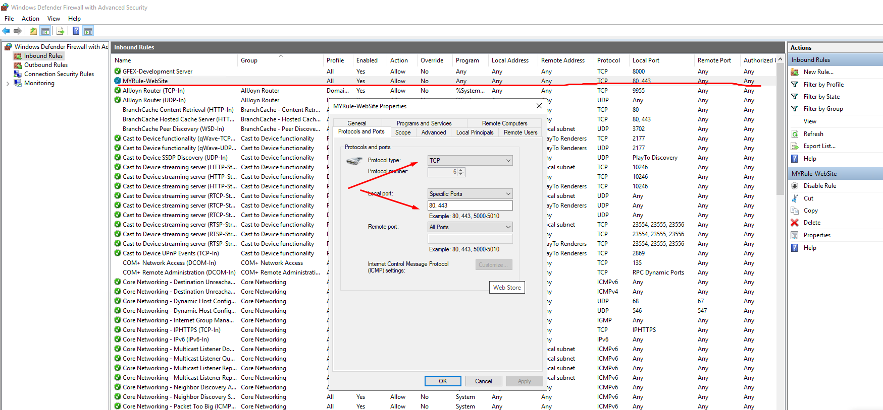

## Install dependencies

Before to install GFeX website, you have install some dependencies such as Xampp, Composer, NodeJS and etc.

* 1. Install NodeJS

You can download node.js windows installer file from the below link.

<https://nodejs.org/en/download/>

After download and install it, you can confirm it by using following command on the command prompt.

# node --version

* 1. Install xampp

You can download xampp windows installer file from the below link.

<https://www.apachefriends.org/download.html>

Xampp contains the Apache Web Server, MySQL Database Server and phpmyadmin for MySQL database. After you download and install it, you can launch xampp-control and start MySQL Server.

To configure the MySQL database connection, you can start Apache Web server and connect phpmyadmin by using the below link.

<http://localhost/phpmyadmin>

Here you have to set MySQL password or create new user for GFeX and then create database named as “gfex”.

To change MySQL Password:

<https://manage.accuwebhosting.com/knowledgebase/2129/How-to-change-phpMyAdmin-password.html>

To add new database on MySQL DB:

<https://www.geeksforgeeks.org/how-to-create-a-new-database-in-phpmyadmin/>

* 1. Install composer

You can download composer from the below link.

<https://getcomposer.org/download/>

## Install Gfex website

You can get the source code and gfex-init.sql file.

3.1 Configure XAMPP for GFeX Website

First extract the GFeX source code into C:\Gfex directory.

And then renames .env.example into .env file. Here you can configure the MySQL connection and set the APP_NAME like the following;

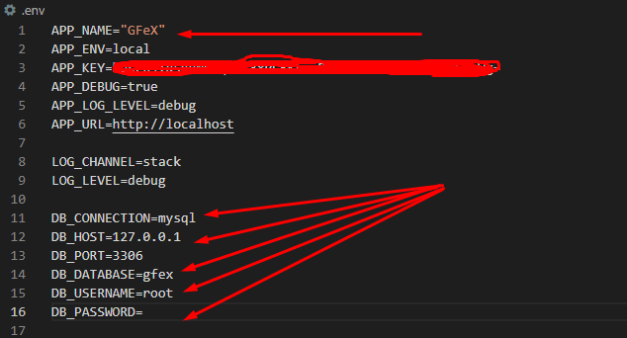

Here you have to use password above steps.

And configure the {XAMPP_INSTALL_DIR} \ apache \ conf \ extra \ httpd-vhosts.conf file

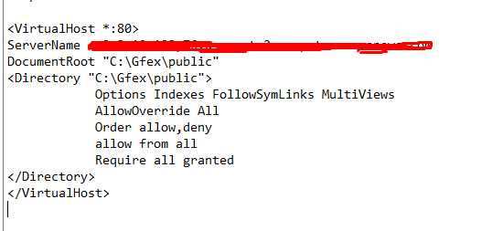

3.2 install dependencies for GFeX website

And then open command prompt window and type the following commands.

# cd {GFeX SOURCE DIRECTORY}

# composer install

# php artisan migrate

# npm run build

And then go to phpmyadmin and import gfex-2022-init.sql file. This will load the default administrator user for login. After logged in, you can change username, email or password in website.

The default user email is admin@gfex.com and password is 123456

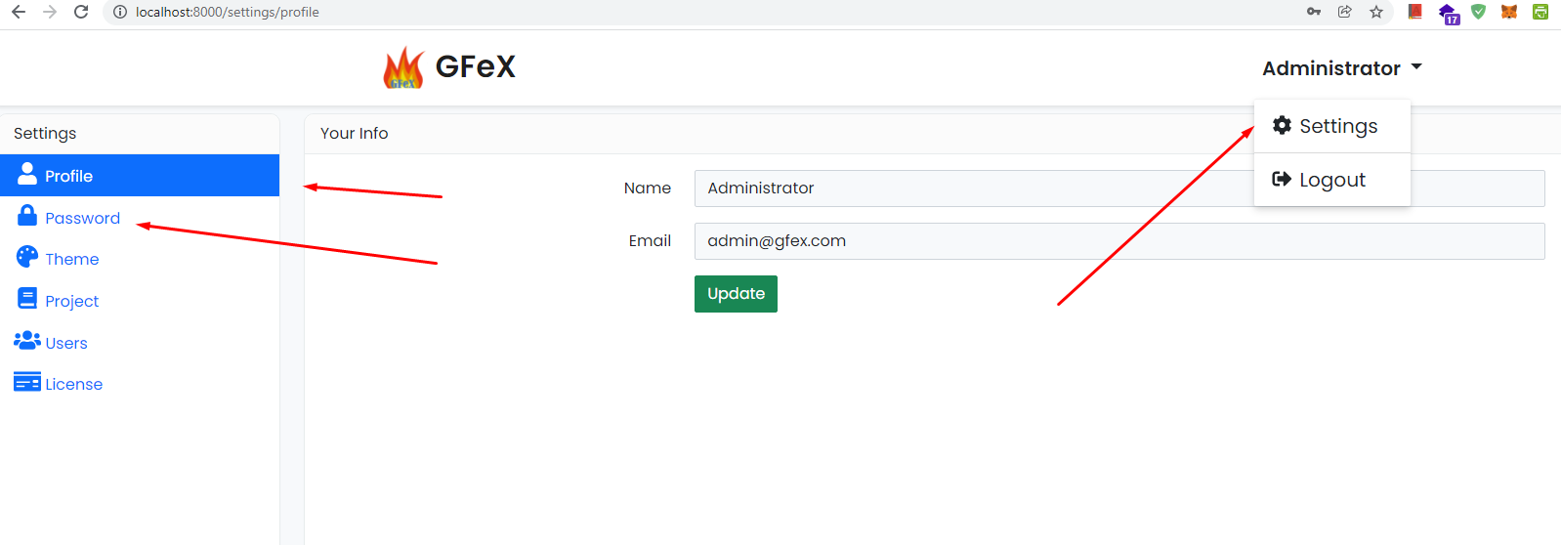

After done this, you can check its working on any web browser.

Thanks