1. Please install Python to your Operating System - https://www.python.org/downloads/

Important: You should enable “**Add python.exe to PATH**” checkbox

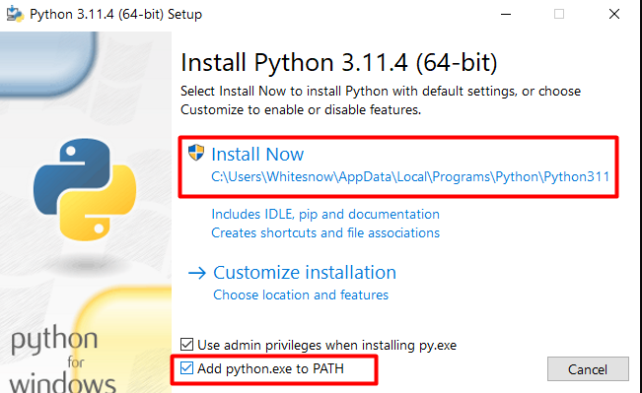

1. Please extract zip file.

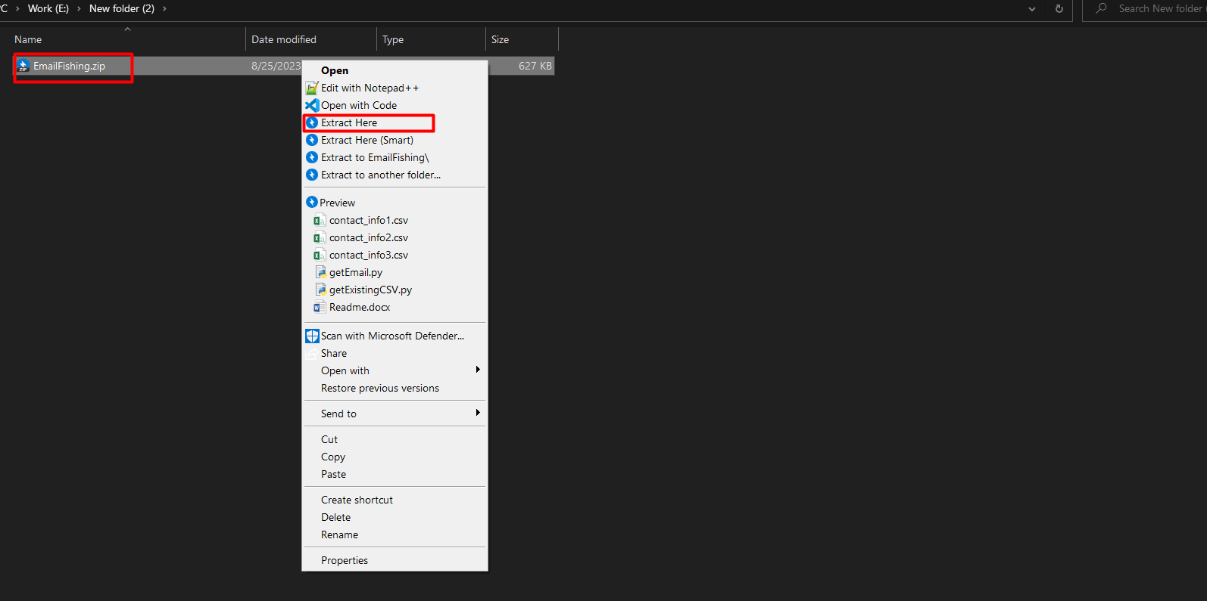

1. Go to location bar.

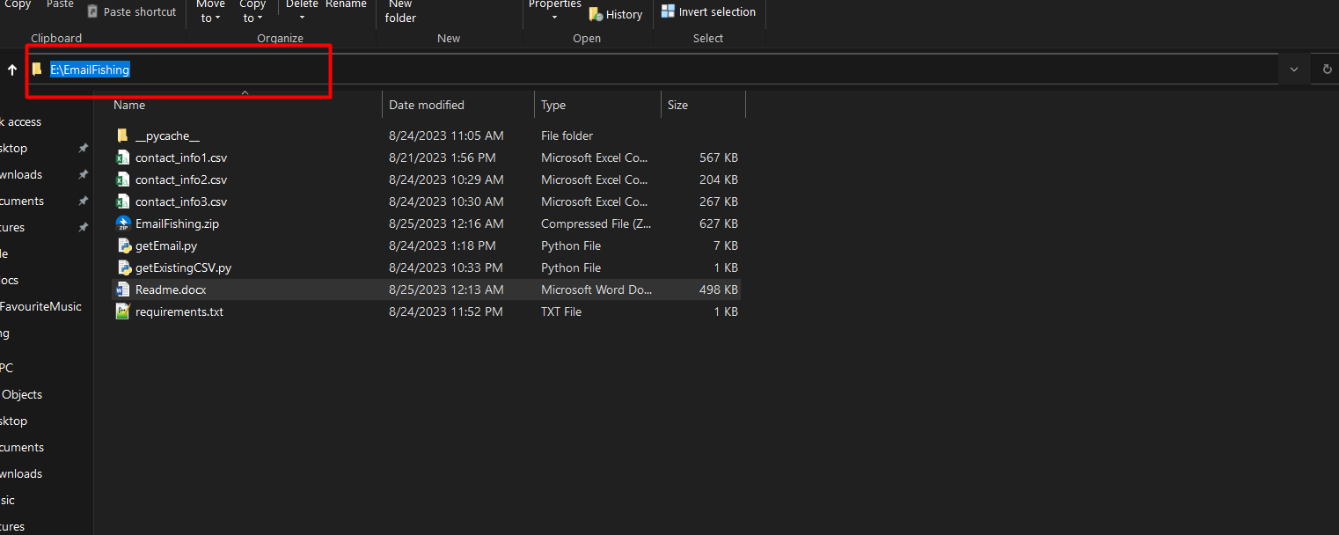

1. Please type “**cmd**” and press enter keyboard.

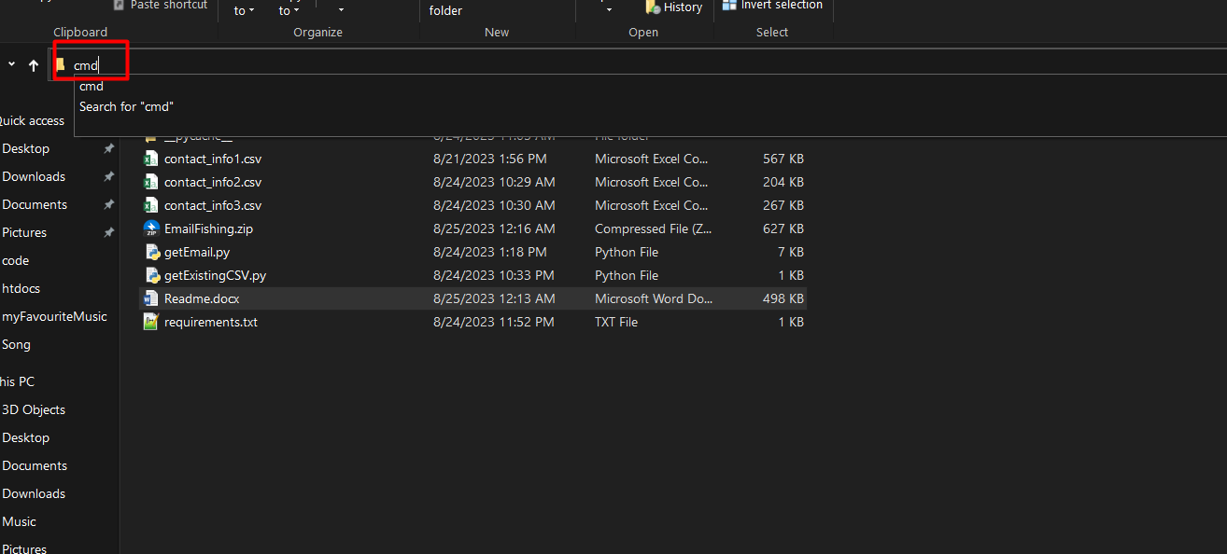

1. You can see command prompt terminal.

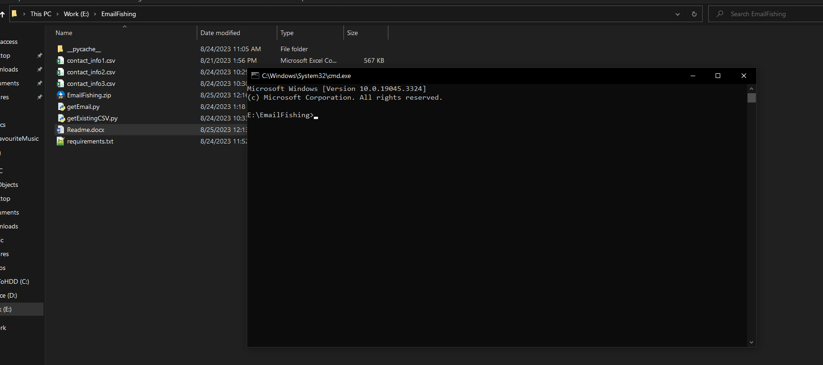

1. Run this command : **pip install –r requirements.txt**

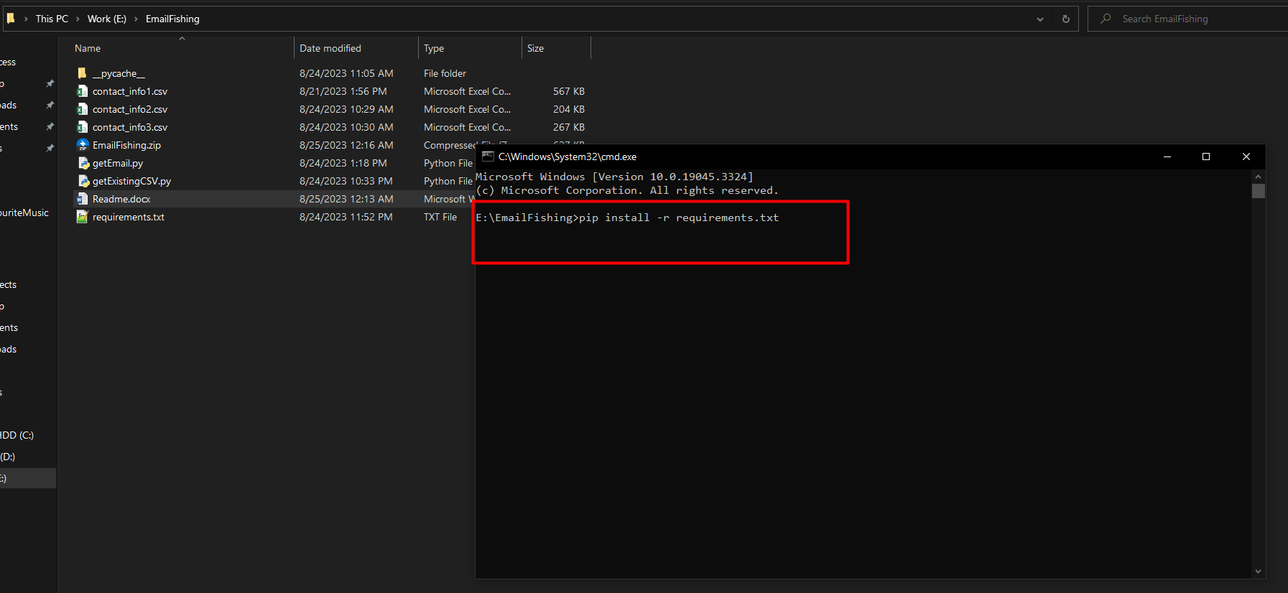

1. After installing all the libraries, run this command : **py getEmail.py**

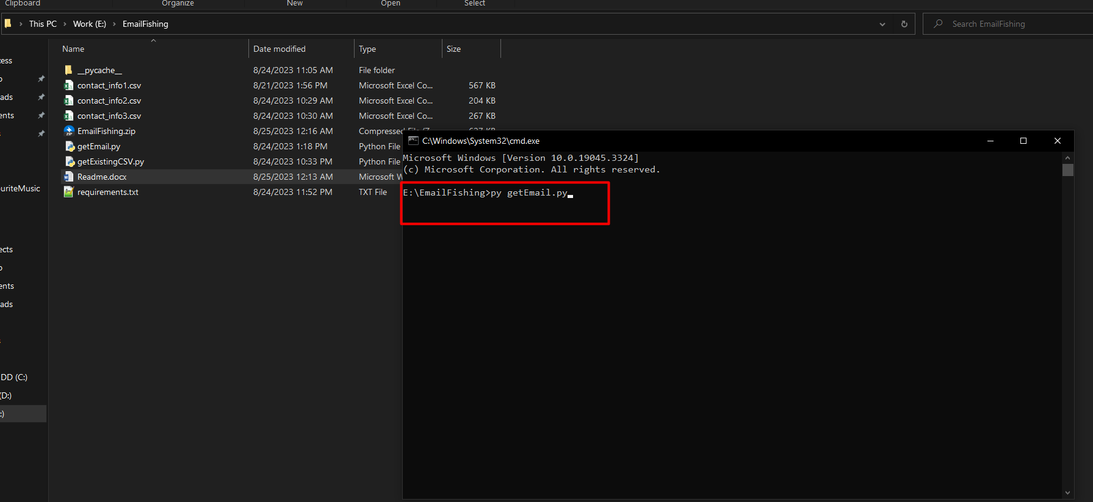

1. After that you will see script is running and your chrome browser will be opened automatically and get emails from ads.

So there are totally 21 categories.

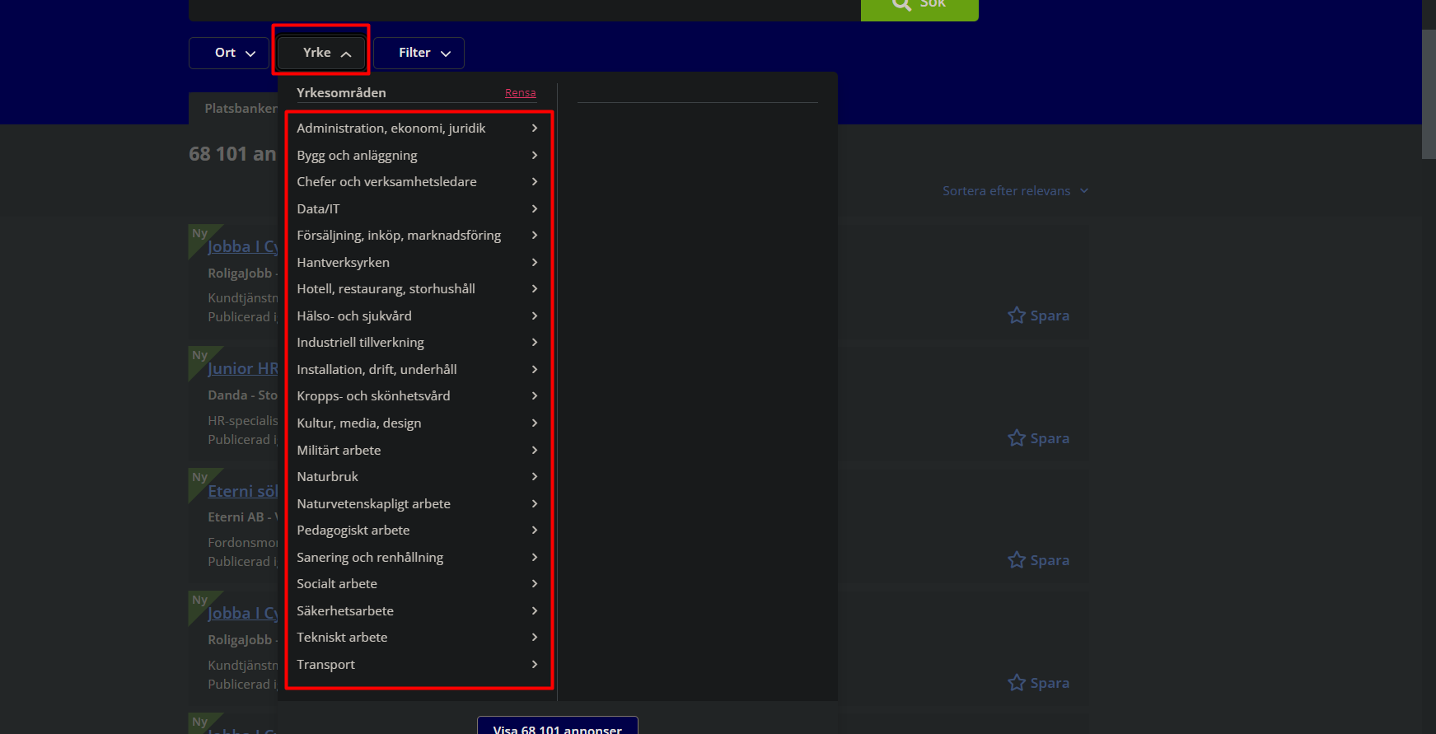

68000 jobs will be divided into 21 categories and output as 21 csv files.  
Once script is stopped, you can simple run this command in terminal again : **py getEmail.py**

It will continue to get emails from where it stopped.