Total Visitors 25

Visitors Count By sub Category procedure name **Dashboard_VisitorsBySubCategory**

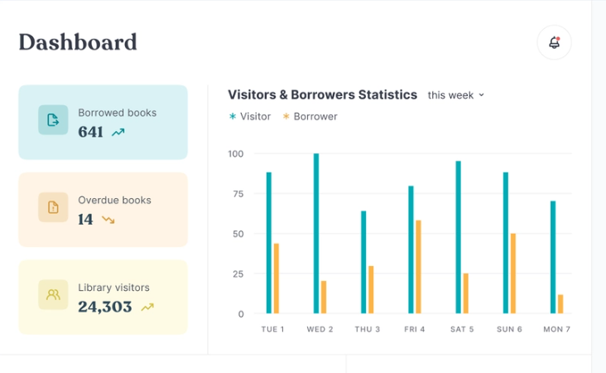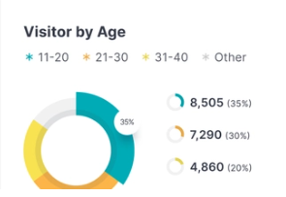

Total Visitors Permanent Visitors Temporary Visitors

Procedure name **Dashboard_VisitorsByType**

Visitors By Location Procedure Name **Dashboard_VisitorsByAreaAndLocation**

Total Visitors  
By Location / Area / Unit

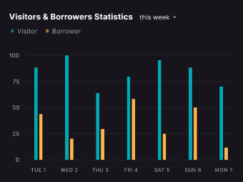

No Of Visitors Location / Office / Unit Name here

**Visitors By Gate**

No Of Visitors Gate Names

Procedure name **Dashboard_VisitorsByGate**

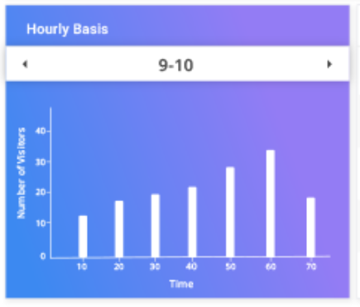Hourly Visitors Graph

No Of Visitors

Hours Gap

Procedure

**Dashboard_VisitorsByHours**

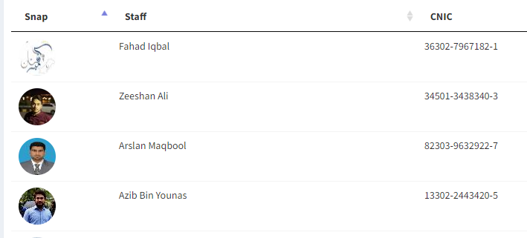**Approved Visitors List**  
Grid on Dashboard grid already available procedure already there need to redesign