Content

What is Acceptance & Commitment Therapy?

Acceptance and Commitment Therapy (pronounced as the word ACT) is an evidence based psychological therapy. It has been clinically proven to be successful for many psychological problems including depression, anxiety and workplace stress.

ACT is an active therapy. You will actively learn new skills to improve your emotional wellbeing. It is a behavioral therapy that uses metaphors, paradoxes and behavioural interventions.

ACT is effective at maintaining long term behavioural change and as such fits well within the Champions for Health programme.

ACT in a nutshell

ACT does not assume humans have a ‘healthy normality’ i.e. humans are not considered to be naturally happy and content. Language creates a struggle between our thoughts and our feelings, which contributes to suffering. Obviously language is very important and useful and enables problem solving and survival in the world around us, however problem solving ability is not so helpful for our internal thoughts and feelings. For example, trying to avoid or get rid of unpleasant thoughts and feelings is not always helpful as often we do this by turning to unhealthy behaviours like withdrawal, excessive drinking or other addictions that become harmful. This is called experiential avoidance.


ACT offers an alternative…

Accept that life can be difficult and rather than trying to avoid thoughts or feelings we don’t like (experiential avoidance) EMBRACE them (stop fighting them and make room for them) AND learn skills to help change the way we view our thoughts to take action to make sure we behave in a way that means we get to do the things we love and value.

Six components of ACT (Hexflex diagram)
You will learn six techniques to help you alter the way unwanted thoughts, feelings, images and memories influence you and the actions you take in response to them.

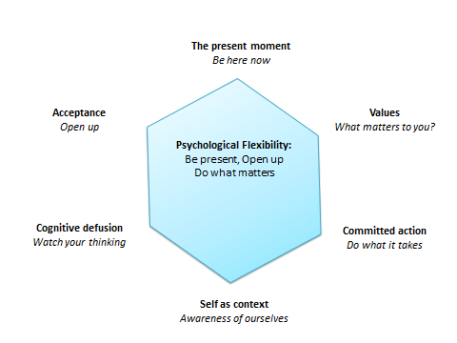

(Hover over diagram/label for each description to appear)

Acceptance
Open up. Be willing to experience what is happening and make room for your thoughts.

Cognitive Fusion
A technique to look at whether thoughts are helpful in moving you towards the things you want to achieve (values)

Being Present
On-going, non-judgmental contact with psychological and environmental events as they occur.

Self as Context
Focusing on your sense of self and your daily experiences with the world.

Values
Who you want to be in the world for example, honest, loving, caring, compassionate, hardworking (etc) a focus on something that is meaningful to you personally.

Committed Action
Commitment to the achievement of a specific values-consistent goal.

Psychological flexibility
The six core components support each other and are used in combination. All aim to increase psychological flexibility.

(Click/hover on word flexibility to see meaning below)

‘The process of contacting the present moment fully as a conscious human being and persisting or changing behaviour in the service of chosen values’.

What this means is learning to connect with the present moment can help you resist responding impulsively to unwanted feelings and emotions and instead help you to respond how you want to (i.e. in a way that is meaningful to you).

AAQ-II questionnaire here -

Try now
Metaphors are often used to convey information about ACT.

The Cold Shower metaphor
Imagine two scenarios: You are thinking of taking a shower but you discover there is no hot water:
1. If you had the choice to have a cold shower…or not to, you might choose not to because it’s cold, uncomfortable! You could not shower, ‘I will be cold afterwards’, ‘I’m not that smelly’ or ‘I’ll wait until the morning’ etc. You might not shower because there’s no point in putting up with that much discomfort for no good reason.
2. But if a close relative or friend was getting married that day, you might want to be clean and fresh. If you stopped for a few minutes and you thought about the person getting married and how much you care about them, and the enjoyment you would get sharing their special day, would you put up with a few minutes of discomfort in the cold shower, because it was important to you? Might you be able to put aside your feelings of discomfort, because you wanted to be fresh and clean for the great day ahead?
In this instance, we can be prepared to make room for the un-comfortableness of the cold. We can choose discomfort in the service of nourishing relationships with people we care about.
In both scenarios, the water is the same unpleasant temperature.

Take a moment to consider, which of the 2 scenarios would bring greater fulfillment? And why?
When we increase our willingness to make room for un-comfortableness it can increase our ability to take on experiences we might previously have avoided. For example, in the second scenario, we made room for the un-comfortableness of the cold shower because it was important.. In the first scenario, we only focused on the uncomfortable feelings and preferred to avoid the shower altogether.
Finding out what’s important to us in life can really help to provide us with direction when uncomfortable thoughts and feelings take us away from what is important
So if someone was socially anxious, yet they wanted to go to a gathering. They could choose to make room for some discomfort (uncertainty, awkwardness) because they value connecting with people. This is about being willing to experience discomfort.
Now take a few minutes to consider something thing you find uncomfortable?
What is it?

For example Vivienne* finds large team meetings difficult and uncomfortable, she experiences a physical reaction, her breathing shallows, her heart rate increases and she sweats (autonomic nervous system). She has thoughts that ‘I am not going to be able to get my point across’, ‘I am not very good with lots of people’ and in response she often avoids the meetings and often withdraws from team events. This is having a detrimental effect on her career.

Now think about what you do to cope with it? Consider what do you do to make yourself feel better when you have an unwanted thought, image, or experience?

Are any of these familiar? Tick all that apply.

- drinking alcohol,
- comfort eating,
- being a ‘good listener’ (asking lots of questions, but sharing little of yourself),
- arriving late,
- leaving early,
- avoiding social events altogether,
- deep breathing,
- relaxation techniques,
- using positive affirmations,
- disputing negative thoughts,
- analysing childhood,
- blaming parents or others,
- telling yourself to ‘get over it’,
- self-hypnosis
- ______________________________(others)

Now how helpful are these coping strategies in the short term? Did they help reduce your unwanted feeling? Or did they add to them? What about the long-term?

What do they cost you in terms of energy/time?

Identify current coping techniques (PDF)

Try at home

A key part of this process will involve you learning and practicing the skills in your daily life. This doesn’t have to be time consuming. A few minutes each day can make a big difference.

This week keep thinking about:

- The thing(s) you find uncomfortable.
- Consider the strategies you use or have used to avoid it.
- Consider how helpful they have been.

You can record them using this (PDF -week 1 try at home and week 1 identifying current coping strategies) if it helps.

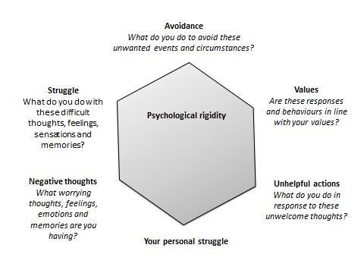

Watch

3 min stress and relaxation guide
https://www.youtube.com/watch?v=EYQsRBNYdPk

happiness trap
https://www.youtube.com/watch?v=93LFNtcR1Ok

Lesson summary
“The goal of ACT is to create a rich and meaningful life, while accepting the pain that inevitably goes with it” (Russ Harris)

ACT helps you work out what's really important and meaningful to you and to develop goals according to what's most important, and then work through the barriers that get in the way of achieving these goals.

Typical barriers:
- Feelings: very often we can't accept our feelings for what they are (feelings) so we act on them and try to avoid them.
- Thoughts: Our brains are constantly busy and we often get so immersed in what our brains are telling us that we lose sight of what's really important to us.
- Being present: Sometimes we are so distracted or preoccupied that we are not ‘there’ enough to follow through with what we value.

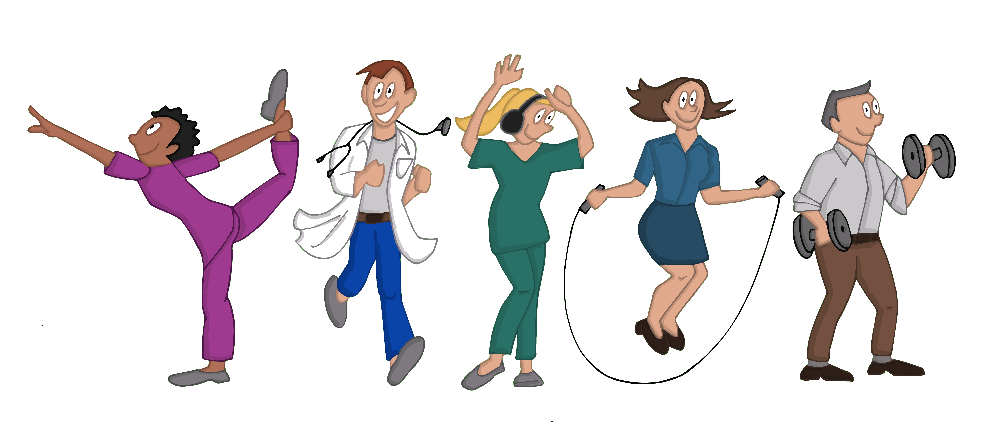

References
Metaphors in ACT understanding how they work, using them, creating your own.
Special issue no 2. ACT digest. Echo’s from acceptance and commitment therapy

Association for contextual behavioural science website (ACBS) https://contextualscience.org/

