# Content

# Psychological flexibility

A general goal of ACT is to increase psychological flexibility.

Psychological flexibility means “contacting the present moment fully as a conscious human being, and based on what the situation affords, changing or persisting in behaviour in the service of chosen values”

What this means is that learning to connect with the present moment can help you resist acting out behaviours which are impulsive responses to feelings and emotions and move towards behaviours that you actually want to do (i.e. those that match your long term values).

ACT considers the role of language to be central in human suffering. Language, the words we hear, speak and influence our behaviours and habitual responses and ACT aims to help you gain mastery over them.

Psychological flexibility is established through the development of positive psychological skills which will help you avoid falling into the trap of unhelpful responses (behavioural or emotional).

Understanding what your goals and values are for the long term can help you persist. So instead of running away from unpleasant thoughts, emotions or memories you can learn to view them differently (change your perspective). Often our responses are habitual or learned behaviours which we can let go of. This takes practice.



# Psychological flexibility in the work place

Evidence has accumulated to support the positive role of psychological flexibility in reducing workplace stress and in building wellbeing and resilience.

ACT has been widely used in the workplace.

For example, if you value your work and career (a value is something that really matters to you) it is likely that at some point along the way to career progression you will experience thoughts, feelings and sensations that are difficult, unwanted or unpleasant. We all have this is common. In the work place environment these may involve challenging work colleagues, anxiety to perform, self-doubt in the face of high work load or changes in the workplace. Identifying such thoughts, noticing and accepting them, can help you develop psychological flexibility and committed action to goals and behaviours which develop your confidence and work skills can boost your career. In contrast treating them as something to fear or avoid may mean that opportunities to move towards your values are missed. For example, focusing on conflict in the workplace may mean opportunities to network are missed, or feeling overwhelmed due to high work load may mean you become easily distracted and lose concentration thus are not able to complete tasks on time. Over time these events can culminate and lead to poor wellbeing (Bond et al book chapter).

*Image of person held back by negative thoughts, door to values blocked by these thoughts*

|  |  |
| --- | --- |
| **Unhelpful or unwanted thoughts** |  |
| Personal | I am worthless/ I am stupid / I have nothing to say |
| Demands on self | I have to / I should… / I must be perfect |
| Magnification | This is the worst thing to ever happen |
| Low tolerance | I can’t cope with this / I can’t take this anymore |

Contact with the present moment can help you focus on what’s happening and to identify situations where you can respond in accordance with your values.

By holding thoughts lightly (and accepting that they are there) you can avoid spending too much energy on suppressing and avoiding them. This will give you more time to consider purposeful actions. This can support job performance, engagement and satisfaction (Bond & Hayes, 2002).

# Try now

Spend a few minutes considering the way you respond to situations and events which have recently caused you to have unwanted or unwelcome thoughts. How did you respond to the thought? Is this something you do often? What happened? Was it in line with your values? Did it move you towards a valued action or away from it? What did it cost you in terms of energy? Practice holding your thoughts lightly. Identify to yourself that ‘I am having a thought that…I am worthless. Acknowledge it and let it float by.

If it helps fill in this chart or use the (explain the situation PDF)

|  |  |  |  |  |
| --- | --- | --- | --- | --- |
| **Explain the situation in a sentence or two.** What happened? | **What unwanted thought, feeling, sensation or memory did you have?** | **How did you respond at the time?**  Did you try to supress them/ did you try to avoid the situation? Did you leave? | **What did this cost in energy?** Did you feel emotionally drained after? Or were you left with energy? How much time did you spend on this response? | **Was this in line with your values?** i.e. did this help you move towards something you hold important? Or did it reduce the experiences and opportunities open to you? |
|  |  |  |  |  |
|  |  |  |  |  |
|  |  |  |  |  |

Being aware of the present moment and what you are experiencing in the moment can help you to view the thoughts, feelings, sensations or memories from an objective perspective. It can help you step back and consider how you wish to respond to them and to choose a behaviour that is in line with the things you most want. Turn off auto-pilot and act mindfully.

Or

*Two sheets of paper activity* (PDF)

Take two sheets of paper and write on one of them ‘values’ and on the other ‘unhelpful thoughts, feeling and sensations’. Hold them up side by side. Now move the ‘values’ sheet in front of the other. Notice that no effort is required to get rid of the other sheet. It is still present but just not as prominent

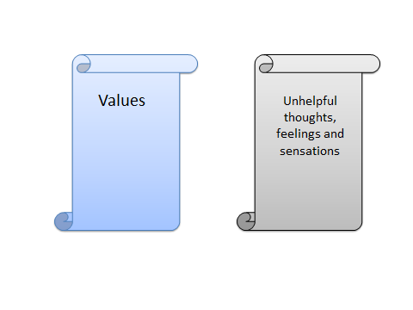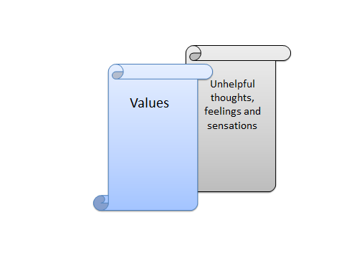

# Try at home

Choose one of the activities you have done previously and look back over it. Try it again. Now set three goals.

**Goal setting (PDF)** related to your chosen value for the week

Consider the goal as a specific activity which will help you achieve your value. Your goal can help you choose actions and behaviours which help you move towards your valued actions. You can choose how you respond to events and challenges in your life.

What meaningful activities do you want to pursue in your life? How are they in line with your valued actions? Set two sign post goals and one goal which when achieved will show you are making progress to where you want to be.

* Goal to sign post way ­­­­­­­­­­­­­­___________________________________________________
* Goal to sign post way __________________________________________________
* Goal to mark progress __________________________________________________

Remember that these goals are here to help you along your road to reaching your valued actions.

Example goals

Value: I value my health and wellbeing and I wish to live my life in a way that enables me to look after myself physically and mentally as this also supports me in other areas of my life.

* **Goal to sign post way** ­­­­­­­­­­­­­­: I am going to think about the food that I am eating and how it contributes to my health and wellbeing. I will keep a track of what I eat once a day for two weeks
* **Goal to sign post way**: I will take a short walk at lunch time to make sure I don’t sit down all day at work and that I get some fresh air (even when it’s raining). I will come prepared for bad weather. I will keep a track of the days I go for my walk and how I felt afterwards / at the end of the day and review it at the end of two weeks
* **Goal to mark progress**: I can see an improvement in my physical health, my fitness has improved slightly (e.g. less out of breath walking) and I consistently make healthier choices when I do my food shopping (e.g. I regularly buy fresh fruit and veg and buy less crisps).

Observation task (PDF)

# Watch

**Breathing exercise for stress**

# <https://www.youtube.com/watch?v=2YY8PWHNkYg>

**Mindful meditation exercise (5 mins)**

<https://www.youtube.com/watch?v=fRpbPk5rMNo>

# Lesson summary

The six core processes of ACT combine and work together to support you in building and developing psychological flexibility across all areas of your life including the work place. This takes time, practice and patience. Start small.

Practice a little bit every day.

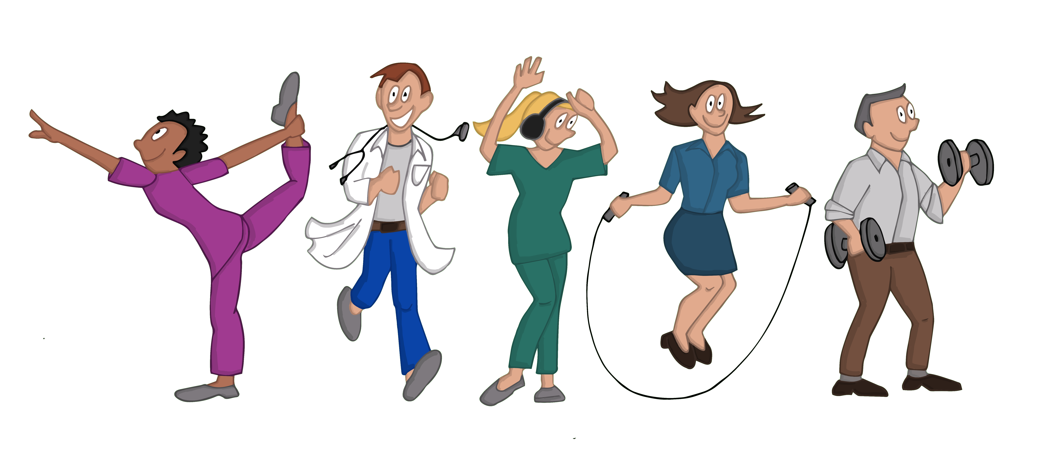

**References**

Bond, F. W., & Bunce, D. (2003). The role of acceptance and job control in mental health, job satisfaction, and work performance. *Journal of Applied Psychology, 88,* 1057–1067.

Donaldson-Feilder, E., & Bond, F. W. (2004). Psychological acceptance and emotional intelligence in relation to workplace well-being. *British Journal of Guidance and* *Counselling, 34,* 187–203*.*

Bond, F. W., & Flaxman, P. E. (2006). The ability of psychological flexibility and job control to predict learning, job performance, and mental health. *Journal of* *Organizational Behavior Management, 26,* 113–130.

Bond, F. W., Flaxman, P. E., & Bunce, D. (2008). The influence of psychological flexibility on work redesign: Mediated moderation of a work reorganization intervention. *Journal of Applied Psychology*, *93,* 645–654.

Mitmansgruber, H., Beck, T. N., & Schüssler, G. (2008). “Mindful helpers”: Experiential avoidance, meta-emotions, and emotion regulation in paramedics. *Journal of Research in Personality, 42*, 1358–1363.

McCracken, L. M., & Yang, S-Y. (2008). A contextual cognitive-behavioral analysis of rehabilitation workers’ health and well-being: Influences of accept

Vilardaga, R., Luoma, J. B., Hayes, S. C., Pistorello, J., Levin, M. E., Hildebrandt, M. J., et al. (2011). Burnout among the addiction counseling workforce: The differential roles of mindfulness and values-based processes and work-site factors. *Journal of Substance* *Abuse Treatment, 40,* 323–335.

Bond, F. W., & Hayes, S. C. (2002). ACT at work. In F. W. Bond & W. Dryden (Eds.),

*Handbook of brief cognitive behavior therapy* (pp. 117–140). Chichester, England: Wiley