# Content

# Personal relevance: what can ACT do for you?

# Stress, anxiety and depression are commonly experienced in the UK (PDF) particularly in complex, busy workplaces environments. (PDF mind resources depression and stress – 2 separate PDFs)

# \\tawe_dfs\users_staff\sfs1\Menna.Brown\Desktop\mug2.jpg

**ACT** Suggests that stress, anxiety and depression are not problems in and of themselves, but that they become problematic when we try not to have them i.e. we often do things that are not in line with our values in order not to feel something. By being open to and accepting of the difficult thoughts and unwanted feelings

# Try now

*Butterfly metaphor (audio available)*

Begin by taking three slow breaths (eyes closed).  Picture yourself sitting in a field on a warm summer day (three more slow breaths).  There is a slight breeze and you can feel the warmth of the sun on your face. (Take a few moments to picture this). As you relax into your experience, your thoughts start to wander and a steady stream of butterflies begins to fly past you.  There are a wide variety of butterflies in the stream…Some are familiar, comforting and attractive, while others are unappealing and make you feel uneasy.

You feel compelled to reach out and hold onto the familiar butterflies, while pushing away the ugly and unappealing ones.

Now take your right hand and hold it to you tightly as if you are embracing the comforting butterflies.  Now take your left hand and begin swatting away the unappealing ones.  Notice how this feels, notice your thoughts and sensations in your body as you are doing this (Take a few moments to do so).

As you continue to struggle, you slowly begin to realize that those you had been trying to push away now outnumber those you were fighting so hard to hold on to.

Thoughts can be like the butterflies in this exercise.  If you hold onto them too tightly or attempt to push them away, they will overwhelm you or remain lifeless in your hands.   However, if you are willing to begin observing thoughts (regardless of how they make you feel) as if they are butterflies landing in the palm of your hand, they will eventually fly away, making room for other thoughts and experiences to present themselves.

# Try at home

*Bad weather metaphor:*

Imagine you are on your way to work when suddenly, the weather changes and you can no longer see the road ahead. There is heavy rain and sleet and the road isn’t visible. It is now very difficult to continue your journey to work.

You could decide to stop and wait for the rain to clear up or lessen. But how long would it take? An hour? A day? Longer? If you decide to stop, you’re going to stay in the car but you’re also going to abandon the pursuit of your valued actions (in this situation, it is going to work).

You think about it, driving in heavy rain is very dangerous, and you will need to slow down. But you will reach your destination eventually. Maybe you’ll pass through this storm (to make that possible, you need to go ahead). Or maybe not, but you won’t mind, you will have arrived at work.

What really matters to you is that you arrive at work, not that you stop the storm.

***Wellbeing writing exercise (PDF)***: clarify and reflect on own experiences

You may find it helpful to answer the following questions: You could write down your answer in a journal or device memo pad

1. What do you want to achieve from taking part in Champions for health?
2. Why does your emotional wellbeing matter to you? For example, do you have a goal in mind? Do you want to clarify your personal values and work towards a healthier life? Do you want to reduce the stress in your life?
3. How much time can you put aside for yourself each week to practice the exercises? Be kind to yourself.

e.g 5 mins/ 10 mins/ 30 mins/ 1 hour per day? What’s realistic?

# Watch

5 minute guided breathing exercise:

<https://www.youtube.com/watch?v=awc8MLSpjlQ>

*Whatever the source of stress, be it changes in the work place, work pressures, family or financial concerns stress based mindfulness techniques offer tools* to regain contact with the present moment when difficult thoughts and feelings dominate your attention’*.*

*Tai chi*

<https://www.youtube.com/watch?v=y-6JRMNjd1I>

Deep breathing and muscle relaxation exercises (5 minutes) *(link to the relaxation resource on wellbeing home page)*

<https://www.youtube.com/watch?v=MmnONuB-tTw>

<https://www.youtube.com/watch?v=nvhVjD-rATM>

# Lesson summary

Struggles vary between people and over time but whether your struggle concerns stress, anxiety, depression or physical illness (and so forth) often there are shared and common features. Practice observing and noticing your thoughts and feelings a little bit each day.

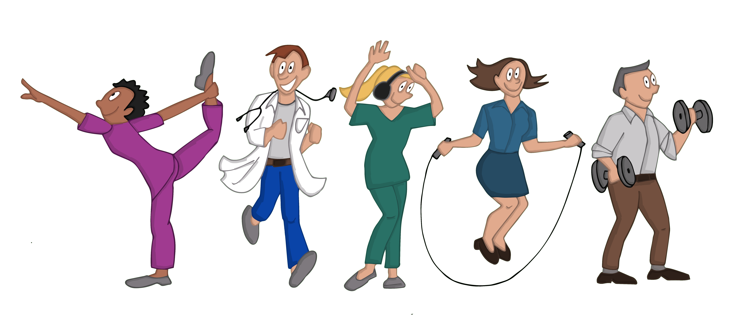

**References**

Harris, R (2006) Embracing Your Demons: an Overview of Acceptance and Commitment Therapy. Psychotherapy VOL 12 NO 4

Association for contextual behavioural science website (ACBS) <https://contextualscience.org/>