# Content

# Welcome back: Review of values

What do you care about the most? What do I want my life to be about? Values are long term aims that we hope to work towards in our daily life. A guiding beacon to light our way and goals are check points along the way. They can help encourage us, motivate us to keep going towards that thing that’s really important rather than doing things which will actually take us in the opposite direction even though they might feel easier in the short term. This understanding alongside skills in acceptance, willingness and cognitive defusion can help you live a valued life.

# Acceptance of difficult thoughts and feelings

Acceptance involves being willing to have all thoughts, both positive and negative and learning to make room for them without putting too much focus and attention on them and without trying to change them. This is used as an alternative to avoiding unwanted thoughts or adopting coping strategies which often consume our time and energy and do not necessarily resolve the issue.

Willingness is a skill you can learn and with practice this skill will reduce the impact of the unwanted thought on you and it will increase the likelihood of you doing things you want to i.e. acting in line with your values. Notice you are having a thought, make room for it and accept it for what it is. A thought you are having.

Remember the cold shower metaphor? This was about willingness to accept difficult feelings and willingness to experience something unpleasant in order to move you closer to something you values.

*Jigsaw metaphor*

**The Jigsaw Piece**

When an unwanted or distressing thought arises, try picturing it as a jigsaw piece.

Your jigsaw has many pieces, each representing the many different aspects of you and your experience. Picture the jigsaw piece with the thought (or feeling) on it and find its allotted space in the jigsaw. There is a space for this piece.  It is a perfect fit.  It belongs here, for whatever reason, even if you don't understand or want it. It is a part of your experience.  Nothing more.  Even if the piece looks odd or painful or disturbing, it is one piece of a large and beautiful picture.

So when is willingness useful? If you have found that your usual coping techniques do not always help you feel better then perhaps it’s time to try an alternative skill. It is another choice available to you.

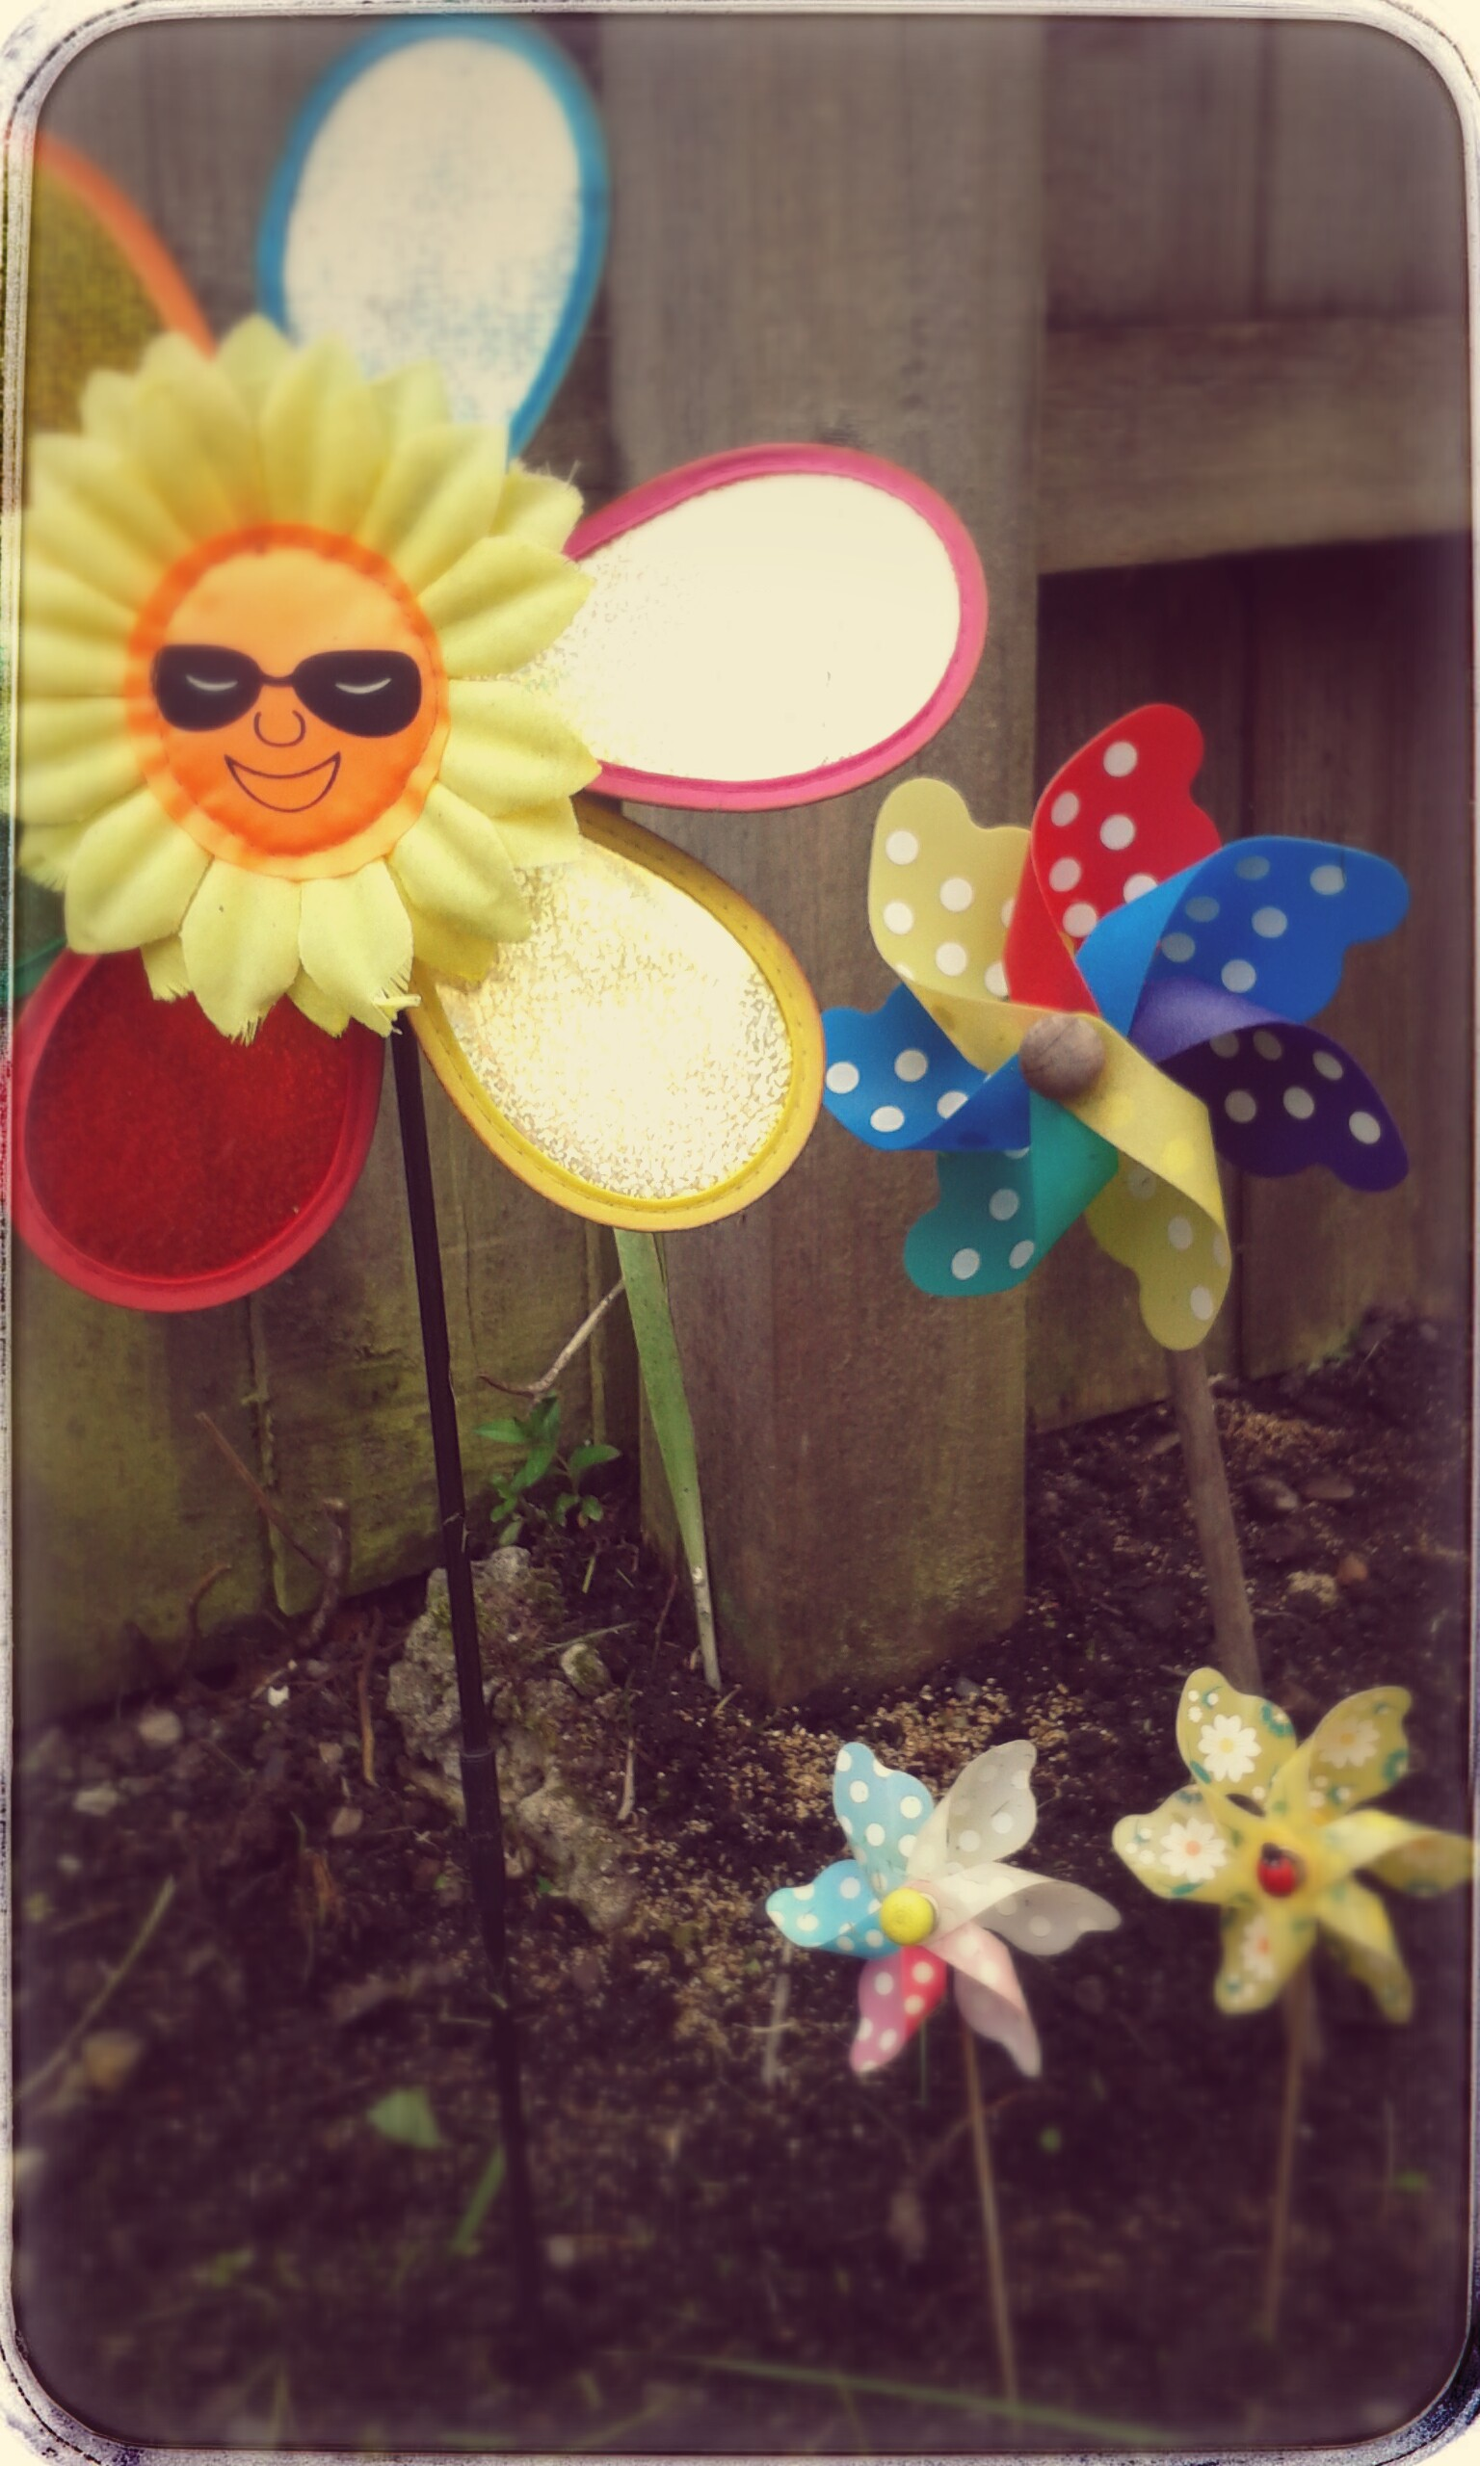

# Try now

*Acceptance exercise*

Imagine an unwanted thought, feeling, physical sensation or memory. It might be a challenge or conflict at work. It just pops into your head. You didn’t ask it to but it did. Imagine it, picture it in a physical form. Interact with it, observe it with curiosity, welcome it like an invited guest, make space for it, soften it, hold it lightly, breathe into it, put your arms around it, carry it with you as you move forwards in life. Open up to it. This is acceptance.

Create space and allow what is present

**NAME technique**- Noticing, Acknowledging, Making room for, Expanding to work with difficult internal barriers.

# Try at home

***Batteries exercise*** (download PDF) to fill in then select one value on the sheet and set three goals to achieve which are in line with this value.

Identify things in your life which might hinder you in achieving your goals. What can you try being more willing to accept and experience? How might this support you in achieving the goals?

***Physical exercise: Acceptance and willingness***

You will need a pen and some small pieces of paper. You can do this alone or with a trusted friend. It’s up to you.

**Purpose**: This physical metaphor is designed to help you distinguish between the different ways that we can respond to certain thoughts, memories, feelings, sensations that come up.

a) We can try to fight them and take active measures to control these thoughts, feelings, sensations etc. when they show up.  
b) We can try to ignore, dissociate, distract, or numb and not be in touch with what’s going on.  
c) Or we can be open and willing to experience whatever is there for however long it wants to stick around for. Without holding onto it or pushing it away.

1. Reflect and think about on something that is causing you difficulty. Give yourself time to do this. It might help to write this down and then come back to the rest of the activity
2. When dealing with this what’s the first thing that shows up? Write this down on a piece of paper (i.e. Thoughts?, Feelings?, Bodily Sensations?, Images that come to mind?, Memories that show up?, Urges?) e.g Anxiety: I feel faint, my heart beats faster, trouble breathing. E.g stress: anger, feel rush of adrenaline, can’t think straight.
3. What thought goes through your head? Write this down on a piece of paper
4. And what shows up next? Write this down on a piece of paper
5. And what shows up next? Write this down on a piece of paper
6. If doing this with someone else have them sit opposite you and slowly throw the pieces of paper across to you. If by yourself hold them above your head and let them go one at a time.
7. You need to try and bat them away from you so they don’t touch you.
8. How did you find this?
9. Ask yourself, would have been able to do something that was important to you at the same time? For example could you have done your work whilst batting them away? Could you have gone to the gym? Or spent time with your family?
10. Gather the paper up.
11. Now cover your eyes with your hands and try to distract yourself however you can. You are not going actively fight with these things but I want you to not to look at them, not to try to notice what’s going on, and just try to distract yourself as much as you can
12. Repeat process of gently throwing cards over yourself.
13. Now what was that experience like for you this time?
14. Ask yourself, would have been able to do something that was important to you at the same time? For example could you have done your work whilst batting them away? Could you have gone to the gym? Or spent time with your family?
15. Gather them up again, repeat but this time open your arms to accept them
16. Now what was that experience like for you this time?
17. Ask yourself, would have been able to do something that was important to you at the same time? For example could you have done your work whilst batting them away? Could you have gone to the gym? Or spent time with your family?

# Watch

Consider that there are different ways to respond to your struggles than you currently use. Try and feel your stress/anxiety as a feeling, fully without trying to change the feeling and without defence. What do you need in order to accept it as a feeling?

**The unwanted party guest**

<https://www.youtube.com/watch?v=VYht-guymF4>

**struggle switch**

<https://www.youtube.com/watch?v=rCp1l16GCXI>

**Mindfulness Meditation (Part 1 of 2)** Acceptance of Thoughts and Feelings (link to YouTube clip)

<https://www.youtube.com/watch?v=YW-TDOgstSE>

# Lesson summary

Finding different ways to distract yourself or numb your response in the present moment, as a way of dealing with stress or difficult situations, can become problematic. Frequent use of distraction and avoidance will lead you further away from your values and from the pursuit of your meaningful goals.

If you practice willingness a little bit every day you will built up your ability to accept such unwanted responses and you can learn to dedicate less time and energy to them. This will help you direct more time to the things you really want to pursue instead.

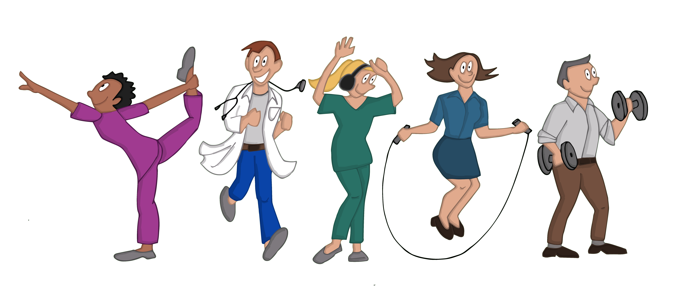

**References**

*Jigsaw metaphor (pachester via* Association for contextual behavioural science website (ACBS) <https://contextualscience.org/>