# Content

# Review of acceptance:

Willingness to accept difficult thoughts and feelings involves you making a space for them and including them into your life jigsaw as, as they form part of the bigger picture even if you do not understand why. It involves willingness to resist battling with them or avoiding them.

ACT aims to support people in altering the way they interact with thoughts and to reduce the unhelpful functions associated with such thoughts.

# Cognitive defusion

We are very good at evaluating, judging and problem solving. These are key human skills. We use language to evaluate situations, judge appropriate courses of action and to problem solve frequently each day. As a result language often has a powerful hold over us. It is easy to see how we could start believing thoughts we have to be truths and to respond to them as they were a real event.

However, this can be problematic. Imagine that you are going for a job interview. Your mind might say to you ‘this is going to be really stressful’ and as a result you may avoid the interview’. Defusion aims to help us untangle and step away from such thoughts so that we can assess them not on how true they are (the interview probably will be stressful) but how helpful they are in moving us towards our values / goals

Cognitive defusion is a technique to create space between ourselves and our thoughts. Learn to take a step back, observe and recognise thoughts for what they are, just words about an event and not an event itself.

This can lessen the impact that difficult or unwanted thoughts can have on us.

**For example**

“I will fail this interview”

Person close to thought bubble

“I am having the thought that I will fail this interview”

Person far away from thought bubble

# Try now

First think about a reoccurring thought that you have about yourself that is unhelpful. It might be a self-judgement that isn’t kind like ‘I am stupid’ / ‘I am boring’ / ‘I am a failure’. Think about this self-judgement for 10 seconds, repeat it in your mind. How do you feel?

Now, take the same thought but say it to yourself like this **‘I am having a thought that** I **am X’**. Say it like that again. How do you feel now?

You can also try picturing the thought as a runner wearing a t-shirt with the word you selected written on it, you can stand there and watch as they jog past you away into the distance (or as a cloud, you can observe it in the sky and watch from far below as the wind takes it away, across the sky).



Alternatively say the thought (in your head) in the voice of a silly or distinctive film/tv character, repeatedly. How does that word feel now?

In these examples you did not need to put in an effort to get rid of the thought. Instead you have noticed that the thought existed, taken a step back and observed it and nothing more than that. Rather than taking the thought to be a fact that is real.

**Remember** This is a skill to learn and practice. Words are often automatic, they have power. Defusion is a skill you can practice that will help you learn that just because you had a thought or feeling it doesn’t mean you have to respond to it. You are not your thoughts. The idea is to change the way you perceive these thoughts rather than alter the nature of them or the frequency of them.

# Try at home

Try out the defusion techniques (PDF cognitive defusion practise sheets) during the week, a couple of minutes a day. Write down how you felt after wards.

What thoughts and feelings are you struggling with? Practice stepping away from them using these techniques. Notice how you feel after them. The **purpose** of these exercises is to see thoughts as what they are, not as what they say they are.

* Thank your mind for the thought and appreciate it and move on
* Sing your difficult thoughts
* Say your difficult thought in a funny voice or say them very, very slowly
* Treat your scary private event/thought as a monster on a bus you are driving
* Picture the thought as a bus and watch it drive around the corner

# Watch

**Observe your thinking /self**

<https://www.youtube.com/watch?v=kl5cyCXelZc>

**Mindfulness exercise**

<https://www.youtube.com/watch?v=jn3D_Biilqc>

<http://www.rowancenterla.com/new-blog/2015/5/6/part-1-you-are-not-your-thoughts-cognitive-defusion-to-change-your-mood>

<http://www.anxietyhappens.com>

# Lesson summary

The **purpose** of these exercises is to see thoughts as what they are, not as what they say they are. Take a step back from negative thoughts and begin to watch your thinking. You can do this by taking an observer’s perspective towards your own thoughts. Observe the power of language and then weaken its control. This will give you more flexibility and choice in your responses to negative thoughts.

Practice a little bit every day.

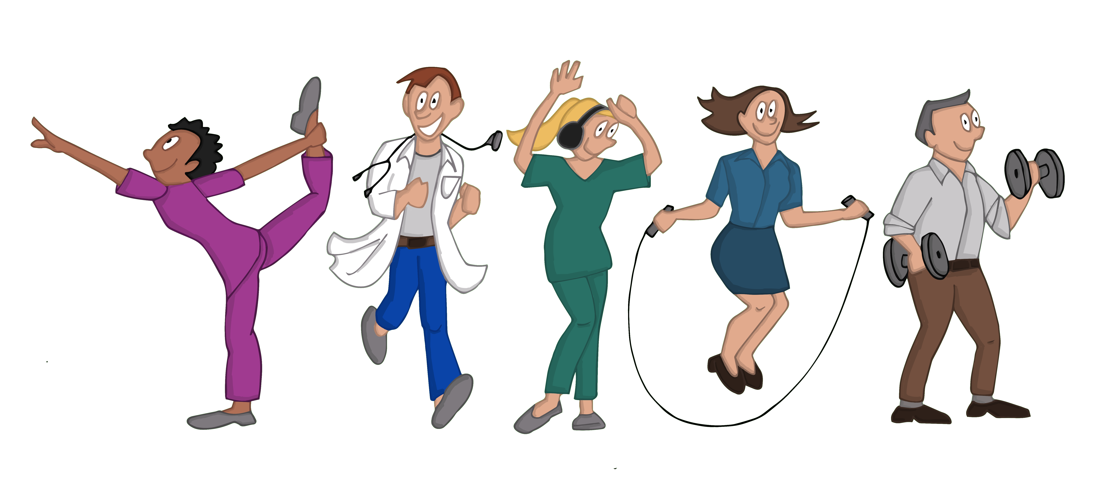

**References**

Association for contextual behavioural science website (ACBS) <https://contextualscience.org/>