# Content

# Review of Being Present

Be present in the moment in a non-judgemental manner – be kind to yourself with regards to the thoughts and feelings that pop up. Experience the moment directly and consider valued actions and attempt to ensure behaviour and actions are more consistent with these values.

# The observing self

We often tell ourselves stories about who we are, the events of the day or in the moment observations. Self as context is a new way of thinking about yourself, your thoughts, feelings and experiences.

For example consider ‘I’ as constant and stable, a container for all of your experiences. It is from this position that we can observe our thoughts and feelings, thoughts and feelings that are not us, but as experiences that come and go through the ebb and flow of life

By becoming the observer you can develop an awareness of your own experiences without attachment to them and this can help you make decisions that are based on your values. This is not an easy task, often we have already responded to thoughts or feelings before we have observed or noticed that they triggered a response. However this is an important step.

1. Observe yourself
2. Notice the thoughts, feelings, judgements and memories you have and how they make you feel with curiosity
3. Notice the things you hear, smell and touch and actions you take
4. Consider them together to understand ’who am I’

**

Look carefully to see what is really there.

|  |
| --- |
| I am….  Thoughts and feelings, judgements and memories noticed …..  What do you hear, smell, touch ….  Actions taken…..  (free text box) |

This skill as observer (self-awareness) can also be applied to any of the physical health behaviour change modules as well. For example, if you are aiming to reduce your alcohol consumption or make healthy food choices to improve your diet, listening to and observing yourself will help you make the changes you want to (valued actions) in the moment.

# Try now

*Your Mind is the World’s Greatest Documentary Maker*

Try to observe your thoughts, feelings and emotions through a ‘story telling’ lens. Spend 3-5 minutes thinking about the different stories you tell yourself. Often we tell ourselves the same stories, repeatedly for years. But is there another story you could tell yourself instead?

First observe that there is a narrator (you), notice the things you are telling yourself about yourself? Second evaluate the story you are telling yourself, do you believe the narrator? Is it true? Do you have to believe it? How do you see the story good or bad or neither? Now write another story.

It is common to have not noticed these unhelpful stories. Remember the way we perceive the story is just as important as the story itself. You can accept the story for what it is, a story, and make room for it and take back the power and lessen its influence over you. You are not the story.

|  |
| --- |
| Robert* told himself that he was not good at public speaking and he believed this story and when he was expected to make a presentation at work he experienced symptoms of stress, he felt faint, his heart beat faster and he had sweaty palms just thinking about it. He responded to these symptoms and had a thought that ‘I’m not good enough’, ‘I can’t do this’ and he became more anxious and wasn’t able to give the presentation.  However, the next time he had to speak publically he managed to step back a little and observe his thoughts and feelings (stories about himself) as passing experiences and connect to what was important to him in the moment’. Having labelled his thought as a thought he remembered he valued his job and decided to spend time learning his presentation and practiced a breathing technique to help him relax. He decided not to avoid the situation by not thinking about it before hand and to accept that he may still experience the same physical symptoms (increased heart rate, sweating, feel faint) but he will accept them for what they are, a natural physical response. |

Short breathing exercises can be helpful in developing self-observation skills, try this 5 minute guided audio/video clip if you want to or just take 3 minutes to breathe slowly.

<https://www.youtube.com/watch?v=awc8MLSpjlQ>

# Try at home

Try this exercise in your own life. When you find that you’re having an unwanted thought or feeling try the following: Take a deep breath and find 10 seconds of kindness, say “The story I’m telling myself is…” and finish with the unwanted worry or a fear you were having.

Then take a step back from your story, take a deep breath and be willing to accept that you had an unwanted thought. Observe yourself having the thought and accept it for just that, a thought you had. Let the thought go.

Write it down or say it out loud whatever suits you.

|  |
| --- |
| For example  The story I’m telling myself is “*I am too stressed out to take on another thing, I am not going to get through this*”.  **Take three deep breaths**  I can be kind to myself  The story I am telling myself is that this is all too much for me to take on and I can’t do it.  Really I am just having the thought that this is too much. I am willing to accept that I have had this thought but it is just a thought it is not all of me.  Accept the thought and imagine it passing you by (like the runner or the cloud earlier)  **Take three deep breaths** |

Remember there is nothing inherently wrong with these stories. They can help reinforce positive behaviours however they can also limit the way we respond to events and situations and restrict our ability to life in a way consistent with our values.

*Sky & weather (audio link here):*

Think of a crystal clear, blue sky. Imagine its expansiveness. Look at its pure beauty. Now picture a cluster of small soft white clouds slowly appearing in the distance, these clouds grow bigger and darker and they roll in and begin to cover the sky so that you can no longer see its crystal clear blue beauty. What if you took a hot air balloon ride or an aeroplane and you rose above those clouds, you would see the blue sky clearly again. The sky was always there it just wasn’t visible to you.

The clouds or storms represent your passing thoughts, feelings, memories and sensations. They roll in and block the view but the sky is always there, it doesn’t go away and it doesn’t change (up past those clouds). The clouds will pass and the sky will be visible again.

In this metaphor the sky represents the stable sense of ‘I’ that is independent of your unwanted thoughts, feelings and stories about yourself. The sky holds the clouds but is independent of them

# Watch

**Self as context**

<https://www.youtube.com/watch?v=kl5cyCXelZc>

**or**

<https://www.youtube.com/watch?v=W2YVtrpGbac>

**Chessboard**

<https://www.youtube.com/watch?v=rf6oVsVnfVE>

**other**

<https://www.youtube.com/watch?v=sVD_WD_9Avs>

# Lesson summary

ACT encourages us to act as our own self-observer in order to notice that while the feelings, sensations, and emotions we experience, can change and vary across situations, the observer does not change. The observer (you) remains the same.

Practice a little bit every day.

Ask yourself to observe what’s happening and also to notice who is doing the observing.

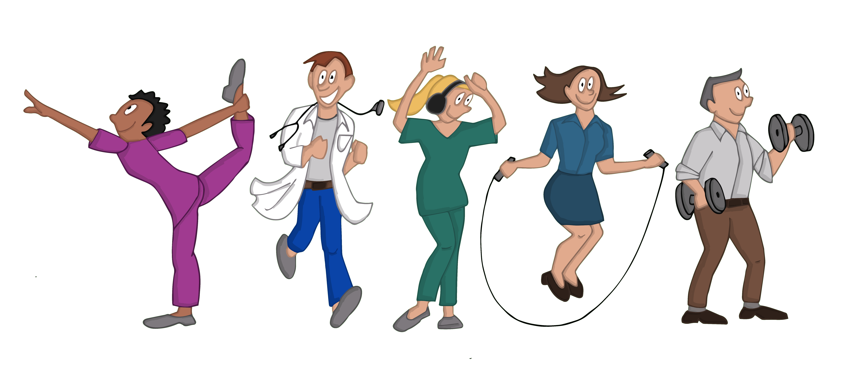

**References**

Association for contextual behavioural science website (ACBS) <https://contextualscience.org/>