# Content

# So what was that again…?

Over the previous 8 weeks you have been introduced to the core processes of ACT which work together to support and develop psychological flexibility on the basis that this can, over time, improve your emotional wellbeing and bring you closer towards living a full and meaningful life.

The experiential exercises and metaphors have been designed to help you understand the ways in which language is involved in human suffering and to identify small changes you can make to reduce the burden of suffering. The skills and techniques described here aim to help you change the way you view your thoughts and to enable you to make choices and actions which are in line with your values.

It’s a lot to take in so let’s recap with more examples and more opportunities to practice these skills.

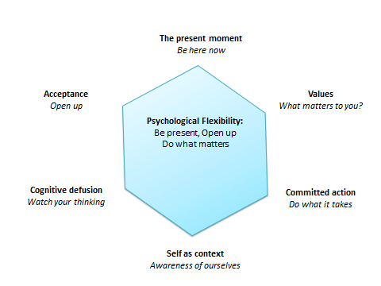

**Barriers**

But what about those barriers that stop you reaching your goals and living in accordance with your values? It is often helpful to consider the barriers along with the goals and values. We all experience barriers and thinking ahead and predicting barriers make it easier to spot them next time. There are different types of barriers that exist (internal and external).

**Internal barriers**

Fearful thoughts that crop up even when we are ready to make positive life changes.

For example ‘*it’s too hard’, ‘I will fail’*.

Make room for the thought and observe it as the thought it is, just that. Difficulty experiencing uncomfortable thoughts even when you feel ready to make those positive changes and are willing to let them in. acknowledge that it is difficult and that with time this will lessen.

Distance from your values can reduce motivation to strive towards them. Connect with them and remind yourself what you value and how you really want to live.

**External barriers**

Events and behaviours of others

For example, colleague’s behaviour at work, they fail to arrive on time for a work meeting or they do not communicate with their team information that you/others require.

Sometimes you can plan for such barriers and prepare how you will respond and what you will do in such a situation. You can think about this ahead of time and write down what you could do to overcome a barrier.

# Try now

Make the Hexflex personal to you. Fill in the gaps with words, phrases or actions that are meaningful to you or that summarise each of the six core processes to you (refer back to previous lessons or work from memory it’s up to you). Write as little or much as you want.

Try to introduce personal examples to help you relate the information to your own experiences.

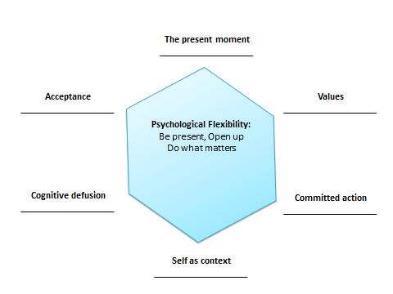

**Barriers activity (PDF download)**

My goal is to _________________________________________________________________

I wish to achieve this ______________________ often or when ________________________

This goal will help me in the pursuit of my value

________________________________________________________________________________

Which is important and meaningful to me (because)

__________________________________________________________________________________

Internal barriers which I might experience

1.

2.

3.

External barriers I might experience are

1.

2.

3.

Ways to overcome these are

1.

2.

3.

# Try at home

Explore your values

Previously we have popular values and a series of exercises including the 80th birthday party, life as a movie and a holiday exercise. You can try these again to explore your own personal values further. It helps to revisit and reconsider the areas in your life which are important to you.

Or try the following values exercise:

Take a few minutes to add the following values into one of the three columns:

Warm, responsible, accepting, honest, Resourceful, Tolerant, generous, successful, kind, friendly, passionate, loyal, understanding, clever, educated, fit, good listener, strong, brave, trusting, positive, cheerful, helpful, determined, loving, confident, inspiring, patient, persistent, calm, focused….

|  |  |  |
| --- | --- | --- |
| Very important to me | Important to me | Not important |
|  |  |  |
|  |  |  |

Which ones did you put in the ‘very important column’? Can you narrow this down to three?

Consider these values as your primary values. The values that are in the values column are your supporting values that help you.

You may then like to try out another values based action at home based on one of the values you have identified here.

*Ten steps to trying on a value exercise (PDF):*

1. **Choose a Value.** Choose valued directions that you are willing to try on for at least a week. This should be a value that *you* can enact and a value that you care about. This is not a time to try to change others or manipulate them into changing.
2. **Notice Reactions.** Notice anything that comes up about whether or not this is a good value, or whether or not you really care about this value. Just notice all thoughts for what they are. Remember that your minds job is to create thoughts. Let your mind do that and you stay on the exercise.
3. **Make a List.** Take a moment to list a few behaviors that one might say are related to the chosen value.
4. **Choose a Behavior.** From this list, choose one behavior or set of behaviors you can commit to between now and next session or the next few sessions.
5. **Notice Judgments.** Notice anything that comes up about whether or not that is a good behavior, whether or not you will enjoy it, or whether you can actually do that to which you are committing yourself.
6. **Make a Plan.** Write down how you will go about enacting this value in the very near future (today, tomorrow, this coming weekend, at the next meeting with your supervisor). Consider anything you will need to plan or get in order (e.g., call another person, clean the house, make an appointment, etc.). Choose when to do that – the sooner the better.
7. **Just Behave.** Even if this value involves other people, *do not tell them what you are doing*. See what you can notice if you just enact this value without telling them it is an ‘experiment’.
8. **Keep a Daily Diary of Your Reactions.** Things to look for are other’s reactions to you, any thoughts feelings or body sensations that occur before, during and after the behavior, and how you feel doing it for the second (or fifth, or tenth, or hundredth) time. Watch for evaluations that indicate whether this activity, value, or valued direction was ‘good’ or ‘bad’ or judgments about others, or yourself in relation to living this value. Gently thank your mind for those thoughts, and see if you can choose not to buy into the judgments it makes about the activity.
9. **Commit.** Every day. Notice anything that shows up as you do so.
10. **Reflect** on them and consider any barriers you might experience and how you can defuse them.

# Watch

**You tube clip on valued directions and acceptance.**

<https://www.youtube.com/watch?v=NdaCEO4WtDU>

**Mindful meditation exercise (4 mins)**

[*https://www.youtube.com/watch?v=6iR2Yw8gBIo*](https://www.youtube.com/watch?v=6iR2Yw8gBIo)

**Useful further reading**

[**http://www.mindfulnessmuse.com/acceptance-and-commitment-therapy/how-to-deal-with-barriers-to-effective-action**](http://www.mindfulnessmuse.com/acceptance-and-commitment-therapy/how-to-deal-with-barriers-to-effective-action)

# Lesson summary

The six core process of ACT work together to build psychological flexibility. Each core process has a set of practical skills and exercises to try out.

**Acceptance** Open up. Be willing to experience what is happening and make room for your thoughts.

**Cognitive Fusion** Change the way you interact with your thoughts, label the process of thinking (“I am having the thought that I am *no good*”).

**Being Present** On-going, non-judgmental contact with psychological and environmental events as they occur.

**Self as Context** Be aware of your experiences without attachment to them.

**Values** are the things that are important and meaningful to you. They guide your actions towards reaching the things you value the most.

**Committed Action** to concrete goals that are consistent with your values.

Practice a little bit every day.



**References**

Association for contextual behavioural science website (ACBS) <https://contextualscience.org/>