Objective
Complete exam questions d, e, and f below
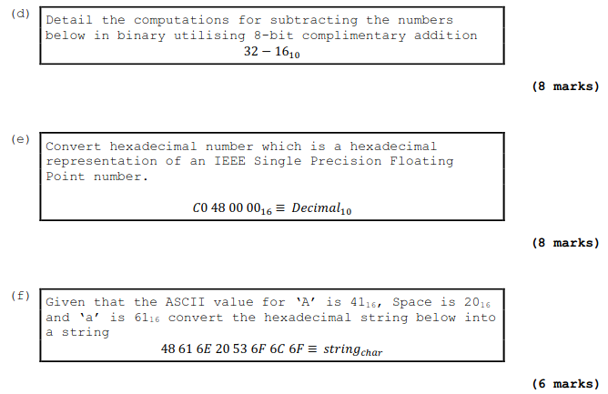
D = 10 0000 - 1 0000 = 1 0000

E = 1100 0000 0100 1000 0000 0000 0000 0000
= 32 25 94 40 64

F = 48 61 6E 20 53 6F 6C 6F
= H a n S o l o
= Han Solo

Hand up this practical report at the end of session and ensure it has been checked
Student Name | Dara Moffett | Student Number | C00261033
Date | 10/11/21 | Checked
Group | A

