Installation Guide:
Install the following software
VS CODE
https://code.visualstudio.com/
Python
https://www.python.org/downloads/
Anaconda
https://www.anaconda.com/download

After installation, get python extension in VS Code
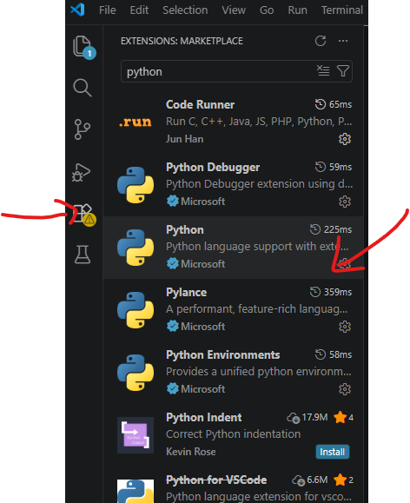

Open VS Code go to file -> open new folder and open the folder containing the code
Press Ctrl + l go to arrow drop down next to plus sign and open new cmd
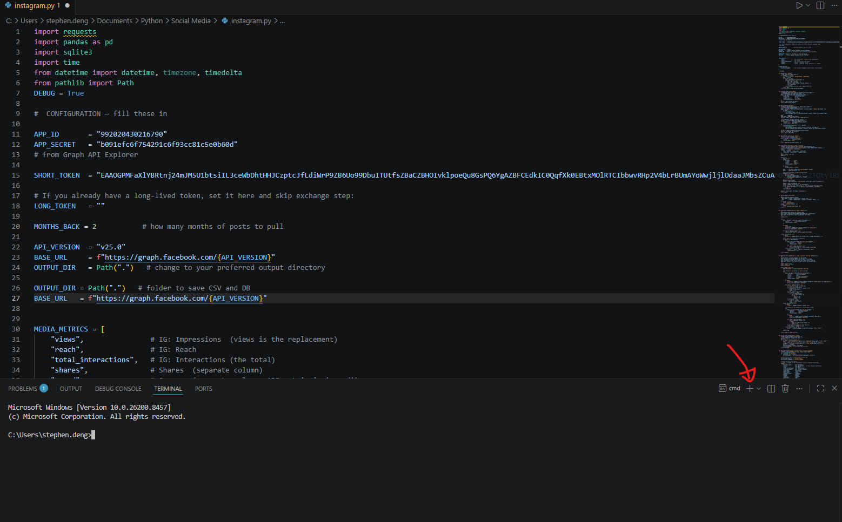
Run the following commands:
cd path/…/project
python -m pip –version
python -m venv .venv
.venv\Scripts\activate.bat
pip install -r requirements.txt

