前面一篇文章《WCF 学习总结1 -- 简单实例》一股脑儿展示了几种WCF部署方式，其中配置文件(App.config/Web.config)都是IDE自动生成，省去了我们不少功夫。现在回过头来看看IDE提供的Wcf Service Library项目模板中的默认服务端配置文件——App.config里面究竟有什么秘密。
服务端的配置文件主要是对services、bindings、behaviors的配置。在默认的App.config中，使用的是WCF Framework定义好的wsHttpBinding默认配置，所以看不到binding配置节。
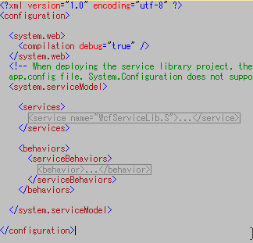
配置节展开如下图：
BTW： "元数据端点”通过WS-MetadataExchange帮我们实现了对服务的描述，提供了WSDL，启动Host之后我们可以通过http://localhost:8732/Design_Time_Addresses/WcfServiceLib/Service1/?wsdl 查看到公开的服务描述。
配置节展开如下图：
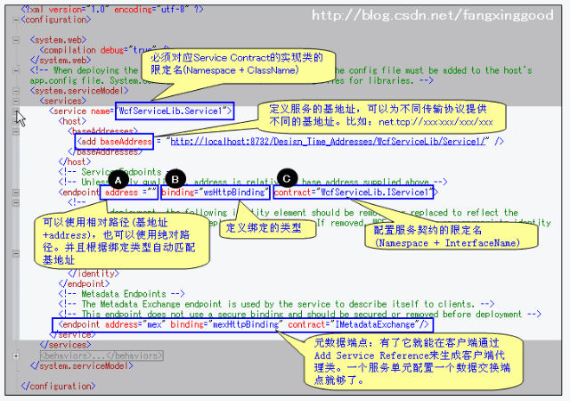
关于WCF中的地址和绑定，需要补充一下。
WCF中支持的传输协议包括HTTP、TCP、Peer network(对等网)、IPC(基于命名管道的内部进程通信)以及MSMQ(微软消息队列)，每个协议对应一个地址类型：
• HTTP地址：http://localhost:8080/
• TCP地址： net.tcp://localhost:8080/
• IPC地址： net.pipe://localhost/ （适用于跨进程，不能使用于不同机器间）
• MSMQ地址： net.msmq://localhost/
• 对等网地址： net.p2p://localhost/
WCF中提供的绑定有：
• • BasicHttpBinding: 最简单的绑定类型，通常用于 Web Services。使用 HTTP 协议，Text/XML 编码方式。
• WSHttpBinding: 比 BasicHttpBinding 更加安全，通常用于 non-duplex 服务通讯。
• WSDualHttpBinding: 和 WSHttpBinding 相比，它支持 duplex 类型的服务。
• WSFederationHttpBinding: 支持 WS-Federation 安全通讯协议。
• NetTcpBinding: 效率最高，安全的跨机器通讯方式。
• NetNamedPipeBinding: 安全、可靠、高效的单机服务通讯方式。
• NetMsmqBinding: 使用消息队列在不同机器间进行通讯。
• NetPeerTcpBinding: 使用 P2P 协议在多机器间通讯。
• MsmqIntegrationBinding: 使用现有的消息队列系统进行跨机器通讯。如 MSMQ。
------ 弱弱的分隔线 -----
• OK，有了上面的基础，就让WCF风暴来的猛烈些吧。做一个多服务，多端点的示例。
• 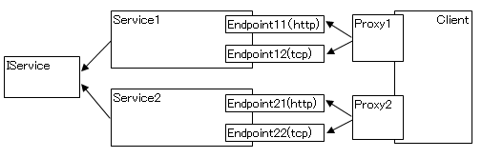
• 1.WcfServiceLib 代码：
•
- • [ServiceContract]
- public interface IService
- {
- [OperationContract]
- string GetMessage();
- }
- public class Service1 : IService
- {
- public string GetMessage()
- {
- var address = OperationContext.Current.Channel.LocalAddress.ToString();
- return string.Format("From Server1: Hello Client at [{0}]", address);
- }
- }
- public class Service2 : IService
- {
- public string GetMessage()
- {
- var address = OperationContext.Current.Channel.LocalAddress.ToString();
- return string.Format("来自 Service2: 好 Client at [{0}]", address);
- }
- }
- [ServiceContract]
- public interface IService
- {
- [OperationContract]
- string GetMessage();
- }
- public class Service1 : IService
- {
- public string GetMessage()
- {
- var address = OperationContext.Current.Channel.LocalAddress.ToString();
- return string.Format("From Server1: Hello Client at [{0}]", address);
- }
- }
- public class Service2 : IService
- {
- public string GetMessage()
- {
- var address = OperationContext.Current.Channel.LocalAddress.ToString();
- return string.Format("来自 Service2: 好 Client at [{0}]", address);
- }
- }
2.WcfConsoleHost 代码：

- static void Main(string[] args)
- {
- ServiceHost host1 = new ServiceHost(typeof(WcfServiceLib.Service1));
- host1.Open();
- Console.WriteLine("Server1 Opened!");
- ServiceHost host2 = new ServiceHost(typeof(WcfServiceLib.Service2));
- host2.Open();
- Console.WriteLine("Server2 Opened!");
- Console.Read();
- }
- static void Main(string[] args)
- {
- ServiceHost host1 = new ServiceHost(typeof(WcfServiceLib.Service1));
- host1.Open();
- Console.WriteLine("Server1 Opened!");
- ServiceHost host2 = new ServiceHost(typeof(WcfServiceLib.Service2));
- host2.Open();
- Console.WriteLine("Server2 Opened!");
- Console.Read();
- }
3.服务端配置文件：

- <?xml version="1.0" encoding="utf-8" ?>
- <configuration>
- <system.web>
- <compilation debug="true" />
- </system.web>
- <system.serviceModel>
- <services>
- <service name="WcfServiceLib.Service1">
- <host>
- <baseAddresses>
- <add baseAddress = "http://localhost:9999/WcfStudy3/Service1" />
- <add baseAddress = "net.tcp://localhost:8888/WcfStudy3/Service1" />
- </baseAddresses>
- </host>
- <endpoint address ="serviceEN_1" binding="wsHttpBinding" contract="WcfServiceLib.IService" />
- <endpoint address ="serviceEN_2" binding="mexTcpBinding" contract="WcfServiceLib.IService" />
- <endpoint address="mex" binding="mexHttpBinding" contract="IMetadataExchange"/>
- </service>
- <service name="WcfServiceLib.Service2">
- <host>
- <baseAddresses>
- <add baseAddress = "http://localhost:9999/WcfStudy3/Service2" />
- <add baseAddress = "net.tcp://localhost:8888/WcfStudy3/Service2" />
- </baseAddresses>
- </host>
- <endpoint address ="serviceCH_1" binding="wsHttpBinding" contract="WcfServiceLib.IService" />
- <endpoint address ="serviceCH_2" binding="mexTcpBinding" contract="WcfServiceLib.IService" />
- <endpoint address="mex" binding="mexHttpBinding" contract="IMetadataExchange"/>
- </service>
- </services>
- <behaviors>
- <serviceBehaviors>
- <behavior>
- <serviceMetadata httpGetEnabled="True"/>
- <serviceDebug includeExceptionDetailInFaults="true" />
- </behavior>
- </serviceBehaviors>
- </behaviors>
- </system.serviceModel>
- </configuration>
- <?xml version="1.0" encoding="utf-8" ?>
- <configuration>
- <system.web>
- <compilation debug="true" />
- </system.web>
- <system.serviceModel>
- <services>
- <service name="WcfServiceLib.Service1">
- <host>
- <baseAddresses>
- <add baseAddress = "http://localhost:9999/WcfStudy3/Service1" />
- <add baseAddress = "net.tcp://localhost:8888/WcfStudy3/Service1" />
- </baseAddresses>
- </host>
- <endpoint address ="serviceEN_1" binding="wsHttpBinding" contract="WcfServiceLib.IService" />
- <endpoint address ="serviceEN_2" binding="mexTcpBinding" contract="WcfServiceLib.IService" />
- <endpoint address="mex" binding="mexHttpBinding" contract="IMetadataExchange"/>
- </service>
- <service name="WcfServiceLib.Service2">
- <host>
- <baseAddresses>
- <add baseAddress = "http://localhost:9999/WcfStudy3/Service2" />
- <add baseAddress = "net.tcp://localhost:8888/WcfStudy3/Service2" />
- </baseAddresses>
- </host>
- <endpoint address ="serviceCH_1" binding="wsHttpBinding" contract="WcfServiceLib.IService" />
- <endpoint address ="serviceCH_2" binding="mexTcpBinding" contract="WcfServiceLib.IService" />
- <endpoint address="mex" binding="mexHttpBinding" contract="IMetadataExchange"/>
- </service>
- </services>
- <behaviors>
- <serviceBehaviors>
- <behavior>
- <serviceMetadata httpGetEnabled="True"/>
- <serviceDebug includeExceptionDetailInFaults="true" />
- </behavior>
- </serviceBehaviors>
- </behaviors>
- </system.serviceModel>
- </configuration>
4. 启动Host，在Client工程中添加Service Reference
因为有两个Service，所以要添加两次。
(1) WcfSvc1（Url：http://localhost:9999/WcfStudy3/Service1）
(2) WcfSvc2（Url：http://localhost:9999/WcfStudy3/Service2） 图略
5. 客户端配置文件： 配置节中，生成了4个Endpoint，分别对应服务端的4个Endpoint。通过
name属性区别。
- <client>
- <endpoint address="http://localhost:9999/WcfStudy3/Service1/serviceEN_1"
- binding="wsHttpBinding" bindingConfiguration="WSHttpBinding_IService"
- contract="WcfSvc1.IService" name="WSHttpBinding_IService">
- </endpoint>
- <endpoint address="net.tcp://localhost:8888/WcfStudy3/Service1/serviceEN_2"
- binding="netTcpBinding" bindingConfiguration="MetadataExchangeTcpBinding_IService"
- contract="WcfSvc1.IService" name="MetadataExchangeTcpBinding_IService" />
- <endpoint address="http://localhost:9999/WcfStudy3/Service2/serviceCH_1"
- binding="wsHttpBinding" bindingConfiguration="WSHttpBinding_IService1"
- contract="WcfSvc2.IService" name="WSHttpBinding_IService1">
- </endpoint>
- <endpoint address="net.tcp://localhost:8888/WcfStudy3/Service2/serviceCH_2"
- binding="netTcpBinding" bindingConfiguration="MetadataExchangeTcpBinding_IService1"
- contract="WcfSvc2.IService" name="MetadataExchangeTcpBinding_IService1" />
- </client>
- <client>
- <endpoint address="http://localhost:9999/WcfStudy3/Service1/serviceEN_1"
- binding="wsHttpBinding" bindingConfiguration="WSHttpBinding_IService"
- contract="WcfSvc1.IService" name="WSHttpBinding_IService">
- </endpoint>
- <endpoint address="net.tcp://localhost:8888/WcfStudy3/Service1/serviceEN_2"
- binding="netTcpBinding" bindingConfiguration="MetadataExchangeTcpBinding_IService"
- contract="WcfSvc1.IService" name="MetadataExchangeTcpBinding_IService" />
- <endpoint address="http://localhost:9999/WcfStudy3/Service2/serviceCH_1"
- binding="wsHttpBinding" bindingConfiguration="WSHttpBinding_IService1"
- contract="WcfSvc2.IService" name="WSHttpBinding_IService1">
- </endpoint>
- <endpoint address="net.tcp://localhost:8888/WcfStudy3/Service2/serviceCH_2"
- binding="netTcpBinding" bindingConfiguration="MetadataExchangeTcpBinding_IService1"
- contract="WcfSvc2.IService" name="MetadataExchangeTcpBinding_IService1" />
- </client>
6. 客户端代码：

- static void Main(string[] args)
- {
- Console.WriteLine("------------");
- WcfSvc1.ServiceClient client1_1 = new WcfSvc1.ServiceClient("WSHttpBinding_IService");
- Console.WriteLine(client1_1.GetMessage());
- Console.WriteLine("------------");
- WcfSvc1.ServiceClient client1_2 = new WcfSvc1.ServiceClient("MetadataExchangeTcpBinding_IService");
- Console.WriteLine(client1_2.GetMessage());
- Console.WriteLine("------------");
- WcfSvc2.ServiceClient client2_1 = new WcfSvc2.ServiceClient("WSHttpBinding_IService1");
- Console.WriteLine(client2_1.GetMessage());
- Console.WriteLine("------------");
- WcfSvc2.ServiceClient client2_2 = new WcfSvc2.ServiceClient("MetadataExchangeTcpBinding_IService1");
- Console.WriteLine(client2_2.GetMessage());
- Console.Read();
- }
- static void Main(string[] args)
- {
- Console.WriteLine("------------");
- WcfSvc1.ServiceClient client1_1 = new WcfSvc1.ServiceClient("WSHttpBinding_IService");
- Console.WriteLine(client1_1.GetMessage());
- Console.WriteLine("------------");
- WcfSvc1.ServiceClient client1_2 = new WcfSvc1.ServiceClient("MetadataExchangeTcpBinding_IService");
- Console.WriteLine(client1_2.GetMessage());
- Console.WriteLine("------------");
- WcfSvc2.ServiceClient client2_1 = new WcfSvc2.ServiceClient("WSHttpBinding_IService1");
- Console.WriteLine(client2_1.GetMessage());
- Console.WriteLine("------------");
- WcfSvc2.ServiceClient client2_2 = new WcfSvc2.ServiceClient("MetadataExchangeTcpBinding_IService1");
- Console.WriteLine(client2_2.GetMessage());
- Console.Read();
- }
7.运行结果：
有人会问，那么生成完的配置文件都要一个个手动修改吗？答案当然不是，VS已经为我们准备了WCF配置工具：IDE > Tools > WCF Service Configuration Editor 。 关于工具的使用，大家可以看这里： http://www.rainsts.net/article.asp?id=441

http://www.cnblogs.com/jackljf/archive/2013/04/01/3588938.html

