Software Test Plan (STP) Template

Items that are intended to stay in as part of your document are in bold; explanatory comments are in italic text. Plain text is used where you might insert wording about your project.

This document is an annotated outline for a Software Test Plan, adapted from the IEEE Standard for Software Test Documentation (Std 829-1998).

Tailor as appropriate. Where you decide to omit a section, you might keep the header, but insert a comment saying why you omit the element.

General Electric Transportation Division



Signal Block Design Tool

Software Quality Assurance Plan

Version: 1.0 Date: (09/03/2014)

Document History and Distribution

- Revision History

Revision # | Revision Date | Description of Change | Author
1 | 09/03/2014 | Initial Release | Chris Diebold

- Distribution

Recipient Name | Recipient Organization | Distribution Method

Table of Contents

1.
Introduction 1
2. Test Items 3
3. Features To Be Tested 4
4. Features Not To Be Tested 4
5. Approach 4
6. Pass / Fail Criteria 6
7. Testing Process 6
8. Environmental Requirements 7
9. Change Management Procedures 8
10. Plan Approvals 8

Introduction

The Software Test Plan (STP) is designed to prescribe the scope, approach, resources, and schedule of all testing activities. The plan must identify the items to be tested, the features to be tested, the types of testing to be performed, the personnel responsible for testing, the resources and schedule required to complete testing, and the risks associated with the plan.

  - Objectives
Requirements
- The software application shall include formulas on the following specific parameters stated below, that will be an intrinsic part of the analysis of signal block characteristics, and allow recommendations on signal block improvements.
- Safe Braking Calculations – is the distance the train travels from when the train driver makes a full-service brake application to when the train stops (see figure 1).
- Runtime Performance Calculations – Run time is the time of travel between any two points, but is normally given from the start of a run – departure from the initial station, to the end of a run – arrival at the final station.

Below is a sample layout of the parameters the calculations is determined for 1, 2 and 5 above:

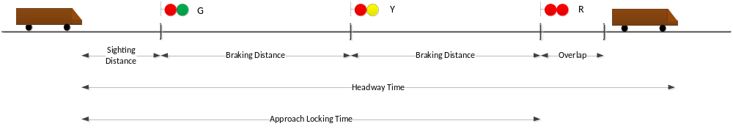

Figure 1 – Safe Braking Distance-Headway and Approach Locking Time

- The software application shall include the capability for database and application user inputs for parameters such as train acceleration, train deceleration; maximum authorized track segment speed, operator reaction time, civil restrictions, track curve data, track grades and more.

- With both the signaling design formulas in section I, and the data entry in section II, the software application shall perform automated analysis, and display the pertinent railroad signaling design output.

- The output of the software application shall determine for any given Railroad Signaling Design the safe train braking distance, the train headway times, the run time performance, clearing times, and approach locking times given the parameters entered into the system. The application shall support display and output of:

- Excel formatted Spreadsheet
- Track and Train Graphs
- Train Simulations

- The Development Tools, Database technology selection, and specific output formats are to be determined during the initial stages of the project.

Software Domain Model
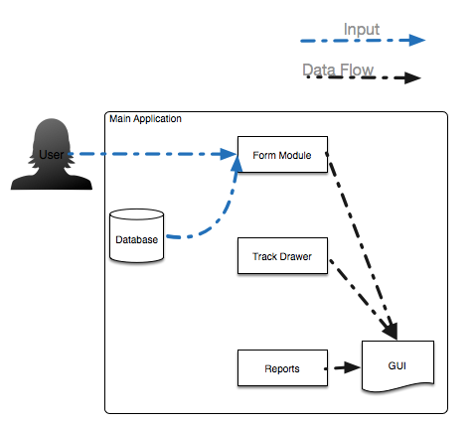
1.2 Testing Strategy
Testing is the process of analyzing a software item to detect the differences between existing and required conditions and to evaluate the features of the software item.
Specific test plan components include:
- Purpose for this level of test,
- Items to be tested,
- Features to be tested,
- Features not to be tested,
- Management and technical approach,
- Pass / Fail criteria,
- Individual roles and responsibilities,
- Milestones,
- Schedules, and
- Risk assumptions and constraints.
1.3 Scope
Develop a software application (tool) that verifies, and recommends improvements, in railroad signaling block design.

1.4 Reference Material
Omitted
1.5 Definitions and Acronyms
SBD – Safe Braking Distance

Test Items
(Specify the test items included in the plan. Supply references to the following item documentation:
- Requirements specification,
- Design specification,
- Users guide,
- Operations guide,
- Installation guide,
- Features (availability, response time),
- Defect removal procedures, and
- Verification and validation plans.)

2.1 Program Modules
- Database
- Forms – a windows form, window, dialog box etc., that the user will use to interact with the system
- Excel Parser- an external program that is imported into the program as a fast way of inputting data into the database
- GE Algorithms- These algorithms are what calculate the SBD and runtime performance calculations
- GUI- a broad term for the main window of the program and all buttons and menu items respectively.
- Renderer- a special track view that draws a track simulation of the data.

2.3 User Procedures
A User manual will be made to go with the system and every feature in the manual will be walked through first by a tester.

Features To Be Tested
Database:
- Connectivity to database
- Initialization and shutdown of database
- Queries:
To test the queries, we will be unit testing all queries made by the system and checking the values returned against the excel spreadsheet DART1 provided by GE. What we are looking for is that the rows returned from the query match the information on the DART spreadsheet needed for calculations.

Forms:
To test the forms we will be using a combination of digits and letters in the fields and checking to see if a field throws the proper exception if an incorrect character is inserted into the form field.
Also, we will be unit testing the information retrieved from the field and matching it against known good data from the Dart spreadsheet.

Excel Parser:
To test this module we will be focused on verifying that the data in an excel spreadsheet is in fact being loaded correctly into the database under the correct tables respectively. As this is an external tool and has no impact on the system as a whole, this is the only test we will conduct on this module.

GE Algorithms:
Safe Braking Distance: the SBD will be unit tested against a few scenarios given in the excel spreadsheet of data provided by GE. We are testing the final SBD value up to 2 decimal places and a threshold value to ensure that sufficient SBD is reached on a particular track.
Runtime Performance: the runtime performance will be unit tested against a few scenarios given in the excel spreadsheet of data provided by GE.

GUI: All button will be tested by sight for functionality.

4. Features Not To Be Tested
(Identify all features and specific combinations of features that will not be tested along with the reasons.)
Omitted.

5. Approach
(Describe the overall approaches to testing. The approach should be described in sufficient detail to permit identification of the major testing tasks and estimation of the time required to do each task. Identify the types of testing to be performed along with the methods and criteria to be used in performing test activities. Describe the specific methods and procedures for each type of testing. Define the detailed criteria for evaluating the test results.)
(For each level of testing there should be a test plan and the appropriate set of deliverables. Identify the inputs required for each type of test. Specify the source of the input. Also, identify the outputs from each type of testing and specify the purpose and format for each test output. Specify the minimum degree of comprehensiveness desired. Identify the techniques that will be used to judge the comprehensiveness of the testing effort. Specify any additional completion criteria (e.g., error frequency). The techniques to be used to trace requirements should also be specified.)
5.2 Integration Testing
(Testing conducted in which software elements, hardware elements, or both are combined and tested until the entire system has been integrated. The purpose of integration testing is to ensure that design objectives are met and ensures that the software, as a complete entity, complies with operational requirements. Integration testing is also called System Testing.)

6. Pass / Fail Criteria
Pass/Fail will be determined based on the following parameters:

- Database
  - Pass if database connection can be open and closed. And all query tests match the spreadsheet row result.
- Forms
  - An exception is thrown if a digit is placed in a text only field and vice versa for a character (letter).
  - When user click submit or similar button, the information is passed properly encapsulated into an object used for calculations
- Excel Parser
  - Data is correctly parsed into database.
- GUI
  - All buttons respond to a click or similar gesture.
- Renderer
  - Track is displayed to scale correctly.
  - Proper dialog box signaling an incorrect/unsafe track conditions.
  - Track information displayed as user mouse overs track segments
- GE Algorithms
- The SBD and runtime performance give the correct result in the unit tests based off of sample data that we know to be correct.
- The GUI simulation displays the correct pop-up dialog box indicating that there is an error in the track layout.

7. Testing Process
(Identify the methods and criteria used in performing test activities. Define the specific methods and procedures for each type of test. Define the detailed criteria for evaluating test results.)

7.1 Test Deliverables
(Identify the deliverable documents from the test process. Test input and output data should be identified as deliverables. Testing report logs, test incident reports, test summary reports, and metrics' reports must be considered testing deliverables.)

7.2 Testing Tasks
(Identify the set of tasks necessary to prepare for and perform testing activities. Identify all intertask dependencies and any specific skills required.)

7.3 Responsibilities
(Identify the groups responsible for managing, designing, preparing, executing, witnessing, checking, and resolving test activities. These groups may include the developers, testers, operations staff, technical support staff, data administration staff, and the user staff.)

7.4 Resources
(Identify the resources allocated for the performance of testing tasks. Identify the organizational elements or individuals responsible for performing testing activities. Assign specific responsibilities. Specify resources by category. If automated tools are to be used in testing, specify the source of the tools, availability, and the usage requirements.)

7.5 Schedule
ommited

8. Environmental Requirements
Omitted the whole section.

8.1 Hardware
(Identify the computer hardware and network requirements needed to complete test activities.)

8.2 Software
(Identify the software requirements needed to complete testing activities.)

8.3 Security
(Identify the testing environment security and asset protection requirements.)

8.4 Tools
(Identify the special software tools, techniques, and methodologies employed in the testing efforts. The purpose and use of each tool shall be described. Plans for the acquisition, training, support, and qualification for each tool or technique.)

8.5 Publications
(Identify the documents and publications that are required to support testing activities.)

8.6 Risks and Assumptions
(Identify significant constraints on testing such as test item availability, test resource availability, and time constraints. Identify the risks and assumptions associated with testing tasks including schedule, resources, approach and documentation. Specify a contingency plan for each risk factor.)

9. Change Management Procedures

Omitted

10. Plan Approvals

omitted

