1. Load from database
2. Click connect
3. Type All
4. Click view data
5. Click main menu
6. Click import from a file
7. Load the file
8. Click on data view

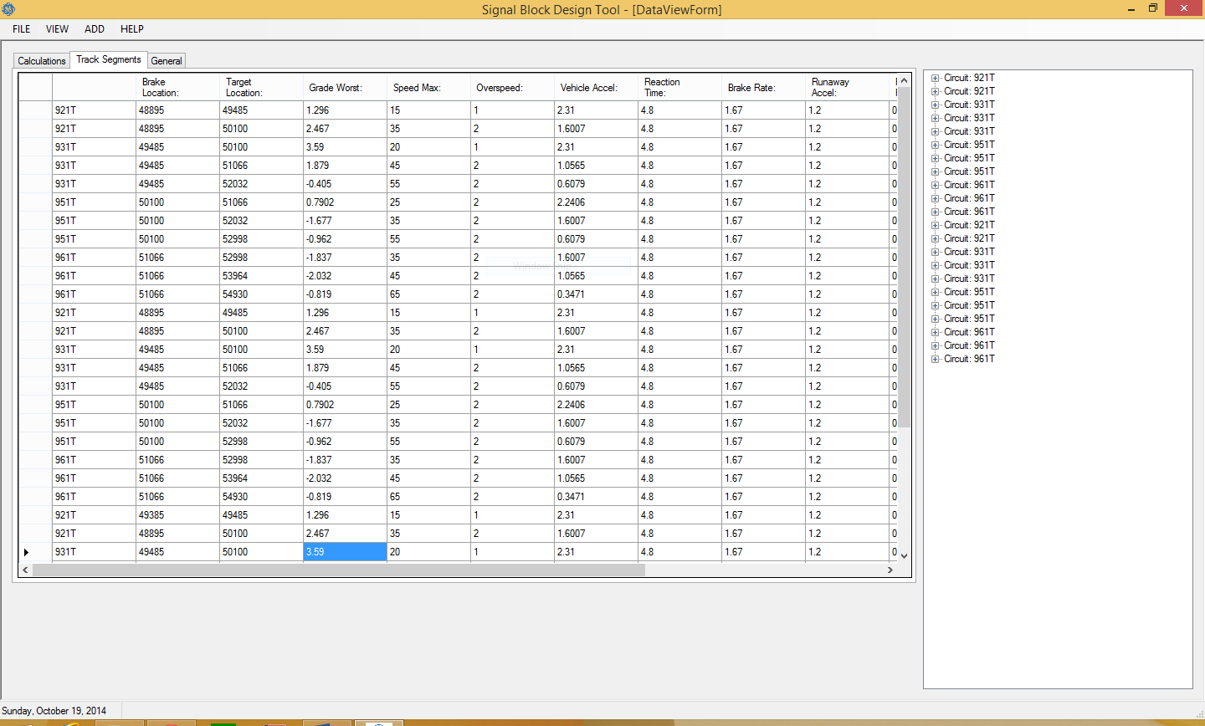

Bug 1: Multiple track segments in view.

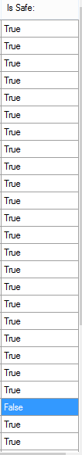

Bug 2: False row not colored red.

Bug 3: in track layout view, it shows correct red segment but I cannot zoom out to see entire track.

General tab dies nothing. Needs to go?