

**FACULTY OF INFORMATION TECHNOLOGY**

**COURSE CODE: CSE 211**

**COURSE TITLE: COMPUTER PROGRAMMING USING VB.NET**

**INTRODUCTION**

In this material, we will be introduced to VB.NET and the .NET frameworks. We will also be looking at the IDEs that are used for this language. This material will also cover the installation process of the Visual Studio 2019 IDE.

**LEARNING OUTCOME**

At the end of this lesson, students should be able to:

1. Understand what VB.NET is.
2. Explain how VB.NET relates to the .NET framework.
3. Successfully download and install the Visual Studio 2019 IDE.

**VB.NET**

Visual Basic .NET (VB.NET) is an object-oriented computer programming language implemented on the .NET Framework. Although it is an evolution of classic Visual Basic language, it is not backwards-compatible with VB6, and any code written in the old version does not compile under VB.NET.

VB.NET has complete support for object-oriented concepts. Everything in VB.NET is an object, including all of the primitive types (Short, Integer, Long, String, Boolean, etc.) and user-defined types, events, and even assemblies. All objects inherits from the base class Object.

**VB.NET SETUP**

We have already mentioned that VB.Net is part of .Net framework and used for writing .Net applications. Therefore, before discussing the available tools for running a VB.Net program, let us understand how VB.Net relates to the .Net framework.

The .Net framework is a revolutionary platform that helps you to write the following types of applications:

* Windows applications
* Web applications
* Web services

The .Net framework applications are multi-platform applications. The framework has been designed in such a way that it can be used from any of the following languages: Visual Basic, C#, C++, Jscript, and COBOL, etc. All these languages can access the framework as well as communicate with each other. The .Net framework consists of an enormous library of codes used by the client languages like VB.Net. These languages use object-oriented methodology.

Microsoft provides the following development tools for VB.Net programming:

* Visual Studio 2010 (VS)
* Visual Basic 2010 Express (VBE)
* Visual Web Developer

**INSTALLATION**

For the purpose of this course, we would be using the Visual Studio 2019 IDE (Integrated Development Environment). In order to download the setup file,

1. visit <https://visualstudio.microsoft.com/>
2. Under Visual Studio, select Community 2019 from the dropdown menu

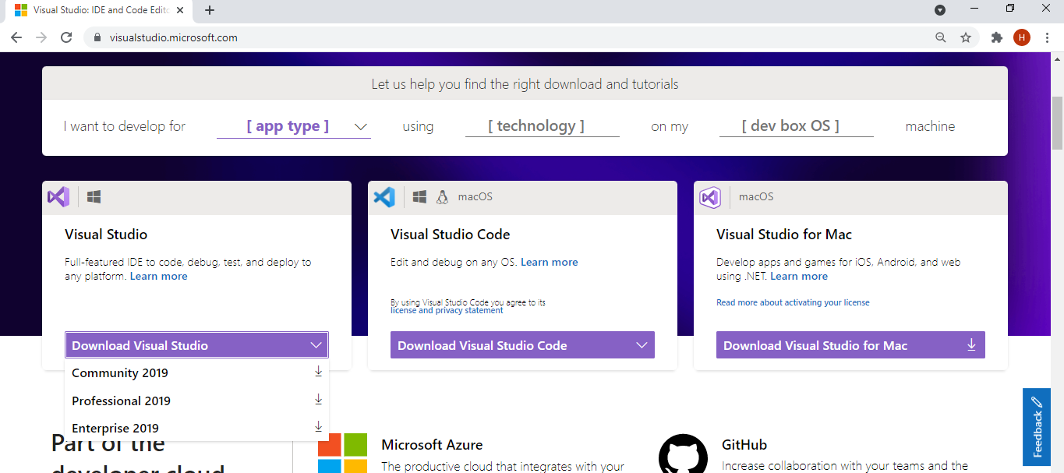

1. This would download the file to your local storage.

To install this application:

1. Click on the executable file
2. A pop-up dialog box appears, click ‘Continue’
3. This box should then appear

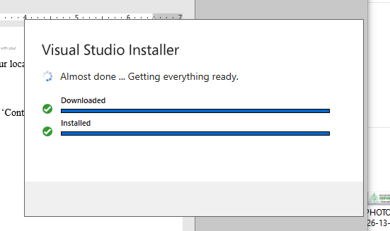

1. Under Workloads, select the .NET Desktop Development and then click on the ‘Install’ button at the bottom right corner of the menu.
2. Then wait for the installation to be completed
3. 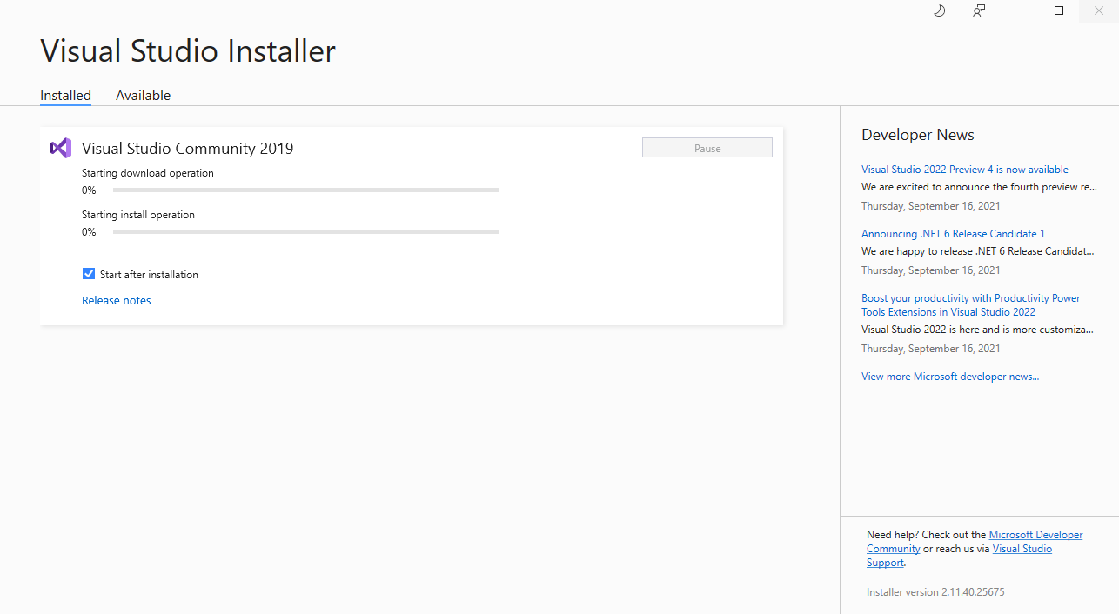If you didn’t check the ‘Start after installation’ checkbox, then click on the launch button after the installation 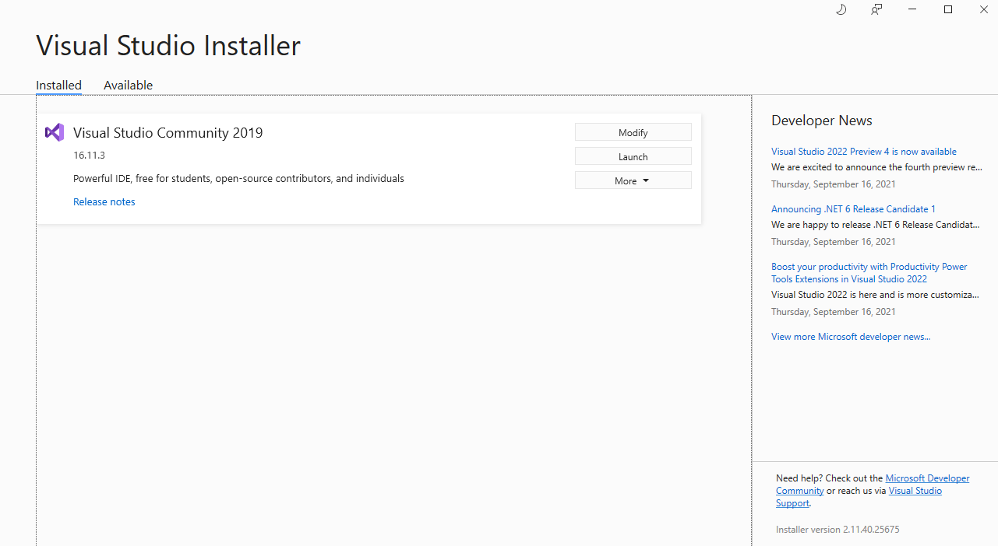
4. Sign in if desired or click on ‘Not now, maybe later’

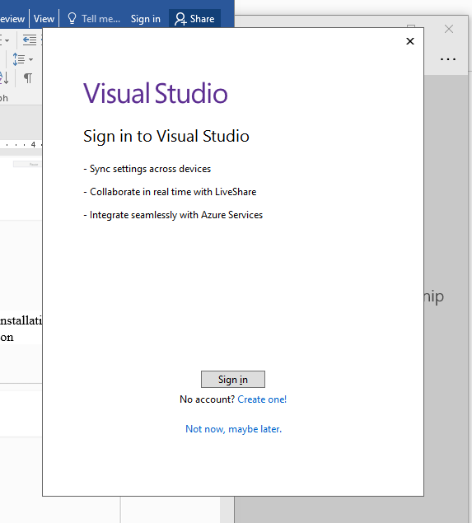

1. 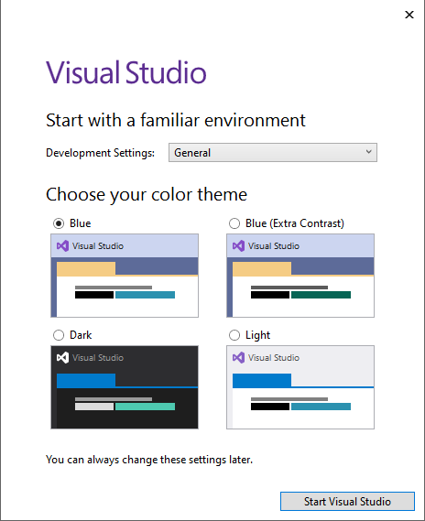Select your preferred theme and the click on the ‘Start Visual Studio’ button.

(Note that this process would require internet connection).