

**FACULTY OF INFORMATION TECHNOLOGY**

**COURSE CODE: CSE 231**

**COURSE TITLE: COMPUTER APPLICATION PACKAGES II**

**INTRODUCTION**

This class would cover graphic representations and graphic software. We would also be using Adobe Photoshop to create designs like greeting cards.

**LEARNING OUTCOME**

At the end of this class, students should be able to:

* Identify different types of graphic representations
* Know the differences between DTP and CAD
* Know the different types of graphic software and their uses
* Use graphic software to create designs.

**GRAPHICS SOFTWARE**

Graphics software is a program that allows you to create, edit and manipulate a variety of computer graphics like photos, clip arts, logos, banners, icons, etc. As discussed earlier, there are a variety of graphics software which include CAD software, DTP software, etc. For this class, we would be focusing on Adobe Photoshop.

Extensions used to save graphic files include .psd, .ai, .pmd, .cdr, etc.

The merits of graphics software include:

* Allows for better planning and modelling when compared to pen and paper.
* It gives you life-size measurement.
* Allows you to represent data in the manner that best suits you.

The demerits are:

* Some people may find it hard to switch from paper to computer.
* You might need training to learn to use a new software.

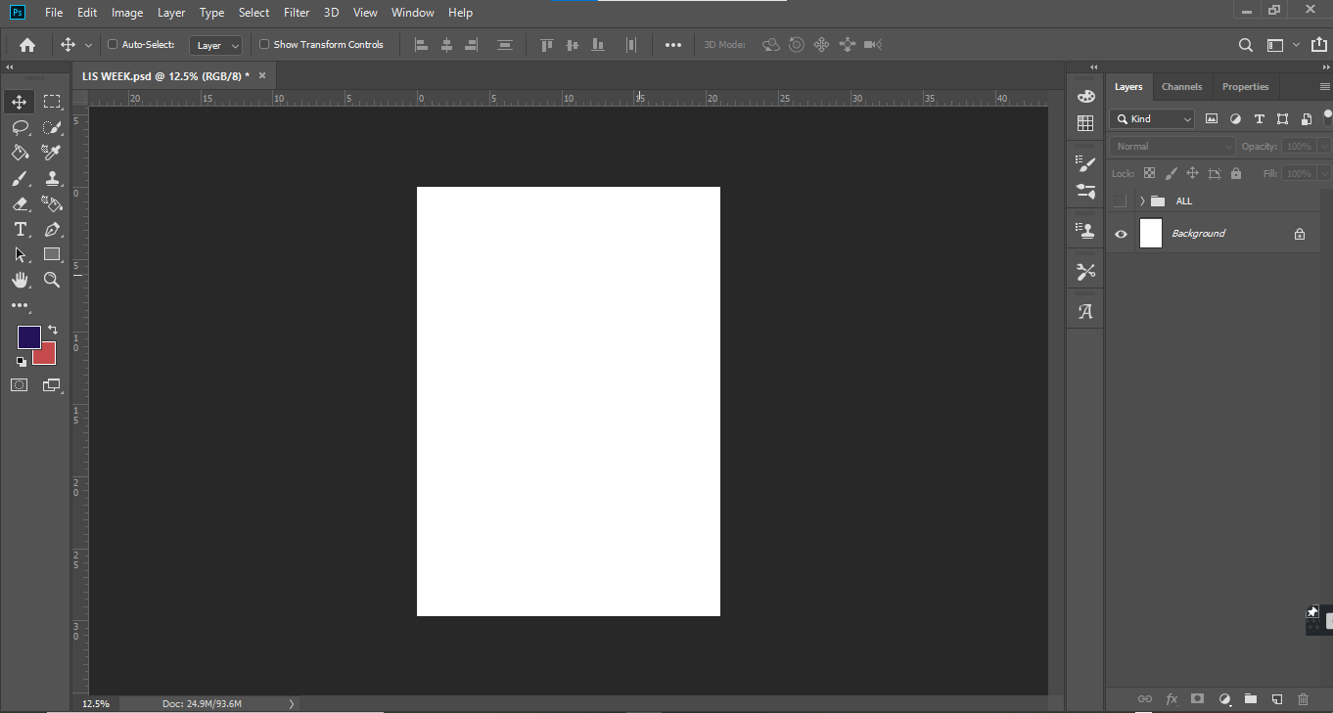

Above is the Adobe Photoshop window.

**DESKTOP PUBLISHING**

Desktop publishing (DTP) refers to the use of page-layout software in the creation of visual displays of ideas and information. It involves the use of WYSIWYG (What You See Is What You Get) page layout to create a high-quality document that contains text, graphics and colors. Documents published using DTP software can be printed or distributed electronically (e.g. email newsletters, electronic books and the web). Before the coming of desktop publishing, people who specialized in areas like graphic design and typesetting had to carry out the individual tasks manually. With desktop publishing software, you can design brochures, logos, business cards, letterheads, booklets, resumes, etc. Examples of DTP software are Adobe InDesign, Microsoft Publisher, Scribus, etc.

**COMPUTER AIDED DESIGN**

Computer aided design (CAD), as the name implies, is the use of computers to aid the in the creation of design. It is a sophisticated type of software that is used in the creation, modification, analysis and optimization of the design. It can be used in the areas of Electronic Design Automation (EDA), Mechanical Design Automation (MDA) and Computer aided drafting for 2D and 3D designs. CAD is used in automotive, industrial and architectural designs. Examples of CAD software are AutoCAD, SketchUp, Blender, etc.

**TYPES OF GRAPHIC PACKAGES**

There are a lot of graphic packages available today. They can therefore be majorly classified based on their uses which are:

* Painting: They are mainly used for digital painting purposes. They consist of features which include pens, pencils, color, paint brushes, line designs, selection tools, etc.
* Drawing: They allow the user to draw with accurate measurement and incorporate depth into the work. Drawing applications also have 2D and 3D capabilities and they allow one to convey ideas in a creative way.
* Computer Aided Design (CAD): CAD software are used to create designs that meet industry standards. As mentioned earlier, they also have 2D and 3D capabilities.
* Photo Editing: These packages are mostly used by photographers and marketers to enhance the quality of photographs. They also allow you to add text and other details to the picture to meet your taste.
* Charting: They are used to represent non-graphical data in a graphical manner. This is done using charts.

**Assignment**

1. List five differences between DTP and CAD