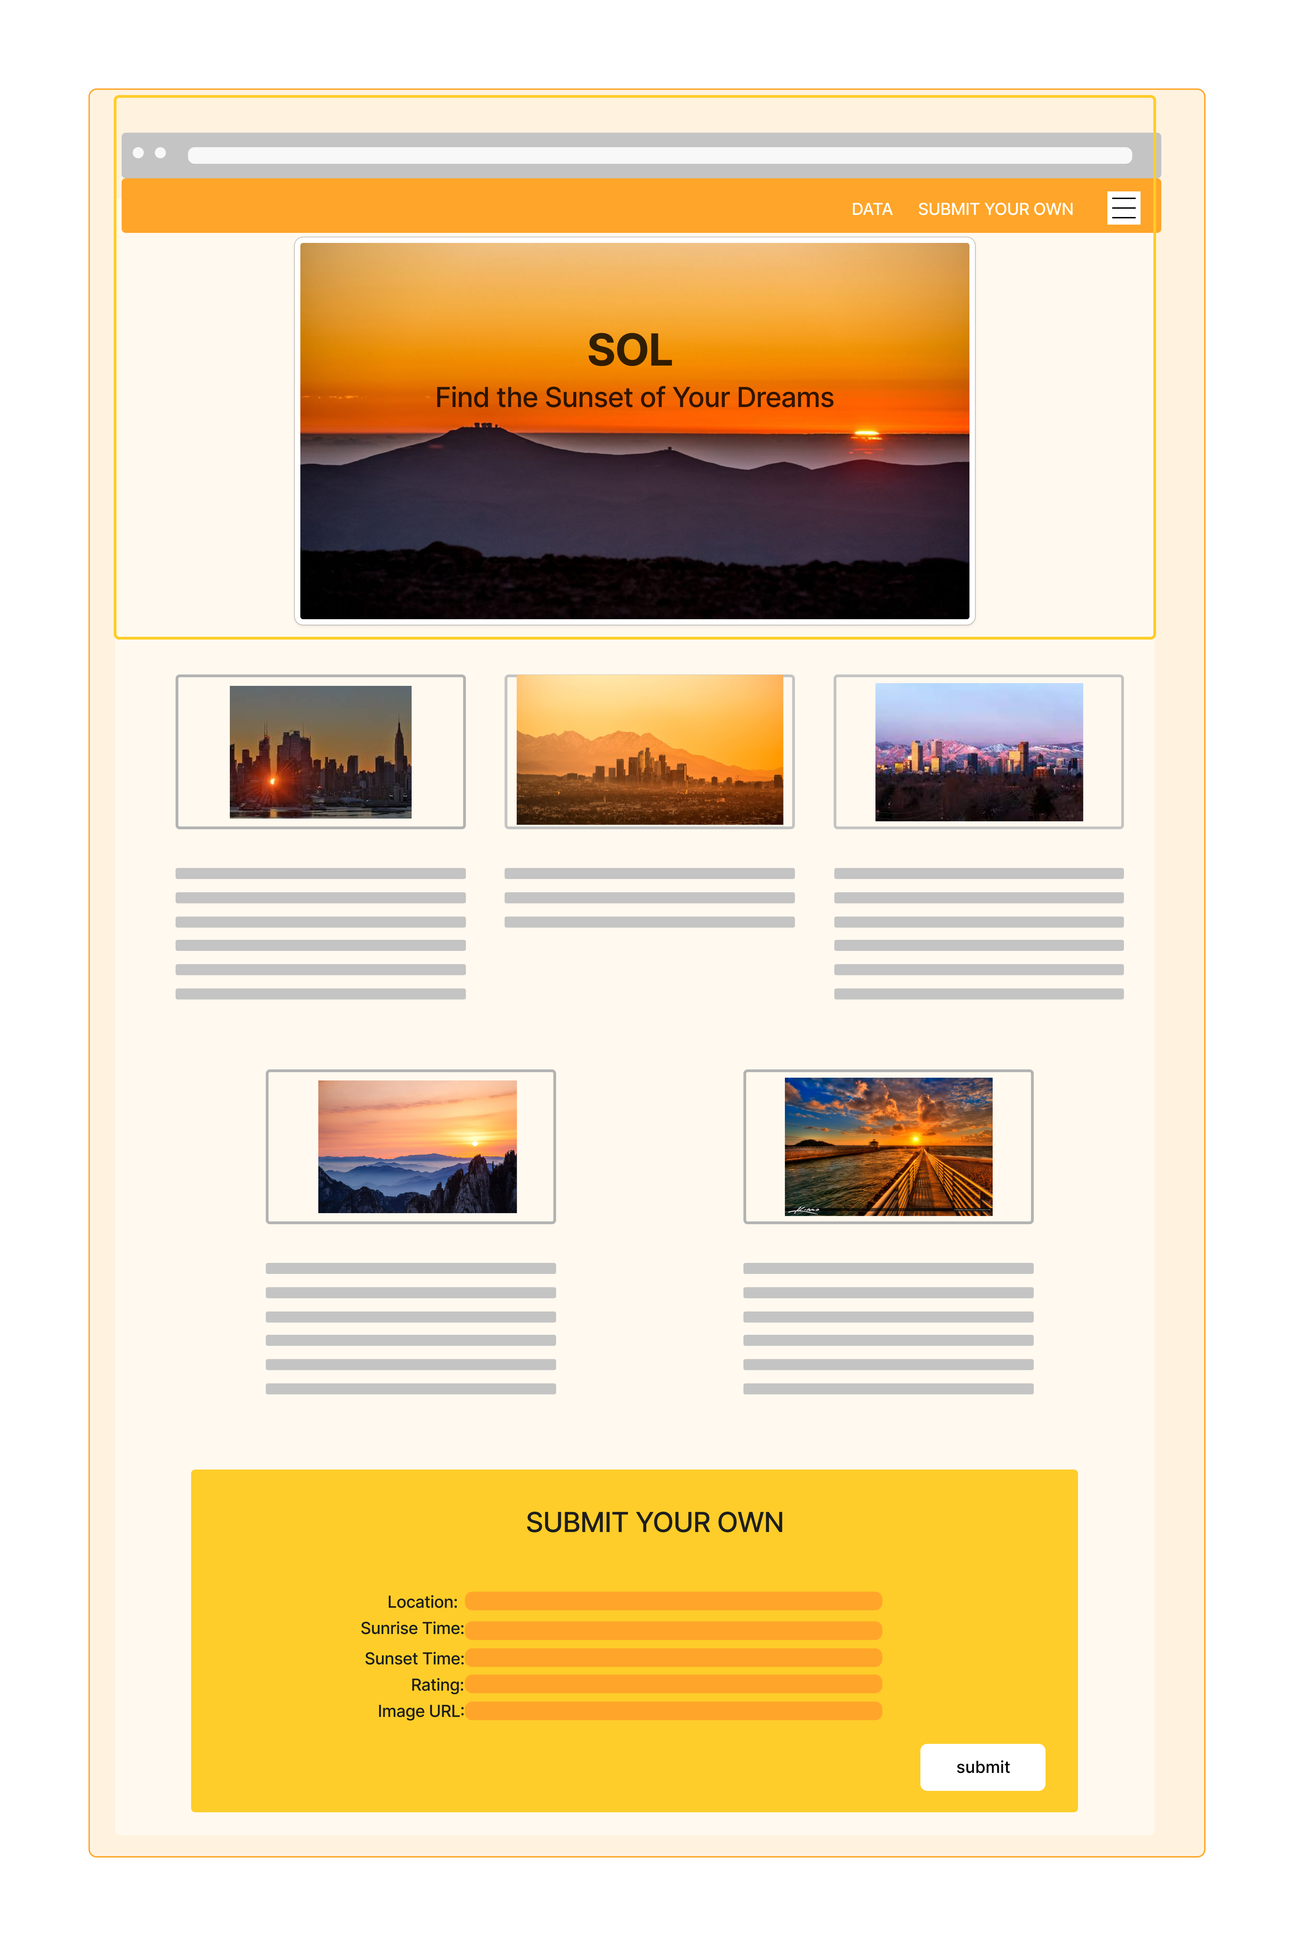

|  |  |  |
| --- | --- | --- |
| **PROJECT PITCH** | | |
| **Owner/s:**  Topher Ludlow, Sam Chappel, Sean Nekouei | **Project Name:**  **SOL** | **Phase and Cohort:**  Phase 1 - SE West |
| **One sentence app description:**  Search sunrise/sunset times and quality ratings, as well as submit own user photos and ratings to a forum | | |
| **Timeline:**  Thursday 12/29: choose api, start wireframe, complete project pitch  Tuesday 01/03: project pitch with Lantz, begin coding if everything goes as planned, decide github plan for code collaboration, create js, html, and css project files  Wednesday 01/04: do the damn thing  Thursday 01/05: continue to do the damn thing | | **Domain Model:**     halp  **User Stories:**  E.g. User will be able to:   * view sunrise/sunset times for auto-populated cities * submit a form to upload photos and ratings of their own sunrises/sunsets   **Stretch Goals:**   * search sunrise/sunset times for their location * navigation links |
| **Wireframes:** Paste wireframes of your project into this doc, or include a link to your wireframes  <https://api.sunrise-sunset.org/json> | | |