LAVOISIER DOCUMENTATION

Presentation

Lavoisier is an Open Source Tool developed at CC-IN2P3 and will be maintained in the long term.

Lavoisier has proven effective in increasing maintainability of the Operations portal. Indeed, the unified view enabled reducing considerably the amount and complexity of its code.

Lavoisier is an extensible service designed to provide an unified view of data collected from multiple heterogeneous data sources (e.g. database, Web Service, LDAP, text files, XML files...). This unified view is represented as XML documents, which can be queried using standard languages, such as XSLT (and soon: XPath, XQuery).

Lavoisier also improves performance by caching the generated data views. The caching mechanism can be tuned according to the characteristics of the data views and of the data sources, and according to the constraints of the use-cases. This tuning has no impact, neither on plug-ins, nor on user's code.

The global architecture has four layers: the legacy data sources, the adapters used to generate the data views, the cache mechanism with flexible refresh triggering rules, and the service exposing both SOAP and REST (with XML or JSON) interfaces.

Features

- Access data views through SOAP, REST/JSON or REST/XML
  - get data data view
  - cross-query data views using standard languages: XSLT (and soon: XPath, XQuery)
- Separation of roles (changes related to a role have no impact on other roles)
  - the plug-in developer adds support for new technologies by developing adapters.
  - the service administrator configures the adaters and cache management according to the characteristics of the data views and data sources, and according to the constraints of the use-cases.
  - the user queries the data views.
- Data cache management
  - select cache type
    - in-memory (simple or hierarchical, parsed once)
    - on-disk (simple or hierarchical)
    - no-cache (directly invoke the data source)
  - combine cache refresh triggering rules: whenCreated, whenNotified, whenTime, whenMaxUnrefreshedTimeElapsed, whenMaxUnrefreshedTimeElapsedAndDataAccessed, whenUpdated, whenRefreshed, whenRefreshedAndPublished
- Extensibility
  - Reusable adapters are provided for commonly used technologies: HTTP, LDAP, RDBMS, XSLT...
  - Support for new technlogies can be added by developing adapters
- Validation of generated XML data
  - check XML syntax only
  - check XML syntax and conformity to provided XML Schema
- Administration
  - get data views index and properties
  - get data views status
  - on-the-fly reconfiguration (detect views to be reconfigured)

Adapters

The adapters are configured in lavoisierconfig.xm file. This configuration will connect the outside data and Lavoisier server.

How To Start

Deploy generic rpm for Lavoisier
Start the service ./bin/lavoisier-admin-start.sh

Host -> lavoisierhostname
URL console -> http://lavoisierhostname:9000/LavoisierService/view/index
Config File -> LAVOISIER_HOME/etc/lavoisier-config.xml

Cache -> defined in the config file
Scripts -> LAVOISIER_HOME/bin
Stylesheet -> defined in the config file

Logs → LAVOISIER_HOME/log4j.log

Once the service is correctly started you can access to the console :

http://lavoisierhostname:9000/LavoisierService/view/index
=> Interface showing the different views with their parameters and configuration .

http://lavoisierhostname.in2p3.fr:9000/LavoisierService/view/status
=> interface showing the status and the date of refresh of views.

http://lavoisierhostname.in2p3.fr:9000/LavoisierService/view/config
=> config file in line

http://lavoisierhostname.in2p3.fr:9000/LavoisierService/view/dependencies
=> graph of dependencies of the views

Interactions with Dashboard

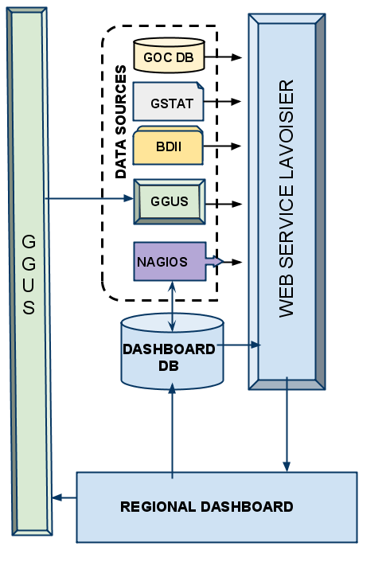

References

- Description and sources of Lavoisier
  - http://grid.in2p3.fr/lavoisier/
  - http://indico.cern.ch/materialDisplay.py?contribId=48&sessionId=13&materialId=paper&confId=048

