### **Abstract**

The project aimed to create a multifunctional and portable measuring device, a multimeter, capable of measuring:

* Voltage
* Current
* Resistance
* Capacitance of capacitors
* Inductance of coils
* Ambient temperature
* Solar light intensity

Our goal was to use basic components and parts to make the project versatile and interesting. Unfortunately, our multimeter cannot evaluate environmental noise. The project incorporated nearly all topics covered in the course, including:

* Arduino programming
* Basic components
* Digital circuits
* Semiconductor devices

Our multimeter offers various functionalities that can be toggled using a button. It includes an on/off switch, coordination LEDs, and an LCD screen that displays the parameter being measured along with its value. Additionally, there are five two-pin sockets for the respective measurements, each with an LED nearby to guide users. The main objective of the project was to create a versatile measuring tool.

The multimeter is equipped with a convenient interface, including an LCD screen to display measurement values and units. Sensors such as a photoresistor and a thermistor are integrated to measure environmental parameters, while the five two-pin sockets allow measurements of electrical parameters like resistance and voltage. Each mode is indicated by an LED, giving users a clear visual cue of the current mode. The device is powered by a 9-volt battery, ensuring portability and ease of use. We aimed to make the device as compact as possible.

### **Table of Contents**

1. **Cover Page**...........................................................................................................................Page 1
2. **Abstract**...............................................................................................................................Page 2
3. **Table of Contents**...............................................................................................................Page 3
4. **Introduction**.......................................................................................................................Page 4
5. **Technical Specifications**...............................................................................................Page 5
   * Voltage................................................................................................................................Page 5
   * Current...............................................................................................................................Page 6
   * Resistance........................................................................................................................Page 7
   * Ambient Temperature....................................................................................................Page 8
   * Light Intensity................................................................................................................Page 8
   * Capacitor Capacitance...................................................................................................Page 9
   * Coil Inductance.............................................................................................................Page 10
6. **Remaining Components**...............................................................................................Page 12
7. **Conclusion**.......................................................................................................................Page 13
8. **Appendices**......................................................................................................................Page 14

### **Introduction**

A multimeter is an indispensable tool that provides accurate readings of various parameters, enabling engineers and technicians to diagnose and solve problems. This project aimed to design and assemble a portable multimeter using basic electronic components and an Arduino microcontroller. The project not only focused on creating a functional measuring device but also provided practical experience and allowed for the application of theoretical knowledge.

The multimeter developed in this project is a compact and versatile device capable of measuring a wide range of parameters, including:

* Voltage (0 to 30 volts)
* Current (0 to 3 amperes)
* Resistance (0 to 100 kilo-ohms)
* Capacitance (5 nanofarads to 2500 microfarads)
* Inductance (0 to 100 microhenries)

Additionally, the device measures environmental parameters such as:

* Ambient temperature (15 to 50 degrees Celsius)
* Light intensity

An Arduino microcontroller acts as the brain of the device, controlling the system, processing data, and managing the LCD display and LEDs. The project incorporated various sensors, including a photoresistor and thermistor, for environmental measurements. These sensors, along with other electronic components, demonstrate the wide applicability of fundamental principles of electronics. These include the use of resistors, capacitors, inductors, diodes, transistors, and operational amplifiers. We aimed to make the multimeter as compact and user-friendly as possible by including features such as an LCD screen, indicator LEDs near the sockets, and a button for switching modes. The device is powered by a 9-volt battery for added portability.

### **Technical Specifications**

#### **Voltage (0–30 Volts)**

Voltage refers to the potential difference with respect to a common ground. Measurements are taken using the Arduino Nano microcontroller, where the point of interest is referenced against the microcontroller's ground. To handle voltages above 5V (the Arduino Nano's limit), a voltage divider circuit is used. This reduces the input voltage (0–30V) to a range suitable for the Arduino (0–5V). The formula used is:

Here, and are the resistances in the voltage divider circuit. After measuring the scaled-down voltage, the Arduino calculates the actual input voltage and displays the result on the LCD.  
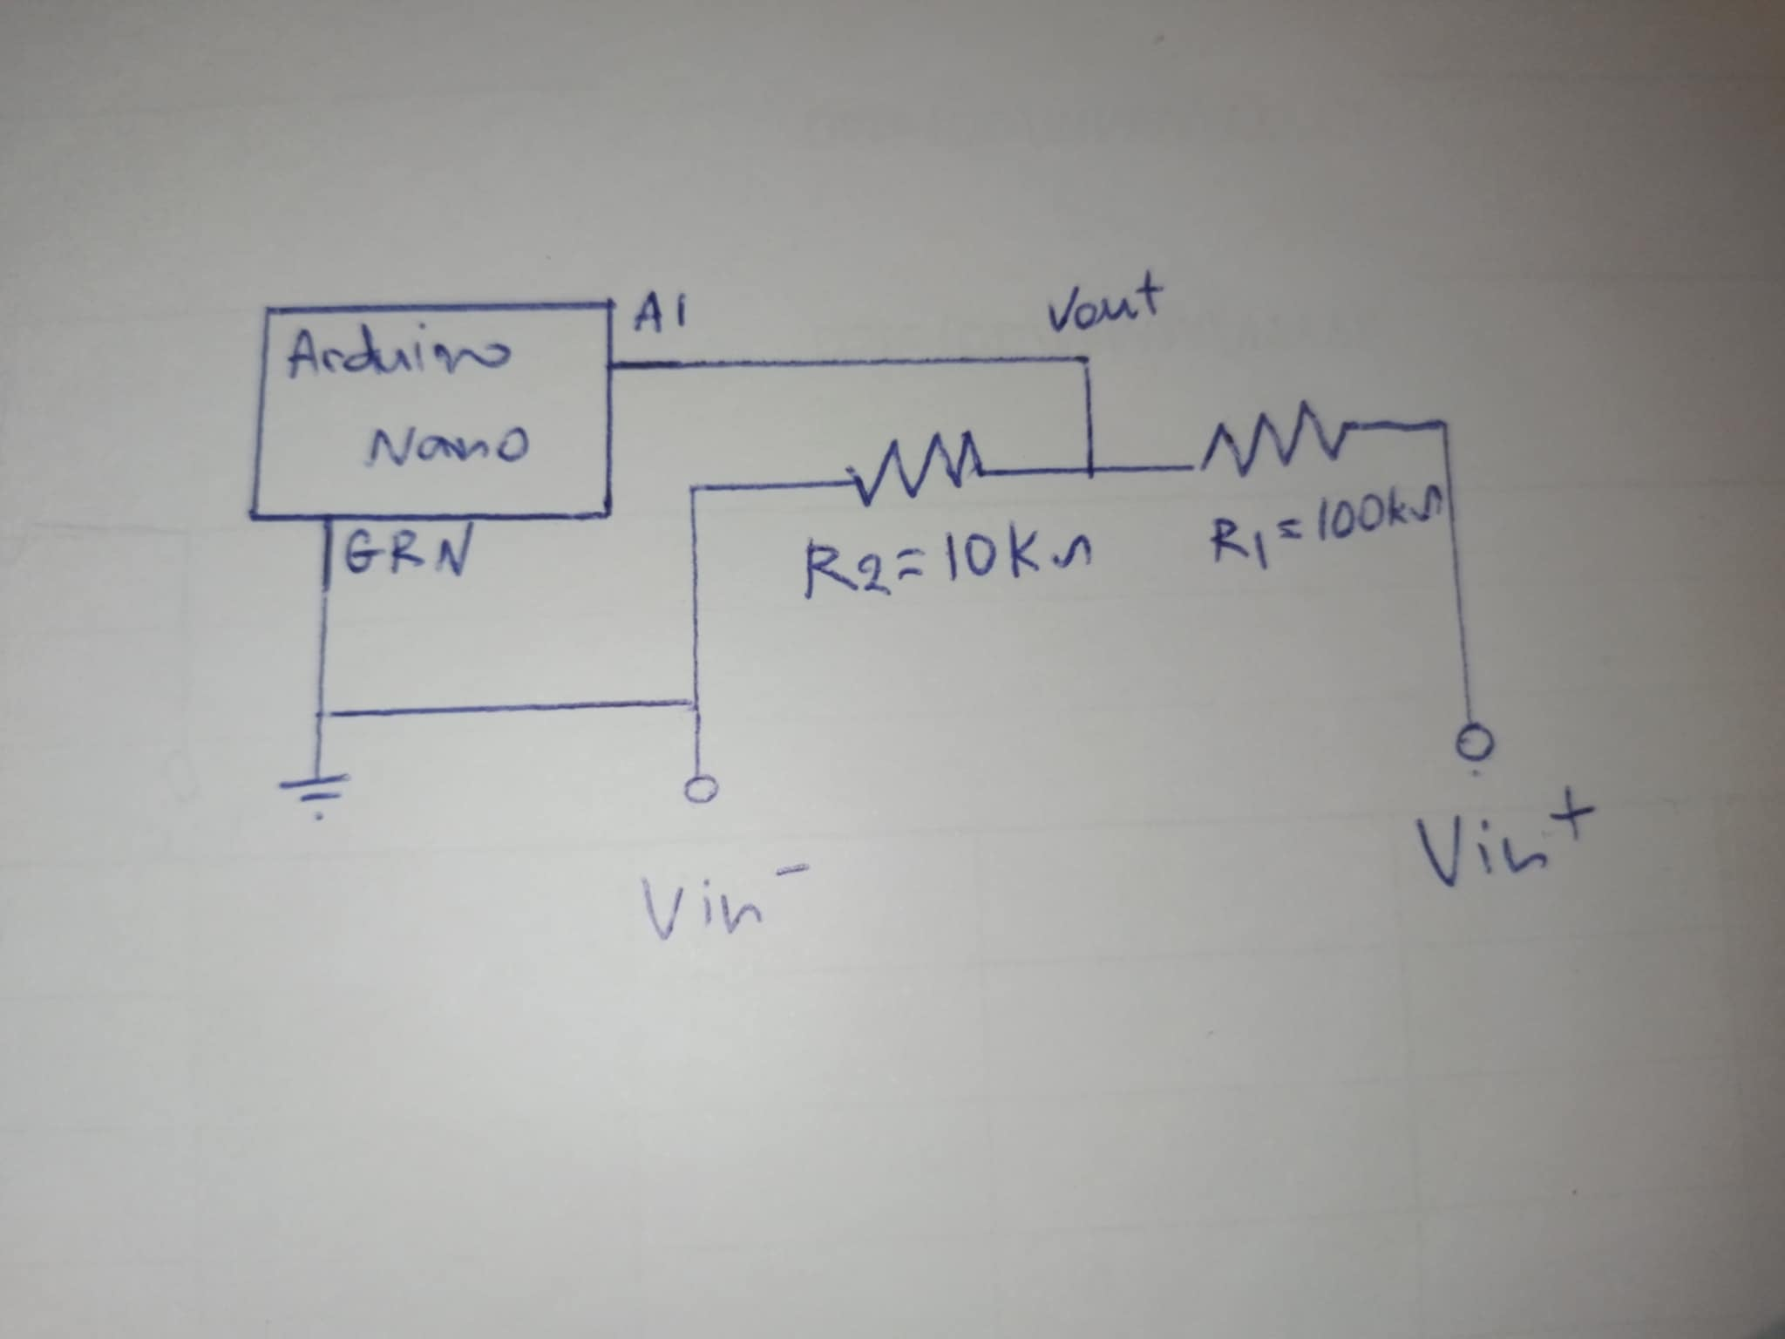

#### **Current (0–3 Amperes)**

Direct current measurement requires an external module, as the Arduino cannot measure current directly. Instead, the potential difference across a known resistance is used to calculate current using Ohm's law:

A low-resistance resistor is used to minimize circuit distortion. To amplify the small voltage drop, an LM358 operational amplifier is employed. The amplified signal is read by the Arduino, which calculates and displays the current value.  
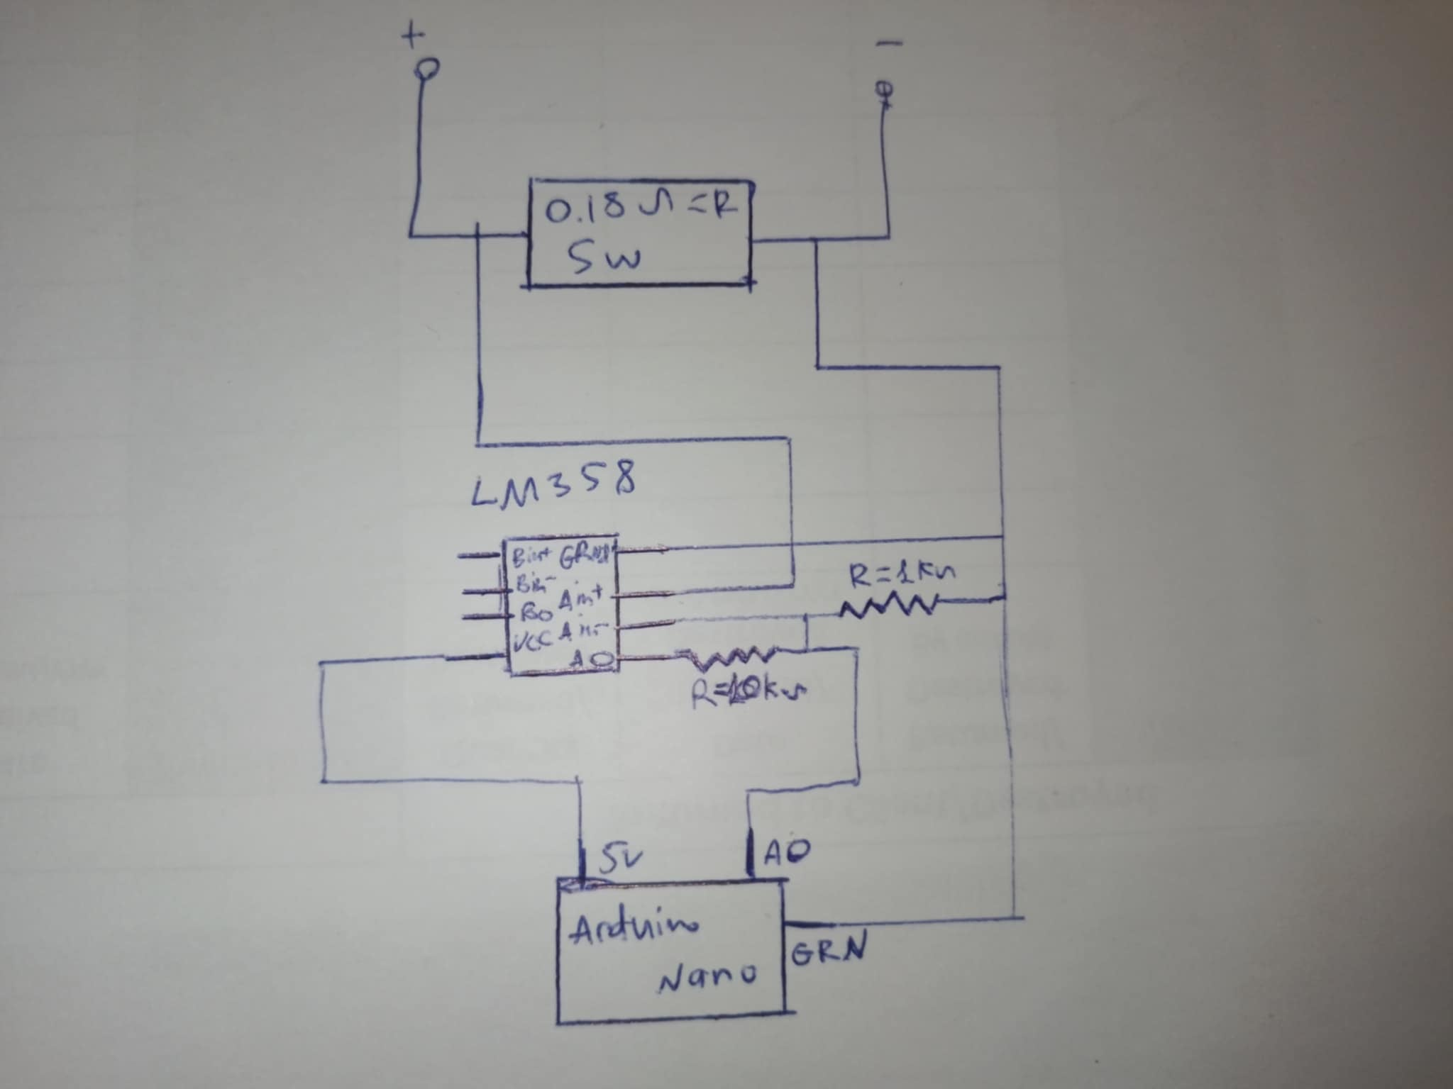

#### **Resistance (0–100 Kilo-ohms)**

Resistance is measured using a voltage divider configuration powered by the Arduino's 5V supply. The formula for calculating resistance is:

Here, is a known reference resistor. To ensure accuracy, a 3.2-kilo-ohm resistor was chosen experimentally to minimize error across a wide range of resistance values.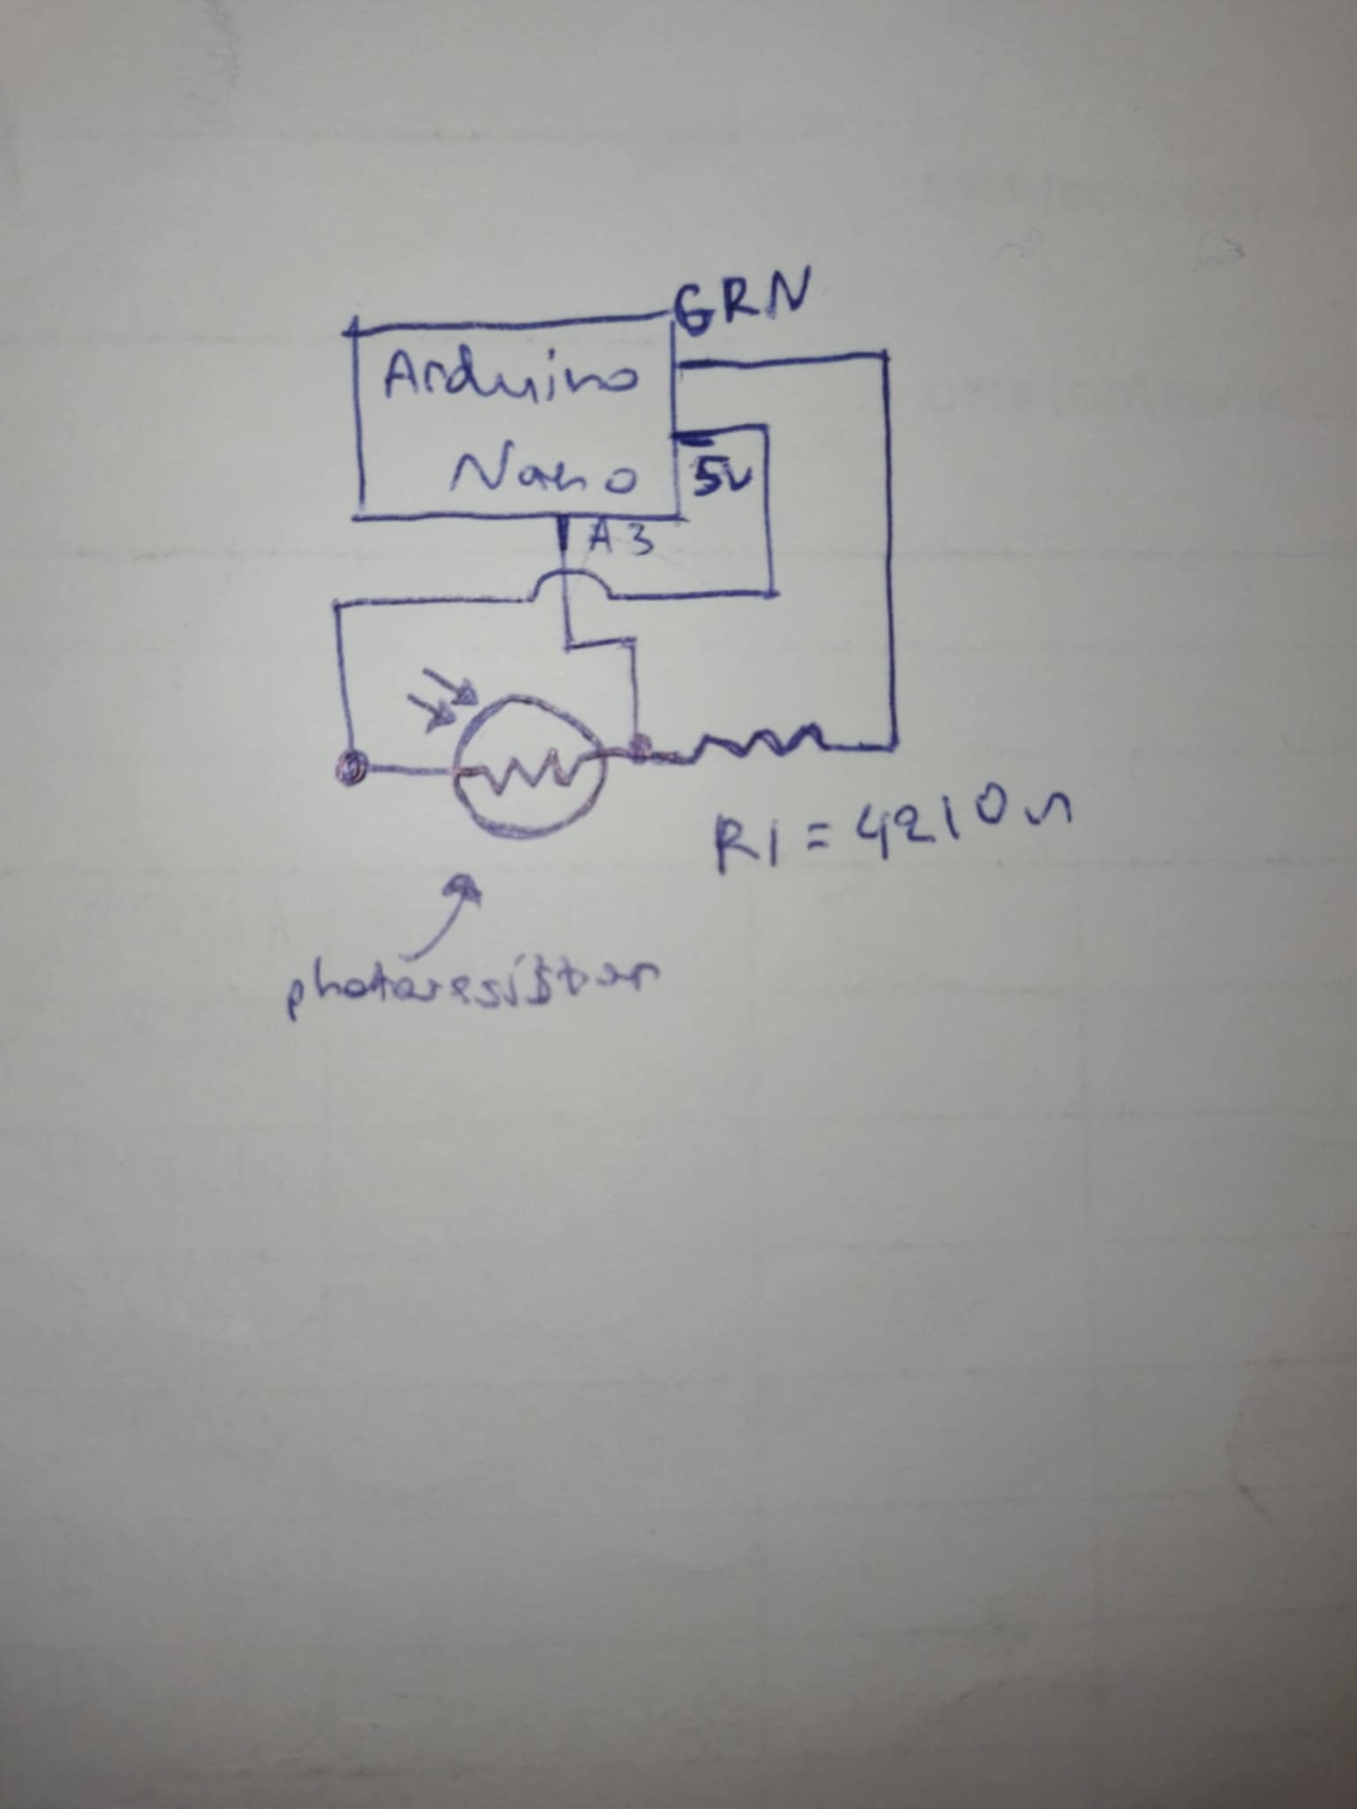

#### **Ambient Temperature (15–50°C)**

A thermistor is used to measure temperature. Its resistance varies with temperature, and this resistance is measured using the same configuration as for resistance measurement. The Steinhart-Hart equation is used to convert the resistance to temperature:

Constants , , and are obtained from the thermistor's datasheet.

#### **Light Intensity**

A photoresistor is used to measure light intensity. The resistance of the photoresistor varies with light exposure, and this resistance is calculated using the same voltage divider configuration as for resistance measurement. The intensity is expressed as a percentage of the maximum possible value based on the photoresistor's datasheet.

#### **Capacitance (5nF–2500µF)**

Capacitance is measured by analyzing the charging behavior of a capacitor connected in an RC circuit. The Arduino monitors the voltage across the capacitor and calculates the capacitance using the formula:

Here, is the time constant, determined as the time taken for the capacitor to charge to 63% of the maximum voltage.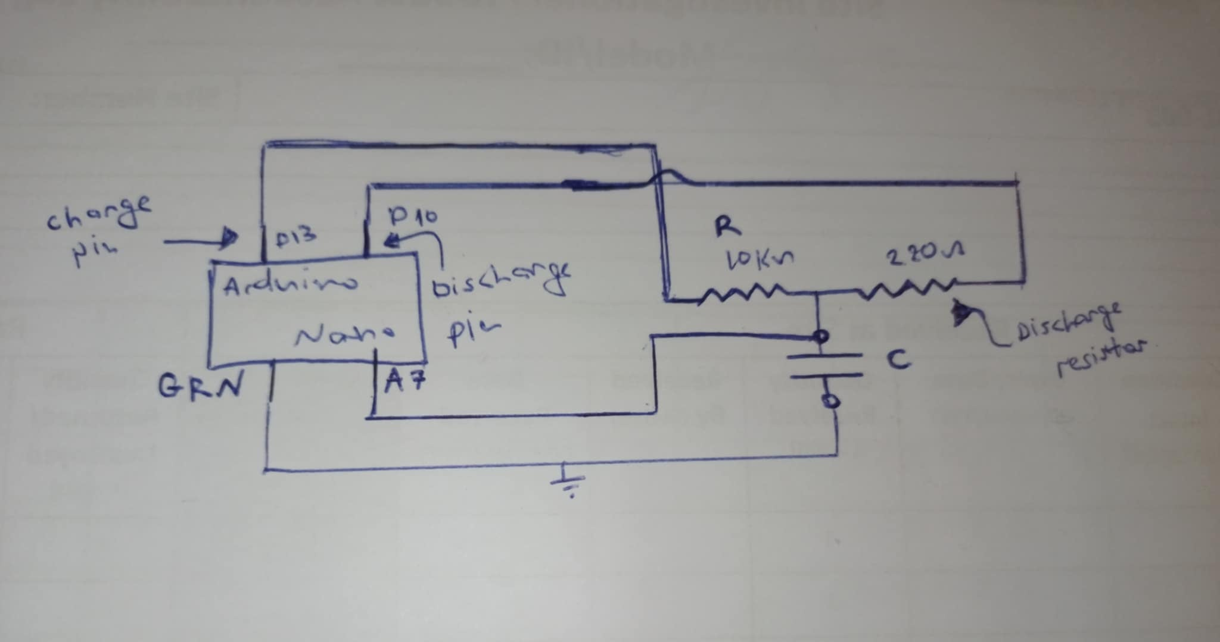

#### **Inductance (0–100 µH)**

Inductance is measured using an RLC circuit. The Arduino calculates the inductance based on the resonant frequency of the circuit using the formula:

Where is the frequency, and is the known capacitance of the circuit.  
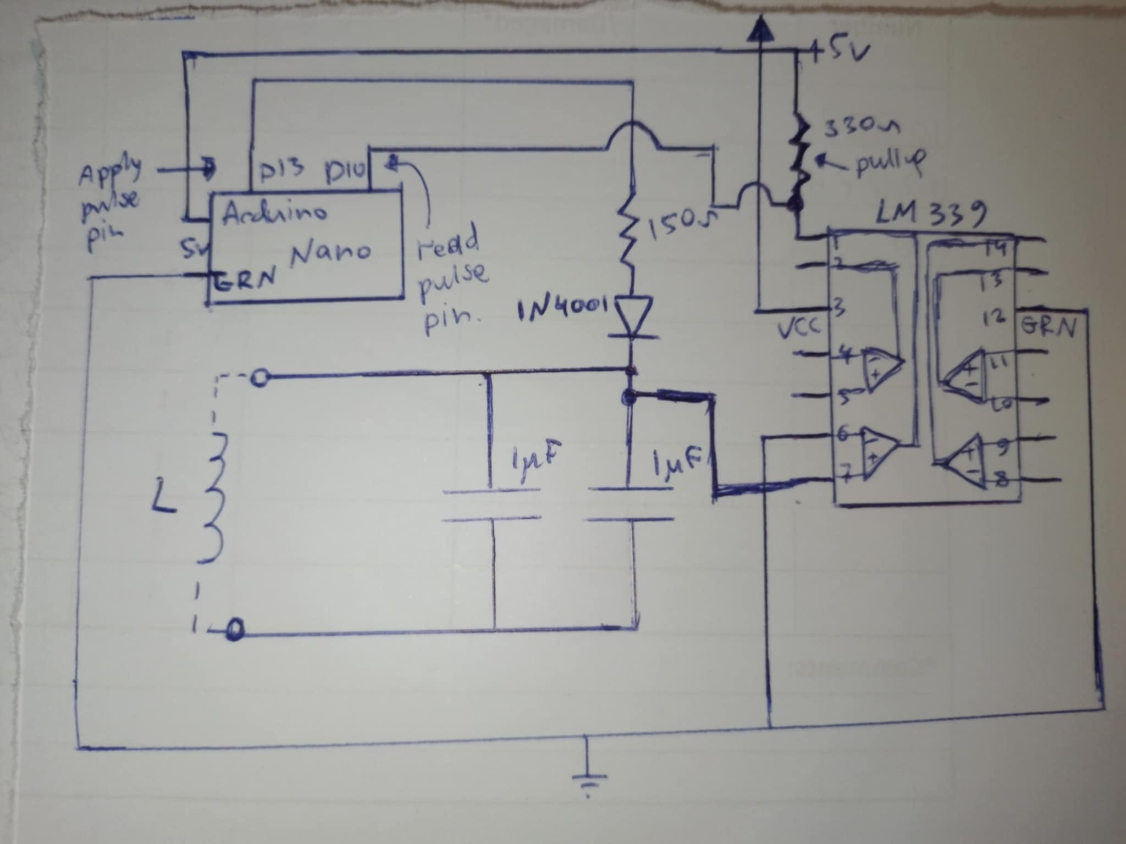

### **Remaining Components**

The multimeter uses an I2C controller to manage the LCD screen. The SDA and SCL pins are connected to the Arduino Nano's A4 and A5 pins. LEDs are controlled by the remaining pins, and a button allows users to switch modes.

### **Conclusion**

Completing the multimeter project is a significant achievement in both practical application and theoretical understanding of electronics and circuit design. The device meets the specified measurement ranges and accuracy requirements. It provides a compact, functional, and educational tool that measures:

* Voltage: 0–30V
* Current: 0–3A
* Resistance: 0–100 kΩ
* Capacitance: 5nF–2500µF
* Inductance: 0–100 µH
* Temperature: 15–50°C

The multimeter also measures light intensity as a percentage of maximum solar radiation. This project offered valuable experience in problem-solving, ensuring measurement accuracy, minimizing power consumption, and optimizing the user interface. The skills gained provide a solid foundation for tackling more advanced electronic projects in the future.