# Toronto Blue Jays Biomechanics Report – Matt Topley

## Player Summary Table

**\*Interpretation and evaluation can be found on page 5 While data extraction and technique is found on page 6\***

|  |  |  |  |  |  |
| --- | --- | --- | --- | --- | --- |
| Pitch Summary | | | | | |
| Pitcher | 1 | 2 | 3 | 4 | 5 |
| Handedness | RHP | LHP | RHP | RHP | RHP |
| Pitch | Fastball | Fastball | Fastball | Fastball | Fastball |
| Velocity | 88.51451 | 92.8393 | 85.71865 | 89.98656 | 90.38325 |
| Spin Rate | 1849.32532 | 2321.55796 | 2236.54856 | 2171.26057 | 1925.891 |
| Stride Length | 1.38m | 1.39m | 1.46m | 1.45m | 1.56m |

## Figure 1. Leg Kinematics

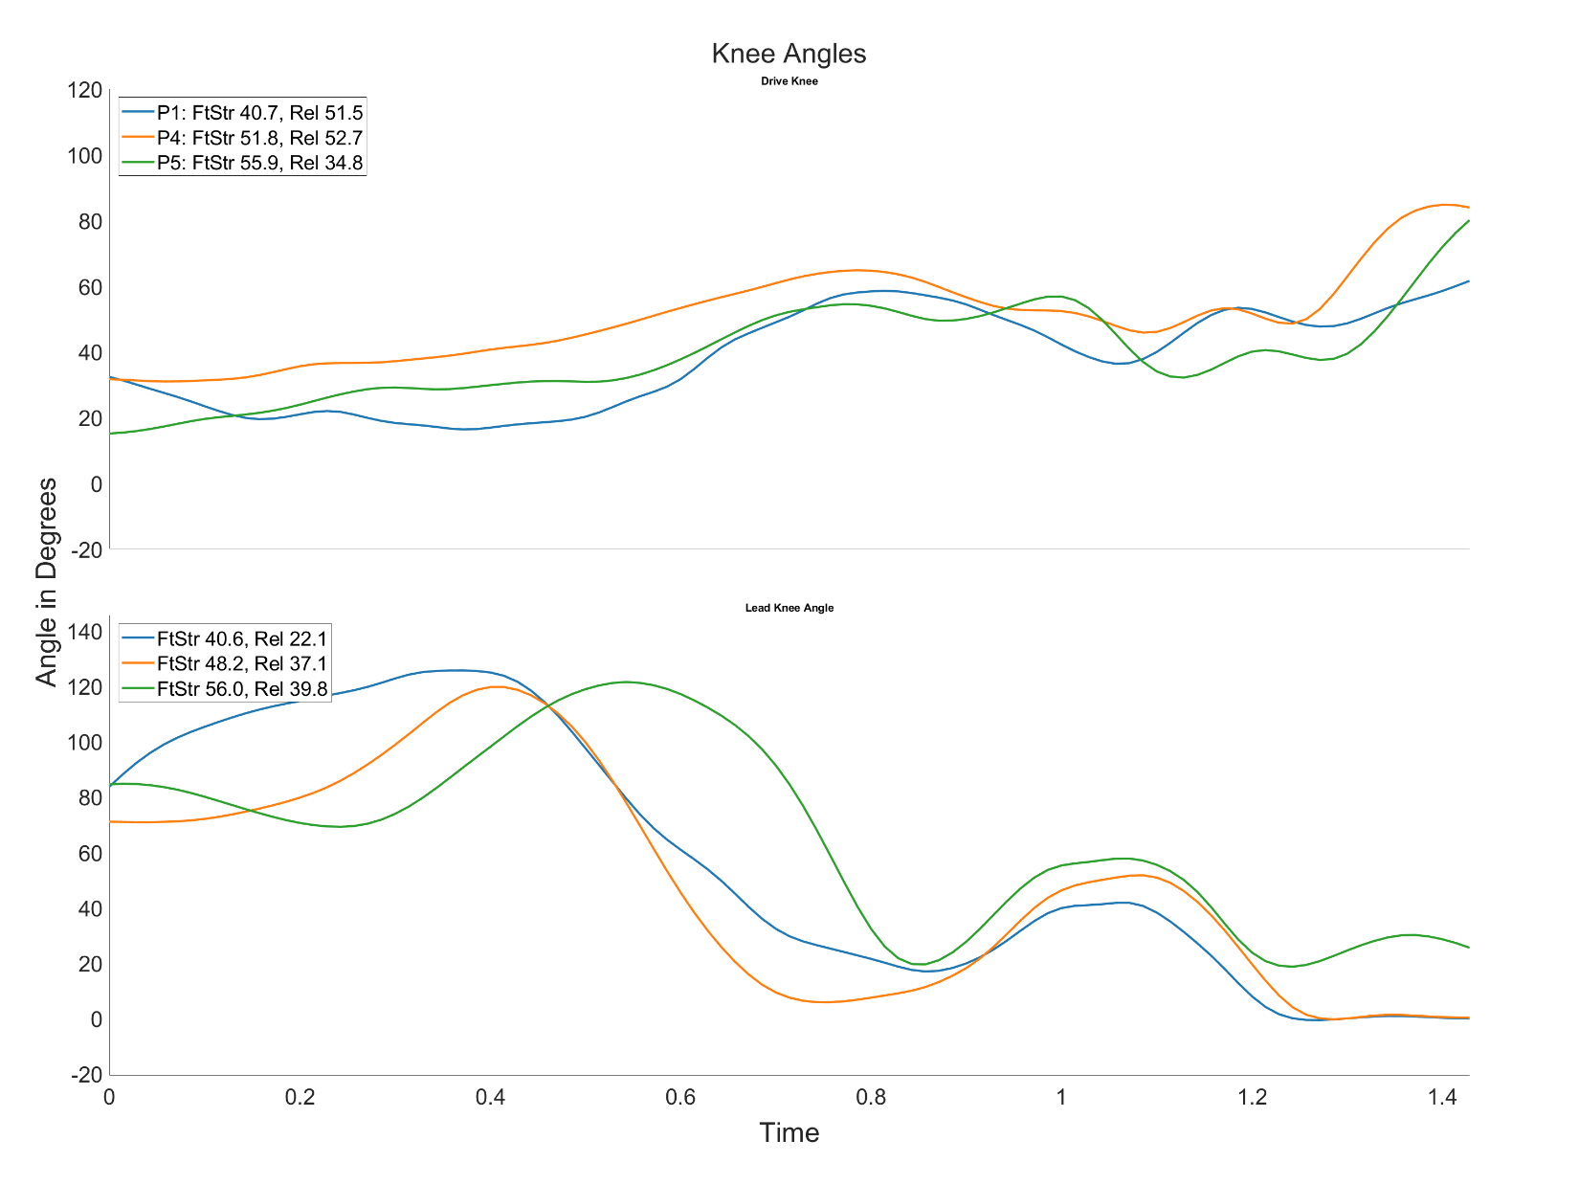

## Figure 2. Hip & Trunk Rotations - and - Figure 3. Trunk Tilt

## Figure 4. Shoulder & Elbow Kinematics

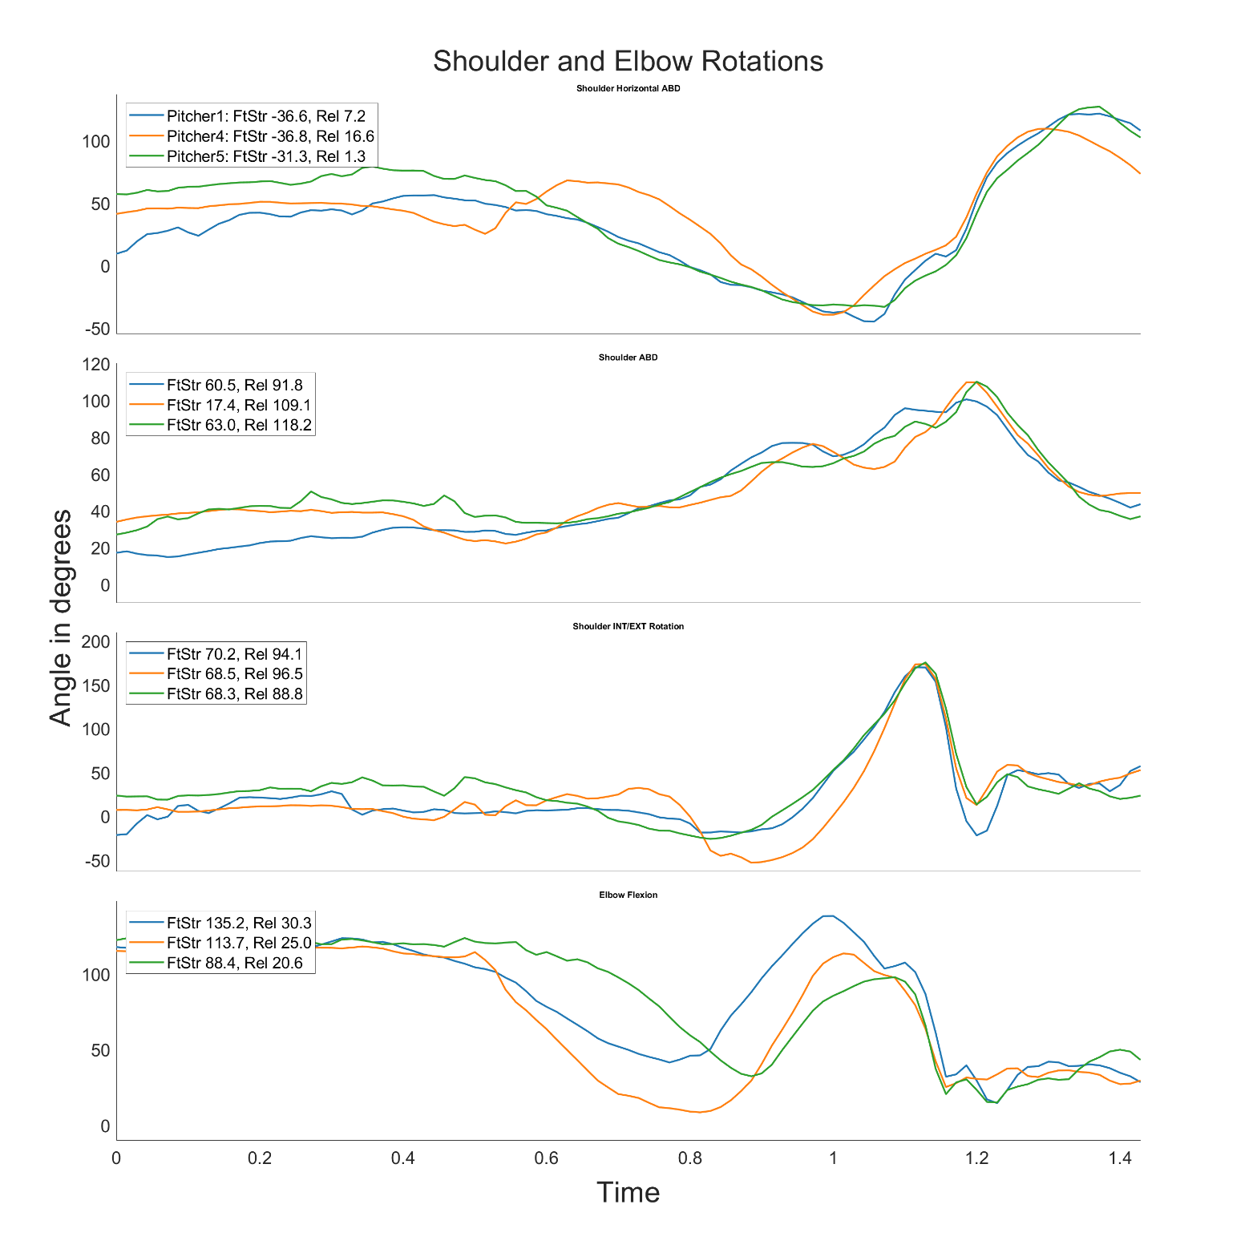

## Figure 5. The Kinetic Chain

## Interpretation and Evaluation

**General Thoughts on the Data**

Scanning through these data the first thing I notice is the signals have some noise that is likely non-physiological (e.g., shoulder rotation exceeding 10Deg of rotation in <.2s if my estimated sampling rate is correct). Long term I would probably smooth these signals with a Butterworth filter to remove high frequency noise from the data. This should preserve the signal content we are interested in without filtering out the physiological data. Additionally, as I state below in the data exploration explanation, not having the sampling rate or timecode of the data points made it difficult to interpret the signals relative to each other because they are not aligned in time to the event, I find most appropriate. However, I think there are some general takes we can make from these data. My following interpretation is assuming these data are an ideal representation of the pitcher’s delivery (i.e., averaged over several games or lab sessions).

**Evaluation of Pitchers**

Despite all three players throwing fastballs, they have slightly different kinematics, which likely contribute to the differences in their velocity, and therefore their max potential velocity, and even some likely current or future health issues. I will mostly be ignoring the leg kinematics for this particular review as there is not much to take away other than one pitcher, but I’m not certain with the timecode that this is not just because one athlete moves later than the others.

Arguably the most important area to consider in regard to generating velocity in this analysis is the trunk and hip motion. Generating torque in the hips and transferring it through the trunk and ultimately releasing the ball with enough forward trunk tilt are key drivers of generating higher pitch velocities. As you can see in Figure 2, All the athletes have similar hip and trunk rotations, with the proper timing sequence of the hips rotating first and the trunk second. Notably, the pitcher with the highest velocity (5) achieves the largest Shoulder-Hip separation at foot strike. Proper Shoulder-Hip separation is vital in efficiently transferring energy and this is clearly reflected in these pitchers. This is also reflected in Figure 5, where you can see the peak in angular velocity occurring in the proper timing sequence for the 5th pitcher, and even in the 4th pitcher, who is the middle velocity athlete. The lowest velocity athlete (1) has their angular velocities for the trunk and hips occur simultaneously, which would indicate they are not efficiently transferring energy through the kinetic chain. The largest correlate of velocity is trunk tilt. In Figure 3, Pitcher 5, clearly has the largest trunk tilt, in both lateral and forward, and when combined with their hip and trunk kinematics it is easy to see why they have the highest velocity fastball. This also likely indicates that they generate more torque through their trunk and not their shoulder, which can be beneficial for a longer career.

For the upper extremity kinematics in Figure 4, the theme from the previous analyses continues. The 5th pitcher demonstrates more desirable kinematics. Crucially, this athlete maintains a more ideal elbow flexion angle throughout their delivery. Thus, this athlete puts less stress on the elbow joint, benefitting them from both a health and velocity generation standpoint. This figure is concerning for pitchers 1 & 4. First, Pitcher 1 has the least desirable Hip and Trunk kinematics of the three athletes and has the largest elbow flexion angles throughout their delivery. This will likely be problematic, and I foresee future issues with their elbow, potentially leading to tommy john. Pitcher 4 on the other hand, also demonstrates less than ideal kinematics throughout their entire delivery. Pitcher 4, I can foresee having potential issue with their shoulder, scapula, and elbow. I can also see this sequence leading to anterior shoulder pain in the athlete. Regardless, both athletes have greater peaks in their shoulder/elbow angular velocities than pitcher 5, while having less ideal kinematics, and lower velocities. This indicates more stress is applied on their upper extremity to achieve ball velocity and will likely increase their odds of injury compared to pitcher 5.

## Explanation of Data Exploration

I am quite familiar with large data sets of biomechanical variables, including pitching like these data so I had particular variables I was interested in a priori. I think the space has been fairly well-published, so I believe there are particular variables that should be looked at first regardless of who is doing the analysis. So, in all most of my time was spent on formatting the figures and this report, rather than extracting and analyzing the data. In total, this took approximately 4-5 hours as suggested. My first step was to load the data, format it to my preferred structure - that in my experience is –easiest for scaling to larger datasets. Then I saved the data structure as a Mat file so the processing and figure plotting would be faster (I have an older home PC so working with csv’s directly is painfully slow).

Next, I wanted to display the separate parts of the kinematic chain as they are all independently important in the pitcher’s delivery to achieve maximum velocity, but this is also particularly important in identifying athletes with ‘problematic’ kinematics or are more likely to get injured. I broke the kinematics down into plots of the key variables at the legs, trunk/pelvis, and upper extremity to see the rotations in the bottom-up manner in which torque generation is developed. I separated these plots from the kinetics, so the transferring of energy can be seen in the actual kinetics, but also separately visualized through the kinematic chain. Finally, Once I had my figures plotted and inserted into this document, I was confident in making evaluations of the athletes.

Typically, I like to trigger analyses off events derived from the time series in data like these. For example, I would trigger the analyses off the ball release, or foot strike, and mark that in the figure as time 0 and then analyze the data before, after, and at the event. This ensures all the subjects time series data are all time locked and aligned to the events of interest. In this data set, I used the discrete variables provided for those indicators which are based on the ‘beginning of movement’. These discrete variables did not align with any of the time series data from what I can tell, nor does the time series have the precision to actually compute those discrete numbers, so I question the homogeneity of sampling rates between the time series and the discrete measurements.

I assume, this was because I was provided with a minimal data set to make this report easier, but it’s a little concerning if not. Further, I think using the ‘beginning’ of the delivery is a bad practice if this is how the data is currently stored. Different pitchers have different delivery mechanics and although there are mechanics, we would ideally like our athletes to have, I highly doubt pitcher will ever have identical ‘beginning’ and ‘end’ time points to their delivery. Ultimately, I bring this up because I think the analysis is less clear in this report than it otherwise would be if I was confident, I could trigger the analyses off events like foot strike and work backwards from there. **\*\*I would like to note, the last two paragraphs are not meant as criticism of the data or processes of the Blue Jays. I don’t have the full picture of your data and its capture, nor do I know what systems are in place for storage and processing. I’m certain I would be less concerned with the issues I brought up if I had that information, but these are things I think applicants should be asking themselves, so I wanted to include all of my thoughts. Thanks!\*\***