**- Stack Path Finder :**

- Example 1:

If we apply pathNavigatorUsingStack() on sample chessboard #1 will return this path:

(0, 0), (1, 0), (1, 1), (1, 2), (1, 3), (1, 4), (1, 5), (1, 6), (1, 7), (1, 8), (2, 8), (3, 8), (4, 8), (5, 8), (6, 8), (7, 8), (8, 8)

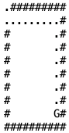

- Example 2:

If we apply pathNavigatorUsingStack() on sample chessboard #3 will return this path:

(0, 0), (0, 1), (1, 1), (1, 2), (2, 2), (3, 2), (4, 2), (4, 3), (4, 4), (4, 5), (4, 6), (5, 6), (6, 6), (6, 7), (6, 8), (6, 9)

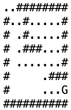

- Example 3:

If we apply pathNavigatorUsingStack() on sample chessboard #5 will return this path:

(0, 0), (1, 0), (1, 1), (1, 2), (2, 2)



- **Queue Path Finder :**

 - Example 1:

If we apply pathNavigatorUsingQueue() on sample chessboard #1 will return this path:

(0, 0), (1, 0), (1, 1), (2, 1), (3, 1), (4, 1), (5, 1), (6, 1), (7, 1), (8, 1), (8, 2), (8, 3), (8, 4), (8, 5), (8, 6), (8, 7), (8, 8)  
 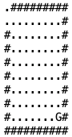

- Example 2:

If we apply pathNavigatorUsingQueue() on sample chessboard #3 will return this path:

(0, 0), (0, 1), (1, 1), (2, 1), (3, 1), (4, 1), (5, 1), (6, 1), (6, 2), (6, 3), (6, 4), (6, 5), (6, 6), (6, 7), (6, 8), (6, 9)

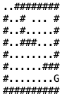

Example 3:

If we apply pathNavigatorUsingQueue() on sample chessboard #5 will return this path:

(0, 0), (1, 0), (1, 1), (2, 1), (2, 2)

