

**College of Computer and Information Sciences**

**Computer Science Department**

**“Topic Title”**

*CSC 361: Artificial Intelligence*

**Prepared by:**

Student 1 Name Student 1 ID

Student 2 Name Student 2 ID

Second Semester 2018/2019

# Abstract

# Introduction

This section states the problem that you are exploring.

The font size must be 12 for the text and 18 for the titles.

The number of pages must be 10 pages without counting the front page and the last page (tasks division).

# Background

# Title1

An example of a figure, note that each figure must have a title:

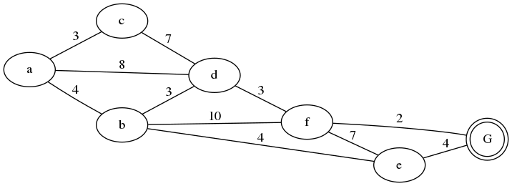

Figure 1: The state space

An example of a table, note that each table must have a title. Its position is above the table.

Table 1: Students marks in the exam

|  |  |
| --- | --- |
| Student | Mark |
| Ahmed | 10 |

# Title2 (add more titles if you need)

This is an example of how to cite a paper:

The theory was first put forward in 1987 [1].

# Discussion

# Conclusion

# References

A bibliography of all cited works and sources you have used throughout this report must be included. All references should follow IEEE format and should be ordered according to their occurrence in the repor.t. You can find more information here (<https://libguides.murdoch.edu.au/IEEE/all> ).

This is an example of a conference paper:

[1] L. Liu and H. Miao, "A specification based approach to testing polymorphic attributes," in *Formal Methods and Software Engineering: Proc. of the 6th Int. Conf. on Formal Engineering Methods, ICFEM 2004, Seattle, WA, USA, November 8-12, 2004*, J. Davies, W. Schulte, M. Barnett, Eds. Berlin: Springer, 2004. pp. 306-19.

**Tasks division**

|  |  |  |
| --- | --- | --- |
| Name | ID | Tasks |
| Student 1 Name | Student 1 ID |  |
| Student 2 Name | Student 2 ID |  |