#Question 1

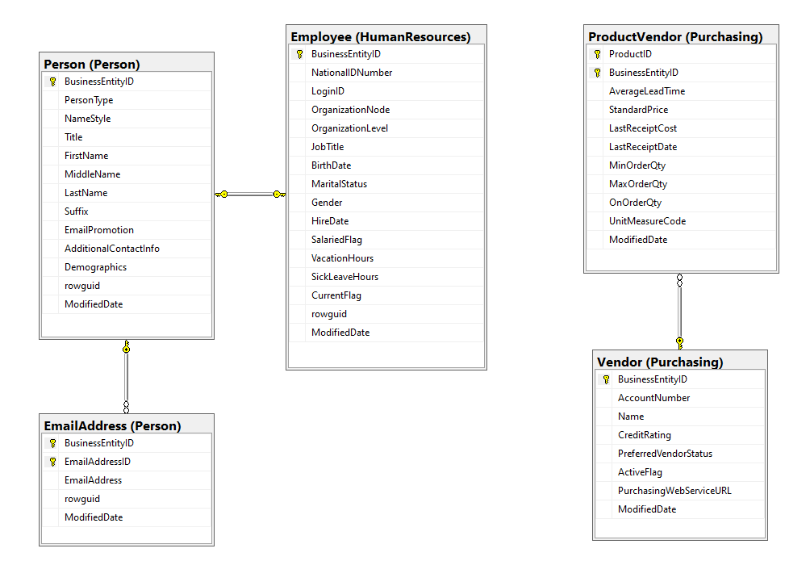

#Question2

DECLARE @TransactionName VARCHAR(20) = 'transaction';

BEGIN TRAN @TransactionName

UPDATE Person.EmailAddress SET ModifiedDate = GETDATE()

FROM Person.EmailAddress JOIN Person.Person

ON EmailAddress.BusinessEntityID = Person.BusinessEntityID

WHERE PersonType = 'EM';

select * from Person.EmailAddress ORDER BY BusinessEntityID

OFFSET 40 ROWS

FETCH NEXT 20 ROWS ONLY;

ROLLBACK TRAN @TransactionName;

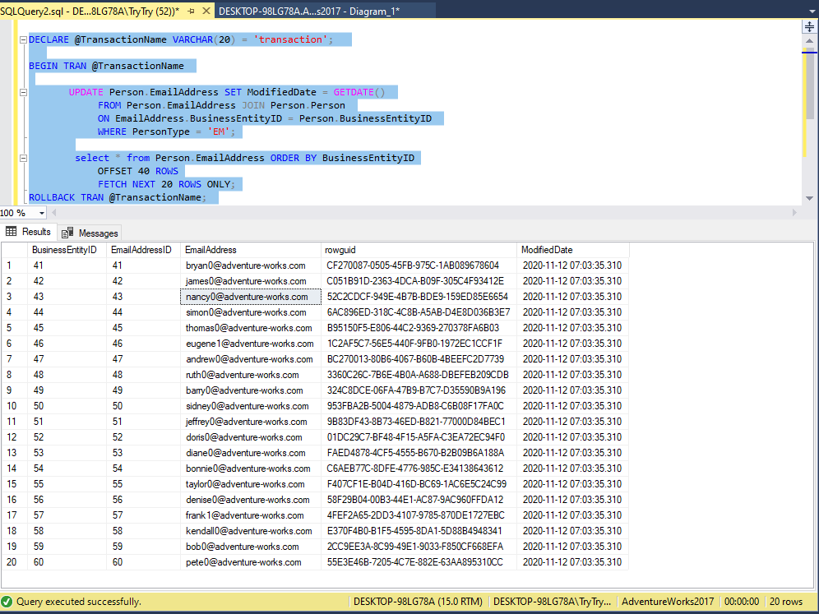

#Question3

DECLARE @TransactionName VARCHAR(20) = 'transaction';

BEGIN TRAN @TransactionName

UPDATE Purchasing.ProductVendor Set StandardPrice = StandardPrice * 1.1 WHERE StandardPrice > 50

select * from Purchasing.ProductVendor WHERE StandardPrice > 50

ROLLBACK TRAN @TransactionName;

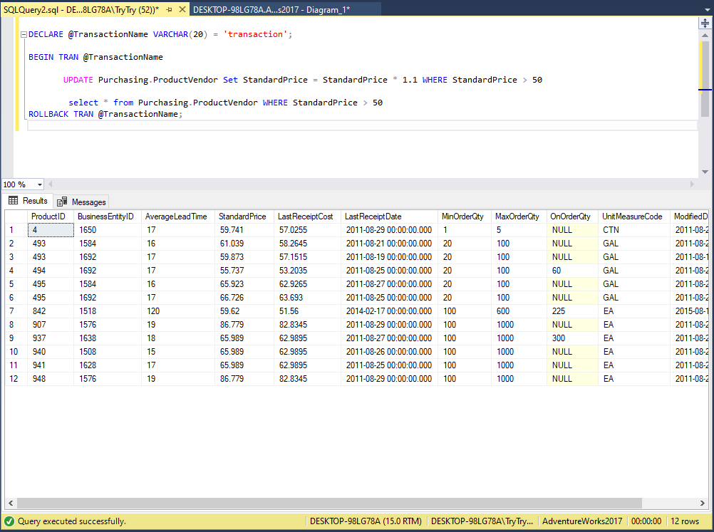

# Question4

DECLARE @TransactionName VARCHAR(20) = 'transaction';

BEGIN TRAN @TransactionName

UPDATE Person.Person Set ModifiedDate = N'2017-10-01' WHERE EmailPromotion = 0 AND FirstName like N'Ca%';

select * from Person.Person WHERE

EmailPromotion = 0 AND FirstName like N'Ca%';

ROLLBACK TRAN @TransactionName;

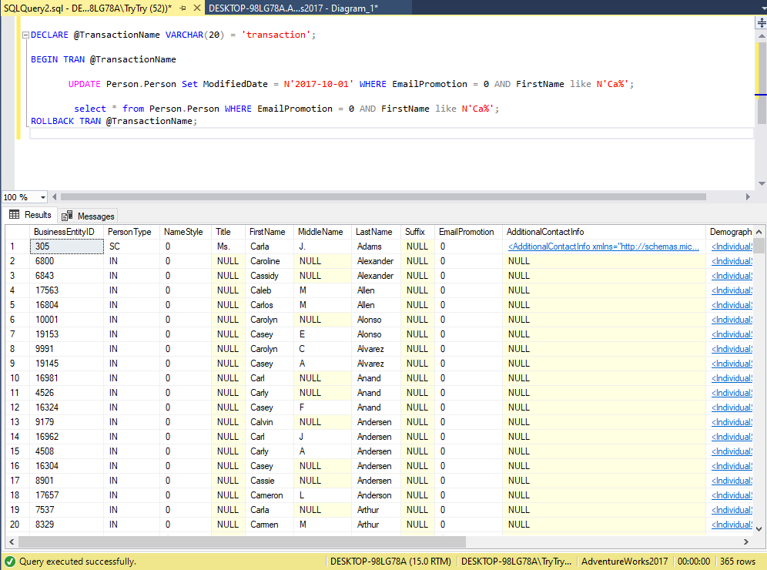

NVarchar is used for Unicode. If your database is not storing multilingual data you can keep using Varchar. As an example: N'abc' simply converts your string to unicode.

#Question5

DECLARE @TransactionName VARCHAR(20) = 'transaction';

BEGIN TRAN @TransactionName

Declare @MaxOrderQTY INT = 5000;

UPDATE Purchasing.ProductVendor SET MaxOrderQty = @MaxOrderQTY WHERE OnOrderQty IN

(SELECT TOP 7 OnOrderQty FROM Purchasing.ProductVendor ORDER BY OnOrderQty DESC)

SELECT TOP 7 * FROM Purchasing.ProductVendor ORDER BY OnOrderQty DESC

ROLLBACK TRAN @TransactionName;

