The goal is to create the front-end part of a small parcel shipment tracking application. a single web page that will allow the customer to follow their parcel, first of all the customer enters his tracking number then the frond-ent part communicates with the back-end with API Rest to retrieve the list of the different status of the parcel, these status will be displayed as a list of status sorted by chronological order as well as a progress bar which is the summary of the current status of the shipment.

The page is the statutes will be displayed either English or French according to the choice of the customer.

**What we provide :**

* The back-end part is already developed with spring boot.
* The database already contains an example for each use case in order to test the good functioning of your development.
* An excel file that contains the back end documentation and the detail of the desired result.

**The technology used :**

**Angular**- HTML CSS- Bootstrap- Jquery / Javascript.

The design must be **Responsive**

For more details please consult the excel file, especially the sheet Satut

**Example of the desired page:**

<https://www.dhlparcel.be/en/consumer/track-your-shipment?tc=8296149002&lc=en-BE>

https://www.dhlparcel.be/en/consumer/track-your-shipment?tc=8296149912&lc=en-BE

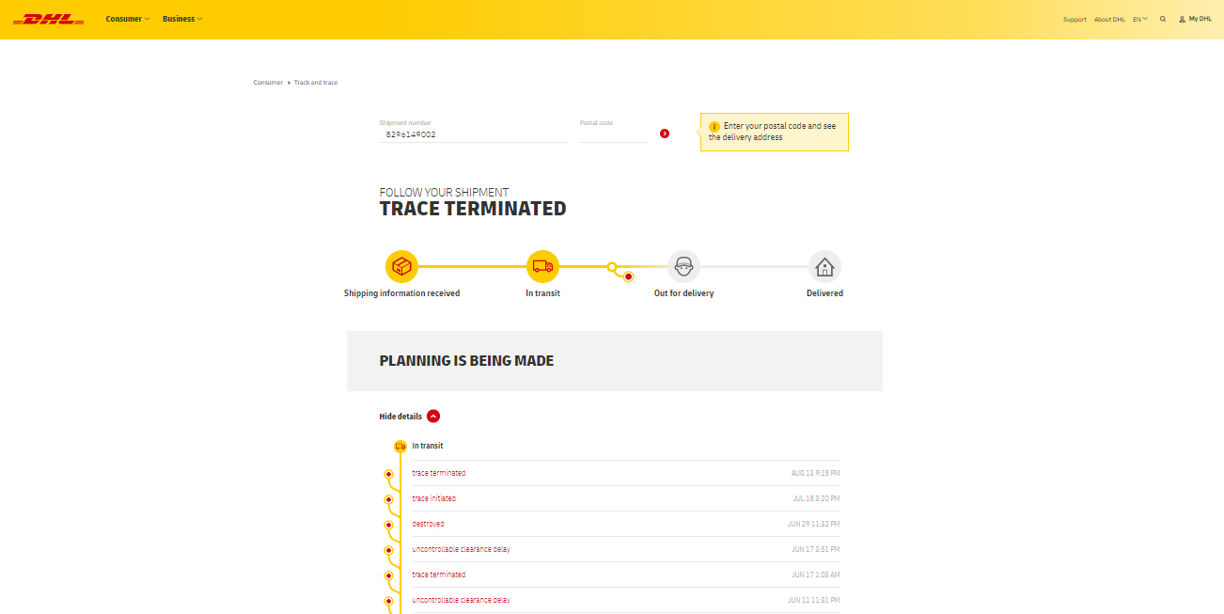

**Demonstration :**

you can use the DHL tracking links to design the page, below the unnecessary features that should not be displayed on the page as well as some remark on the colors ...

