|  |  |
| --- | --- |
| Week #12 Assignment  10 Percent Assignment | Major assignment  Maziar Shajari  Advanced Database |

* **Do not submit .zip files. Submit only your report as a text files (MS Word is preferred but first you need to create your report and then open it with MS Word or similar programs to create a text file).**
* **You have to use everything you have already learned, to complete your assignment. Adding comments, renaming the column’s title if needed, proper format of the queries, … have points and will be considered as queries’ format.**
* **Do not forget to have a title on top of your report with your name, assignment title and …**
* **Do not forget to include the question and questions’ number and queries before your results.**
* **(No need to show all rows if your result contains more than 15 rows).**

We are going to work with **Adventurework2017** database. Therefore, open **Adventurework2017** database as your default database. Do not forget to use the SQL standards.

|  |  |  |  |
| --- | --- | --- | --- |
| **#** | **Question** | **Mark** | **Table** |
| 1 | **Delete, Restore Database, Retrieve data.**  Delete Adventureworks2014 and create it again (Restore). (You can use any version of the database)  Show the first and last names of the persons in the Person.Person table with the following condition. you need the one(s) with the first name staring with ‘Amb’ without any middle name. | 10 | Person.Person |
| 2 | **Update data**   1. Update the person title of Amy Alberts to ‘Ms.’ and Modify the date (modifieddate) to the current date too.  * There might be more than one Amy Alberts. Only update the ones without any title. | 10 | Person.Person |
| 3 | **Join tables**  We need several items from 3 tables.  First, we need First name, Last name and title from Person.person.  Also, we need businessEntityID from Person.BusinessEntity.  And we need the AddressID from person.BusinessEntityAddress.  With a Join query show the needed results. Display only the first 15 rows. | 10 | Person.person.  Person.BusinessEntity.  person.BusinessEntityAddress. |
| 4 | **Database Diagrams**  A) Create a Database diagram for the step 3.  B) Make a database diagram using three tables.  (PurchaseOrderDetail, Purchasing.Vendor  PurchaseOrderHeader) | 10 |  |
| 5 | **Views**  Create a view with only 5 columns. Three columns are (OrderQty, UnitPrice, PurchaseOrderID) from PurchaseOrderDetail table and two columns are (OrderDate, VendorID) from PurchaseOrderHeader table. We need to see only the first 10 Rows.  We need to see what is stored in your virtual table and display it after using the view. | 10 | PurchaseOrderHeader  PurchaseOrderDetail |
| 6 | **Trigger**   1. Create a trigger to fire when a row is going to be updated. The trigger must show a message to indicate that an update happened with the update’s date. 2. Update all the modified date with the current date and show the results. Show the message. | 20 | PurchaseOrderDetail |
| 7 | **Case & Join command**  In the sales person’s table, we need to compare the values of last year and recent sale of the sale persons.  If they have sold more than last year, write ‘Need more bonus’. Otherwise, write ‘No bonus’. Name the column as ‘Bonus’  We also need the name of the persons.  Order the result by last name.  The result must be similar to the screen shot below. | 20 | Sales.SalesPerson  Person.Person |
| 8 | Report Format | 10 |  |
|  | SUM | 100 |  |

**Answer1:**

**Delete:**

USE master ;

GO

DROP DATABASE AdventureWorks2017 ;

GO

**Restore:**

USE master

GO

RESTORE DATABASE AdventureWorks2017 FROM DISK = 'e:\AdventureWorks2017.bak' WITH

MOVE 'AdventureWorks2017' TO 'e:\AdventureWorks2017.mdf',

MOVE 'AdventureWorks2017_log' TO 'e:\AdventureWorks2017.ldf', REPLACE

**Show the first and last names of the persons in the Person.Person table with the following condition. you need the one(s) with the first name staring with ‘Amb’ without any middle name:**

select FirstName, LastName from Person.Person where FirstName like 'Amb%' and MiddleName is null

**Answer2:**

**Update data**

1. **Update the person title of Amy Alberts to ‘Ms.’ and Modify the date (modifieddate) to the current date too.**

* **There might be more than one Amy Alberts. Only update the ones without any title.**

update Person.Person Set Title='Ms.', ModifiedDate = GETDATE() where FirstName='Amy' and LastName='Alberts' and Title is null

**Answer3:**

**Join tables**

**We need several items from 3 tables.**

**First, we need First name, Last name and title from Person.person.**

**Also, we need businessEntityID from Person.BusinessEntity.**

**And we need the AddressID from person.BusinessEntityAddress.**

select a.FirstName, a.LastName, a.Title, a.BusinessEntityID, b.AddressID from Person.Person a left join Person.BusinessEntityAddress b on a.BusinessEntityID=b.BusinessEntityID

**Answer4:**

**Database Diagrams**

**A) Create a Database diagram for the step 3.**

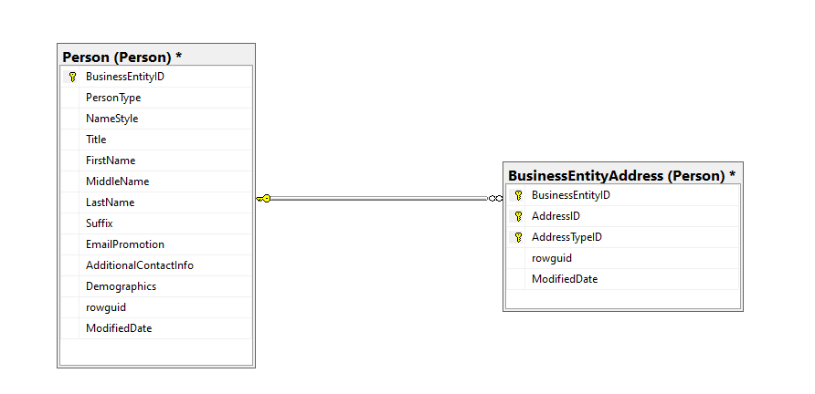

**B) Make a database diagram using three tables.**

**(PurchaseOrderDetail, Purchasing.Vendor**

**PurchaseOrderHeader)**

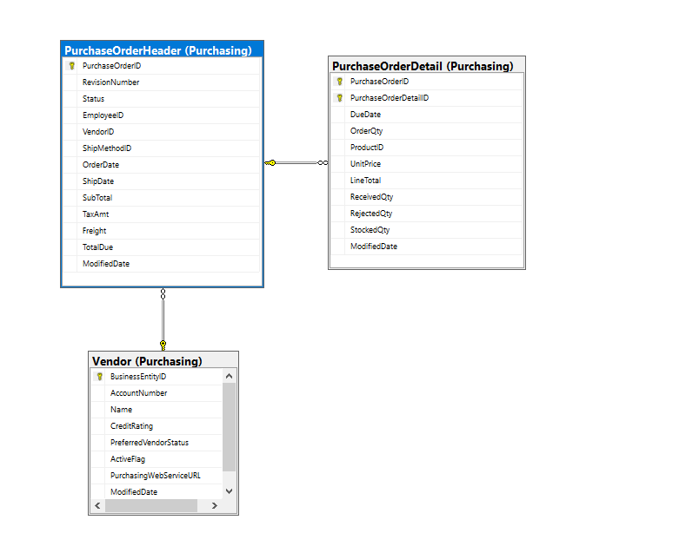

**Answer5:**

**Views**

**Create a view with only 5 columns. Three columns are (OrderQty, UnitPrice, PurchaseOrderID) from PurchaseOrderDetail table and two columns are (OrderDate, VendorID) from PurchaseOrderHeader table. We need to see only the first 10 Rows.**

**We need to see what is stored in your virtual table and display it after using the view.**

Drop View Columns5;

Go

CREATE VIEW Columns5

AS

SELECT TOP 10

a.OrderQty,a.UnitPrice,a.PurchaseOrderID,b.OrderDate,b.VendorID

FROM

Purchasing.PurchaseOrderDetail a

left join Purchasing.PurchaseOrderHeader b

on a.PurchaseOrderID = b.PurchaseOrderID;

Go

select * from Columns5;

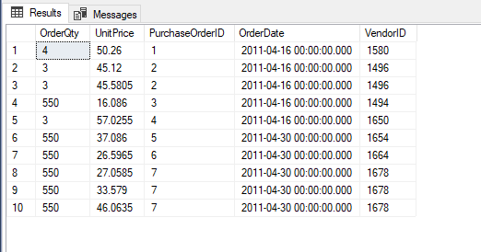

**Answer6:**

**Trigger**

1. **Create a trigger to fire when a row is going to be updated. The trigger must show a message to indicate that an update happened with the update’s date.**

CREATE TRIGGER trigger1

ON Purchasing.PurchaseOrderDetail

FOR UPDATE

AS PRINT N'one row updated ,updated date='+CAST(GETDATE() AS NVARCHAR(30));

GO

1. **Update all the modified date with the current date and show the results. Show the message.**

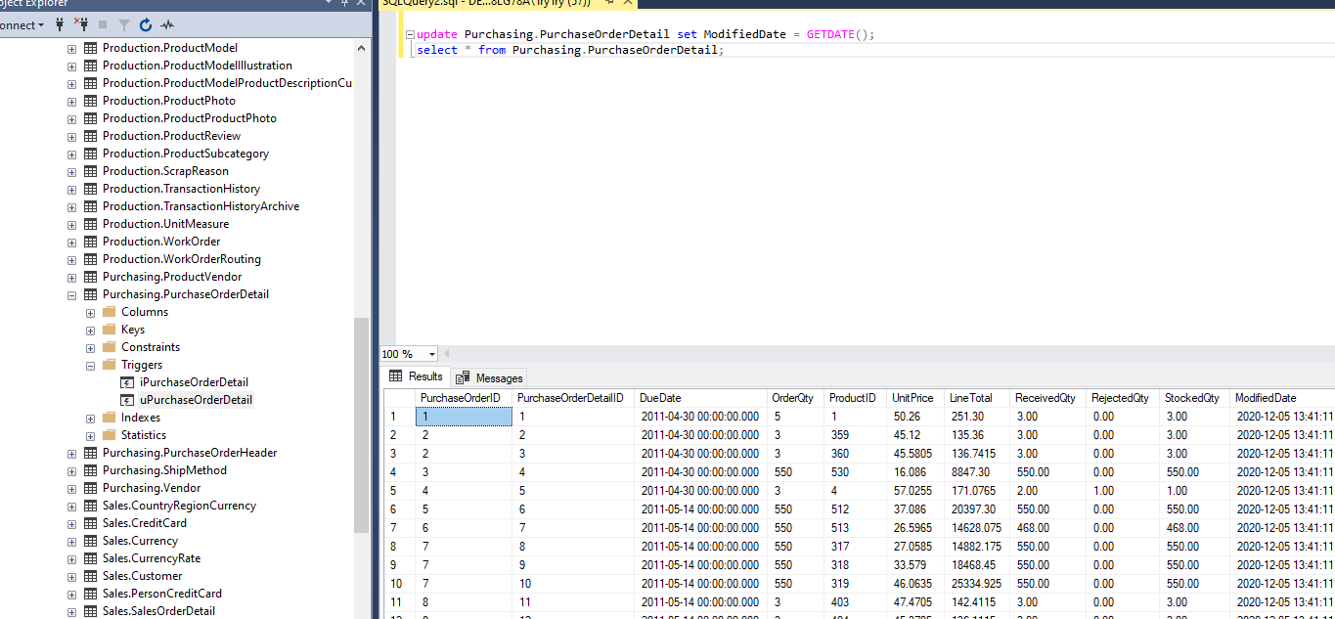

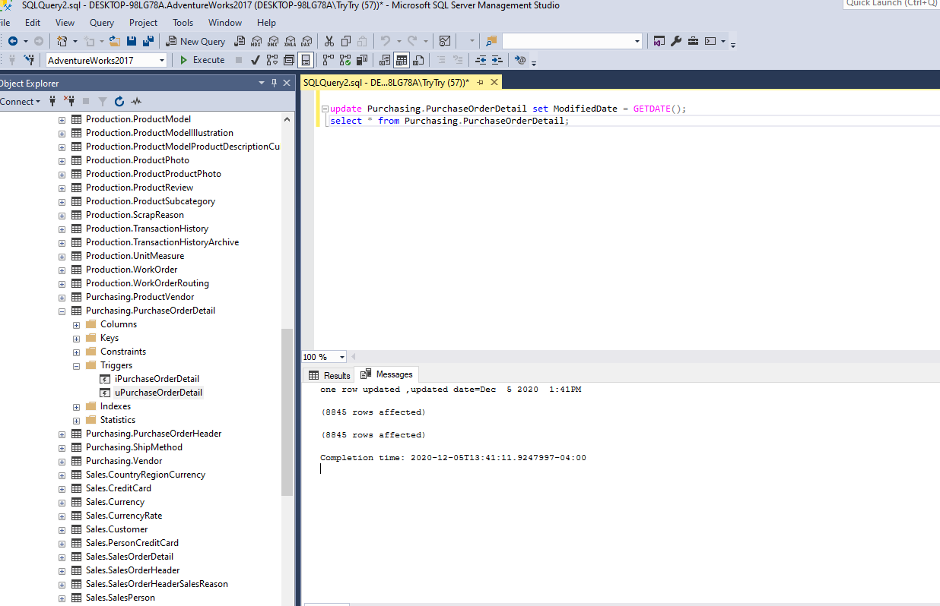

**Answer7:**

**Case & Join command**

**In the sales person’s table, we need to compare the values of last year and recent sale of the sale persons.**

**If they have sold more than last year, write ‘Need more bonus’. Otherwise, write ‘No bonus’. Name the column as ‘Bonus’**

**We also need the name of the persons.**

**Order the result by last name.**

**The result must be similar to the screen shot below**

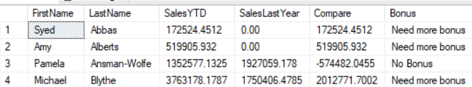

select b.FirstName, b.LastName,a.SalesYTD, a.SalesLastYear, (a.SalesYTD - a.SalesLastYear) as Compare,Bonus =

CASE

WHEN (a.SalesYTD - a.SalesLastYear) > 0 THEN 'Need more bonus'

ELSE 'No Bonus'

END from Sales.SalesPerson a left join Person.Person b on a.BusinessEntityID = b.BusinessEntityID order by b.LastName;

