1. Splash is not showing as i want. My logo, first image, doesnt look complity, like second image. I want it to show complete, in the center of the image.

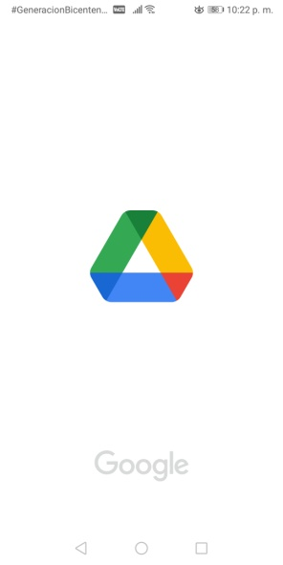



1. My app have 1 tab (video), that is always listening the changes of the database, so, it always moves and i dont want that, i need it to update only when i make ion-infinite scroll work

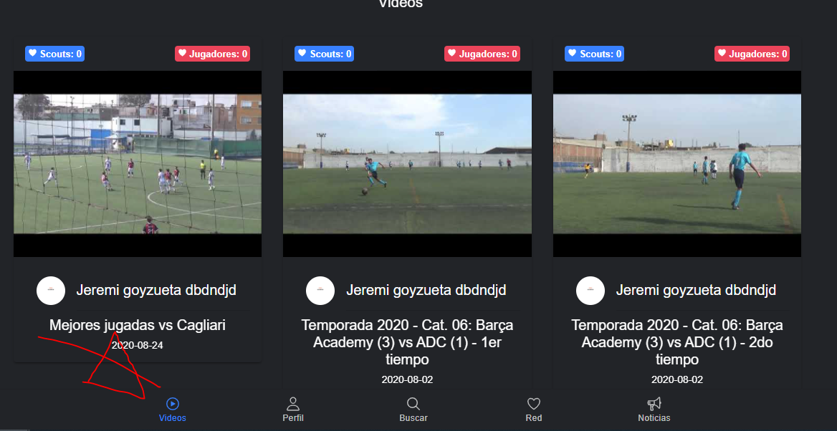

1. Send push notifications acording to some data filters (location data: country, state and city)
2. When someone clic a notification, before app open, it shows an ad and then open a specific route of the app