Tutorial for github & aws deployment

1.construct github repository.

-please run this git commands:

git clone <https://github.com/Linkolis/12_client_app_front_end.git>

cd 12_client_app_front_end

after copy source code to this directory,

git add .

git commit -m “first upload”

git push

2. deploy first static website in amazon s3

ng build -> generates dist directory (static website)

go to <https://s3.console.aws.amazon.com/s3/home>

Create new bucket.

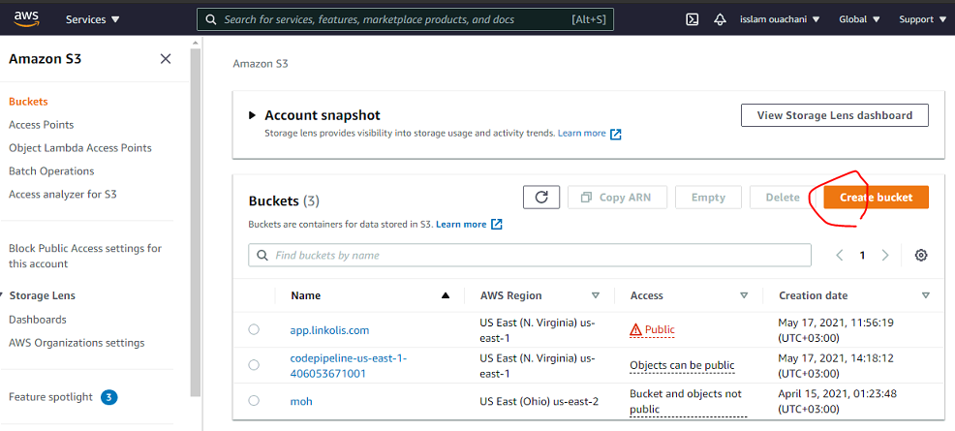

Bucket name: app.linkolas.com

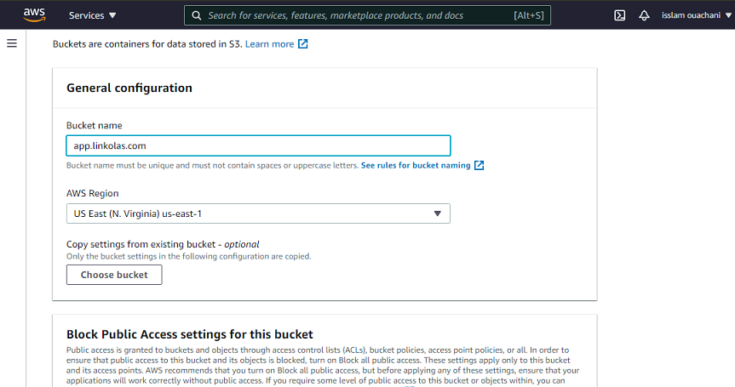

Uncheck “Block all public access”

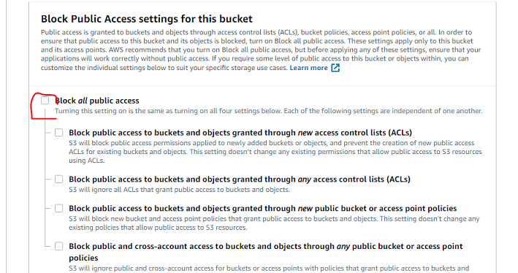

Click Create bucket

Go to “Permissions” of this bucket.

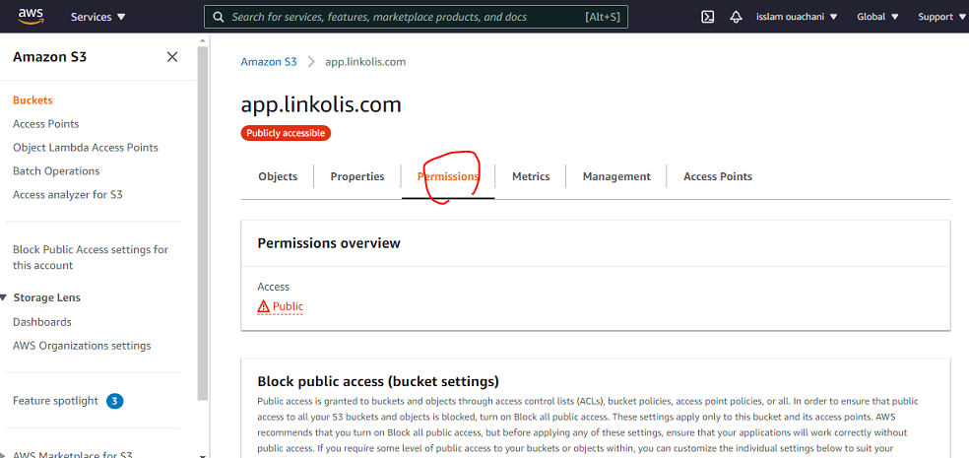

Edit Bucket policy

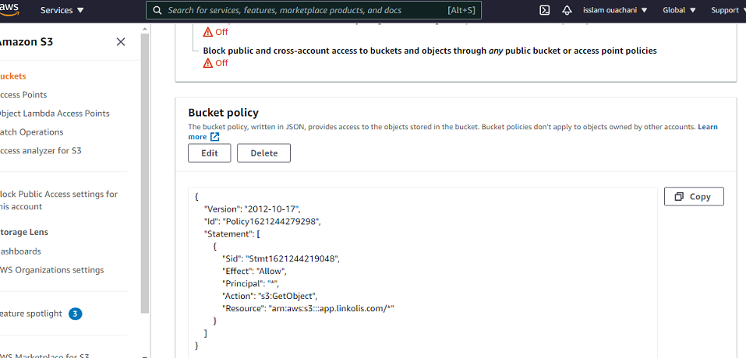

Go to “Objects”

And upload static website (dist directory)

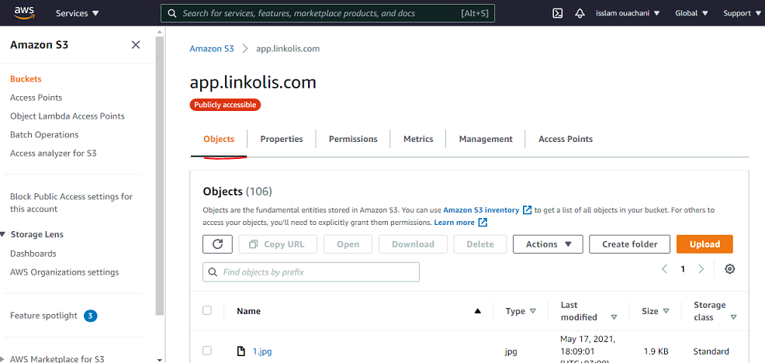

Test s3 bucket url

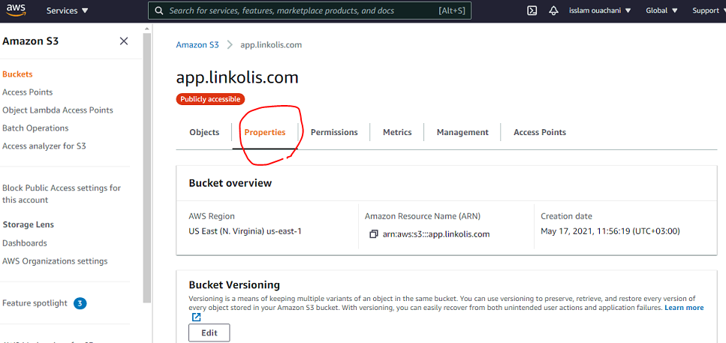

…

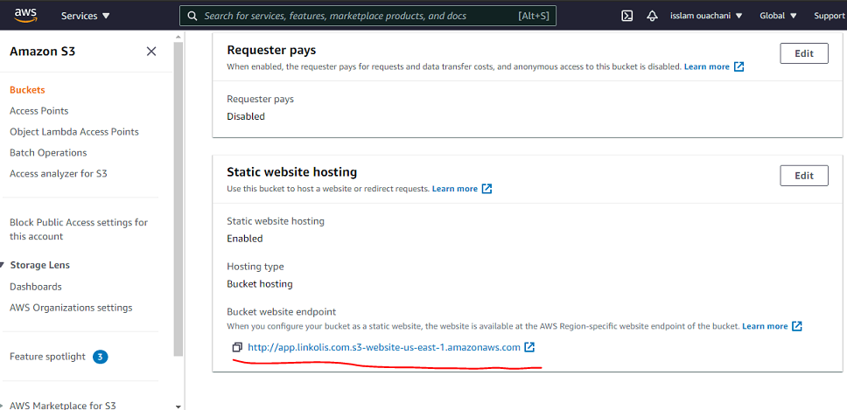

3. Create AWSCodePipeline

Go to CodePipeline service

<https://console.aws.amazon.com/codesuite/codepipeline/pipelines>

click Create pipeline

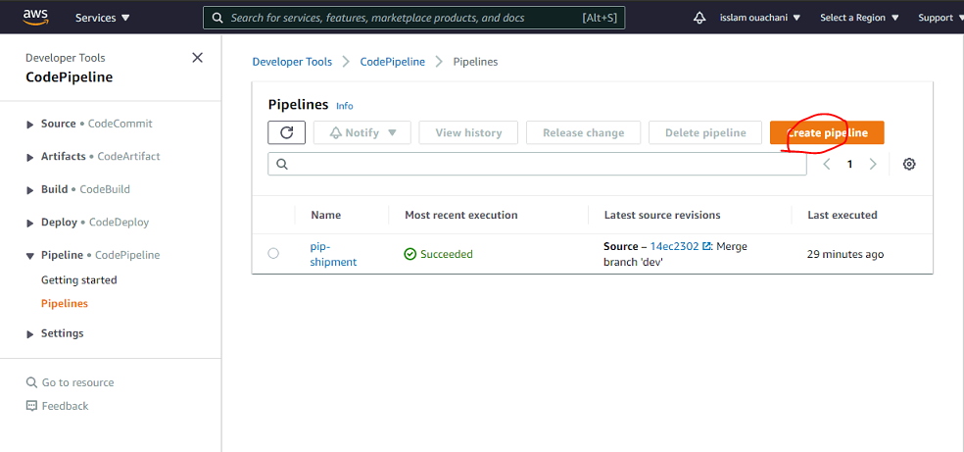

Pipeline name:any name (for example:pip-client-app)

Click “Next” button

Set github source provider

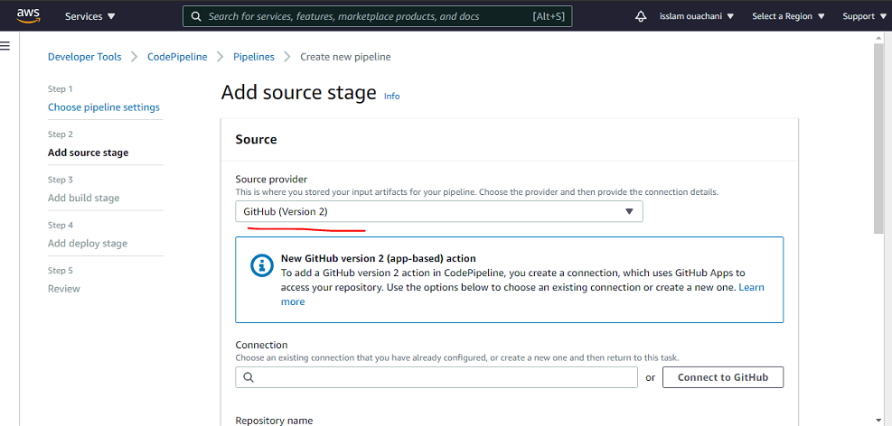

Click “Connect to Github”

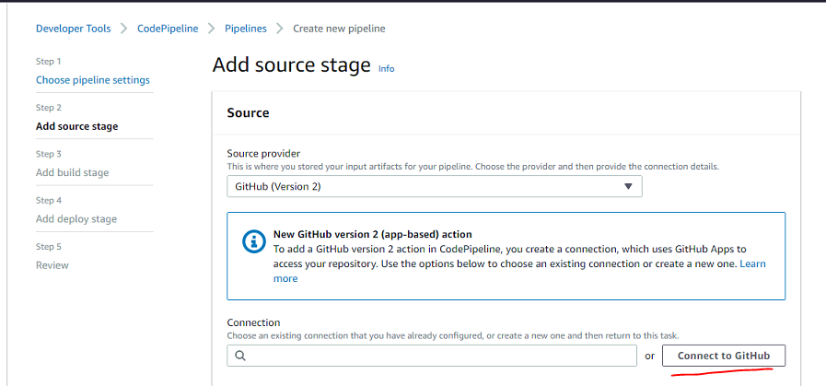input connectin name:

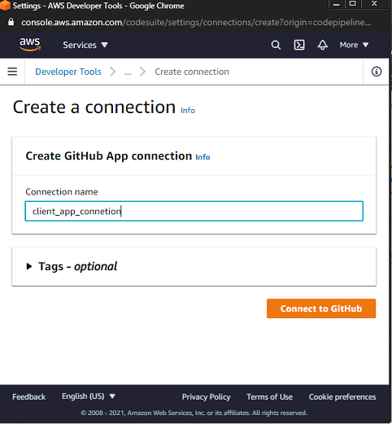

Click “Connect to Github”

And Click “Install a new app”

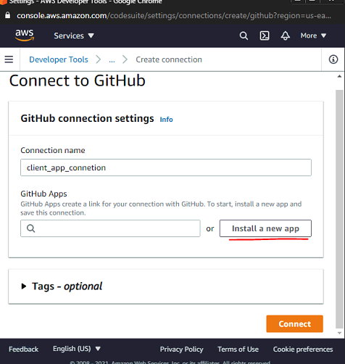

Pass Github authentication

Select github repository

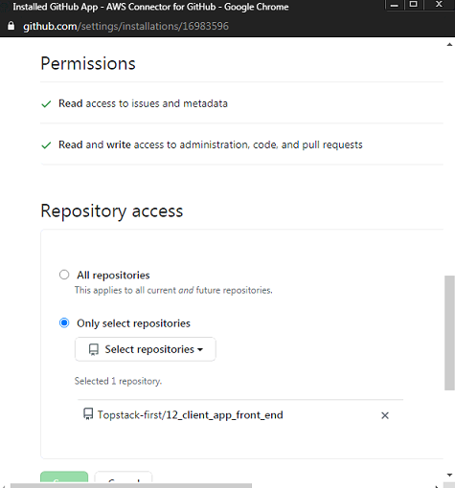

Select repository and branch also in creating pipeline

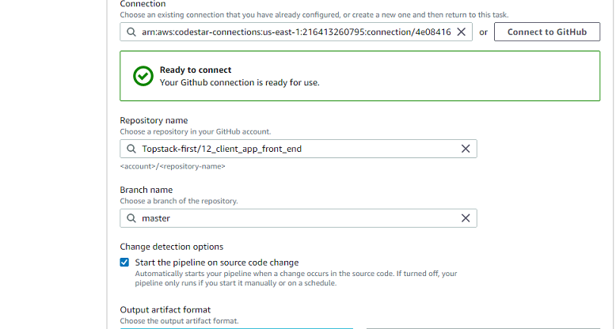

Click “Next”

Select Build provider , Region and create project

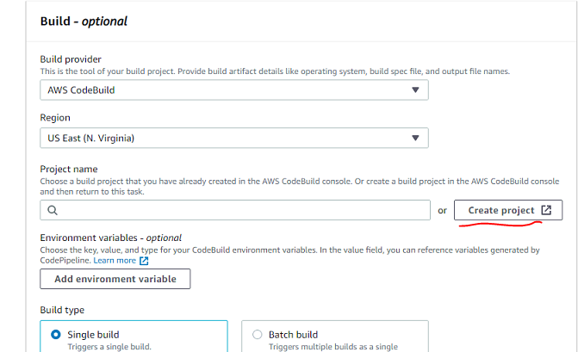

Input project’s name

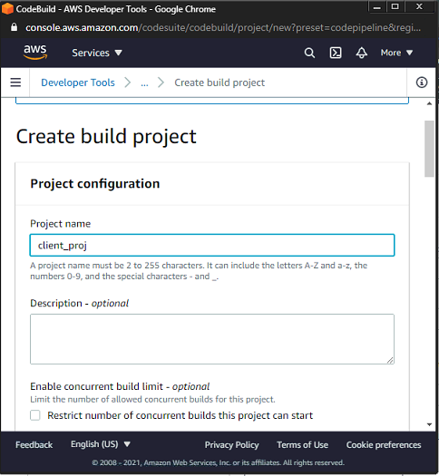

Select operating system (“windows server 2019”), Runtime(Base) and Image

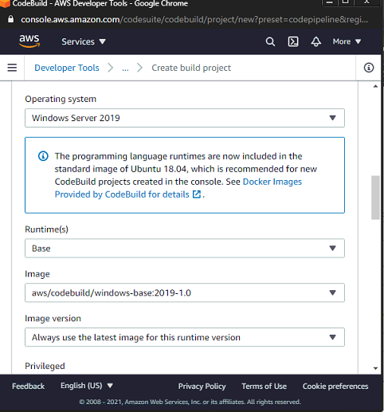

Click “Continue to CodePipeline”

And Click “Next” to continue

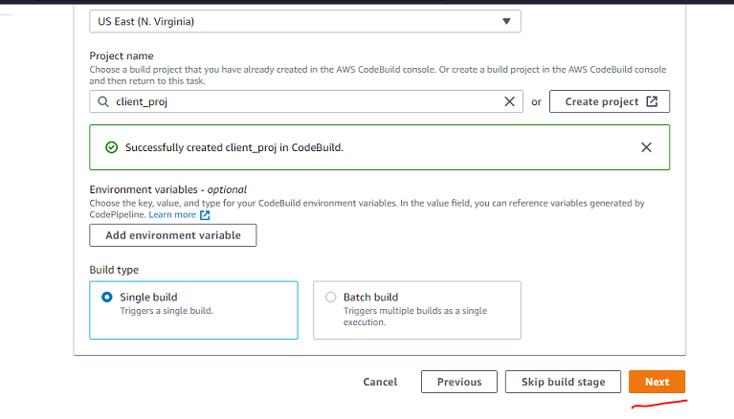

Select Deploy provider (Amazon S3), Region and Bucket(app.linkolis.com)

And check Extract file before deploy

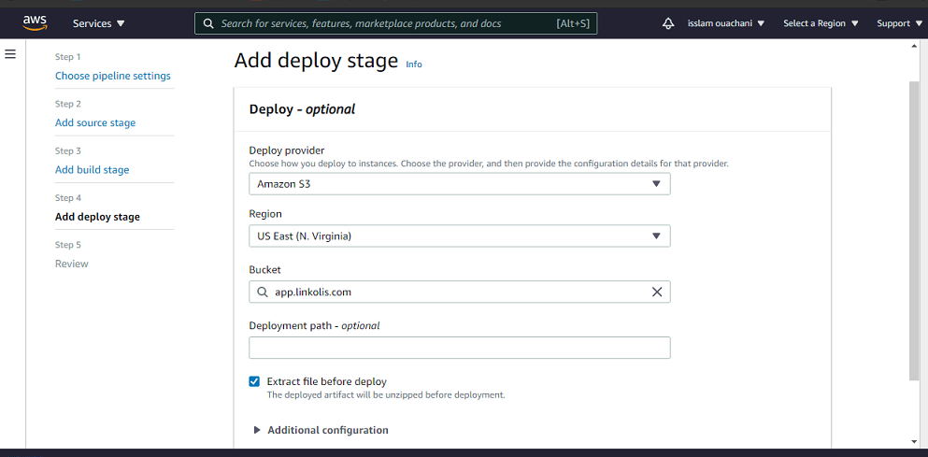

Click “Next”

You will see “Review” flow.

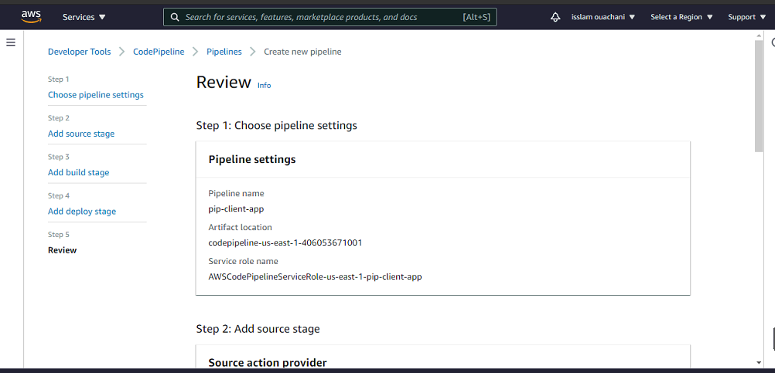

Click “Create pipeline” so will create new CodePipeline

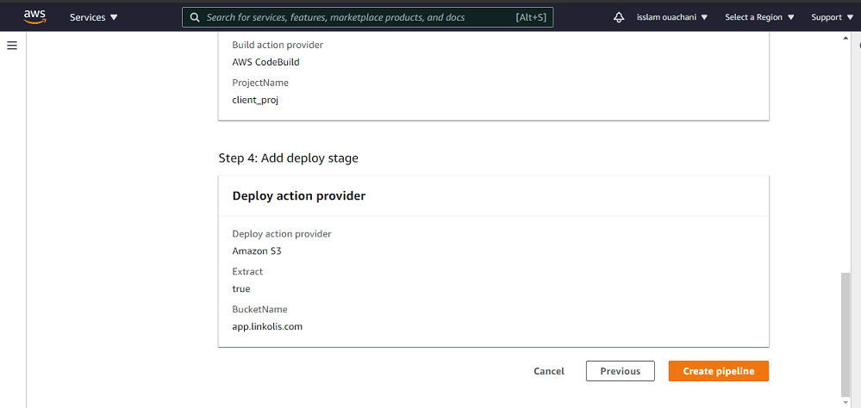

Click “Edit”

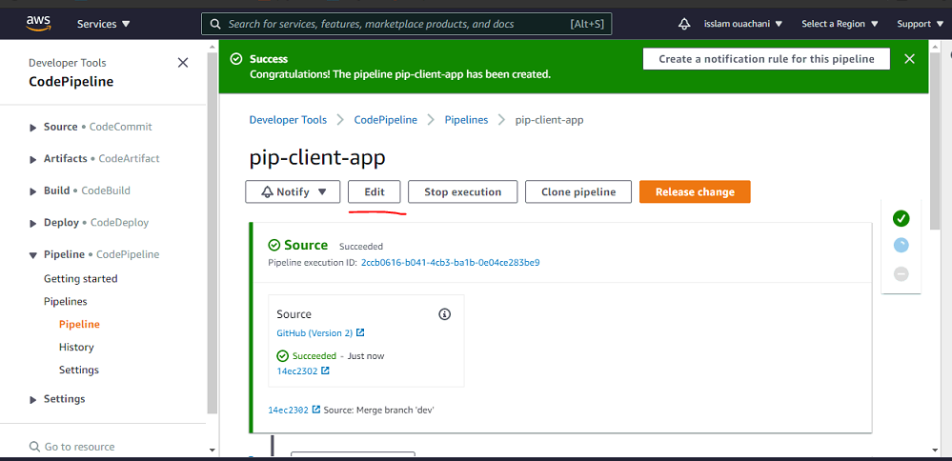

Click “AWS CodeBuild” in Edit stage

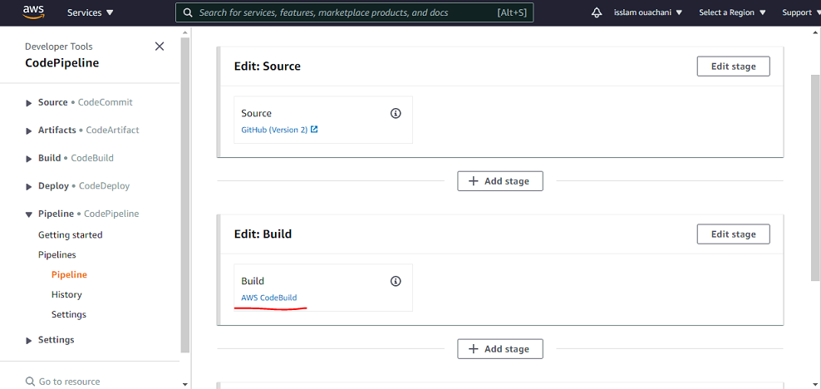

Select “Buildspec”

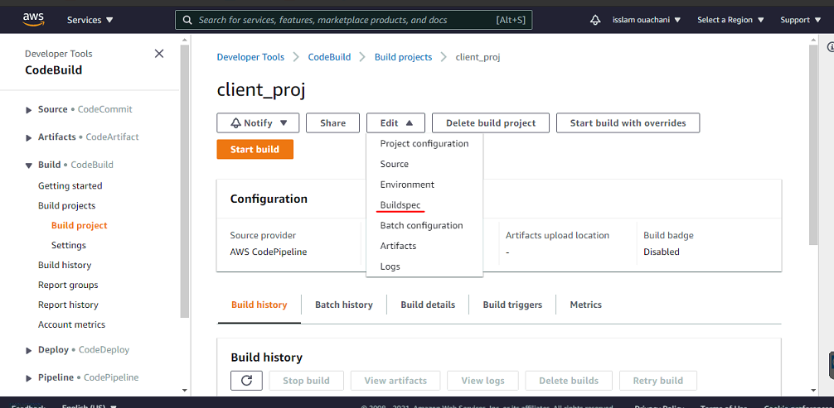

Select “Insert build commands”

And Switch to editor

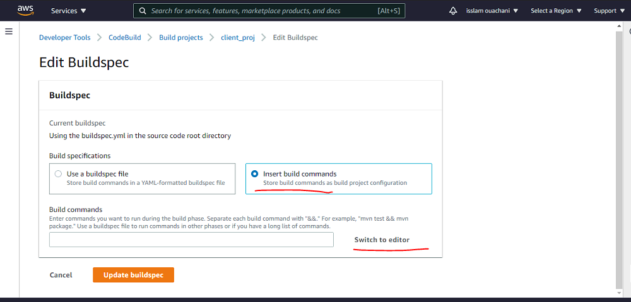

Copy and paste this commands in there

version: 0.2

env:

variables:

CACHE_CONTROL: "86400"

S3_BUCKET: "{{your_url}}"

BUILD_FOLDER: "dist"

phases:

install:

runtime-versions:

nodejs: 14

commands:

- echo Installing source NPM dependencies...

- npm install

- npm install -g @angular/cli

build:

commands:

- echo Build started

- ng build

artifacts:

files:

- '**/*'

base-directory: 'dist*'

discard-paths: yes

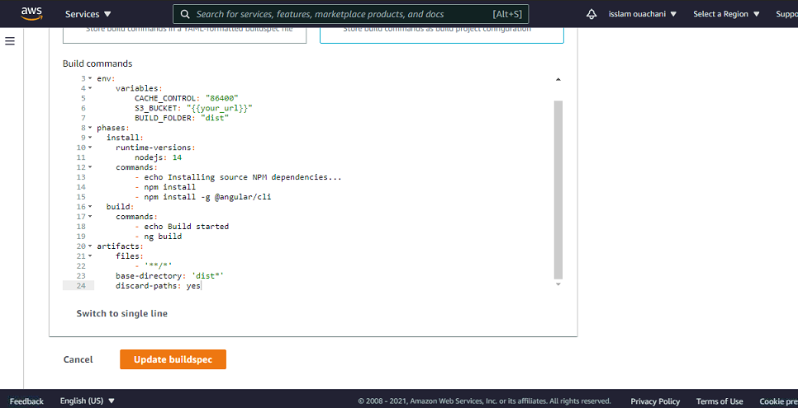

Click “Update buildspec”

To check autobuild from github,

Go to pipeline

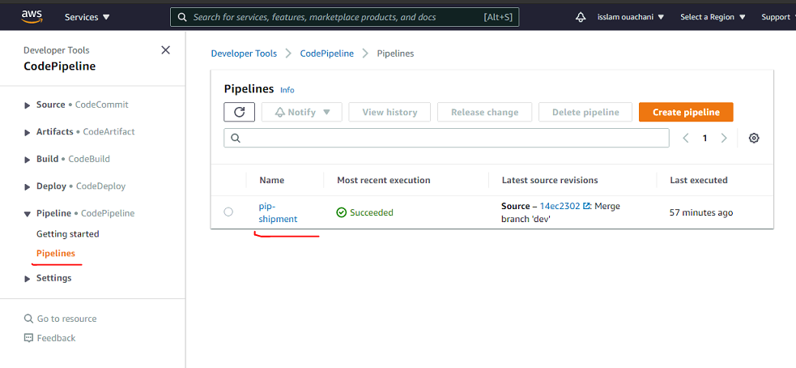

You can see this screen

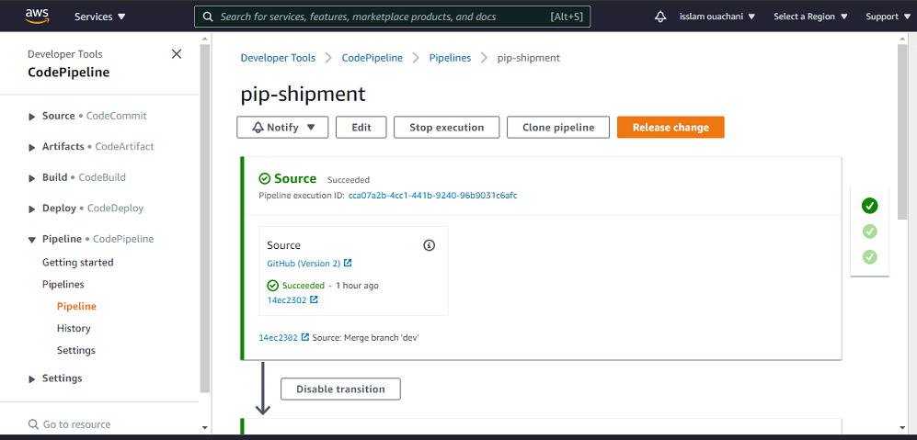

Finally please commit to dev branch and merge to master branch in github.

It will be built automatically and deployed to asw s3 bucket.

4. Create subdomain and create new record in root domain

Go to Route 53 service

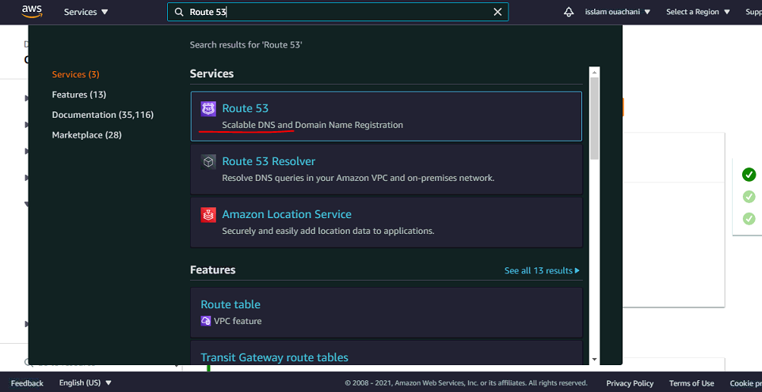

Go to “Hosted zones”

Click “Create hosted zone”

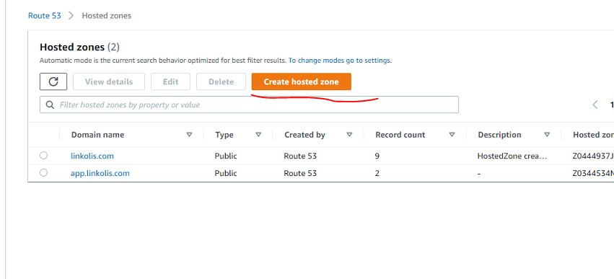

Input subdomain (app.linkolas.com)

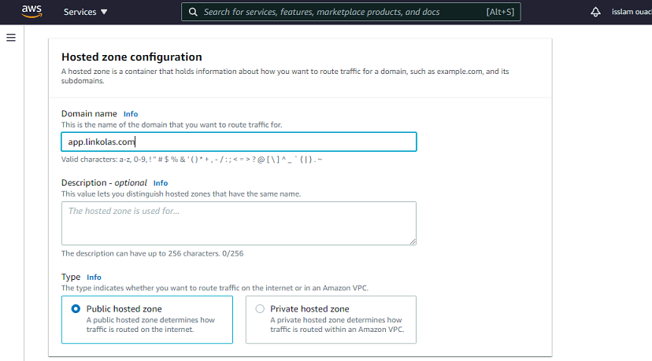

And create hosted zone.

So subdomain will be created.

Select root domain and create record

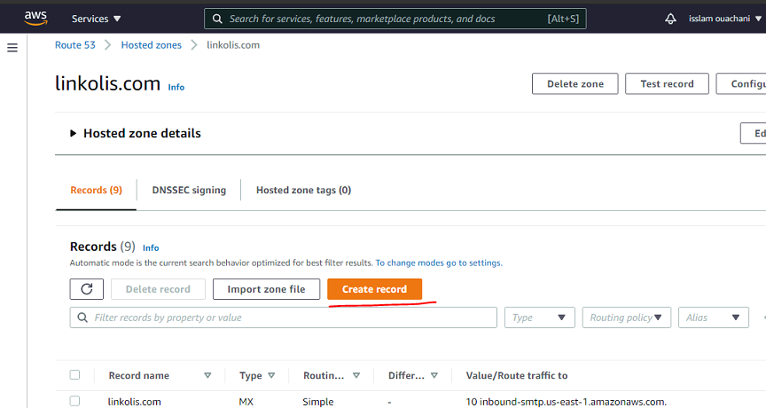

Input record name (app), record type, route traffic etc like below picture

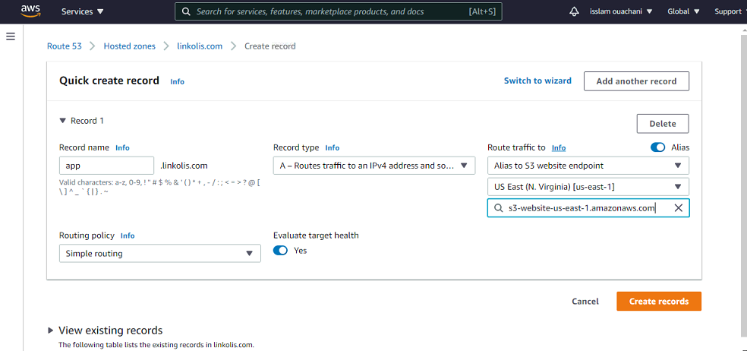

Click “Create records”

So you can access to s3 bucket web endpoint by using subdomain.

Thanks for your reading!