**Documentation**

Asteroids Game

**Mishchenko**

**1. Database**

Added two tables.



**2. API**

Added 5 apis and 1 function.

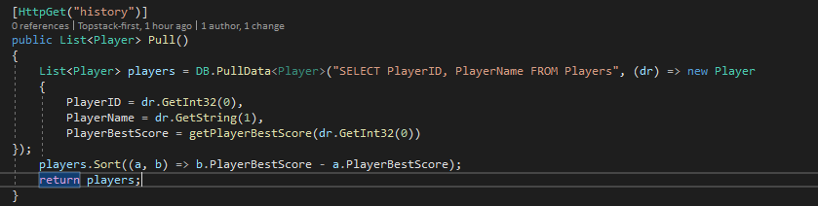

This api returns all players and his best scores

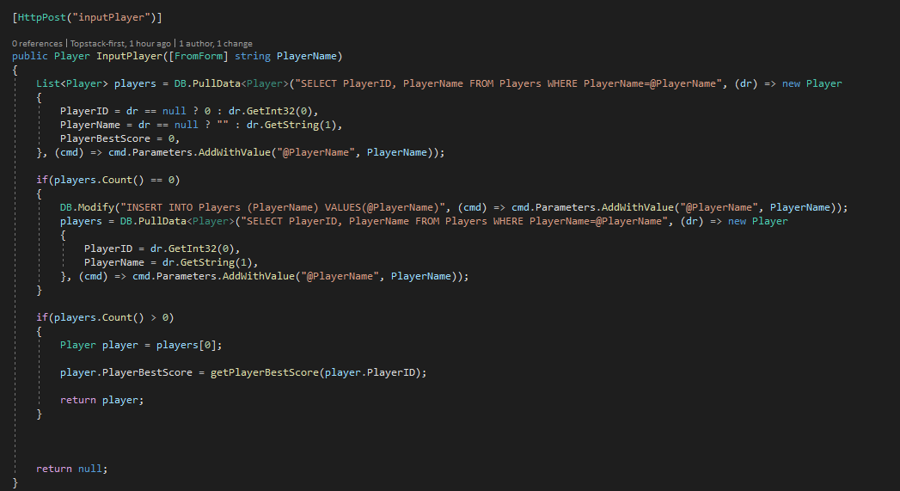

This api inputs or select a player with their name

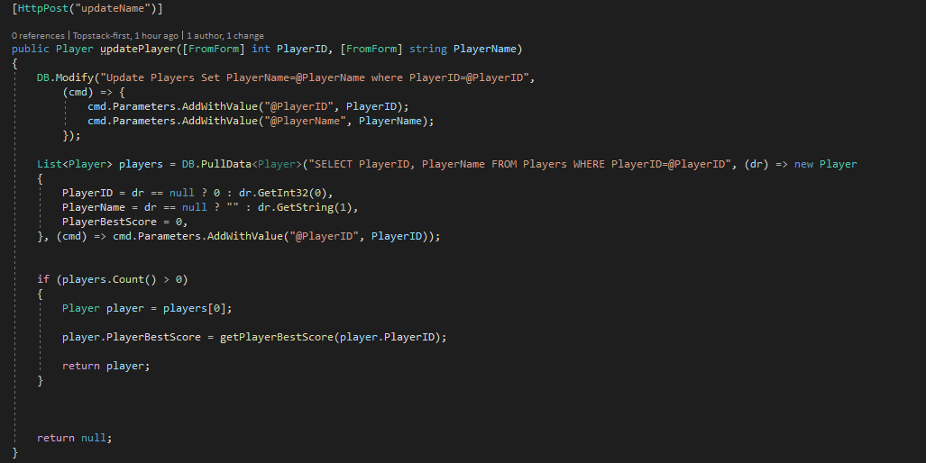

This api updates player’s name

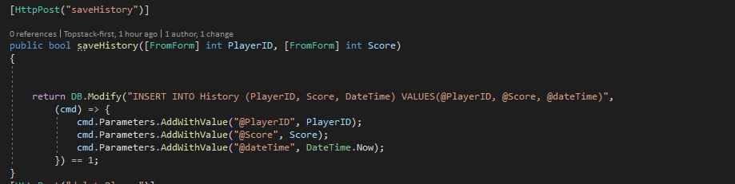

This api saves game play.

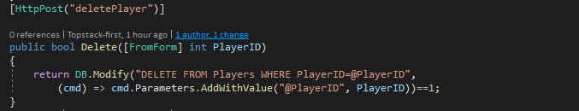

This api deletes the player

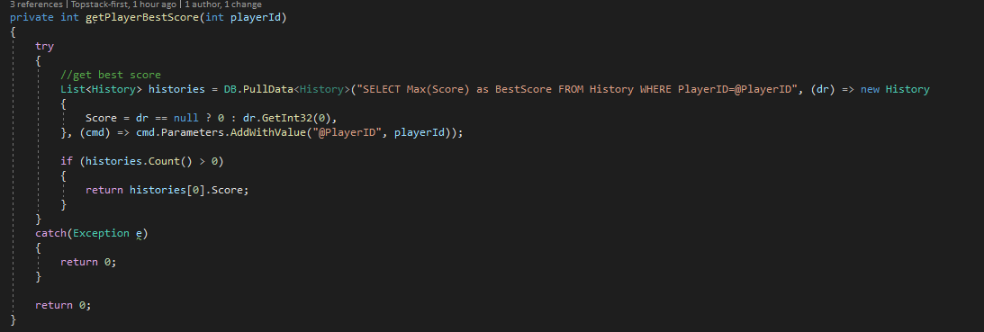

This function gets player’s best score.

**1. game.js**

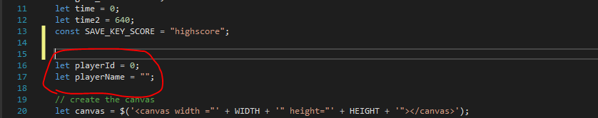

Added player’s information.

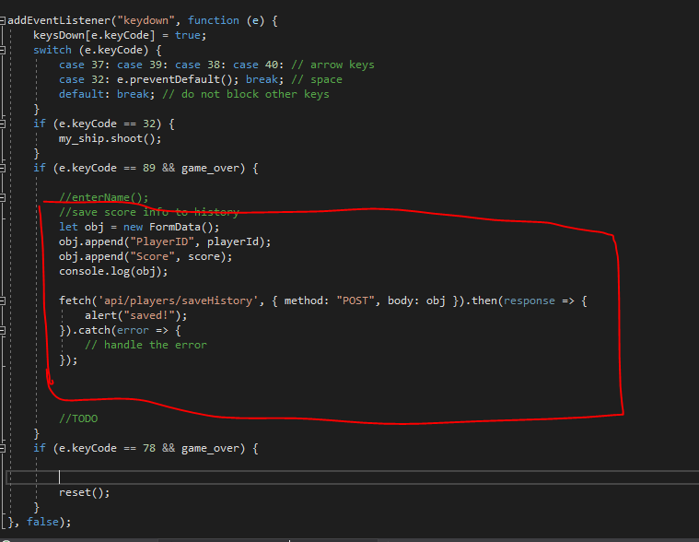

**Added saving function**

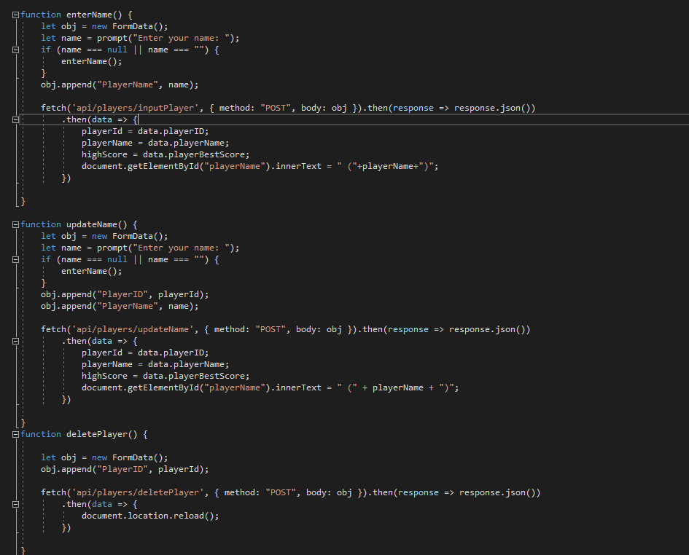

**Added enterName(), updateName(), deletePlayer()**

**3. scoreTable.js**

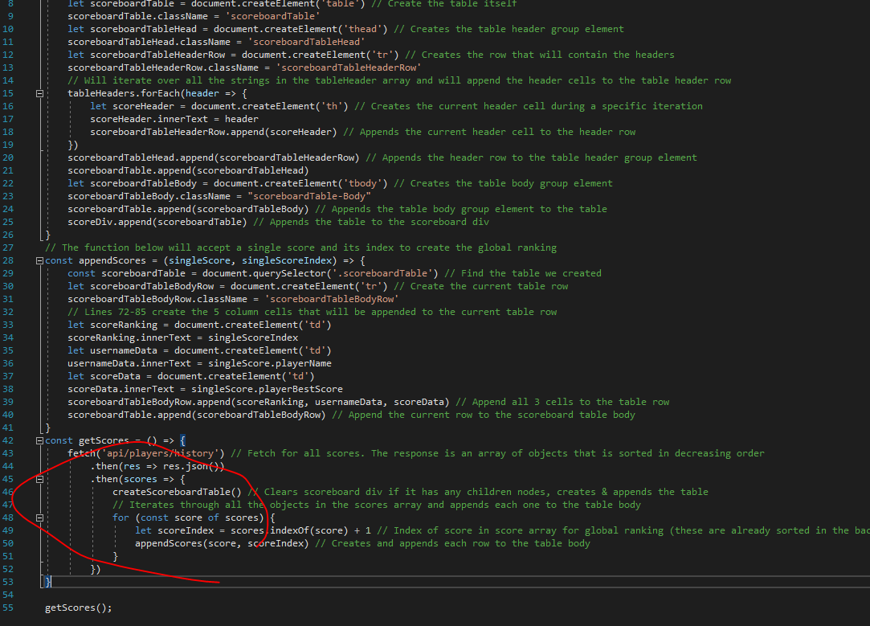

**Updated scoretable.js**