INTRODUCTION
- Networking Overview

A network enables two computers to communicate with each other. There is a wide array of topologies (mesh/tree/star), mediums (ethernet/fiber/coax/wireless), and protocols (TCP/UDP/IPX) that can be used to facilitate the network. It is important as security professionals to understand networking because when the network fails, the error may be silent, causing us to miss something.
Setting up a large, flat network is not extremely difficult, and it can be a reliable network, at least operationally. However, a flat network is like building a house on a land plot and considering it secure because it has a lock on the door. By creating lots of smaller networks and having them communicate, we can add defense layers. Pivoting around a network is not difficult, but doing it quickly and silently is tough and will slow attackers down. Back to the house scenario, let's walk through the following examples:
Example No. 1
Building smaller networks and putting Access Control Lists around them is like putting a fence around the property's border that creates specific entry and exit points. Yes, an attacker could jump over the fence, but this looks suspicious and is not common, allowing it to be quickly detected as malicious activity. Why is the printer network talking to the servers over HTTP?
Example No. 2
Taking the time to map out and document each network's purpose is like placing lights around the property, making sure all activity can be seen. Why is the printer network talking to the internet at all?
Example No. 3
Having bushes around windows is a deterrent to people attempting to open the window. Just like Intrusion Detection Systems like Suricata or Snort are a deterrent to running network scans. Why did a port scan originate from the printer network?
These examples may sound silly, and it is common sense to block a printer from doing all of the above. However, if the printer is on a "flat /24 network" and gets a DHCP address, it can be challenging to place these types of restrictions on them.

Story Time - A Pentesters Oversight
Most networks use a /24 subnet, so much so that many Penetration Testers will set this subnet mask (255.255.255.0) without checking. The /24 network allows computers to talk to each other as long as the first three octets of an IP Address are the same (ex: 192.168.1.xxx). Setting the subnet mask to /25 divides this range in half, and the computer will be able to talk to only the computers on "its half." We have seen Penetration Test reports where the assessor claimed a Domain Controller was offline when it was just on a different network in reality. The network structure was something like this:
- Server Gateway: 10.20.0.1/25
- Domain Controller: 10.20.0.10/25
- Client Gateway: 10.20.0.129/25
- Client Workstation: 10.20.0.200/25
- Pentester IP: 10.20.0.252/24 (Set Gateway to 10.20.0.1)
The Pentester communicated with the Client Workstations and thought they did an excellent job because they managed to steal a workstation password via Impacket. However, due to a failure to understand the network, they never managed to get off the Client Network and reach more "high value" targets such as database servers. Hopefully, if this sounds confusing to you, you can come back to this statement at the end of the module and understand it!

Basic Information
Let us look at the following high-level diagram of how a Work From Home setup may work.
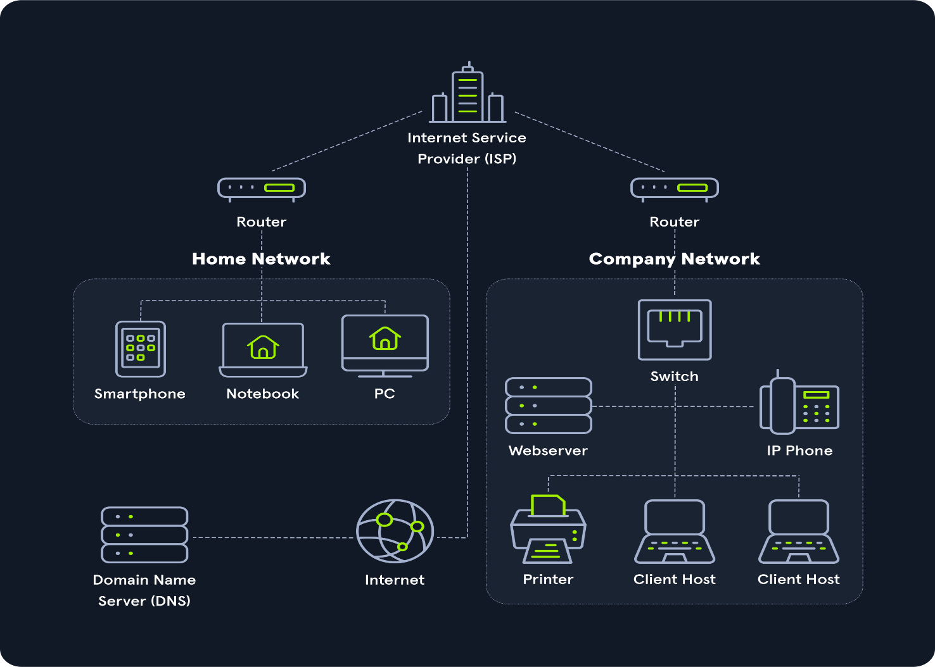
The entire internet is based on many subdivided networks, as shown in the example and marked as "Home Network" and "Company Network." We can imagine networking as the delivery of mail or packages sent by one computer and received by the other.
Suppose we imagine as a scenario that we want to visit a company's website from our "Home Network." In that case, we exchange data with the company's website located in their "Company Network." As with sending mail or packets, we know the address where the packets should go. The website address or Uniform Resource Locator (URL) which we enter into our browser is also known as Fully Qualified Domain Name (FQDN).
The difference between URLs and FQDNs is that:
- an FQDN (www.hackthebox.eu) only specifies the address of the "building" and
- an URL (https://www.hackthebox.eu/example?floor=2&office=dev&employee=17) also specifies the "floor," "office," "mailbox" and the corresponding "employee" for whom the package is intended.
We will discuss the exact representations and definitions more clearly and precisely in other sections.
The fact is that we know the address, but not the exact geographical location of the address. In this situation, the post office can determine the exact location, which then forwards the packets to the desired location. Therefore, our post office forwards our packets to the main post office, representing our Internet Service Provider (ISP).
Our post office is our router which we utilize to connect to the "Internet" in networking.
As soon as we send our packet through our post office (router), the packet is forwarded to the main post office (ISP). This main post office looks in the address register/phonebook (Domain Name Service) where this address is located and returns the corresponding geographical coordinates (IP address). Now that we know the address's exact location, our packet is sent directly there by a direct flight via our main post office.
After the web server has received our packet with the request of what their website looks like, the webserver sends us back the packet with the data for the presentation of the website via the post office (router) of the "Company Network" to the specified return address (our IP address).

Extra Points
In that diagram, I would hope the company network shown consists of five separate networks!
- The Web Server should be in a DMZ (Demilitarized Zone) because clients on the internet can initiate communications with the website, making it more likely to become compromised. Placing it in a separate network allows the administrators to put networking protections between the web server and other devices.
- Workstations should be on their own network, and in a perfect world, each workstation should have a Host-Based Firewall rule preventing it from talking to other workstations. If a Workstation is on the same network as a Server, networking attacks like spoofing or man in the middle become much more of an issue.
- The Switch and Router should be on an "Administration Network." This prevents workstations from snooping in on any communication between these devices. I have often performed a Penetration Test and saw OSPF (Open Shortest Path First) advertisements. Since the router did not have a trusted network, anyone on the internal network could have sent a malicious advertisement and performed a man in the middle attack against any network.
- IP Phones should be on their own network. Security-wise this is to prevent computers from being able to eavesdrop on communication. In addition to security, phones are unique in the sense that latency/lag is significant. Placing them on their own network can allow network administrators to prioritize their traffic to prevent high latency more easily.
- Printers should be on their own network. This may sound weird, but it is next to impossible to secure a printer. Due to how Windows works, if a printer tells a computer authentication is required during a print job, that computer will attempt an NTLMv2 authentication, which can lead to passwords being stolen. Additionally, these devices are great for persistence and, in general, have tons of sensitive information sent to them.

Fun Story
During COVID, I was tasked to perform a Physical Penetration Test across state lines, and my state was under a stay at home order. The company I was testing had minimal staff in the office. I decided to purchase an expensive printer and exploited it to put a reverse shell in it, so when it connected to the network, it would send me a shell (remote access). Then I shipped the printer to the company and sent a phishing email thanking the staff for coming in and explaining that the printer should allow them to print or scan things more quickly if they want to bring some stuff home to WFH for a few days. The printer was hooked up almost instantly, and their domain administrator's computer was kind enough to send the printer his credentials!
If the client had designed a secure network, this attack probably would not have been possible for many reasons:
- Printer should not have been able to talk to the internet
- Workstation should not have been able to communicate to the printer over port 445
- Printer should not be able to initiate connections to workstations. In some cases, printer/scanner combinations should be able to communicate to a mail server to email scanned documents

NETWORKING STRUCTURE
- Network Types

Each network is structured differently and can be set up individually. For this reason, so-called types and topologies have been developed that can be used to categorize these networks. When reading about all the types of networks, it can be a bit of information overload as some network types include the geographical range. We rarely hear some of the terminologies in practice, so this section will be broken up into Common Terms and Book Terms. Book terms are good to know, as there has been a single documented case of an email server failing to deliver emails longer than 500 miles but don't be expected to be able to recite them on demand unless you are studying for a networking exam.
Common Terminology
Network Type | Definition
Wide Area Network (WAN) | Internet
Local Area Network (LAN) | Internal Networks (Ex: Home or Office)
Wireless Local Area Network (WLAN) | Internal Networks accessible over Wi-Fi
Virtual Private Network (VPN) | Connects multiple network sites to one LAN

WAN
The WAN (Wide Area Network) is commonly referred to as The Internet. When dealing with networking equipment, we'll often have a WAN Address and LAN Address. The WAN one is the address that is generally accessed by the Internet. That being said, it is not inclusive to the Internet; a WAN is just a large number of LANs joined together. Many large companies or government agencies will have an "Internal WAN" (also called Intranet, Airgap Network, etc.). Generally speaking, the primary way we identify if the network is a WAN is to use a WAN Specific routing protocol such as BGP and if the IP Schema in use is not within RFC 1918 (10.0.0.0/8, 172.16.0.0/12, 192.168.0.0/16).

LAN / WLAN
LANs (Local Area Network) and WLANs (Wireless Local Area Network) will typically assign IP Addresses designated for local use (RFC 1918, 10.0.0.0/8, 172.16.0.0/12, 192.168.0.0/16). In some cases, like some colleges or hotels, you may be assigned a routable (internet) IP Address from joining their LAN, but that is much less common. There's nothing different between a LAN or WLAN, other than WLAN's introduce the ability to transmit data without cables. It is mainly a security designation.

VPN
There are three main types Virtual Private Networks (VPN), but all three have the same goal of making the user feel as if they were plugged into a different network.
Site-To-Site VPN
Both the client and server are Network Devices, typically either Routers or Firewalls, and share entire network ranges. This is most commonly used to join company networks together over the Internet, allowing multiple locations to communicate over the Internet as if they were local.
Remote Access VPN
This involves the client's computer creating a virtual interface that behaves as if it is on a client's network. Hack The Box utilizes OpenVPN, which makes a TUN Adapter letting us access the labs. When analyzing these VPNs, an important piece to consider is the routing table that is created when joining the VPN. If the VPN only creates routes for specific networks (ex: 10.10.10.0/24), this is called a Split-Tunnel VPN, meaning the Internet connection is not going out of the VPN. This is great for Hack The Box because it provides access to the Lab without the privacy concern of monitoring your internet connection. However, for a company, split-tunnel VPN's are typically not ideal because if the machine is infected with malware, network-based detection methods will most likely not work as that traffic goes out the Internet.
SSL VPN
This is essentially a VPN that is done within our web browser and is becoming increasingly common as web browsers are becoming capable of doing anything. Typically these will stream applications or entire desktop sessions to your web browser. A great example of this would be the HackTheBox Pwnbox.

Book Terms
Network Type | Definition
Global Area Network (GAN) | Global network (the Internet)
Metropolitan Area Network (MAN) | Regional network (multiple LANs)
Wireless Personal Area Network (WPAN) | Personal network (Bluetooth)
GAN
A worldwide network such as the Internet is known as a Global Area Network (GAN). However, the Internet is not the only computer network of this kind. Internationally active companies also maintain isolated networks that span several WANs and connect company computers worldwide. GANs use the glass fibers infrastructure of wide-area networks and interconnect them by international undersea cables or satellite transmission.

MAN
Metropolitan Area Network (MAN) is a broadband telecommunications network that connects several LANs in geographical proximity. As a rule, these are individual branches of a company connected to a MAN via leased lines. High-performance routers and high-performance connections based on glass fibers are used, which enable a significantly higher data throughput than the Internet. The transmission speed between two remote nodes is comparable to communication within a LAN.
Internationally operating network operators provide the infrastructure for MANs. Cities wired as Metropolitan Area Networks can be integrated supra-regionally in Wide Area Networks (WAN) and internationally in Global Area Networks (GAN).
PAN / WPAN
Modern end devices such as smartphones, tablets, laptops, or desktop computers can be connected ad hoc to form a network to enable data exchange. This can be done by cable in the form of a Personal Area Network (PAN).
The wireless variant Wireless Personal Area Network (WPAN) is based on Bluetooth or Wireless USB technologies. A wireless personal area network that is established via Bluetooth is called Piconet. PANs and WPANs usually extend only a few meters and are therefore not suitable for connecting devices in separate rooms or even buildings.
In the context of the Internet of Things (IoT), WPANs are used to communicate control and monitor applications with low data rates. Protocols such as Insteon, Z-Wave, and ZigBee were explicitly designed for smart homes and home automation.

- Networking Topologies

A network topology is a typical arrangement and physical or logical connection of devices in a network. Computers are hosts, such as clients and servers, that actively use the network. They also include network components such as switches, bridges, and routers, which we will discuss in more detail in later sections, which have a distribution function and ensure that all network hosts can establish a logical connection with each other. The network topology determines the components to be used and the access methods to the transmission media.
The transmission medium layout used to connect devices is the physical topology of the network. For conductive or glass fiber media, this refers to the cabling plan, the positions of the nodes, and the connections between the nodes and the cabling. In contrast, the logical topology is how the signals act on the network media or how the data will be transmitted across the network from one device to the devices' physical connection.

We can divide the entire network topology area into three areas:
1. Connections
Wired connections | Wireless connections
Coaxial cabling | Wi-Fi
Glass fiber cabling | Cellular
Twisted-pair cabling | Satellite
and others | and others

2. Nodes - Network Interface Controller (NICs)
Repeaters | Hubs | Bridges | Switches
Router/Modem | Gateways | Firewalls
Network nodes are the transmission medium's connection points to transmitters and receivers of electrical, optical, or radio signals in the medium. A node may be connected to a computer, but certain types may have only one microcontroller on a node or may have no programmable device at all.

3. Classifications
We can imagine a topology as a virtual form or structure of a network. This form does not necessarily correspond to the actual physical arrangement of the devices in the network. Therefore these topologies can be either physical or logical. For example, the computers on a LAN may be arranged in a circle in a bedroom, but it is very unlikely to have an actual ring topology.
Network topologies are divided into the following eight basic types:
Point-to-Point | Bus
Star | Ring
Mesh | Tree
Hybrid | Daisy Chain
More complex networks can be built as hybrids of two or more of the basic topologies mentioned above.

Point-to-Point
The simplest network topology with a dedicated connection between two hosts is the point-to-point topology. In this topology, a direct and straightforward physical link exists only between two hosts. These two devices can use these connections for mutual communication.
Point-to-point topologies are the basic model of traditional telephony and must not be confused with P2P (Peer-to-Peer architecture).
Point-To-Point Topology
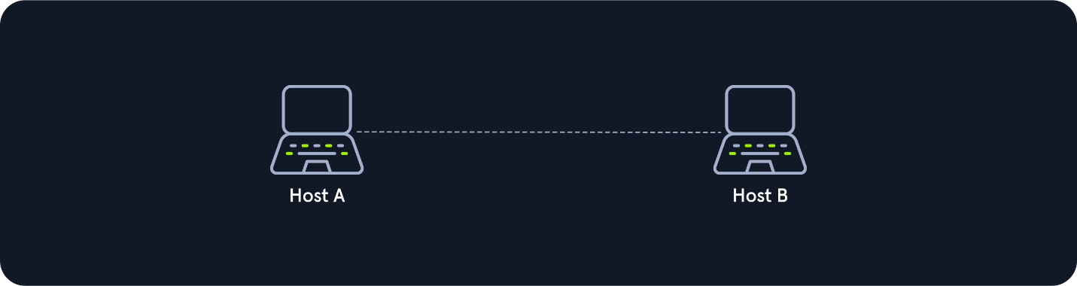
Bus
All hosts are connected via a transmission medium in the bus topology. Every host has access to the transmission medium and the signals that are transmitted over it. There is no central network component that controls the processes on it. The transmission medium for this can be, for example, a coaxial cable.
Since the medium is shared with all the others, only one host can send, and all the others can only receive and evaluate the data and see whether it is intended for itself.
Bus Topology
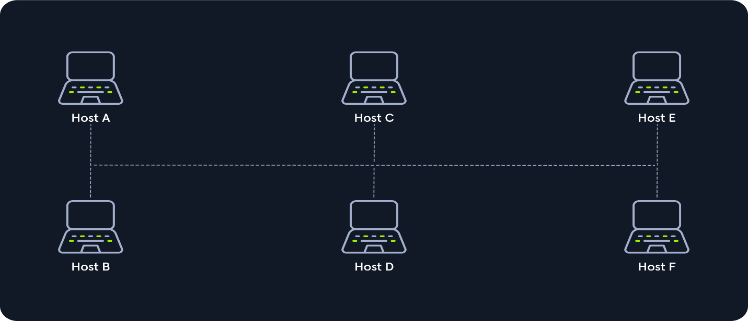
Star
The star topology is a network component that maintains a connection to all hosts. Each host is connected to the central network component via a separate link. This is usually a router, a hub, or a switch. These handle the forwarding function for the data packets. To do this, the data packets are received and forwarded to the destination. The data traffic on the central network component can be very high since all data and connections go through it.
Star Topology
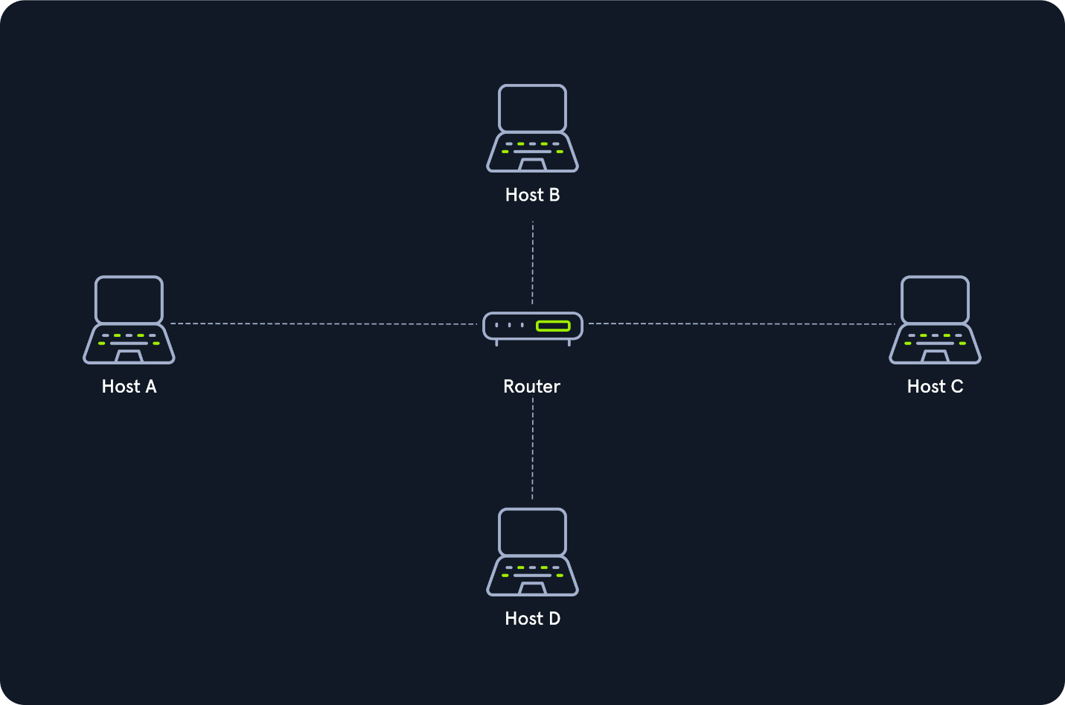
Ring
The physical ring topology is such that each host or node is connected to the ring with two cables:
- One for the incoming signals and
- the another for the outgoing ones.
This means that one cable arrives at each host and one cable leaves. The ring topology typically does not require an active network component. The control and access to the transmission medium are regulated by a protocol to which all stations adhere.
A logical ring topology is based on a physical star topology, where a distributor at the node simulates the ring by forwarding from one port to the next.
The information is transmitted in a predetermined transmission direction. Typically, the transmission medium is accessed sequentially from station to station using a retrieval system from the central station or a token. A token is a bit pattern that continually passes through a ring network in one direction, which works according to the claim token process.
Ring Topology
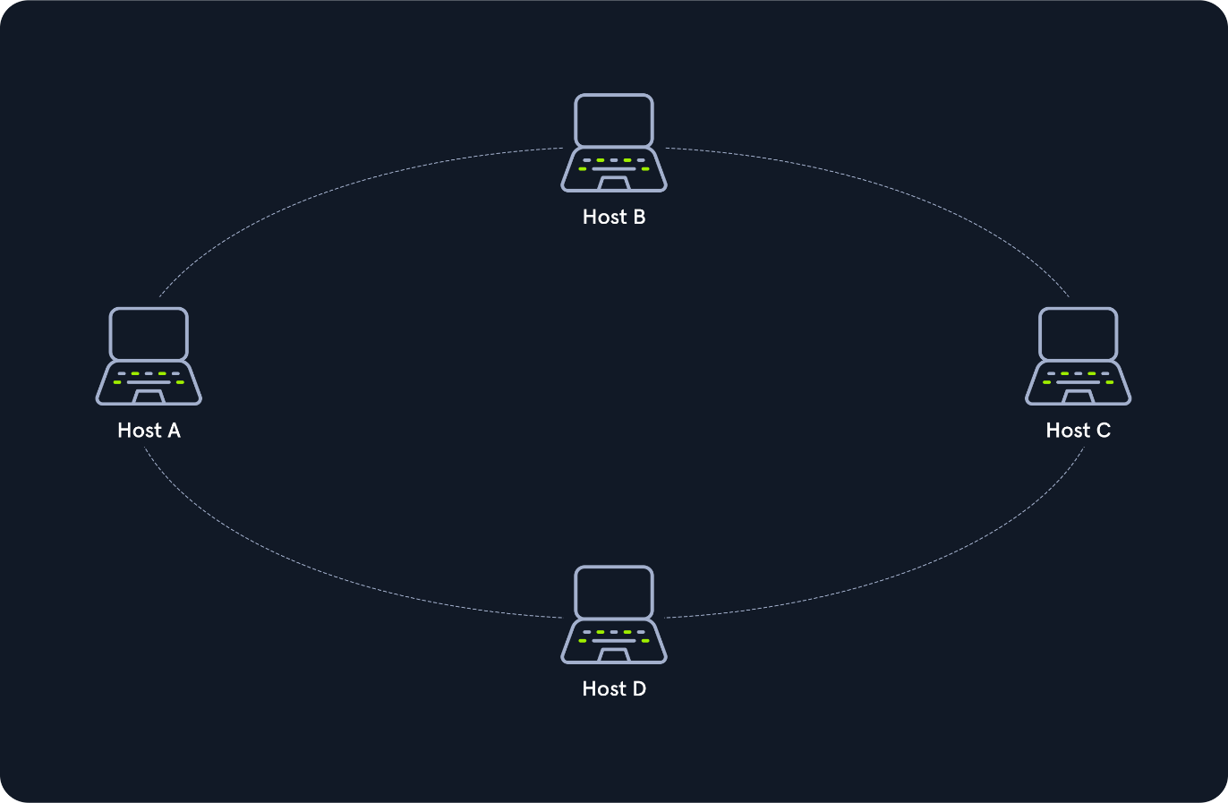
Mesh
Many nodes decide about the connections on a physical level and the routing on a logical level in meshed networks. Therefore, meshed structures have no fixed topology. There are two basic structures from the basic concept: the fully meshed and the partially meshed structure.
Each host is connected to every other host in the network in a fully meshed structure. This means that the hosts are meshed with each other. This technique is primarily used in WAN or MAN to ensure high reliability and bandwidth.
In this setup, important network nodes such as routers could be networked together. If one router fails, the others can continue to work without problems, and the network can absorb the failure due to the many connections.
Each node of a fully meshed topology has the same routing functions and knows the neighboring nodes it can communicate with proximity to the network gateway and traffic loads.
In the partially meshed structure, the endpoints are connected by only one connection. In this type of network topology, specific nodes are connected to exactly one other node, and some other nodes are connected to two or more other nodes with a point-to-point connection.
Mesh Topology
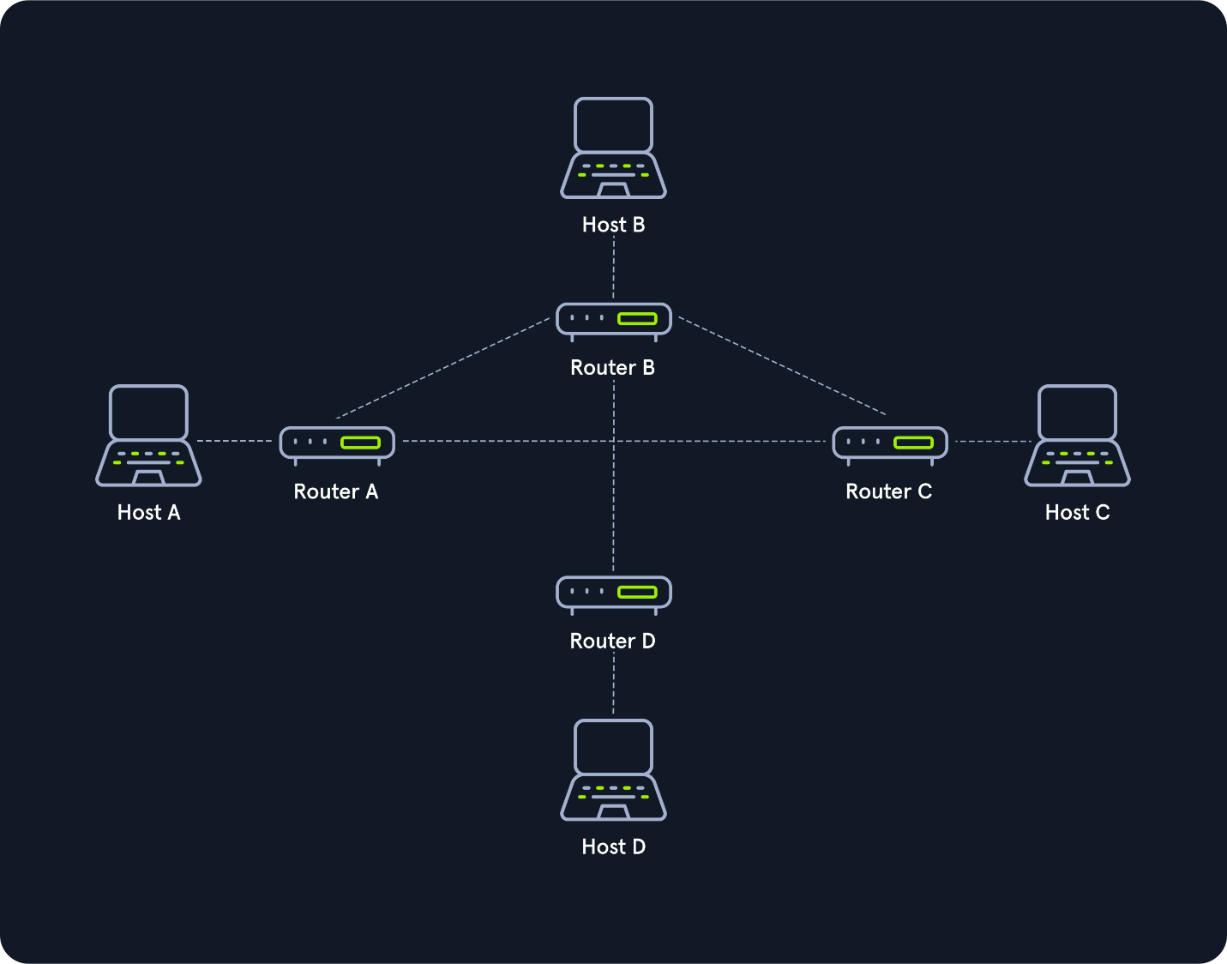
Tree
The tree topology is an extended star topology that more extensive local networks have in this structure. This is especially useful when several topologies are combined. This topology is often used, for example, in larger company buildings.
There are both logical tree structures according to the spanning tree and physical ones. Modular modern networks, based on structured cabling with a hub hierarchy, also have a tree structure. Tree topologies are also used for broadband networks and city networks (MAN).

Tree Topology
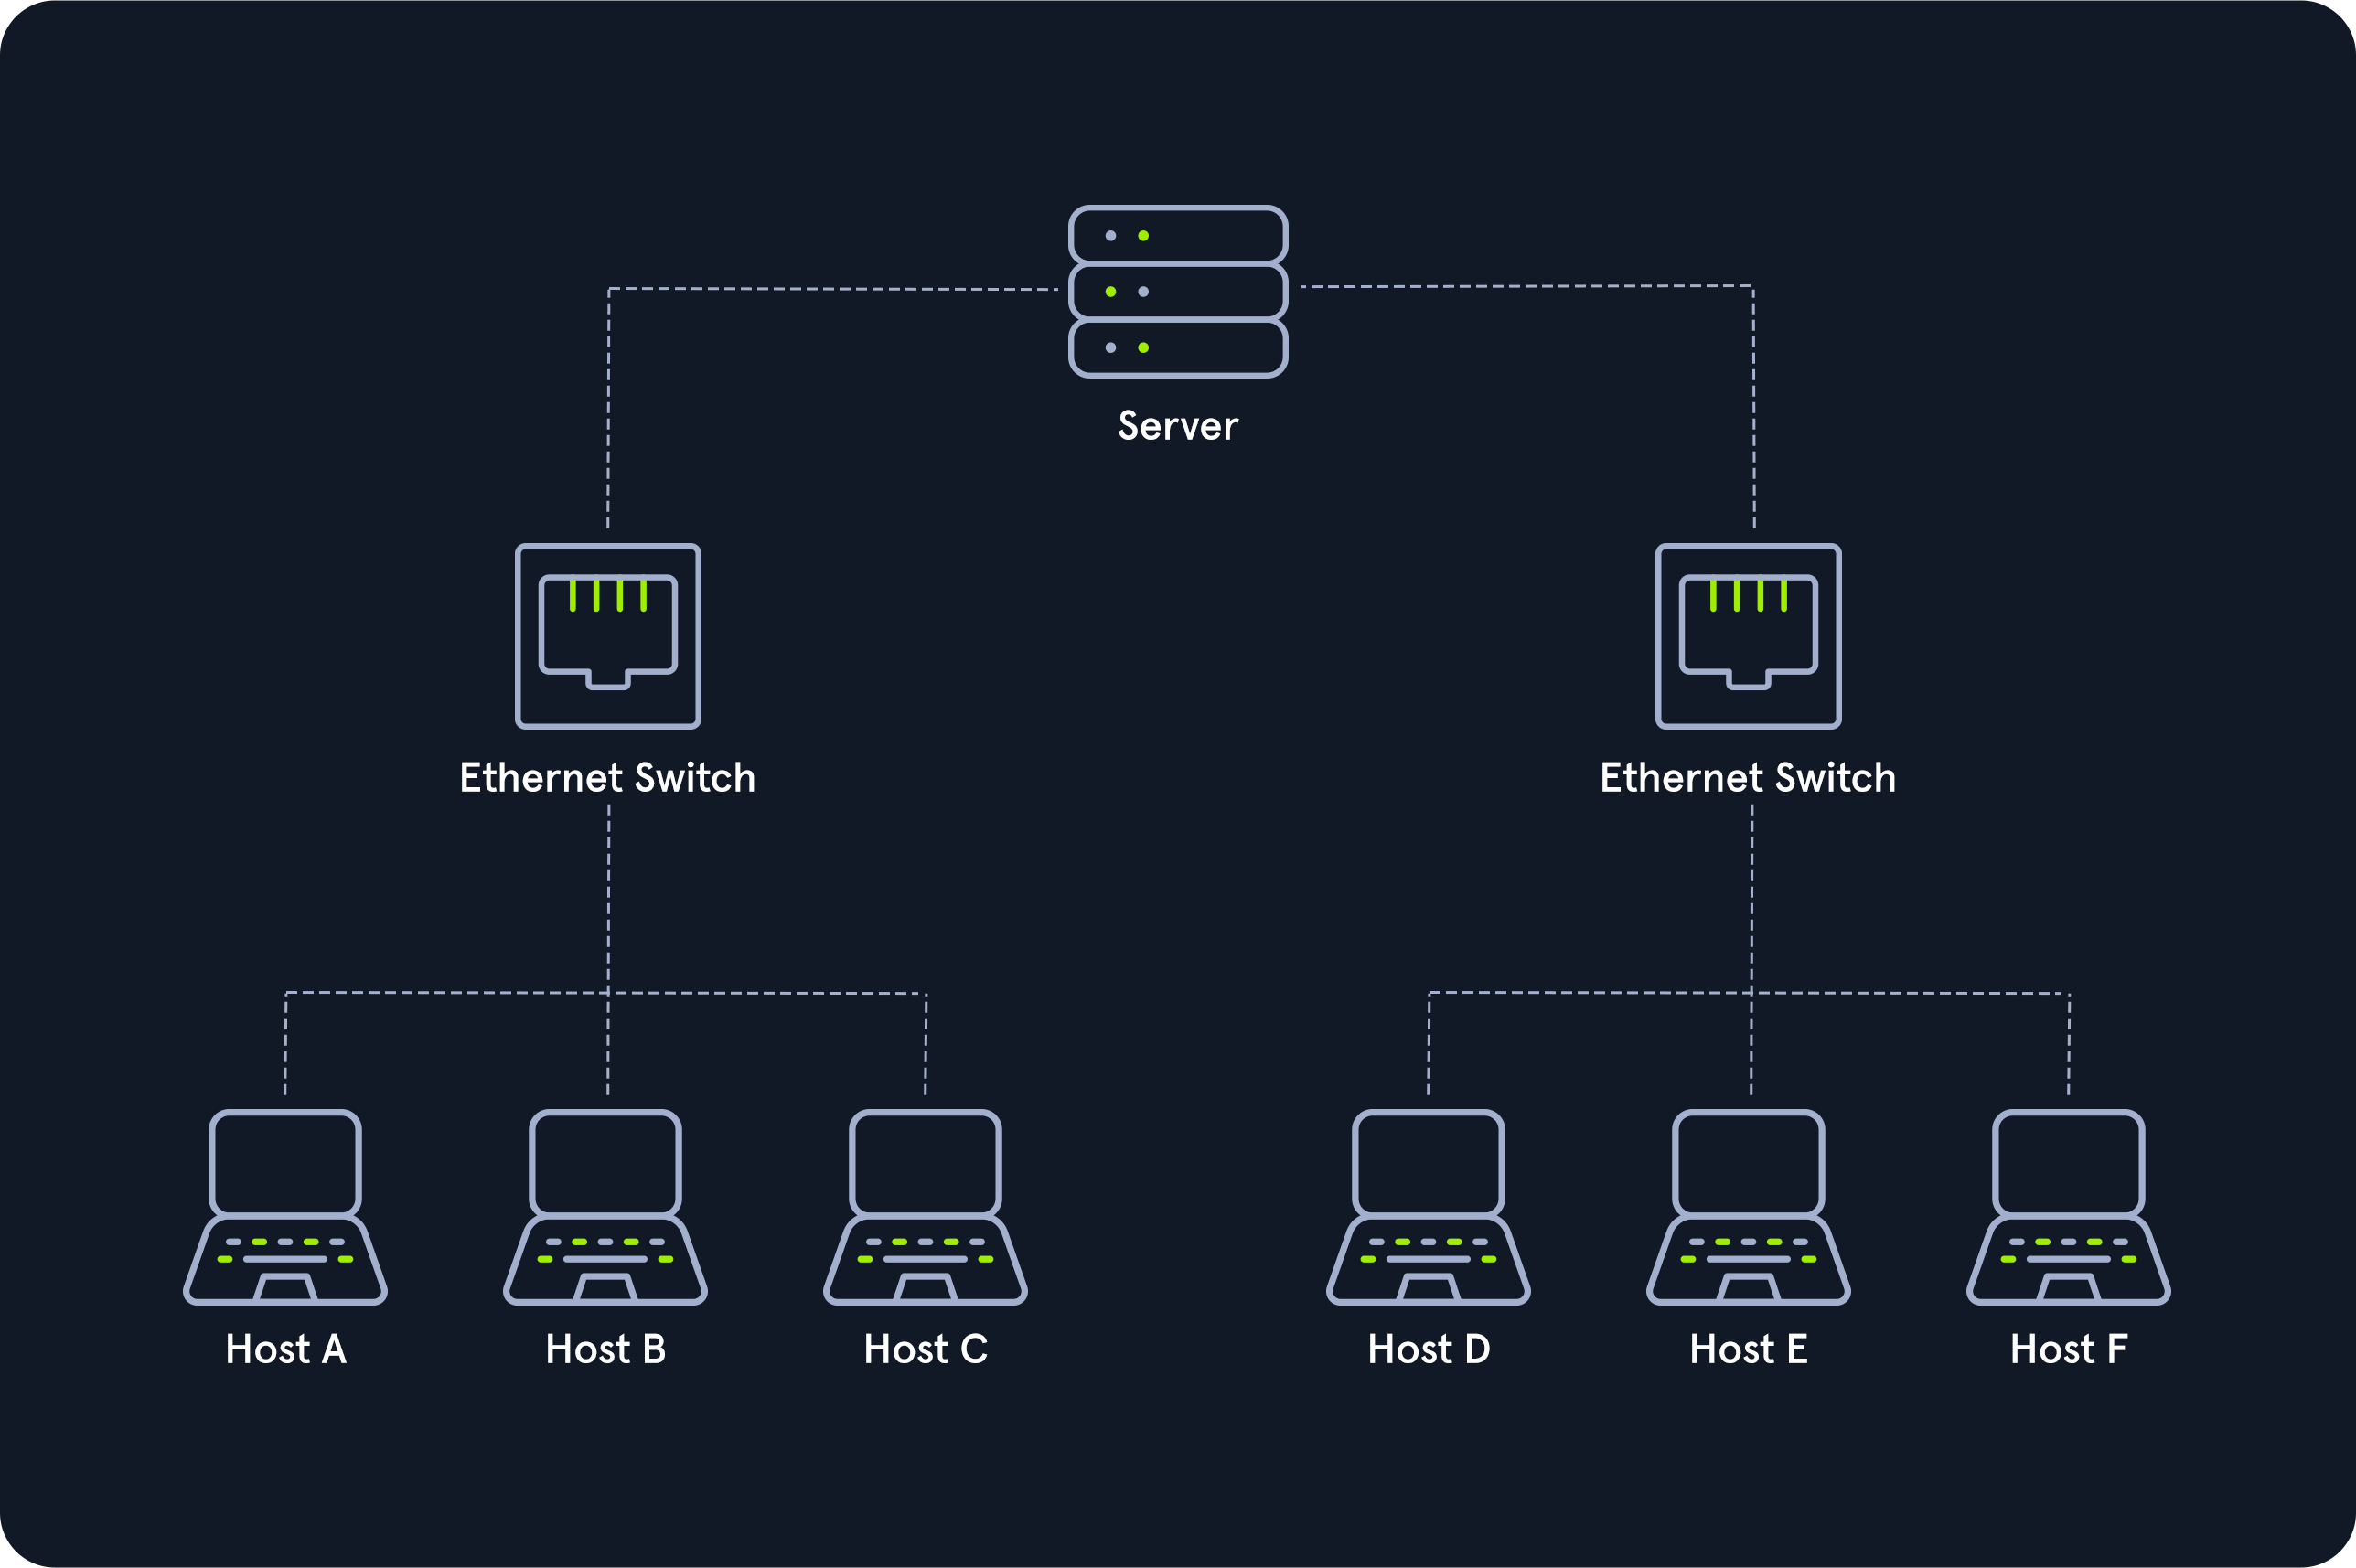
Hybrid
Hybrid networks combine two or more topologies so that the resulting network does not present any standard topologies. For example, a tree network can represent a hybrid topology in which star networks are connected via interconnected bus networks. However, a tree network that is linked to another tree network is still topologically a tree network. A hybrid topology is always created when two different basic network topologies are interconnected.

Hybrid Topology
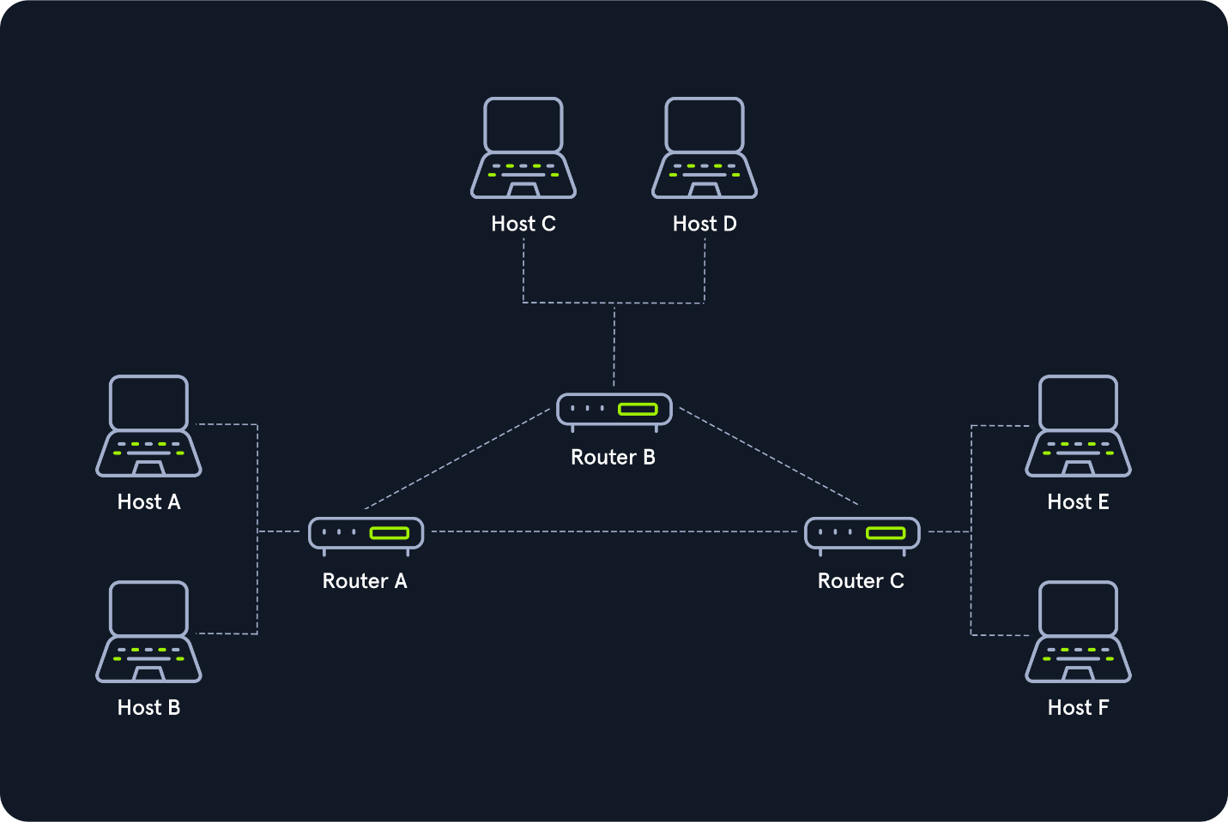
Daisy Chain
In the daisy chain topology, multiple hosts are connected by placing a cable from one node to another.
Since this creates a chain of connections, it is also known as a daisy-chain configuration in which multiple hardware components are connected in a series. This type of networking is often found in automation technology (CAN).
Daisy chaining is based on the physical arrangement of the nodes, in contrast to token procedures, which are structural but can be made independent of the physical layout. The signal is sent to and from a component via its previous nodes to the computer system.

Daisy Chain Topology
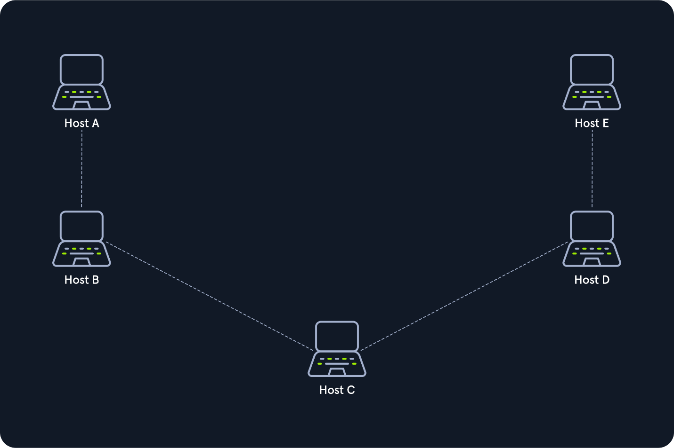

- Proxies

Many people have different opinions on what a proxy is:
- Security Professionals jump to HTTP Proxies (BurpSuite) or pivoting with a SOCKS/SSH Proxy (Chisel, ptunnel, sshuttle).
- Web Developers use proxies like Cloudflare or ModSecurity to block malicious traffic.
- Average people may think a proxy is used to obfuscate your location and access another country's Netflix catalog.
- Law Enforcement often attributes proxies to illegal activity.
Not all the above examples are correct. A proxy is when a device or service sits in the middle of a connection and acts as a mediator. The mediator is the critical piece of information because it means the device in the middle must be able to inspect the contents of the traffic. Without the ability to be a mediator, the device is technically a gateway, not a proxy.
Back to the above question, the average person has a mistaken idea of what a proxy is as they are most likely using a VPN to obfuscate their location, which technically is not a proxy. Most people think whenever an IP Address changes, it is a proxy, and in most cases, it's probably best not to correct them as it is a common and harmless misconception. Correcting them could lead to a more extended conversation that trails into tabs vs. spaces, emacs vs. vim, or finding out they are a nano user.
If you have trouble remembering this, proxies will almost always operate at Layer 7 of the OSI Model. There are many types of proxy services, but the key ones are:
- Dedicated Proxy / Forward Proxy
- Reverse Proxy
- Transparent Proxy

Dedicated Proxy / Forward Proxy
The Forward Proxy, is what most people imagine a proxy to be. A Forward Proxy is when a client makes a request to a computer, and that computer carries out the request.
For example, in a corporate network, sensitive computers may not have direct access to the Internet. To access a website, they must go through a proxy (or web filter). This can be an incredibly powerful line of defense against malware, as not only does it need to bypass the web filter (easy), but it would also need to be proxy aware or use a non-traditional C2 (a way for malware to receive tasking information). If the organization only utilizes FireFox, the likelihood of getting proxy-aware malware is improbable.
Web Browsers like Internet Explorer, Edge, or Chrome all obey the "System Proxy" settings by default. If the malware utilizes WinSock (Native Windows API), it will likely be proxy aware without any additional code. Firefox does not use WinSock and instead uses libcurl, which enables it to use the same code on any operating system. This means that the malware would need to look for Firefox and pull the proxy settings, which malware is highly unlikely to do.
Alternatively, malware could use DNS as a c2 mechanism, but if an organization is monitoring DNS (which is easily done using Sysmon ), this type of traffic should get caught quickly.
Another example of a Forward Proxy is Burp Suite, as most people utilize it to forward HTTP Requests. However, this application is the swiss army knife of HTTP Proxies and can be configured to be a reverse proxy or transparent!

Forward Proxy
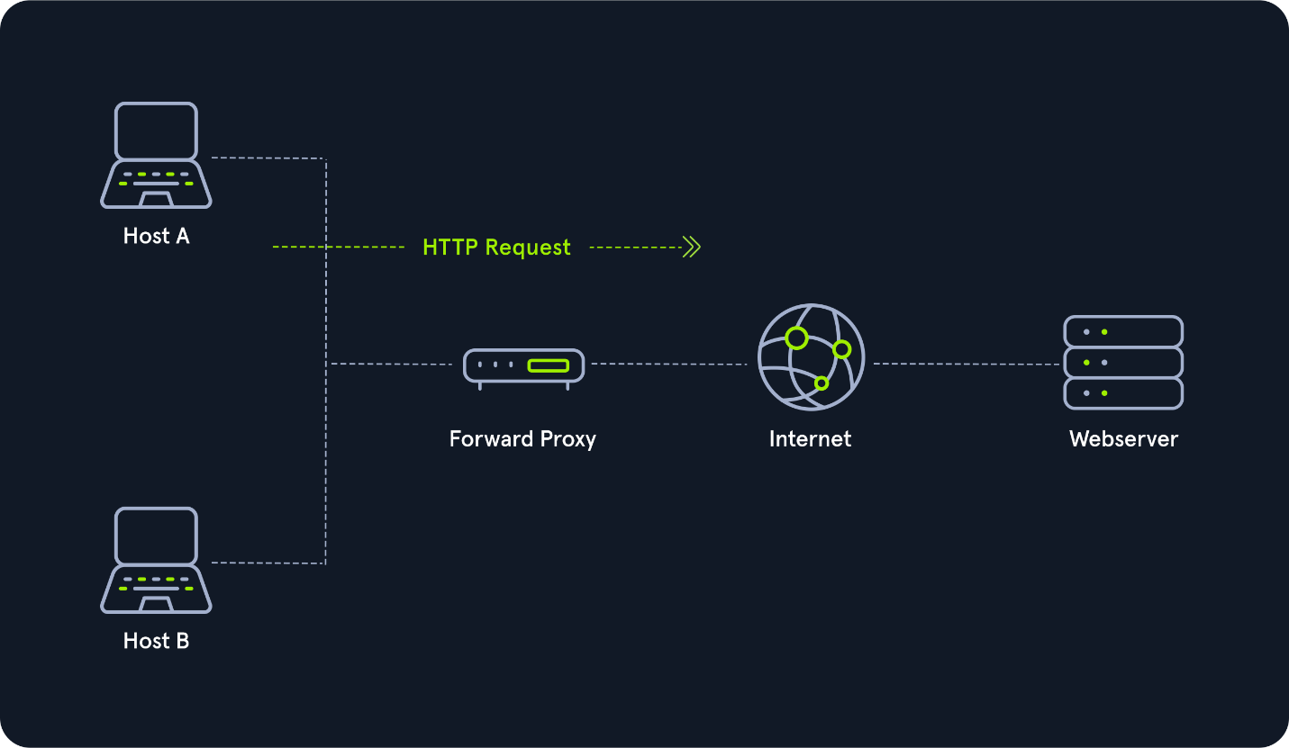

Reverse Proxy
As you may have guessed, a reverse proxy, is the reverse of a Forward Proxy. Instead of being designed to filter outgoing requests, it filters incoming ones. The most common goal with a Reverse Proxy, is to listen on an address and forward it to a closed-off network.
Many organizations use CloudFlare as they have a robust network that can withstand most DDOS Attacks. By using Cloudflare, organizations have a way to filter the amount (and type) of traffic that gets sent to their webservers.
Penetration Testers will configure reverse proxies on infected endpoints. The infected endpoint will listen on a port and send any client that connects to the port back to the attacker through the infected endpoint. This is useful to bypass firewalls or evade logging. Organizations may have IDS (Intrusion Detection Systems), watching external web requests. If the attacker gains access to the organization over SSH, a reverse proxy can send web requests through the SSH Tunnel and evade the IDS.
Another common Reverse Proxy is ModSecurity, a Web Application Firewall (WAF). Web Application Firewalls inspect web requests for malicious content and block the request if it is malicious. If you want to learn more about this, we recommend reading into the ModSecurity Core Rule Set, as its a great starting point. Cloudflare, also can act as a WAF but doing so requires letting them decrypt HTTPS Traffic, which some organizations may not want.

Reverse Proxy
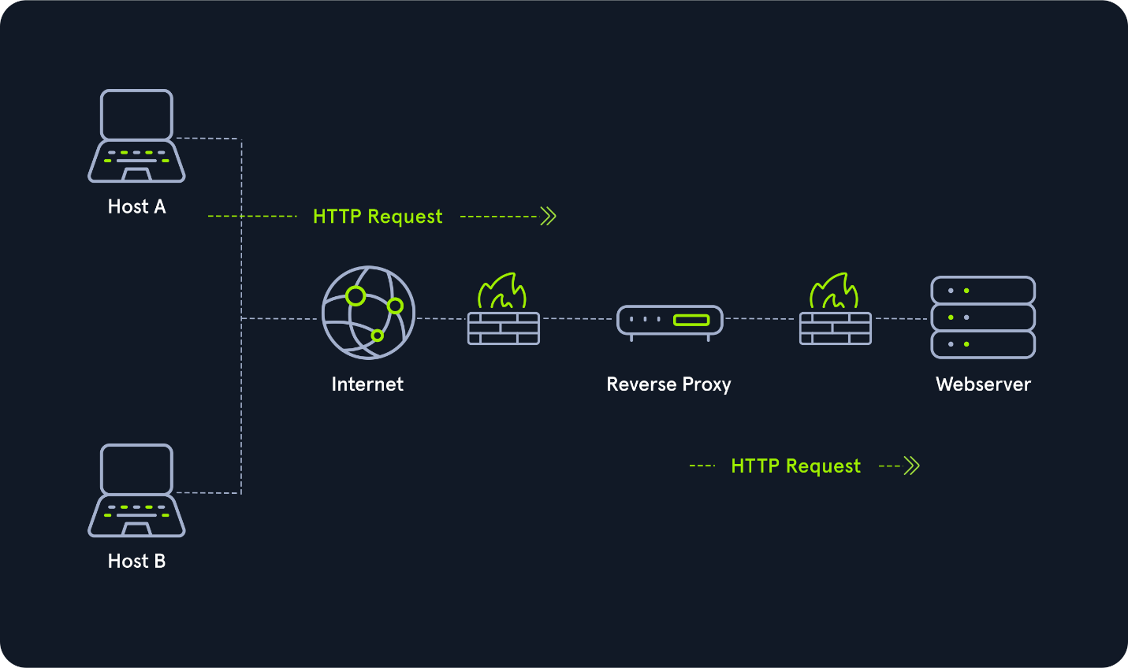
(Non-) Transparent Proxy
All these proxy services act either transparently or non-transparently.
With a transparent proxy, the client doesn't know about its existence. The transparent proxy intercepts the client's communication requests to the Internet and acts as a substitute instance. To the outside, the transparent proxy, like the non-transparent proxy, acts as a communication partner.
If it is a non-transparent proxy, we must be informed about its existence. For this purpose, we and the software we want to use are given a special proxy configuration that ensures that traffic to the Internet is first addressed to the proxy. If this configuration does not exist, we cannot communicate via the proxy. However, since the proxy usually provides the only communication path to other networks, communication to the Internet is generally cut off without a corresponding proxy configuration.

NOTE
In networking and penetration testing,
Pivoting means using one compromised system (a "foothold") inside a network as a launch point to reach other systems or networks that you normally couldn’t access directly.
Think of it like this:
- You hack into one machine that has access to an internal network.
- Instead of only exploring that single machine, you use it as a bridge/tunnel/proxy to "pivot" into deeper parts of the target environment.

Example:
- You compromise a web server that has only external internet access and a private connection to an internal database server.
- From your attacking machine outside, you cannot reach the database server directly.
- But by pivoting through the web server, you can route your traffic through it to access the database.

Types of pivoting:
- Port forwarding / tunneling – redirecting traffic through the compromised host (e.g., SSH tunnels, meterpreter portfwd).
- Proxying – making the compromised host act like a proxy for network traffic (e.g., SOCKS proxy via proxychains).
- VPN-style pivoting – fully routing your traffic through the target host as if you were "inside" the private network.
👉 In short:
Pivoting is about expanding access deeper into a network by leveraging already-compromised systems as gateways.

🔹 In General English
Compromised usually means:
- Weakened, damaged, or exposed in a way that reduces effectiveness or safety.
Examples:
- “The security of the building was compromised when the lock broke.”
- “His integrity was compromised by accepting the bribe.”
So in general, it means something that was secure or intact is no longer fully trustworthy.

🔹 In Networking / Cybersecurity
In the context of networking, compromised means:
- A system, account, or network device has been successfully attacked or taken over by an unauthorized party.
- The attacker now has some level of control, access, or influence over it.

Examples in networking:
- Compromised system/host
  - A computer that’s been hacked with malware, giving the attacker remote access.
  - Used as a pivot point to attack other machines.
- Compromised credentials
  - A username and password that’s been stolen or leaked, allowing attackers to log in as the victim.
- Compromised network
  - When an attacker breaches internal defenses (like a firewall) and can move laterally inside.

👉 So, when we say in pentesting:
- “Use the compromised host as a pivot” → it means “use the machine you already hacked into (that you control without authorization) as a stepping stone to reach other internal resources.”

