Telnet is an early network protocol and command-line utility used to establish a virtual terminal session with a remote computer over a TCP/IP network, allowing users to interact with the remote system's command line. While historically used for accessing remote servers, its lack of encryption makes it insecure for transmitting sensitive data and has led to its replacement by more secure protocols like SSH. However, Telnet remains useful for testing network connectivity to specific TCP ports and for managing certain legacy network devices.
“Great things are not done by impulse, but by a series of small things brought together.” Vincent Van Gogh

How Telnet Works
- 1. Client-Server Model:
A Telnet client initiates a connection to a Telnet server on a remote computer.
- 2. TCP/IP:
The connection is established over the Transmission Control Protocol/Internet Protocol (TCP/IP), typically on TCP port 23.
- 3. Virtual Terminal:
Once connected, the client and server establish a virtual terminal, enabling the client to send commands to the remote system and receive text-based output.
- 4. Plaintext Transmission:
All data, including usernames and passwords, is sent unencrypted over the network.
Uses of Telnet
- Remote Access:
Accessing the command-line interface (CLI) of remote devices like servers, routers, and network switches.
- Network Diagnostics:
Testing if a specific port on a remote server is open and listening for connections, or checking basic TCP/IP connectivity.
- IoT Device Access:
Connecting to and managing Internet of Things (IoT) devices, especially for initial setup or in situations where security is not a primary concern.
Why Telnet is Insecure
- Lack of Encryption: The most significant drawback of Telnet is that it transmits all data, including login credentials, in clear text, making it susceptible to snooping and man-in-the-middle attacks.
Modern Alternative
- SSH (Secure Shell): For secure remote access and management, SSH is the preferred protocol. SSH encrypts all communication between the client and server, providing a much more secure alternative to Telnet.

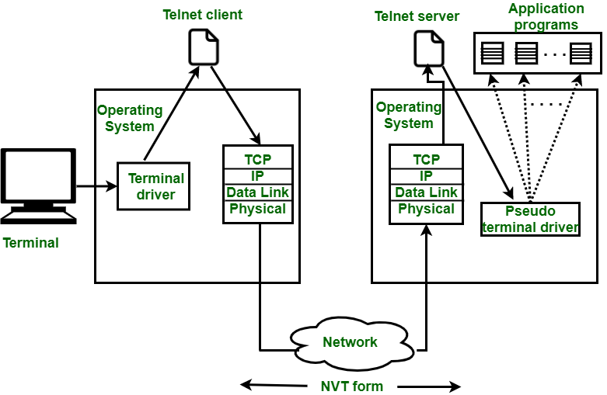2. The File Transfer Protocol (FTP) is a standard communication protocol used for the transfer of computer files from a server to a client on a computer network. FTP is built on a client–server model architecture using separate control and data connections between the client and the server.^{[1]} FTP users may authenticate themselves with a plain-text sign-in protocol, normally in the form of a username and password, but can connect anonymously if the server is configured to allow it. For secure transmission that protects the username and password, and encrypts the content, FTP is often secured with SSL/TLS (FTPS) or replaced with SSH File Transfer Protocol (SFTP).
The first FTP client applications were command-line programs developed before operating systems had graphical user interfaces, and are still shipped with most Windows, Unix, and Linux operating systems.^{[2][3]} Many dedicated FTP clients and automation utilities have since been developed for desktops, servers, mobile devices, and hardware, and FTP has been incorporated into productivity applications such as HTML editors and file managers.
An FTP client used to be commonly integrated in web browsers, where file servers are browsed with the URI prefix "ftp:// ". In 2021, FTP support was dropped by Google Chrome and Firefox,^{[4][5]} two major web browser vendors, due to it being superseded by the more secure SFTP and FTPS; although neither of them have implemented the newer protocols.^{[6][7]}

What is OpenVPN?
OpenVPN is an open-source software that creates a secure virtual private network (VPN) between your computer and another network over the Internet.
- It encrypts all traffic between your device and the VPN server.
- It allows you to access private networks securely, like HackTheBox labs.
In simple words:
OpenVPN acts like a secure “tunnel” from your computer to another network.

🔑 Why it’s used on HTB
HTB labs are on a private network. Your computer is on your local internet, but the HTB machines are not directly accessible.
- You connect via OpenVPN to the HTB network.
- Once connected, your machine can ping, scan, and exploit the lab machines safely.
- All traffic is encrypted, so it’s secure even on public Wi-Fi.

⚡ Basic OpenVPN workflow on HTB
- Download your .ovpn file from HTB (it’s your personal VPN configuration).
- Install OpenVPN on your system if not already installed:
Port | Service | Description
20, 21 | FTP (File Transfer Protocol) | Transfer files between computers.
22 | SSH (Secure Shell) | Secure remote login and commands.
23 | Telnet | Old (insecure) remote login service.
25 | SMTP (Simple Mail Transfer Protocol) | Sending email.
53 | DNS (Domain Name System) | Resolves domain names → IP addresses.
67, 68 | DHCP (Dynamic Host Configuration Protocol) | Automatically gives IP addresses to devices.
80 | HTTP (HyperText Transfer Protocol) | Websites (not encrypted).
110 | POP3 (Post Office Protocol v3) | Receiving email (download to client).
123 | NTP (Network Time Protocol) | Clock synchronization.
143 | IMAP (Internet Message Access Protocol) | Reading email on a server.
161, 162 | SNMP (Simple Network Management Protocol) | Network monitoring/management.
389 | LDAP (Lightweight Directory Access Protocol) | Directory services (e.g., Active Directory).
443 | HTTPS (Secure HTTP) | Encrypted websites.
445 | SMB (Server Message Block) | File/printer sharing (Windows networks).
514 | Syslog | System logging messages.
993 | IMAPS | Secure IMAP (email).
995 | POP3S | Secure POP3 (email).
1433 | Microsoft SQL Server | Database service.
1521 | Oracle DB | Oracle database service.
3306 | MySQL | Popular database service.
3389 | RDP (Remote Desktop Protocol) | Remote desktop for Windows.
5432 | PostgreSQL | Database service.
5900 | VNC | Remote desktop (cross-platform).
8080 | HTTP (alternative) | Often used for proxy servers / test web servers.
That number is the CIDR subnet mask — it tells you how big your network is.

🔍 What /20 means
- /24 = 255.255.255.0 → 256 IPs (most home networks)
- /20 = 255.255.240.0 → 4096 IPs 😮 (a much larger range)
So your network is 172.29.. from 172.29.0.0 → 172.29.15.255.
Your host IP falls somewhere inside that range, e.g. 172.29.123.45/20.

✅ How to scan it
If you want to scan your local subnet with nmap:
sudo nmap -sn 172.29.0.0/20
- -sn → ping scan (just shows live hosts).
- /20 → tells nmap to scan the whole subnet.
⚠️ Warning: /20 is large (over 4000 IPs). It’ll take longer. If you only want to see nearby hosts, you could scan a smaller chunk, e.g.:
sudo nmap -sn 172.29.0.0/24
(This checks just 256 addresses inside the bigger network.)

👉 So to answer your doubt:
Your network just happens to use /20 instead of /24. Nothing wrong — it just means more possible devices on that subnet.

