**[05] 고급위젯**

1. 웹뷰 : 사용자가 웹브라우저 기능을 앱 안에 직접 포함할 수 있는 위젯

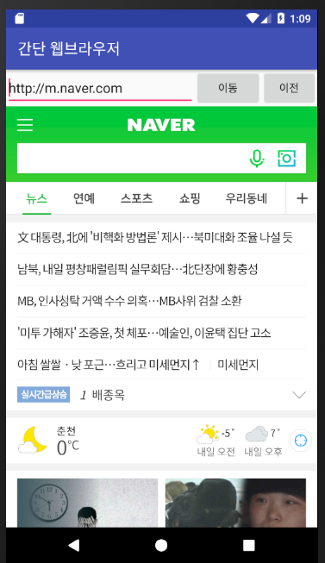

**Androidmanifest.xml**

*<?***xml version="1.0" encoding="utf-8"***?>*

*<!-- 패키지 이름 -->*

<**manifest xmlns:android="http://schemas.android.com/apk/res/android"  
 package="com.tj.ch05_webview"**>

*<!--앱에 대한 정보 -->*

*<!--이 프로젝트가 인터넷 사용을 허용한다는 의미-->*

<**uses-permission android:name="android.permission.INTERNET"**/>  
 <**application  
 android:allowBackup="true"  
 android:icon="@mipmap/ic_launcher"  
 android:label="간단한 웹브라우저"  
 android:roundIcon="@mipmap/ic_launcher_round"  
 android:supportsRtl="true"  
 android:theme="@style/AppTheme"**

*<!-- http 등의 일반 텍스트 트래픽의 사용 -->* **android:usesCleartextTraffic="true"**>  
 <**activity android:name=".MainActivity"**>  
 <**intent-filter**>  
 <**action android:name="android.intent.action.MAIN"** />  
  
 <**category android:name="android.intent.category.LAUNCHER"** />  
 </**intent-filter**>  
 </**activity**>  
 </**application**>  
</**manifest**>

**activity_main.xml**

*<?***xml version="1.0" encoding="utf-8"***?>*<**LinearLayout xmlns:android="http://schemas.android.com/apk/res/android"  
 android:layout_width="match_parent"  
 android:layout_height="match_parent"  
 android:orientation="vertical"**>  
 <**LinearLayout  
 android:layout_width="match_parent"  
 android:layout_height="wrap_content"  
 android:orientation="horizontal"**>  
 <**EditText  
 android:id="@+id/editUrl"  
 android:layout_width="250dp"  
 android:layout_height="wrap_content"  
 android:text="http://m.naver.com"**/>  
 <**Button  
 android:id="@+id/btnGo"  
 android:layout_width="wrap_content"  
 android:layout_height="wrap_content"  
 android:text="이동"**/>  
 <**Button  
 android:id="@+id/btnBack"  
 android:layout_width="wrap_content"  
 android:layout_height="wrap_content"  
 android:text="이전"**/>  
 </**LinearLayout**>  
 <**WebView  
 android:id="@+id/webView"  
 android:layout_width="match_parent"  
 android:layout_height="match_parent"**/>  
</**LinearLayout**>

**MainActivity.java**

**public class** MainActivity **extends** AppCompatActivity {  
 **private** EditText **editUrl**;  
 **private** Button **btnGo**, **btnBack**;  
 **private** WebView **webView**;  
 @Override  
 **protected void** onCreate(Bundle savedInstanceState) {  
 **super**.onCreate(savedInstanceState);  
 setContentView(R.layout.***activity_main***);  
 **editUrl** = findViewById(R.id.***editUrl***);  
 **btnGo** = findViewById(R.id.***btnGo***);  
 **btnBack** = findViewById(R.id.***btnBack***);  
 **webView** = findViewById(R.id.***webView***);  
 **webView**.setWebViewClient(**new** WebViewClient());  
 **webView**.getSettings().setBuiltInZoomControls(**true**);  
 **webView**.getSettings().setJavaScriptEnabled(**true**);  
 **webView**.setWebChromeClient(**new** WebChromeClient());  
 **webView**.loadUrl(**"http://192.168.219.100:8181"**);  
 **editUrl**.setOnKeyListener(**new** View.OnKeyListener() {  
 @Override  
 **public boolean** onKey(View v, **int** keyCode, KeyEvent event) {  
 String temp = **editUrl**.getText().toString();  
 **if**(keyCode==KeyEvent.***KEYCODE_ENTER***){  
 System.***out***.println(**"엔터 눌렀네"**);  
 **goclickListener**.onClick(**btnGo**);  
 }  
 **return false**;  
 }  
 });  
 **btnGo**.setOnClickListener(**goclickListener**);  
 **btnBack**.setOnClickListener(**new** View.OnClickListener() {  
 @Override  
 **public void** onClick(View v) {  
 **webView**.goBack();  
 }  
 });  
 }  
 **private** View.OnClickListener **goclickListener** = **new** View.OnClickListener() {  
 @Override  
 **public void** onClick(View v) {  
 System.***out***.println(**"간다"**);  
 **webView**.loadUrl(**editUrl**.getText().toString());  
 }  
 };  
}

**class** CookWebViewClient **extends** WebViewClient{  
 @Override  
 **public boolean** shouldOverrideUrlLoading(WebView view, String url) {  
 **return super**.shouldOverrideUrlLoading(view, url);  
 }  
}