**[ 8 ] 세션 숙제**

1. 제출할 파일 : css폴더와 member폴더를 압축하여 제출바랍니다
   * css/footer.css와 css/join.css와 css/login.css
   * member/footer.jsp
   * member/header.jsp
   * member/join.jsp
   * member/joinPro.jsp (회원가입이 성공시 id를 세션에 setAttribute()함)
   * member/login.jsp
   * member/loginPro.jsp(로그인 성공시 id와 name을 세션에 setAttribute()하고 main.jsp로 감. 로그인 실패시 login.jsp로 가서 “아이디/비밀번호를 잊으셨나요”메시지 나타남.
   * member/logout.jsp(세션에 removeAttribute()를 하거나 invalidate()한 후 로그인 성공 메시지 뿌리고 main.jsp로 감
   * member/main.jsp

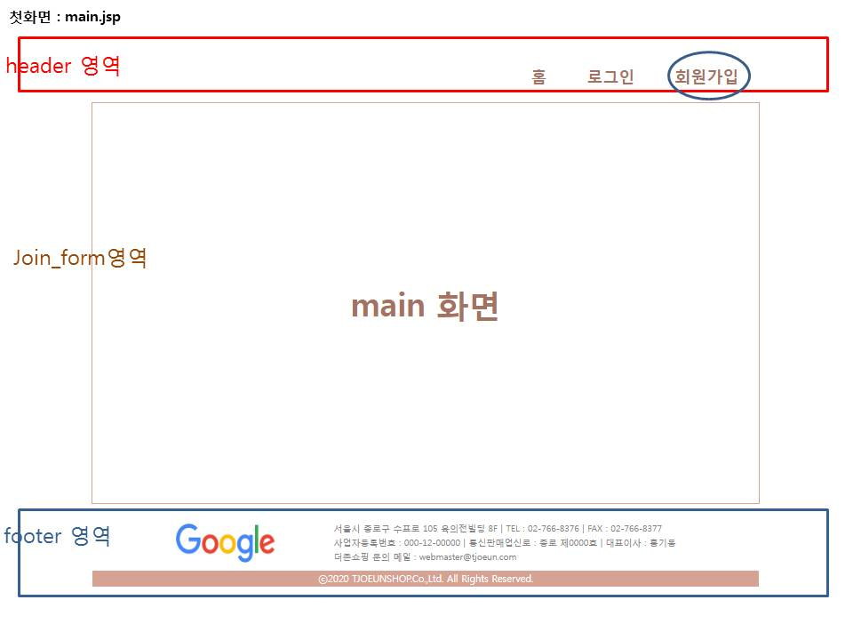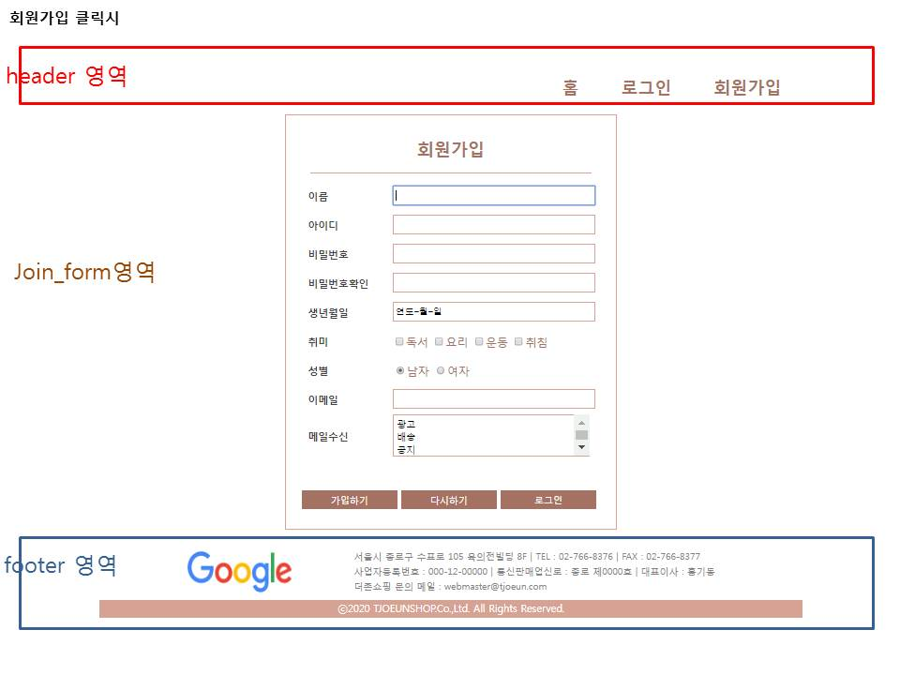

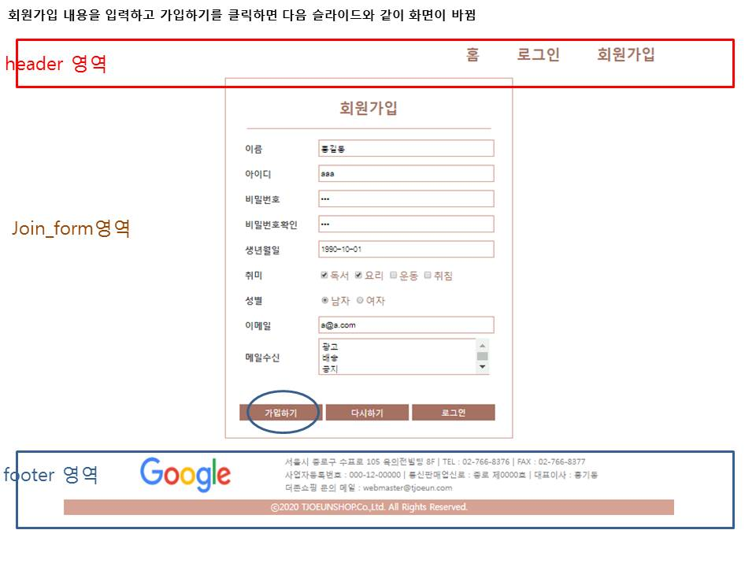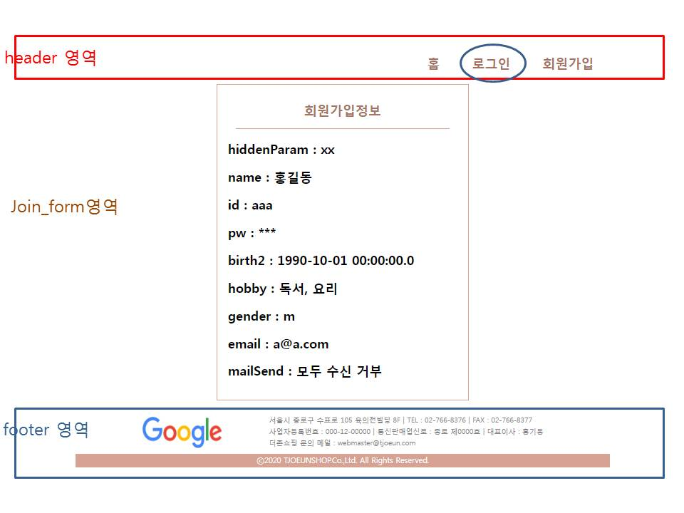

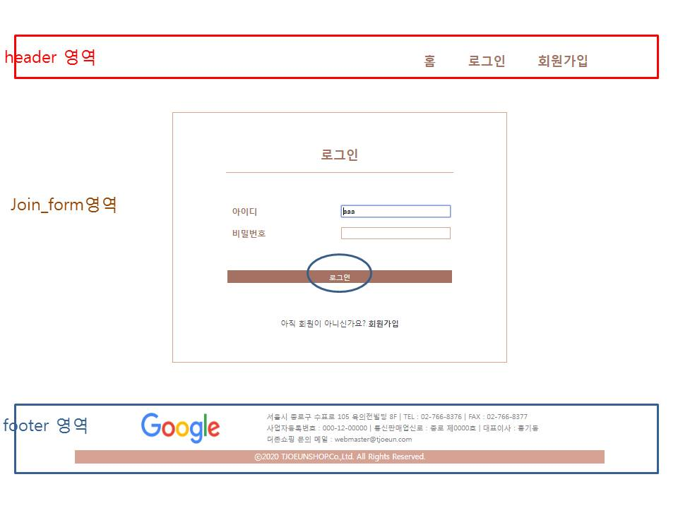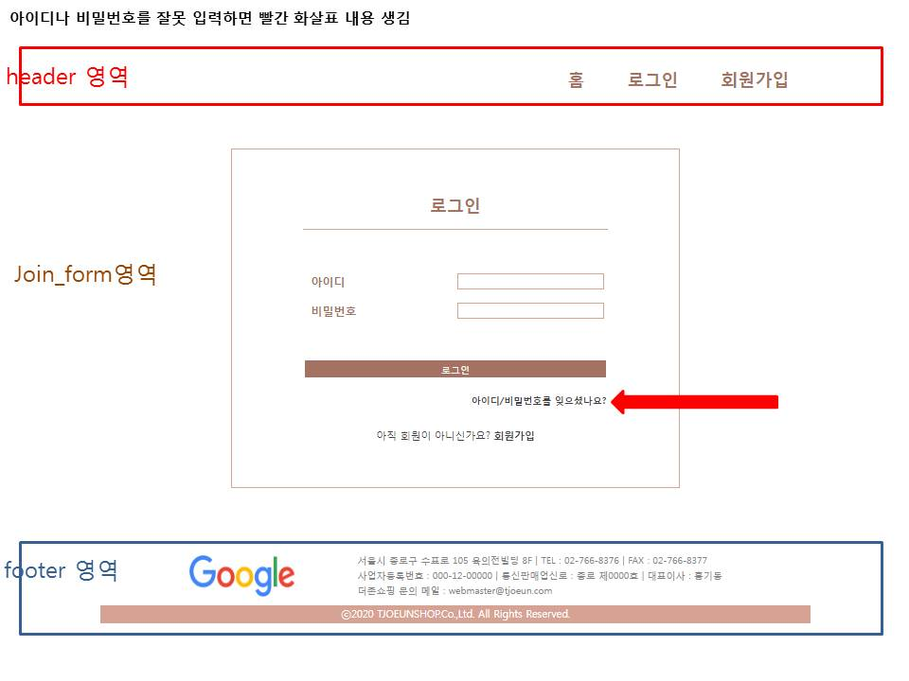

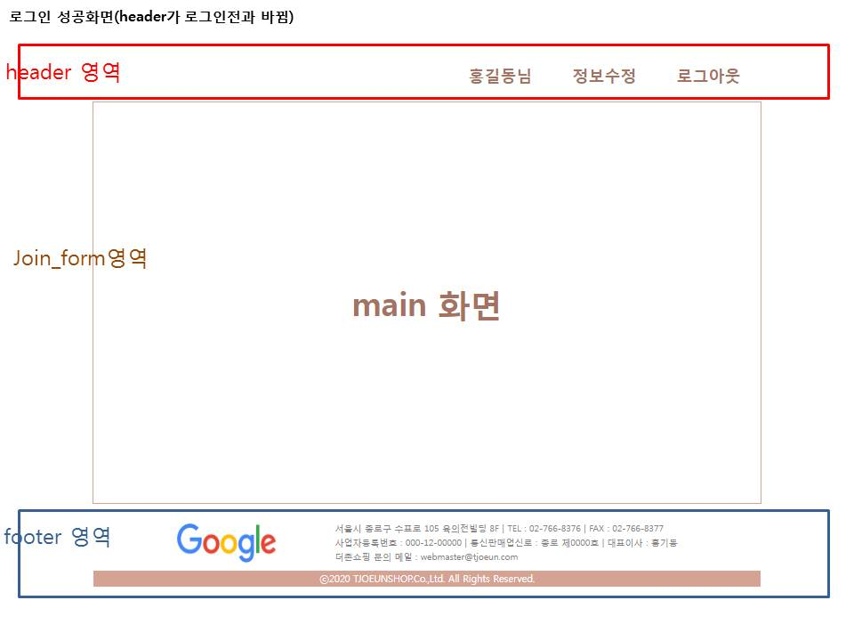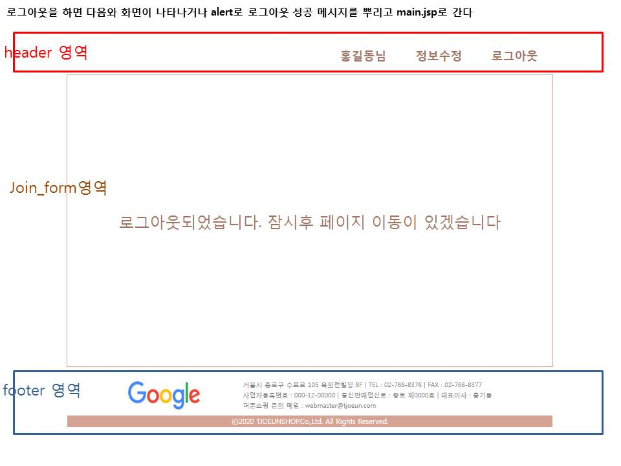

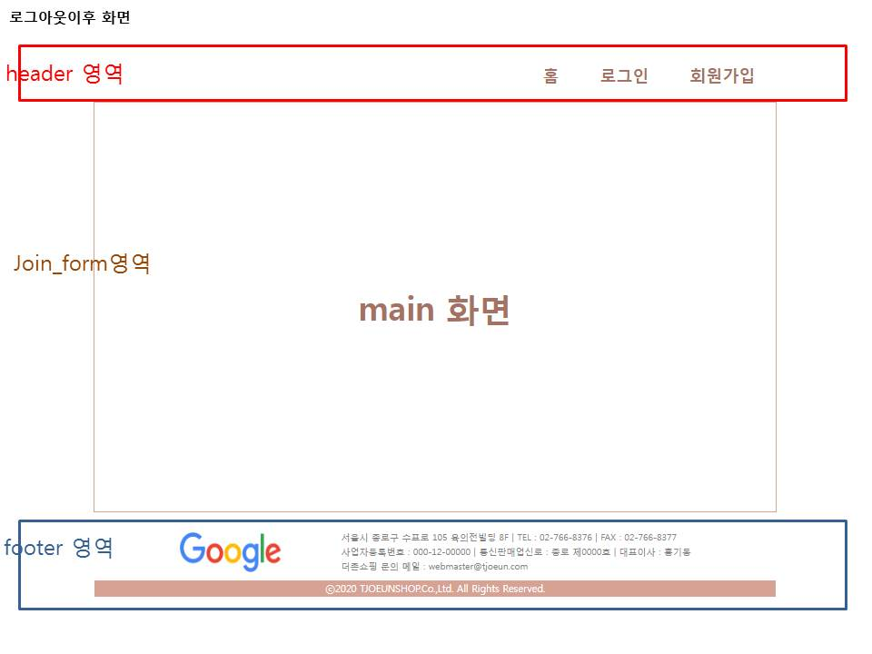

1. 소스

**css/footer.css**

@charset *"UTF-8"*;

@charset *"UTF-8"*;

**footer** {overflow:*hidden*;width: *1000px*;margin: *0* *auto*;}

**footer** **div** { float:*left*; height: *90px*;}

**footer** **div***.office_logo* {width: *300px*;text-align: *center*;}

**footer** **div***.office_logo* **img** {

margin-left:*100px*;

width:*150px*;

height: *60px*;

padding:*20px*;

}

**footer** **div***.office_address*{ width:*700px*;}

**footer** **div***.office_address* **ul**{ margin: *15px* *20px* *20px* *20px*;}

**footer** **div***.office_address* **ul** **li**{

padding:*2px*;

color:*gray*;

font-size: *0.8em*;

list-style: *none*;

}

**footer** **div***.copyright*{

clear: *both*;

border: *0*;

width: *1000px*;

height: *25px*;

margin: *0* *auto*;

background-color: *#D4A190*;

color: *white*;

text-align: *center*;

line-height: *25px*;

font-size: *0.9em*;

}

**css/join.css**

@charset *"UTF-8"*;

*#joinForm_wrap* {width:*430px*; margin: *10px* *auto*; border: *1px* *solid* *#D4A190*; padding:*20px*;}

*#join_title*{

width:*400px*; margin:*10px* *auto*;

padding-bottom:*20px*; border-bottom:*1px* *solid* *#D4A190*;

color:*#A47160*; font-size:*1.5em*;

text-align:*center*; font-weight:*bold*;

}

*#joinForm_wrap* **table**{margin:*0* *auto*; color:*#A47160*;}

*#joinForm_wrap* **table** **tr**{height:*40px*; }

*#joinForm_wrap* **table** **th**{

width:*120px*; font-size:*0.9em*;

color:*#3F3F48*; text-align:*left*; padding-left:*10px*;

}

*#joinForm_wrap* **table** **td** {width: *300px*;}

*.name***,** *.id***,** *.pw***,** *.pwChk***,** *.birth***,** *.email***,** *.mailSend* {

border: *1px* *solid* *#D4A190*; height:*20px*; width:*95%*; padding:*3px*;

}

*.mailSend* {height: *60px*;}

*.joinBtn_style* {

color: *#ffffff*; background: *#A47160*;

border:*0*; outline: *none*;

width:*32%*; padding:*5px* *0*;

}

css/login.css

@charset *"UTF-8"*;

*#loginForm_wrap* {

width:*430px*;

margin: ***75****px* *auto*;

border : *1px* *solid* *#D4A190*;

padding:*50px* *100px*;

}

*#login_title*{

text-align: *center*;

margin:*10px* *auto*;

padding-bottom: *20px*;

border-bottom: *1px* *solid* *#D4A190*;

color:*#A47160*;

font-size: *1.5em*;

font-weight: *bold*;

}

*#loginForm_wrap* **table** {margin: *0* *auto*;}

*#loginForm_wrap* **table** **tr**{height: *40px*;}

*#loginForm_wrap* **table** **th**{

width: *120px*;

color: *#A47160*;

text-align: *left*;

padding-left: *10px*;

}

*#loginForm_wrap* **table** **td** {

width:*300px*;

}

*#id***,** *#pw* { border: *1px* *solid* *#D4A190*; width: *95%*; padding: *3px*;}

*#loginForm_wrap* **table** **tr** *#login_findIdPw*{

height: *20px*;

text-align: *right*;

font-size: *0.8em*;

font-weight: *bold*;

color:*#3F3F48*;

}

*#loginForm_wrap* **table** **tr** *#login_findIdPw:hover*{ cursor:*pointer*;}

*#loginForm_wrap* *#login_join*{

text-align: *center*;

color:*#3F3F48*;

font-size: *.9em*;

}

*#loginForm_wrap* *#login_join* **a** {

text-decoration: *none*;

color:*#3F3F48*;

font-weight: *bold*;

}

*.loginBtn_style*{

color:*#ffffff*;

background-color: *#A47160*;

border-style: *none*; outline:*none*;

width: *100%*; height: *120%*; padding:*3px*;

}

**member/main.jsp**

<%@ page language=*"java"* contentType=*"text/html; charset=UTF-8"*

pageEncoding=*"UTF-8"*%>

<!DOCTYPE html>

<html>

<head>

<meta charset=*"UTF-8"*>

<title>Insert title here</title>

<style>

*#mainForm_wrap*{

width:*1000px*; margin: *10px auto*; height: *600px*;

border: *1px solid #D4A190*;

line-height: *600px*;

text-align: *center*;

font-size: *2em*; color: *#A47160*;

}

</style>

</head>

<body>

<jsp:include page=”header.jsp”/>

<div id=*"mainForm_wrap"*>

main 화면

</div>

<%@include file=*"footer.jsp"* %>

</body>

</html>