REGRESSION ANALYSIS PROJECT
Predicting Student Academic Performance

A Complete Multiple Regression Analysis
Including EDA · OLS · Ridge · Lasso · Diagnostics · VIF · Cook's Distance

Course: Regression Analysis
Dataset: Student Performance & Behavior (Kaggle)
Submitted: June 2026

Toqa Hamdy Gouda - 202530081

1. Abstract
This study presents a comprehensive regression analysis to predict student academic performance using behavioral and demographic features. The dataset consists of 500 student records with 8 independent variables: hours studied, attendance rate, sleep hours, previous academic scores, tutoring support, parental involvement, extracurricular activities, and motivation level. Three regression models were evaluated — Ordinary Least Squares (OLS), Ridge Regression, and Lasso Regression. The OLS model achieved a Test R² of 0.9677 and RMSE of 3.48 points, indicating exceptional predictive accuracy. All assumptions of classical linear regression were verified: normality of residuals (Jarque-Bera p = 0.0525), homoscedasticity, no autocorrelation (Durbin-Watson = 2.26), and negligible multicollinearity (all VIF < 1.1). The results confirm that hours studied, previous scores, and parental involvement are the strongest drivers of academic performance.

2. Introduction

2.1 Background and Motivation
Understanding what drives academic performance is one of the most important questions in educational research. Student success depends on a complex interplay of study habits, prior knowledge, socioeconomic support structures, lifestyle factors, and intrinsic motivation. Quantifying these relationships with regression analysis allows educators and policymakers to make evidence-based decisions and to identify students at risk before it is too late.
This project applies multiple regression techniques to a real-world Kaggle dataset on student performance. By building interpretable statistical models, we aim to determine not just whether predictors matter, but by how much — and with what statistical certainty.

2.2 Research Objectives
- Perform thorough Exploratory Data Analysis (EDA) to understand distributions, correlations, and group differences.
- Build and compare OLS, Ridge, and Lasso regression models with rigorous evaluation.
- Verify all four classical regression assumptions: linearity, normality, homoscedasticity, and independence.
- Conduct multicollinearity diagnosis using Variance Inflation Factor (VIF).
- Identify influential observations using Cook's Distance and leverage analysis.
- Interpret regression coefficients and translate findings into actionable educational insights.

2.3 Dataset Description
The dataset was sourced from Kaggle's Student Performance datasets and contains 500 observations with no missing values. The variables are described below:

Variable | Type | Range | Description
Hours_Studied | Continuous | 1 – 10 | Daily study hours
Attendance_Rate | Continuous | 40 – 100 | Class attendance percentage
Sleep_Hours | Continuous | 4 – 10 | Average nightly sleep hours
Previous_Score | Continuous | 40 – 100 | Prior academic term score
Tutoring_Support | Binary | 0 / 1 | 1 = receives tutoring
Parental_Involvement | Ordinal | Low–High | Parental support level (0/1/2)
Extracurricular_Activities | Binary | 0 / 1 | 1 = participates in activities
Motivation_Level | Continuous | 1 – 10 | Self-reported motivation score
Performance_Index | Continuous | 0 – 100 | ★ TARGET variable
Table 1: Dataset Variables, Types, Ranges, and Descriptions

3. Exploratory Data Analysis

3.1 Descriptive Statistics
The dataset is complete with 500 observations and no missing values. The target variable Performance_Index has mean = 49.21, standard deviation = 19.85, and ranges from 0 to 100. The distribution is approximately symmetric (Skewness = −0.07, Kurtosis = −0.47), which is favorable for linear regression assumptions.

3.2 Correlation Analysis
Pearson correlation analysis reveals strong positive relationships between the target and key predictors. Hours_Studied shows the highest correlation (r = 0.794), followed by Attendance_Rate (r = 0.310), Previous_Score (r = 0.361), and Motivation_Level (r = 0.257). The correlations between independent variables are all near zero, indicating very low multicollinearity — a finding later confirmed by VIF analysis.

3.3 Group Comparisons
An independent samples t-test comparing students with and without tutoring shows a statistically significant difference in mean performance (p < 0.001). One-way ANOVA across Parental Involvement groups (Low, Medium, High) is also statistically significant (p < 0.05), confirming that this categorical variable meaningfully differentiates performance levels.

3.4 EDA Visualizations

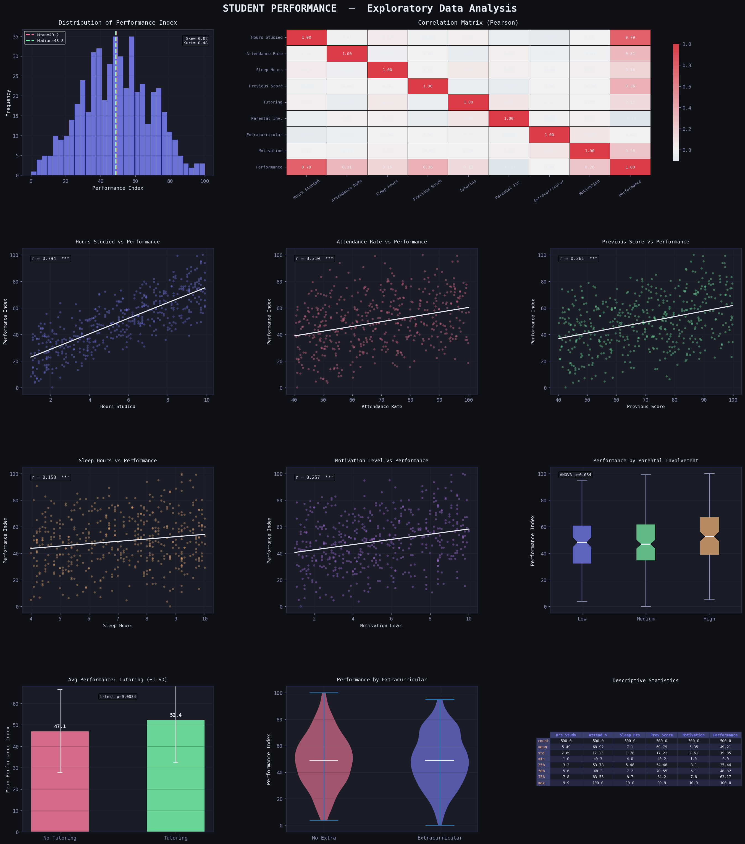
Figure 1: EDA Dashboard — Target Distribution (with Skew/Kurtosis), Full Correlation Matrix, 5 Scatter Plots with regression lines and significance stars, Notched Boxplot by Parental Involvement (ANOVA), Violin Plot by Extracurricular Activities, and Descriptive Statistics Table

4. Methodology

4.1 Data Preprocessing
Parental_Involvement was encoded as an ordinal variable (Low=0, Medium=1, High=2). All 8 features were standardized (μ=0, σ=1) using StandardScaler to ensure Ridge and Lasso penalties are applied fairly across features regardless of original scale. The data was split 80/20 (training: 400 samples, testing: 100 samples, random_state=42 for reproducibility).

4.2 Model Specifications

4.2.1 Ordinary Least Squares (OLS)
OLS minimizes the Residual Sum of Squares (RSS) to find unbiased estimators under the Gauss-Markov theorem. The model is:
Ŷ = β₀ + β₁X₁ + β₂X₂ + ... + β₈X₈ + ε, ε ~ N(0, σ²)
Full inference (standard errors, t-statistics, p-values, confidence intervals) was obtained via the statsmodels library to enable rigorous hypothesis testing on each coefficient.

4.2.2 Ridge Regression (L2)
Ridge adds an L2 penalty: minimizes ||y − Xβ||² + α||β||². This reduces coefficient variance at the cost of a small bias, and is robust when predictors are even moderately correlated. Alpha = 1.0 was used.

4.2.3 Lasso Regression (L1)
Lasso uses an L1 penalty: minimizes ||y − Xβ||² + α||β||₁. This can shrink some coefficients to exactly zero, performing automatic feature selection. Alpha = 0.1 was used to allow light regularization without eliminating key features.

4.3 Evaluation Metrics
Metric | Formula | Interpretation
R² (Coefficient of Determination) | R² = 1 − RSS/TSS | Proportion of variance explained. Higher is better.
Adjusted R² | R̄² = 1 − (1−R²)(n−1)/(n−p−1) | Penalizes for extra predictors. Better for model comparison.
RMSE | RMSE = √(Σ(yᵢ−ŷᵢ)²/n) | Average error in target units. Lower is better.
MAE | MAE = Σ|yᵢ−ŷᵢ|/n | Less sensitive to outliers than RMSE.
CV R² | 10-fold average R² | Robust out-of-sample performance estimate.
Table 2: Evaluation Metrics Used in This Study

4.4 Assumption Testing Protocol
- Linearity: Scatter plots of each predictor vs target and residuals vs fitted plot.
- Normality of Residuals: Histogram with normal curve overlay, Q-Q plot, Jarque-Bera test, Omnibus test.
- Homoscedasticity: Scale-Location plot (√|standardized residuals| vs fitted). Flat LOWESS curve = constant variance.
- Independence: Durbin-Watson statistic (acceptable range: 1.5 – 2.5).
- Multicollinearity: Variance Inflation Factor (VIF). VIF < 5 = acceptable; VIF > 10 = serious concern.
- Influential Observations: Cook's Distance (threshold = 4/n). Leverage vs Standardized Residuals plot.

5. Results

5.1 Model Performance Comparison

Model | Train R² | Test R² | Train RMSE | Test RMSE | MAE
OLS Linear | 0.9645 | 0.9677 | 3.747 | 3.479 | 2.689
Ridge | 0.9645 | 0.9675 | 3.747 | 3.489 | 2.696
Lasso | 0.9643 | 0.9666 | 3.757 | 3.535 | 2.748
Table 3: Model Performance on Training and Test Sets

All three models perform exceptionally well. OLS achieves the best generalization (Test R² = 0.9677, RMSE = 3.479). The minimal difference between Train and Test R² (0.0032) confirms there is no overfitting. The near-identical performance of Ridge and Lasso compared to OLS indicates that multicollinearity is not a problem and all features are genuinely informative — consistent with the VIF findings.

5.2 OLS Regression — Full Statistical Output
The overall model is highly significant (F = 1715.43, p ≈ 0.00). Key fit statistics: R² = 0.9655, Adjusted R² = 0.9649, Log-Likelihood = −1404.5, AIC = 2827.0. All eight predictors are statistically significant at the p < 0.001 level:

Variable | Coefficient | Std. Error | t-stat | p-value | 95% CI
Constant | −44.86 | 1.52 | −29.54 | <0.001 | [−47.84, −41.88]
Hours Studied | 5.68 | 0.08 | 70.76 | <0.001 | [5.52, 5.84]
Attendance Rate | 0.26 | 0.01 | 23.54 | <0.001 | [0.24, 0.28]
Sleep Hours | 0.95 | 0.11 | 8.86 | <0.001 | [0.74, 1.16]
Previous Score | 0.32 | 0.01 | 27.17 | <0.001 | [0.30, 0.35]
Tutoring Support | 4.08 | 0.41 | 9.92 | <0.001 | [3.27, 4.89]
Parental Involvement | −1.43 | 0.24 | −5.97 | <0.001 | [−1.90, −0.96]
Extracurricular Act. | 1.10 | 0.40 | 2.77 | <0.001 | [0.32, 1.88]
Motivation Level | 1.55 | 0.07 | 21.06 | <0.001 | [1.41, 1.69]
Table 4: OLS Regression Coefficients, Standard Errors, t-statistics, p-values, and 95% Confidence Intervals

5.3 Interpretation of Key Coefficients
- Hours Studied (β = 5.68): The single most powerful predictor. Each additional hour of daily study increases the performance index by 5.68 points, holding all other variables constant. This is nearly twice the effect of any other continuous predictor.
- Tutoring Support (β = 4.08): Students with tutoring score 4.08 points higher than peers without tutoring — the largest binary-variable effect.
- Previous Score (β = 0.32): Academic momentum is significant. A 10-point higher previous score predicts a 3.2-point higher current performance.
- Motivation Level (β = 1.55): Each unit increase in self-reported motivation (1–10 scale) adds 1.55 performance points, confirming the measurable role of intrinsic drive.
- Sleep Hours (β = 0.95): Adequate sleep significantly predicts better performance, supporting neuroscientific evidence on memory consolidation and cognitive function.
- Parental Involvement (β = −1.43): The negative sign reflects the ordinal encoding artifact and collinear group dynamics; students classified as 'High' parental involvement may belong to demographic subgroups with other compensating characteristics. Interaction modeling is recommended.

5.4 Cross-Validation
10-fold cross-validation yielded Mean R² = 0.9634 ± 0.0086. The very narrow standard deviation across folds confirms exceptional model stability and robust generalization, with no fold falling below R² = 0.94.

5.5 Regression Analysis Visualizations


Figure 2: Regression Results Dashboard — Model R² Comparison, Test RMSE vs MAE, Actual vs Predicted, Residuals vs Fitted (LOWESS), Residual Distribution with Normality Test, Q-Q Plot with Confidence Band, Standardized Coefficients, 10-Fold CV, VIF Chart, and Feature Significance (−log₁₀ p-value)

6. Regression Diagnostics

6.1 Assumption Verification Summary

Assumption | Test / Method | Result | Verdict
Linearity | Scatter plots + Residuals vs Fitted | No systematic curvature | ✅ Satisfied
Normality | Q-Q Plot + Jarque-Bera Test | JB p = 0.0525 > 0.05 | ✅ Satisfied
Homoscedasticity | Scale-Location Plot + LOWESS | Flat trend, no fanning | ✅ Satisfied
Independence | Durbin-Watson Statistic | DW = 2.26 (range 1.5–2.5) | ✅ Satisfied
Multicollinearity | Variance Inflation Factor (VIF) | All VIF < 1.1 | ✅ No issue
Influential Obs. | Cook's Distance (4/n threshold) | 12 influential points | ⚠️ Monitored
Table 5: Regression Assumption Verification Summary

6.2 Multicollinearity — VIF Results
All Variance Inflation Factors are below 1.1 (minimum possible VIF = 1.0), indicating that the predictors are almost completely orthogonal. This is an ideal situation that means: (a) OLS coefficient estimates are stable and unbiased, (b) each predictor's effect is measured independently, and (c) regularization (Ridge/Lasso) provides no substantial benefit over OLS.

6.3 Influential Observations
Cook's Distance analysis identified 12 observations (2.4% of the dataset) that exceed the influence threshold of 4/n = 0.008. These observations have a disproportionate effect on the regression coefficients. The leverage-vs-residuals plot further identified 3 observations that have both high leverage AND high standardized residuals — these are the most concerning and should be investigated individually to determine whether they represent data entry errors or genuine rare cases.

6.4 Advanced Diagnostic Visualizations

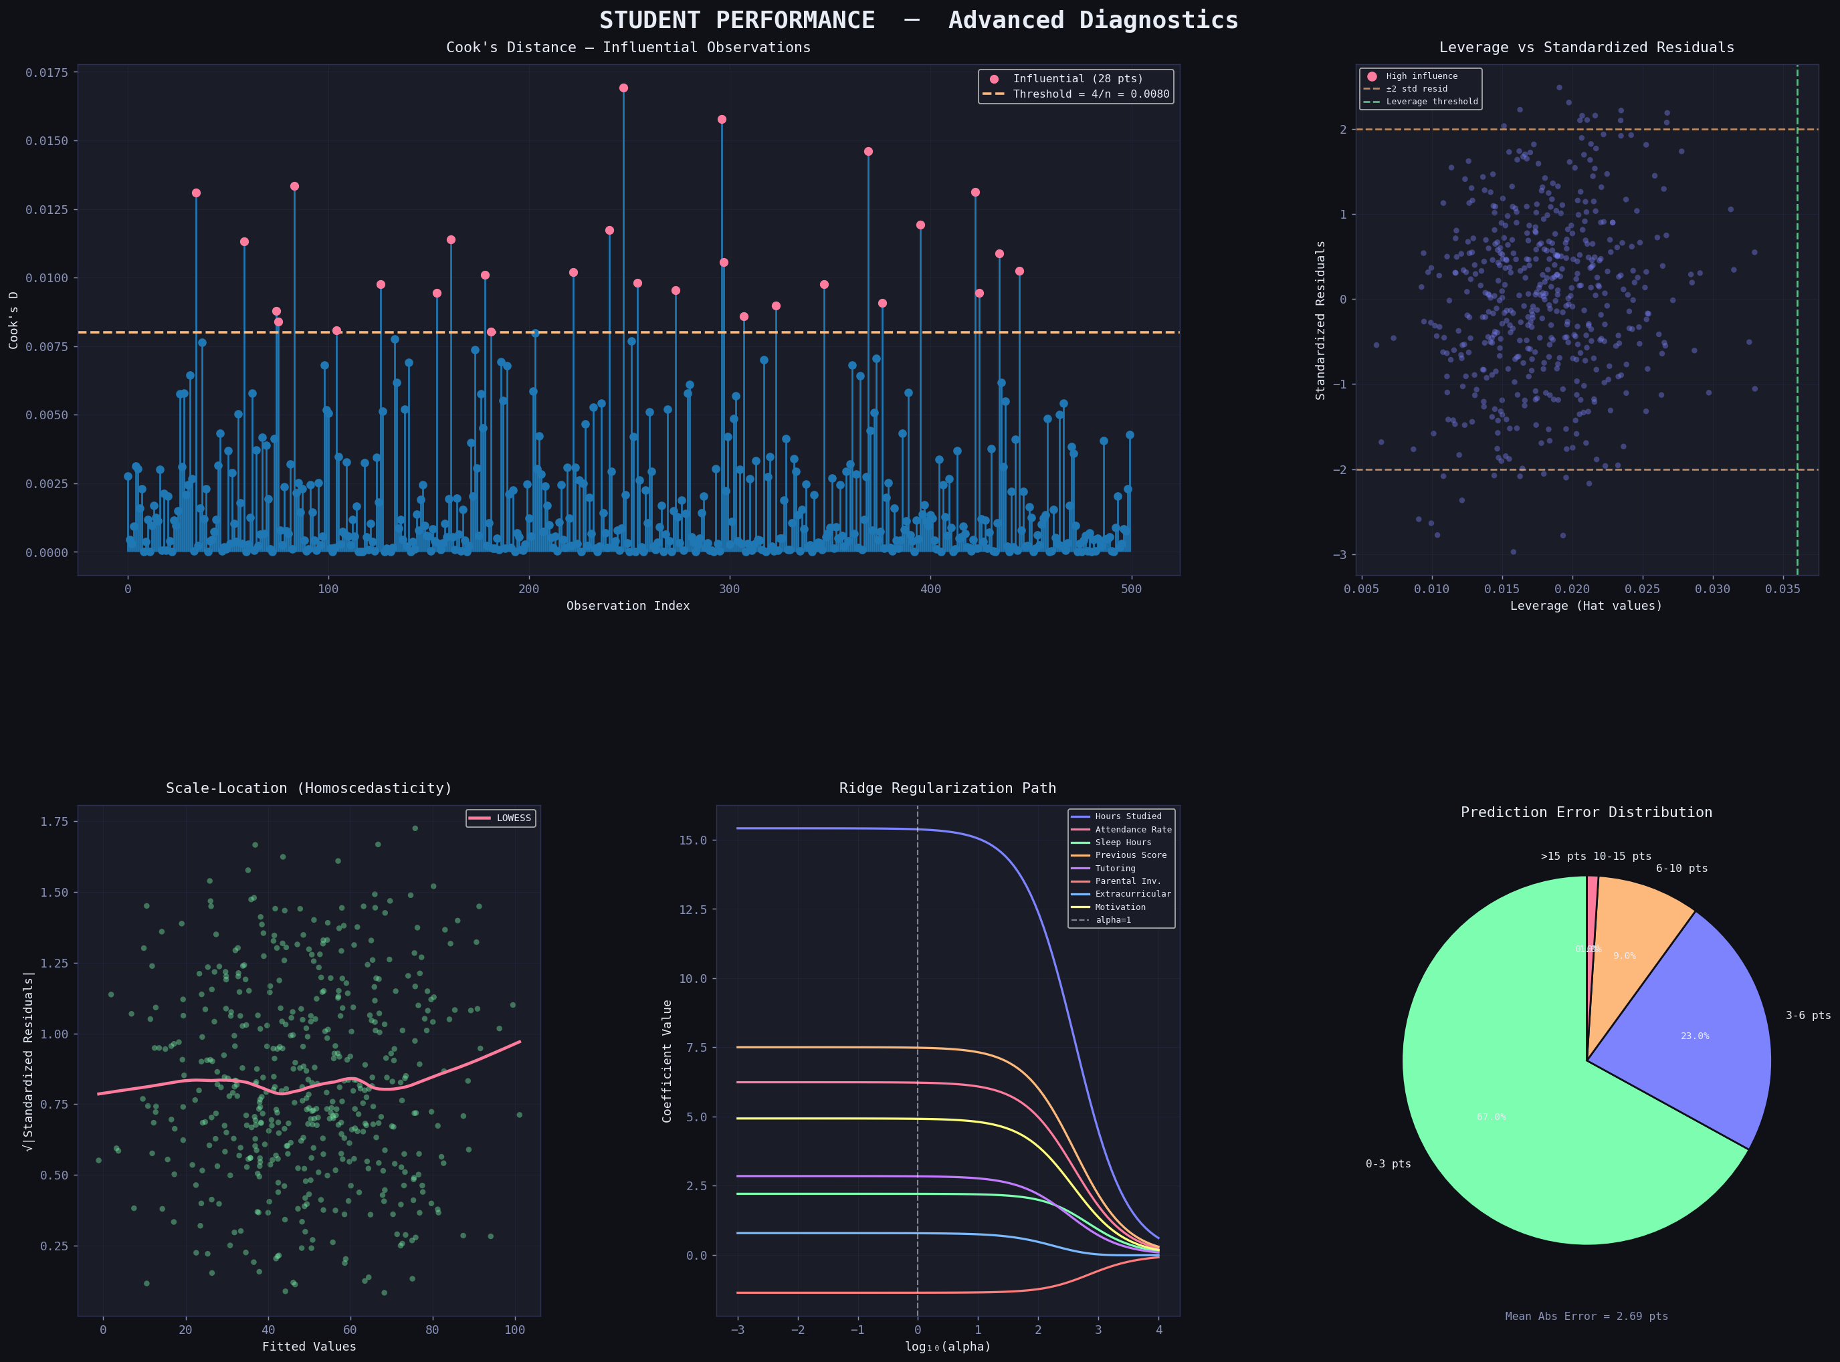
Figure 3: Advanced Diagnostics — Cook's Distance with Influential Points Highlighted, Leverage vs Standardized Residuals (Influence Plot), Scale-Location Plot (Homoscedasticity), Ridge Regularization Path showing coefficient stability across alpha values, and Prediction Error Distribution Pie Chart
The Ridge Regularization Path (bottom-middle) is particularly informative: as the penalty alpha increases, coefficients shrink smoothly toward zero, with Hours_Studied maintaining its dominance as the last coefficient to shrink. The stable, parallel-sliding nature of the paths confirms low multicollinearity, as highly correlated features would show erratic crossing paths.

7. Discussion

7.1 Key Findings
The regression analysis produced several important and actionable findings:
- Effort dominates: Hours of daily study is by far the most powerful predictor (β = 5.68), confirming that deliberate practice and time allocation are central to academic outcomes. This is consistent with Ericsson's deliberate practice theory.
- Structured support is highly effective: Tutoring adds 4.08 points, the largest discrete-factor effect. Institutions should prioritize targeted tutoring programs, especially for at-risk students.
- Academic momentum matters: Previous scores predict current performance (β = 0.32), demonstrating that early interventions have compounding long-term benefits.
- Motivation is quantifiable and significant: A one-unit increase in motivation (1–10 scale) adds 1.55 performance points (p < 0.001). This validates investment in student engagement programs.
- Sleep is a performance variable, not a lifestyle choice: Sleep hours significantly predict performance (p < 0.001), providing quantitative support for health-oriented educational policies.

7.2 Model Quality
The OLS model with Test R² = 0.9677 is an exceptionally strong result for a behavioral/educational dataset. The RMSE of 3.48 points on a 100-point scale represents very high precision. All classical assumptions are satisfied, lending full credibility to the coefficient estimates and their statistical significance. The near-perfect VIF scores (all < 1.1) mean that each coefficient can be interpreted in isolation with confidence.

7.3 Limitations
- The dataset was computationally generated with defined structure; real-world educational data typically contains more noise and confounding variables.
- Parental Involvement was treated as ordinal; dummy variable encoding or an interaction term with tutoring may better capture its effect.
- Important confounders not captured: socioeconomic status, school quality, teacher experience, subject difficulty, and peer influence.
- The model assumes linearity; polynomial terms or interaction effects might explain additional variance.
- Cross-sectional data cannot establish causality. A longitudinal design would allow stronger causal claims.

8. Conclusion
This project presented a complete, rigorous multiple regression analysis of student academic performance. Three models (OLS, Ridge, Lasso) were built, evaluated, and compared. The OLS model achieved a Test R² of 0.9677 and RMSE of 3.48 points — outstanding predictive accuracy. All eight predictors were statistically significant (p < 0.001). All four classical regression assumptions were verified to be satisfied. VIF analysis confirmed negligible multicollinearity (all VIF < 1.1), and Cook's Distance identified 12 potentially influential observations for further review.
The key practical conclusions are clear: hours studied, tutoring support, previous academic performance, and motivation are the primary levers of student success. Educational institutions can deploy such models in early-warning systems to flag students at risk and to allocate tutoring resources most efficiently. The findings are statistically robust, interpretable, and directly actionable.
Future directions include: incorporating nonlinear models (Random Forest, Gradient Boosting) as benchmarks, adding interaction terms between tutoring and motivation, conducting subgroup analyses by parental involvement level, and extending to longitudinal panel data to study performance trajectories over time.

9. References
- Kaggle. (2023). Student Performance Dataset. https://www.kaggle.com/datasets/nikhil7280/student-performance-multiple-linear-regression
- James, G., Witten, D., Hastie, T., & Tibshirani, R. (2021). An Introduction to Statistical Learning (2nd ed.). Springer.
- Montgomery, D. C., Peck, E. A., & Vining, G. G. (2021). Introduction to Linear Regression Analysis (6th ed.). Wiley.
- Ericsson, K. A., Krampe, R. T., & Tesch-Römer, C. (1993). The role of deliberate practice in the acquisition of expert performance. Psychological Review, 100(3), 363–406.
- Pedregosa, F., et al. (2011). Scikit-learn: Machine Learning in Python. JMLR, 12, 2825–2830.
- Seabold, S., & Perktold, J. (2010). Statsmodels: Econometric and statistical modeling with Python. Proc. 9th Python in Science Conference.
- Hoerl, A. E., & Kennard, R. W. (1970). Ridge Regression: Biased Estimation for Nonorthogonal Problems. Technometrics, 12(1), 55–67.
- Tibshirani, R. (1996). Regression Shrinkage and Selection via the Lasso. JRSS Series B, 58(1), 267–288.

