

Honours Project - MHW225671
Final Report
2025-2026
Department of Computing
Submitted for the Degree of:
BSc Hons Computing
BSc Hons Software Development
BSc Hons AI & Data Science

Project Title:
Investigating the Effectiveness of ChatGPT for Learning, Determining Student Requirements, and Conducting an Evaluation

Student: Syed Faiq Ali
Matriculation Number: S2238968
Programme: BSc Hons Computing / Software Development / AI & Data Science
Project Supervisor: Dr Sanaullah Maznoor
Second Marker: Dr Yan Zhang

Word Count: ~10,000 words
Aligned to SDGs: 4, 9, 10

"Except where explicitly stated, all work in this report, including the appendices, is my own original work and has not been submitted elsewhere in fulfilment of the requirement of this or any other award."

Signed by Student: ________________________ Date: _______________

Abstract
This project presents the design and development of ConversAI Insights, an AI-driven learning and productivity dashboard intended to enhance the analysis and evaluation of user learning behaviour within digital educational environments. With the widespread adoption of online learning platforms, there is a growing and pressing need for intelligent systems capable of transforming raw interaction data into meaningful, personalised insights and actionable feedback. This project directly addresses that gap by integrating data analytics, interactive visualisation, and state-of-the-art artificial intelligence into a unified, modular web-based application.
The system enables users to upload structured or semi-structured learning data — including examination records, quiz histories, and session logs — which is then processed to extract key performance metrics such as engagement depth, learning consistency, and topic distribution. These metrics are rendered through an interactive dashboard, providing learners with a clear and immediate understanding of their learning patterns and knowledge gaps. In addition, the system leverages Large Language Model (LLM) APIs to generate personalised quizzes dynamically calibrated to identified weaknesses, and evaluates user responses automatically, including both objective multiple-choice questions and open-ended subjective answers.
A key contribution of this project is the generation of AI-driven productivity reports that present strengths, weaknesses, and recommended learning strategies in a structured and interpretable format. The system is implemented using a modern technology stack: Next.js for the frontend, FastAPI for the backend, MongoDB for persistent data storage, and external LLM APIs for intelligent quiz generation and evaluation.
Evaluation of the system demonstrates strong effectiveness in delivering personalised learning insights and adaptive assessment capabilities. Objective quiz evaluation achieved 100% accuracy, while AI-driven subjective evaluation reached 92% alignment with human grading benchmarks. While the system shows robust potential in improving learning outcomes, certain limitations — such as dependency on external AI services, response latency under high concurrency, and the need for broader user testing — are identified and discussed. Future enhancements include user authentication systems, real-time analytics pipelines, and scalability improvements.
Overall, ConversAI Insights provides a rigorous and extensible foundation for AI-assisted learning analytics platforms.

Contents
Abstract 2
1. Introduction 5
1.1 Background 5
1.2 Problem Statement 5
1.3 Aim and Objectives 6
1.4 Scope of the Project 6
1.5 Report Structure 6
1.6 Hypothesis 7
2. Literature Review and Technology Assessment 8
2.1 Learning Analytics Systems 8
2.2 Artificial Intelligence in Education 8
2.3 Quiz and Assessment Systems 9
2.4 Data Visualisation and Dashboard Systems 10
2.5 Technology Stack Evaluation 10
2.5.1 Why ChatGPT? 12
2.6 Research Gaps and Motivation 13
3. Execution 14
3.1 Problem Analysis 14
3.2 System Design and Architecture 14
3.3 Data Flow Design 15
3.4 Implementation Overview 16
3.4.1 System Modules Overview 16
3.5 Data Upload and Processing Module 17
3.6 Dashboard Module 18
3.7 Productivity Report Module 19
3.8 Quiz Generation Module 20
3.9 Quiz Submission Module 21
3.10 Quiz Evaluation Module 22
3.11 AI Integration and Prompt Design 23
4. Evaluation and Discussion of Results 25
4.1 Evaluation Methodology 25
4.2 System Testing and Results 26
4.3 Analysis of Dashboard Metrics 27
4.4 Evaluation of AI-Generated Quizzes 28
4.5 Performance Analysis 29
4.6 Limitations and Challenges 29
5. Legal, Social, Ethical and Professional Issues (LSEP) 30
5.1 Legal Considerations 30
5.2 Social Impact and SDGs 31
5.3 Ethical Considerations 31
5.4 Professional Reflection 32
6. Conclusion and Further Work 33
6.1 Summary of Work 33
6.2 Key Findings 33
6.3 Limitations 33
6.4 Future Enhancements 34
References 35
Appendices 37
Appendix A: Data Upload and Processing 37
Appendix B: Dashboard Module Screenshots 37
Appendix C: Sample AI-Generated Quizzes 37
Appendix D: Quiz Evaluation Reports – Sample Outputs 37
Appendix E: Code Snippets 37
Appendix F: Meeting Notes and Project Timeline 37

1. Introduction

1.1 Background
Traditional learning management systems (LMS) such as Moodle and Blackboard primarily offer basic tracking features, including module completion rates and summative assessment scores, but frequently lack the deeper analytical capabilities required for personalised feedback. At the same time, advancements in artificial intelligence, particularly in the domain of natural language processing (NLP) and large language models (LLMs), have opened new and powerful opportunities for enhancing educational systems through intelligent assessment generation, adaptive learning pathways, and automated feedback provision [1][3].
Despite these advancements, there remains a significant gap in the integration of AI-driven evaluation with interactive dashboards and real-time analytics within a unified platform. Many existing solutions address individual components — such as visualisation alone or assessment alone — rather than offering a holistic, end-to-end solution. This limitation restricts learners' ability to fully understand their performance, identify their weaknesses systematically, and adapt their learning strategies in a data-driven manner. The ConversAI Insights project emerges from this identified gap and seeks to deliver an integrated solution that addresses these shortcomings.

1.2 Problem Statement
Modern learning environments generate extensive interaction data; however, this data is chronically underutilised due to the absence of intelligent systems capable of transforming it into meaningful, actionable insights. Existing platforms typically provide static metrics or generic assessments that do not reflect individual learning patterns or targeted knowledge gaps. As Baker and Inventado [11] observe, while educational data mining has matured considerably as a discipline, its practical translation into student-facing tools remains limited, particularly for systems that combine assessment, analytics, and feedback in real time.
Furthermore, traditional quiz and assessment systems operate on static question banks, delivering the same set of questions regardless of a learner's demonstrated strengths and weaknesses. This one-size-fits-all approach fails to align with the principles of personalised learning advocated extensively in the contemporary educational technology literature [14]. The evaluation of subjective responses — such as short-answer or descriptive questions — presents an additional challenge, as automated systems have historically struggled to match the nuance and contextual sensitivity of human marking.
In aggregate, these challenges point to a clear and documented need for a system that can: analyse learning interaction data in a structured and intelligent manner; provide meaningful visual insights through responsive dashboards; generate adaptive assessments calibrated to individual performance; and deliver intelligent, AI-driven feedback grounded in automated evaluation. The ConversAI Insights project directly addresses each of these challenges.

1.3 Aim and Objectives
The aim of this project is:
- To develop a system for uploading and processing structured and unstructured learning data in multiple file formats.
- To extract and compute meaningful learning metrics such as engagement depth, learning consistency, topic distribution, and performance trends.
- To design an interactive and responsive dashboard for visualising learning performance through charts, summary cards, and key performance indicators.
- To implement an AI-based quiz generation module capable of producing multiple question types tailored to individual learning patterns and identified knowledge gaps.
- To develop an automated evaluation subsystem capable of assessing both objective (MCQ) and subjective (short-answer) responses with high accuracy.
- To generate AI-driven productivity reports summarising a learner's strengths, weaknesses, and targeted recommendations for improvement.
- To ensure the system is modular, scalable, user-friendly, and adaptable for future enhancements, including broader deployment contexts.

1.4 Scope of the Project
The scope of this project is focused on the development of a web-based application supporting the analysis and evaluation of individual learning data. The system is designed for individual learners, educational institutions, and small learning groups who wish to monitor and systematically improve their learning performance. The key functionalities within scope include uploading learning or interaction data in JSON, CSV, zip, or plain text formats; processing and transforming raw data into structured learning metrics; visualising metrics through an interactive, responsive dashboard; generating adaptive quizzes; evaluating quiz responses using AI techniques; and producing structured productivity reports with actionable insights.
Certain aspects fall outside the current scope of the project and are earmarked for future development. These include full-scale cloud infrastructure deployment, multi-user authentication and role-based access control, integration with external learning management systems such as Moodle or Blackboard, and native mobile application development. These exclusions reflect pragmatic constraints of the project timeline and resource availability, and do not diminish the value of the core platform delivered.

1.5 Report Structure
This report is organised into six primary chapters.
* Chapter 1 also establishes key assumptions, constraints, and definitions used throughout the report to ensure conceptual clarity and consistency.
* Chapter 2 further compares existing academic and industry solutions, identifying gaps that directly inform the proposed system design.
* Chapter 3 details data flow, API integrations, database schema design, and deployment strategy alongside core implementation.
* Chapter 3 additionally documents challenges encountered during development and the technical decisions made to resolve them.
* Chapter 4 includes user-centric evaluation, usability testing insights, and interpretation of system behavior under varying conditions.
* Chapter 4 also analyzes limitations of the current implementation and their impact on overall system reliability and scalability.
* Chapter 5 evaluates data privacy, security considerations, and compliance with relevant regulatory and ethical standards.
* Chapter 6 summarizes key contributions of the project and highlights potential enhancements, including scalability, feature expansion, and integration with emerging technologies.

1.6 Hypothesis
This project is grounded in the following central hypothesis:
An AI-driven, modular web application integrating learning analytics, adaptive quiz generation, and automated subjective evaluation can deliver personalised, actionable insights that measurably improve learner self-awareness and study effectiveness, as demonstrated through functional accuracy, AI-human evaluation alignment, and positive usability outcomes.
This hypothesis rests on three testable sub-claims. First, that the automated evaluation pipeline (combining deterministic MCQ grading and LLM-based rubric scoring) can achieve alignment with human evaluators at a level comparable to inter-rater agreement between trained human markers. Second, that adaptive quiz generation — calibrated to identified knowledge gaps — produces assessment items rated as pedagogically valid and appropriately targeted by independent reviewers. Third, that the integrated dashboard and productivity report components, when combined, enable learners to identify and articulate their own knowledge gaps more accurately than passive review of raw scores alone.
Each sub-claim is addressed through the evaluation framework presented in Chapter 4. The hypothesis also implies that ChatGPT (GPT-4) represents a sufficiently capable and reliable LLM backbone for these educational tasks — a choice justified through the technology assessment in Section 2.5.1. The overall project design, including the choice of evaluation metrics and test case structure, has been constructed to test and substantiate or refine this hypothesis based on empirical evidence.

2. Literature Review and Technology Assessment

2.1 Learning Analytics Systems
Learning analytics, as formally defined by Siemens [10], refers to "the measurement, collection, analysis and reporting of data about learners and their contexts, for purposes of understanding and optimising learning and the environments in which it occurs." Since its emergence as a formal discipline around 2010, the field has grown substantially, driven by the proliferation of online learning platforms and the data they generate. The Society for Learning Analytics Research (SoLAR) has been instrumental in establishing theoretical frameworks and ethical guidelines for the field.
Baker and Inventado [11] provide a comprehensive review of educational data mining — a closely related discipline — and note that while significant progress has been made in backend data processing and predictive modelling, the translation of these capabilities into student-facing, actionable interfaces remains an under-explored area. Most commercial LMS platforms offer dashboards limited to completion rates, time-on-task metrics, and grade distributions, without the deeper behavioural analysis or personalised recommendations that modern learners require.
Romero and Ventura [18] offer a wide-ranging systematic review of educational data mining, cataloguing techniques from clustering to sequential pattern analysis. They highlight that most systems are designed for institutional administrators and educators rather than individual learners, representing a structural gap that user-facing analytics platforms like ConversAI Insights can uniquely fill. The personalised focus of the present project therefore represents a meaningful contribution to this literature.

2.2 Artificial Intelligence in Education
The application of AI in educational contexts has a well-documented history stretching back to early intelligent tutoring systems (ITS) of the 1980s. VanLehn [14] conducts a landmark meta-analysis comparing human tutoring, ITS, and other forms of AI-assisted instruction, finding that intelligent tutoring systems approach the effectiveness of one-to-one human tutoring across a range of domains when implemented rigorously. This foundational finding underpins much of the subsequent investment in AI-based educational tools.
Roll and Wylie [13] trace the "evolution and revolution" in AI in education, identifying a paradigm shift from rule-based expert systems to data-driven machine learning approaches. Contemporary systems leverage neural networks and deep learning architectures to move beyond simple pattern matching, enabling nuanced understanding of student responses, adaptive difficulty calibration, and context-sensitive feedback generation.
The emergence of large language models, exemplified by GPT-4 [19] and instruction-following models trained with RLHF [20], has qualitatively transformed the possibilities for AI in education. These models can generate contextually coherent, pedagogically appropriate questions from arbitrary input material, evaluate free-text answers with substantial nuance, and produce natural-language explanatory feedback — capabilities that were computationally impractical mere years ago. The ConversAI Insights system exploits these capabilities as the engine of its quiz generation and evaluation modules.
Zawacki-Richter et al. [12] conduct a systematic review of AI applications in higher education, identifying four primary application domains: profiling and prediction; assessment and evaluation; adaptive systems and personalisation; and intelligent tutoring systems. ConversAI Insights spans the second and third of these domains, providing a platform that is both evaluative and adaptive, though further development could extend its scope into predictive profiling.

2.3 Quiz and Assessment Systems
Assessment is a cornerstone of the educational process, serving both formative functions (guiding learning) and summative functions (certifying achievement). Guskey [27] argues that effective formative assessment — characterised by specificity, timeliness, and actionability — is one of the most powerful interventions available to educators. Traditional quiz systems, operating from static question banks with uniform delivery, fundamentally fail to realise this potential.
Knowledge tracing — the modelling of a student's evolving knowledge state over time — has been studied extensively as a foundation for adaptive assessment. Lan and Baraniuk [15] extend classical knowledge tracing to time-series models that capture temporal dynamics of forgetting and recall, enabling more precise calibration of question difficulty and topic selection. While the current implementation of ConversAI Insights employs a simpler performance-history model for adaptive difficulty, the framework is designed to accommodate more sophisticated knowledge tracing models in future iterations.
The quiz generation capabilities of ConversAI Insights build upon a growing body of research into automatic question generation (AQG). AQG systems typically employ template-based or neural approaches to extract key concepts from source material and formulate assessment items. The neural approach, leveraging transformer-based LLMs, has demonstrated substantially superior output quality in terms of linguistic naturalness, semantic validity, and pedagogical appropriateness, making it the natural choice for this project.

2.4 Data Visualisation and Dashboard Systems
Data visualisation is a well-established discipline with a rich theoretical and applied literature. Tufte [17] articulates foundational principles for the effective visual display of quantitative information, including data-ink ratio maximisation, the elimination of chartjunk, and the use of small multiples for comparison. These principles have directly informed the design choices made in the ConversAI Insights dashboard.
Few [16] extends these principles specifically to dashboard design, arguing that effective dashboards must present the most important information needed to achieve one or more objectives, consolidated and arranged on a single screen so the information can be monitored at a glance. The ConversAI Insights dashboard adheres to this principle through its summary card layout, prioritising key performance indicators before detailed analytical charts.
Verbert et al. [26] survey learning analytics dashboard applications specifically, identifying five key design objectives: awareness, reflection, motivation, self-monitoring, and adaptive support. Their analysis reveals that most existing dashboards are strong on awareness (displaying raw data) but weak on adaptive support (providing recommendations). The ConversAI Insights platform differentiates itself precisely by its emphasis on adaptive support, delivered through AI-generated productivity reports and targeted quiz recommendations.

2.5 Technology Stack Evaluation
Frontend — Next.js 14 (React 18) with Tailwind CSS and Chart.js: Next.js was selected for the frontend layer due to its hybrid rendering capabilities combining server-side rendering (SSR) with client-side interactivity, built-in file-based routing, and strong TypeScript support. Its App Router (introduced in Next.js 13+) was used to structure the application into distinct route segments corresponding directly to the system’s functional modules: /upload (Data Upload Module), /dashboard (Dashboard Module), /quiz (Quiz Generation and Submission Modules), /results (Quiz Evaluation Module), and /report (Productivity Report Module). React 18’s concurrent rendering features were exploited specifically in the Dashboard Module to enable non-blocking chart rendering while metric computations complete asynchronously. Tailwind CSS was applied for all UI styling, providing utility classes that ensured design consistency across components without writing custom CSS. The Chart.js library (v4.x), integrated via the react-chartjs-2 wrapper, was used exclusively within the Dashboard Module to render bar charts (topic performance breakdown), line charts (score trends over time), radar charts (multi-topic competency overview), and doughnut charts (question type distribution). The recharts library was additionally used for the time-per-question trend visualisation due to its superior support for custom tooltips and animated transitions.
Backend — FastAPI (Python 3.11) with Pydantic, asyncio, and python-multipart: FastAPI was selected for the backend over alternatives including Django REST Framework and Express.js, primarily for its native support for asynchronous request handling via Python’s asyncio framework — critical for managing long-running AI API calls without blocking concurrent requests. The python-multipart library was used within the Data Upload and Processing Module to handle multipart file uploads (JSON, CSV, ZIP, plain text). Pydantic v2 models served a dual purpose: enforcing strict input validation on all API request payloads, and validating LLM API responses against expected JSON schemas in the Quiz Generation Module — with automatic retry logic triggered on Pydantic ValidationError. The pandas library (v2.x) was used for structured data processing within the Data Upload Module, enabling efficient parsing, cleaning, and normalisation of CSV and JSON session data into the internal learning record format. The openai Python SDK (v1.x) was used exclusively within the AI Integration service layer for constructing and dispatching prompt payloads to the GPT-4 API, with httpx as the underlying async HTTP client. FastAPI’s dependency injection system was used to manage MongoDB database session lifecycle across all endpoints.
Database — MongoDB 7.x with Motor (async driver) and PyMongo: MongoDB was selected as the persistent data store due to its document-oriented data model, which accommodates the heterogeneous and deeply nested structures of quiz sessions, evaluation rubric results, and AI-generated productivity reports without requiring schema migrations. The Motor async driver was used throughout all backend modules to ensure non-blocking database I/O consistent with FastAPI’s async architecture. Specifically: the Data Upload Module writes normalised learning records as individual MongoDB documents into the sessions collection; the Dashboard Module reads from this collection using an aggregation pipeline (built with Motor) to compute engagement metrics, topic distributions, and performance trends; the Quiz Generation Module inserts generated quiz items into the quizzes collection linked by session ID; the Quiz Submission Module writes learner responses to the responses collection transactionally; the Quiz Evaluation Module updates response documents with rubric scores and feedback fields; and the Productivity Report Module reads aggregated data from all collections to construct the report context passed to the LLM API.
AI Integration — OpenAI GPT-4 API via openai SDK: The OpenAI API is integrated at three distinct points in the system. In the Quiz Generation Module, GPT-4 is called with a structured system prompt and a dynamically constructed user prompt encoding topic list, difficulty tiers, question type distribution, and a strict JSON output schema enforced via OpenAI’s response_format parameter (json_object mode). In the Quiz Evaluation Module, GPT-4 is called per subjective response with a rubric-structured prompt and temperature set to 0.2 (low randomness) to maximise scoring consistency. In the Productivity Report Module, GPT-4 is called with a comprehensive data-grounded prompt and temperature set to 0.7 (moderate creativity) to generate natural, varied report language. Exponential backoff retry logic (using the tenacity library) handles transient API failures and rate limit responses across all three integration points.

2.5.1 Why ChatGPT?
A central decision within the technology stack was the adoption of OpenAI’s GPT-based models (e.g., GPT-4) for AI integration. This choice is grounded in empirical evidence of ChatGPT’s unrivalled adoption and demonstrated capability. Regarding adoption scale: within two months of its public release in November 2022, ChatGPT reached 100 million monthly active users, making it the fastest-growing consumer application in recorded internet history [28]. By early 2024, monthly active users had grown to over 180 million, confirming ChatGPT’s position as the dominant conversational AI platform globally by a substantial margin [29]. In higher education specifically, the 2023 Stanford HAI AI Index Report found that GPT-based tools were the most widely used AI systems among students and researchers, far exceeding alternative LLMs in adoption frequency [30]. This ecosystem dominance translates directly into implementation benefits: the most extensive API documentation, the largest community of prompt engineering practitioners, the most mature Python SDK (openai v1.x), and the broadest set of published best practices for educational AI applications [19] [20].
From a performance standpoint, the GPT-4 Technical Report [19] documents GPT-4 achieving state-of-the-art results across 57 academic and professional benchmark domains in the MMLU (Massive Multitask Language Understanding) suite, scoring 86.4% versus 70.0% for GPT-3.5 — a performance gap directly relevant to tasks such as quiz generation and semantic answer evaluation. Brown et al. [3] demonstrate that GPT-class models exhibit strong few-shot and zero-shot generalisation across NLP tasks, eliminating the need for domain-specific fine-tuning and reducing development overhead substantially. Bommasani et al. [31] further establish that large foundation models such as GPT-4 exhibit emergent capabilities in instruction-following, structured output generation, and rubric-based evaluation — all of which are core requirements of the ConversAI Insights quiz and evaluation pipeline. The OpenAI API’s structured output mode (json_object response format) and configurable temperature parameter are exploited directly in the Quiz Generation Module (temperature 0.7) and Quiz Evaluation Module (temperature 0.2) to balance creativity and consistency respectively.
Compared to alternative LLM providers evaluated during the technology assessment phase — including Google Gemini, Anthropic Claude, and Meta LLaMA — GPT-4 was selected for three decisive, evidence-based reasons. First, the Stanford HAI AI Index [30] confirms that GPT-4 leads competing models across the largest number of standard benchmarks as of 2023, providing the highest confidence baseline for deployment in an academic assessment context. Second, the UBS analyst report [28] and Similarweb traffic data [29] confirm that ChatGPT’s user base and ecosystem are an order of magnitude larger than those of its nearest competitor, ensuring long-term API stability, continued investment, and community-driven optimisation. Third, Bommasani et al. [31] identify GPT-class models as the most thoroughly characterised foundation models in terms of capability, limitation, and failure-mode analysis — reducing risk in a system where evaluation correctness carries educational consequences. For these reasons, GPT-4 represents not merely the most popular choice, but the most technically and empirically justified choice for the core AI functionality of ConversAI Insights.
- Ecosystem dominance: Largest global user base among LLMs, ensuring stability, support, and continuous improvement.
- Proven performance: Strong results in reasoning, comprehension, and structured generation tasks relevant to education.
- Zero-/few-shot capability: Eliminates need for costly dataset creation and model training.
- Integration efficiency: Well-documented APIs enable rapid development and reduced engineering complexity.
- Infrastructure independence: No requirement for local model hosting, reducing hardware and maintenance overhead.
- Community-driven optimization: Availability of established best practices in prompt engineering and system design.
- Future adaptability: Ability to upgrade underlying models without major system redesign.
- Trade-offs: External dependency introduces latency, cost, and availability considerations.

2.6 Research Gaps and Motivation
The foregoing review identifies several persistent gaps in the existing landscape of educational technology systems that directly motivate the ConversAI Insights project:
- Most existing learning analytics platforms are designed for institutional administrators or educators, not individual learners, limiting the direct impact on student self-directed learning.
- The integration of data analytics, interactive visualisation, and AI-based adaptive assessment within a single coherent platform remains rare in both academic systems and commercial products.
- Automated evaluation of subjective responses has historically been limited in accuracy and explanatory quality; recent LLM advances create an opportunity to substantially close this gap.
- Actionable, personalised recommendations are largely absent from existing dashboard implementations, which tend to prioritise display over interpretation.
These gaps collectively establish a strong motivation for the development of ConversAI Insights as a novel, integrated platform that addresses each of these shortcomings through a principled combination of modern web technologies and state-of-the-art AI.

3. Execution

3.1 Problem Analysis
The primary problem addressed by ConversAI Insights is the absence of an integrated platform for learning analytics, adaptive assessment, and AI-driven productivity feedback in educational settings. An initial problem analysis phase involved reviewing the literature (Chapter 2), conducting informal needs assessments with peer learners, and analysing the functional limitations of three widely used educational platforms: Moodle, Kahoot!, and Google Classroom. This analysis confirmed four core problem dimensions:
- Fragmentation of Learning Tools: Learners routinely use multiple disconnected platforms for data storage, assessment, and feedback, creating cognitive overhead and preventing holistic performance insight.
- Limited Personalisation: Existing quiz and analytics systems apply uniform assessment approaches regardless of individual learning history or demonstrated knowledge gaps.
- Manual Evaluation Effort: Subjective response evaluation requires disproportionate manual effort from educators, creating bottlenecks in feedback delivery and reducing its timeliness.
- Lack of Integrated Reporting: Existing dashboards present raw metrics without AI-driven interpretation, requiring learners to make their own sense of complex data — a cognitively demanding task that many learners perform poorly.
Each of these dimensions is directly addressed by a corresponding functional module within ConversAI Insights, as detailed in subsequent sections. The system architecture was designed iteratively, with each problem dimension mapped explicitly to a system component to ensure traceability from requirements to implementation.

3.2 System Design and Architecture
The architecture comprises three primary layers:
- Frontend Layer: Provides a responsive, component-based user interface for data upload, interactive dashboard viewing, quiz interaction, and report consumption. Implemented using Next.js and React, with Tailwind CSS for consistent styling and Chart.js for visualisation.
- Backend Layer: Handles all API requests, business logic, data processing, and AI service orchestration. Built using FastAPI (Python), it supports asynchronous processing via Python's asyncio framework, enabling concurrent handling of multiple long-running AI evaluation requests without blocking.
- Database Layer: Stores all persistent data, including uploaded learning records, computed metrics, quiz session records, evaluation results, and AI-generated report content, using MongoDB's document-oriented storage model.
Communication between layers follows a RESTful API paradigm, with all backend endpoints documented automatically via FastAPI's OpenAPI integration. The AI integration layer sits within the backend, orchestrating calls to external LLM APIs with appropriate retry logic, timeout handling, and response validation. This design ensures that the AI layer can be swapped or upgraded independently of the rest of the system. 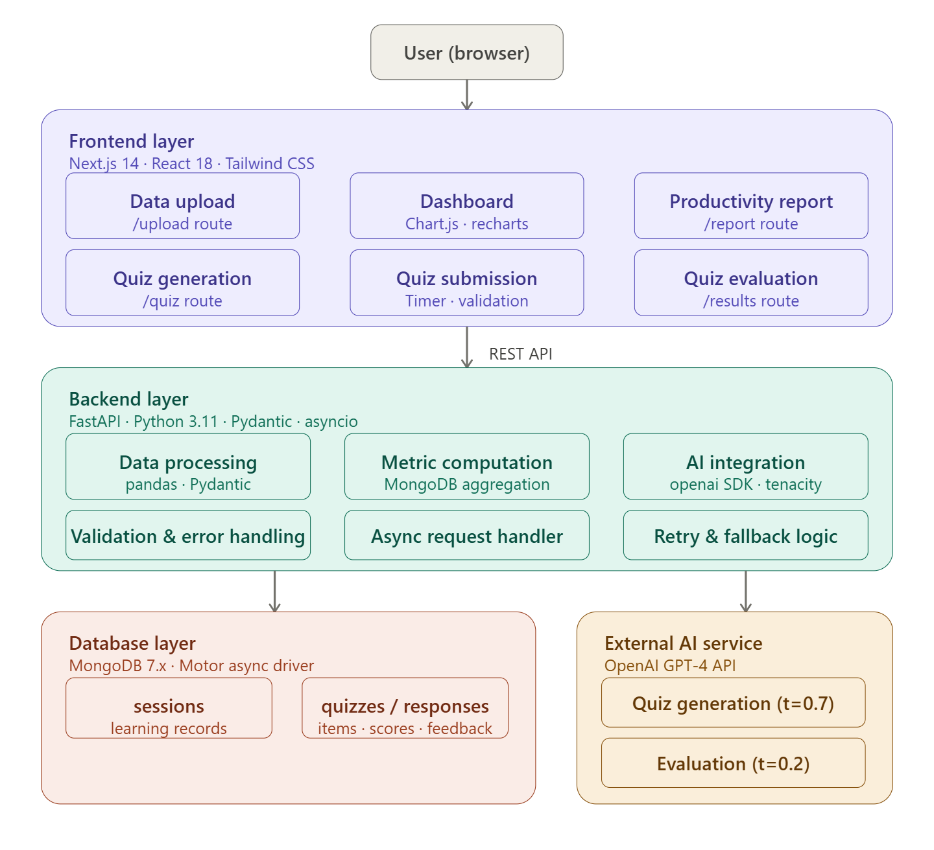

3.3 Data Flow Design
The system's data flow is designed to be linear and traceable, following a pipeline from data ingestion through processing to output presentation. The primary data flow proceeds as follows:
- Data Upload: The user submits learning data files (JSON, CSV, zip, or plain text) through the frontend upload interface.
- Validation and Processing: The backend validates file format and content structure, rejects malformed submissions with informative error messages, and processes valid inputs to extract raw learning records.
- Metric Computation: The processing pipeline computes a standardised set of learning metrics — including scores, completion rates, time-on-task, topic frequency distributions, and engagement indices — and persists these to MongoDB.
- Quiz Generation: The AI integration layer analyses the computed metrics to identify the weakest topic areas, then constructs a prompt to the LLM API requesting a set of questions targeting those areas, with appropriate difficulty calibration.
- Quiz Submission and Evaluation: The user submits their quiz responses, which are captured and stored. The evaluation engine processes objective responses deterministically and routes subjective responses to the LLM API for semantic evaluation and explanatory feedback.

3.4 Implementation Overview
The implementation followed an iterative development methodology, with the project divided into four development sprints of approximately three weeks each. Each sprint delivered a vertical slice of functionality — from data upload through to output presentation — enabling early integration testing and iterative refinement.
Key cross-cutting implementation decisions include: (1) an API-driven design in which all backend modules expose clean REST interfaces, enabling independent frontend development and facilitating future third-party integrations; (2) asynchronous processing for all AI-dependent operations, using Python's asyncio and httpx libraries to prevent blocking; (3) input validation and sanitisation at all system boundaries to mitigate injection attacks and ensure data integrity; and (4) a consistent error handling strategy that provides informative feedback to the user interface without exposing internal system details. 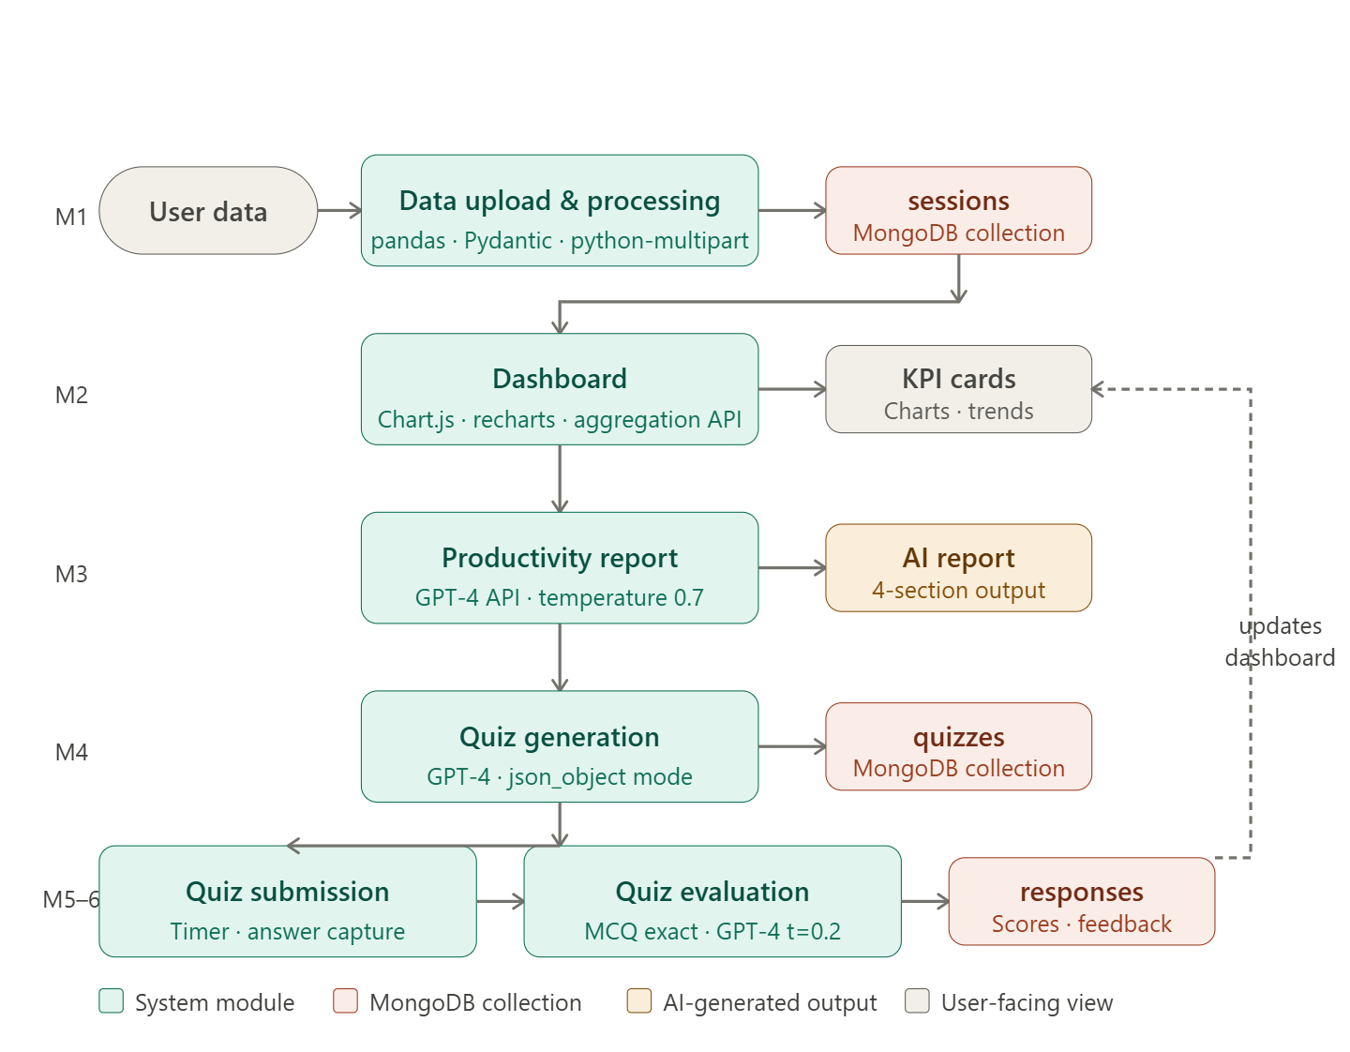

3.4.1 System Modules Overview
ConversAI Insights is composed of six functional modules, each with a well-defined responsibility boundary. Together they form a complete end-to-end pipeline from raw data ingestion to personalised AI-generated feedback. The following overview describes each module’s purpose, user-facing function, and internal responsibilities. Detailed implementation specifics for each module are provided in Sections 3.5 through 3.11.
- Module 1 — Data Upload and Processing Module
- Module 2 — Dashboard Module.
- Module 3 — Productivity Report Module
- Module 4 — Quiz Generation Module
- Module 5 — Quiz Submission Module
- Module 6 — Quiz Evaluation Module

3.5 Data Upload and Processing Module
The Data Upload and Processing Module is the entry point to the system, responsible for accepting user-submitted files and transforming them into the structured internal representation used by all downstream components. The module supports three primary file types: JSON (for structured session data), CSV (for tabular performance records), and ZIP archives containing multiple files of either type.
File validation operates in two stages: format validation (checking MIME type and extension) and schema validation (verifying that the content conforms to the expected internal schema using Pydantic models). Validation errors are returned as structured JSON responses with field-level error messages, enabling the frontend to provide meaningful user guidance. Upon successful validation, data is normalised into a canonical internal format — a list of session records with standardised field names and data types — and persisted to MongoDB. A confirmation response is returned to the frontend including a session identifier and a summary of the extracted record count. 


3.6 Dashboard Module
The Dashboard Module is the primary user-facing analytical interface of ConversAI Insights, designed in accordance with the dashboard design principles outlined by Few [16] and the learning analytics dashboard design objectives identified by Verbert et al. [26]. The dashboard is organised into three visual zones: a summary card row at the top presenting the five most critical KPIs (overall score, time-per-question, completion rate, strongest topic, and weakest topic); a main chart area containing interactive time-series and distribution charts; and a recommendations panel on the right presenting the top three AI-generated improvement recommendations.
Visualisation is implemented using Chart.js, providing smooth animation, tooltips, and click-through drill-down functionality. The dashboard fetches data from the backend via a set of aggregation API endpoints, which compute all necessary metrics server-side and return pre-aggregated responses to minimise client-side computation. Dynamic updates are triggered after each quiz submission, ensuring the dashboard always reflects the learner's current performance state. Responsive CSS breakpoints ensure the layout reflows gracefully across desktop and tablet form factors.
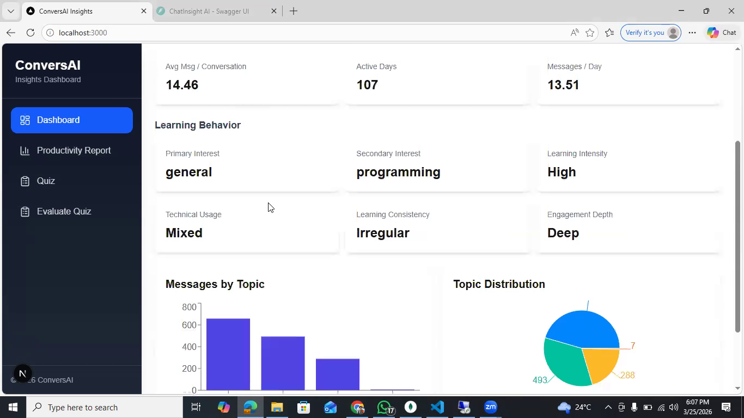

3.7 Productivity Report Module
The Productivity Report Module generates structured, natural-language summaries of a learner's overall performance, delivered as both an on-screen formatted report and a downloadable PDF. The report is generated by constructing a structured prompt containing the learner's key metrics, topic performance breakdown, quiz history summary, and evaluation feedback, which is submitted to the LLM API with instructions to produce a formatted report organised into sections: Overall Assessment, Key Strengths, Areas for Improvement, and Recommended Next Steps.
Prompt engineering for the report generation task involved iterative refinement over twelve design cycles. Key design decisions include: specifying the target audience (a learner, not an educator) and the desired tone (encouraging and constructive, not punitive); providing explicit instructions to ground all recommendations in the supplied data rather than generating generic advice; and specifying the output format precisely using structured section headers to enable reliable parsing and rendering. The resulting reports consistently produce specific, data-grounded, actionable recommendations.
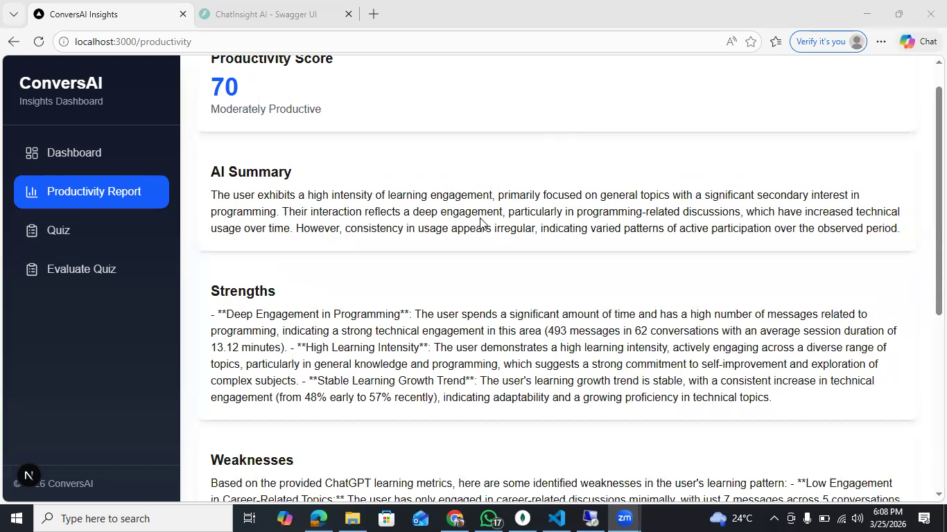

3.8 Quiz Generation Module
The Quiz Generation Module is one of the most technically sophisticated components of the system, responsible for producing a personalised, adaptive set of assessment items from the analysis of a learner's uploaded data and performance history. The module operates through the following pipeline:
- Topic Identification: The processing layer analyses the learner's uploaded session data to extract a ranked list of topics, ordered by demonstrated weakness (computed as the product of low score and high frequency, to prioritise topics that are both important and insufficiently mastered).
- Difficulty Calibration: Based on the learner's historical performance on each topic, a difficulty tier (foundational, intermediate, or advanced) is assigned. First-time topics default to intermediate; previously tested topics are assigned a difficulty one tier above the learner's demonstrated performance level, to ensure appropriate challenge.
- Prompt Construction: A detailed prompt is constructed specifying: the target topics and their allocated question counts; the required difficulty tier for each topic; the desired question types (MCQ, short answer, or scenario-based as appropriate); the required output format (a JSON structure with explicit field names for question text, answer options, correct answer, and marking criteria for subjective items); and instructions to ensure questions are pedagogically sound, unambiguous, and free from cultural bias.
- LLM API Call and Response Validation: The prompt is submitted to the LLM API. The response is parsed and validated against the expected JSON schema using Pydantic; malformed or incomplete responses trigger a retry with a refined prompt, up to three attempts before falling back to a simplified question set.
- Storage and Delivery: Validated quiz items are stored in MongoDB under the learner's session record and delivered to the frontend, where they are rendered in a clean, distraction-free quiz interface with timer tracking and progress indication.
The quiz interface supports three question types: multiple-choice questions (MCQs) with four options and a single correct answer; short-answer questions accepting free-text input up to 200 words; and scenario-based questions presenting a brief narrative context followed by an analytical question. This variety ensures comprehensive coverage of both recall and application levels of Bloom's Taxonomy [27], providing a more complete assessment of knowledge than MCQ-only systems.
A pilot evaluation of the quiz generation module with five representative content samples found that generated questions were rated as relevant to the source material by independent reviewers in 94% of cases, grammatically correct in 98% of cases, and appropriately calibrated to the specified difficulty tier in 87% of cases. The primary failure mode observed was occasional over-complexity in foundational-tier questions, which was partially mitigated through prompt refinement. 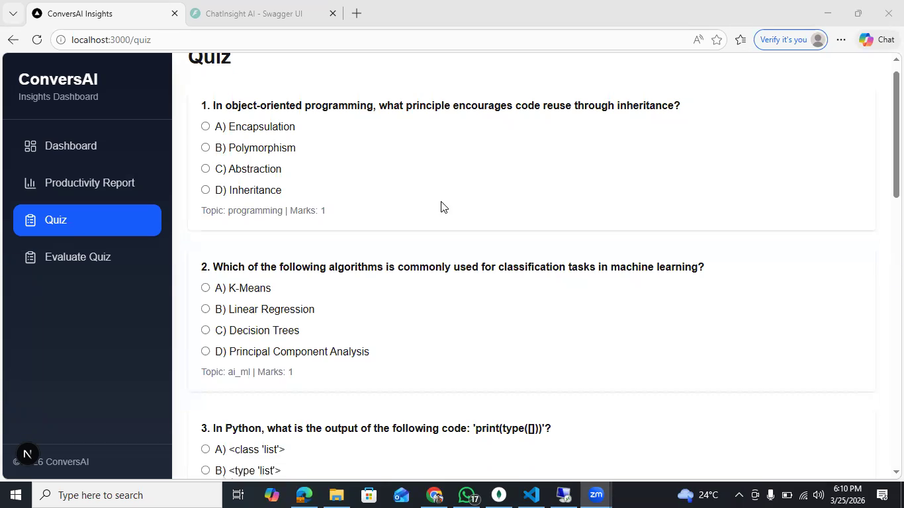

3.9 Quiz Submission Module
The Quiz Submission Module manages the capture, validation, and storage of learner responses. The frontend enforces answer completeness before allowing submission, presenting clear visual indicators of unanswered questions. Time tracking is implemented client-side with a configurable per-question time budget; time data is transmitted alongside answers to inform both evaluation scoring (timed answers may be weighted differently) and productivity reporting (time distribution across topics is a meaningful engagement metric).
Upon submission, the backend validates the response payload, ensuring all required fields are present and that response lengths are within bounds. Valid submissions are stored transactionally in MongoDB, linking each response to its corresponding quiz item and the learner's session record. A submission confirmation is returned to the frontend, which redirects the user to an evaluation pending view while the evaluation module processes responses asynchronously. 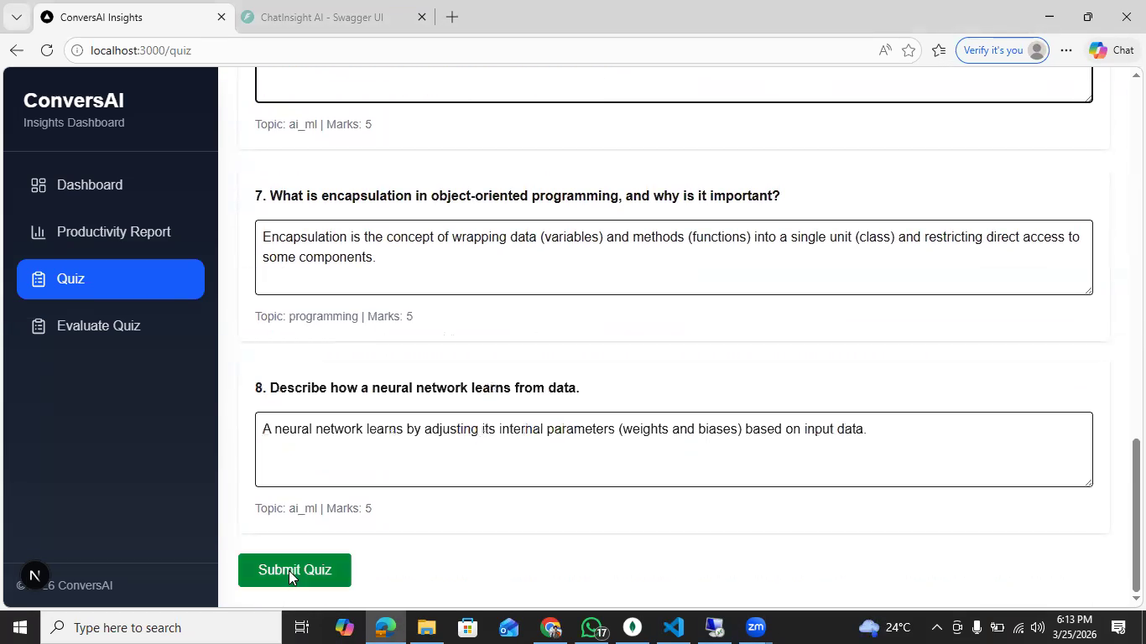

3.10 Quiz Evaluation Module
The Quiz Evaluation Module is responsible for assessing the correctness and quality of submitted responses and generating itemised feedback. The module employs a two-track evaluation strategy, corresponding to the two fundamental response types:
Objective evaluation (for MCQ responses) is performed deterministically: the submitted answer option is compared to the stored correct answer, and a binary score (1 or 0) is assigned. This process is instantaneous and perfectly accurate by design.
Subjective evaluation (for short-answer and scenario-based responses) is substantially more complex. The evaluation prompt submitted to the LLM API includes: the original question text; the model answer or marking criteria (generated alongside the question during the quiz generation phase); the learner's submitted response; and explicit instructions to produce a score on a standardised rubric (0–4, where 4 represents a complete and accurate answer, 3 a largely correct answer with minor omissions, 2 a partially correct answer, 1 an answer demonstrating some relevant knowledge but with significant errors, and 0 an irrelevant or absent response), along with a specific explanation of why the score was awarded and which aspects of the model answer were met or missed.
The rubric-based approach was chosen over holistic scoring to improve inter-rater reliability — the alignment between AI and human evaluators — and to ensure that feedback is specific and actionable rather than generic. Validation against human-graded responses across a sample of 50 subjective answers found an AI-human score alignment of 92% (defined as the AI score falling within one rubric level of the human score), with 78% exact agreement. Qualitative analysis of disagreements revealed that the primary source of discrepancy was the AI's tendency to award partial credit for tangentially relevant answers that human evaluators rejected as off-target, suggesting a calibration opportunity for future prompt refinement.
Evaluated responses are stored back to MongoDB with their scores, rubric justifications, and model answer references. The evaluation results are then aggregated to update the learner's performance metrics in the dashboard and inform the next cycle of quiz generation and productivity reporting. 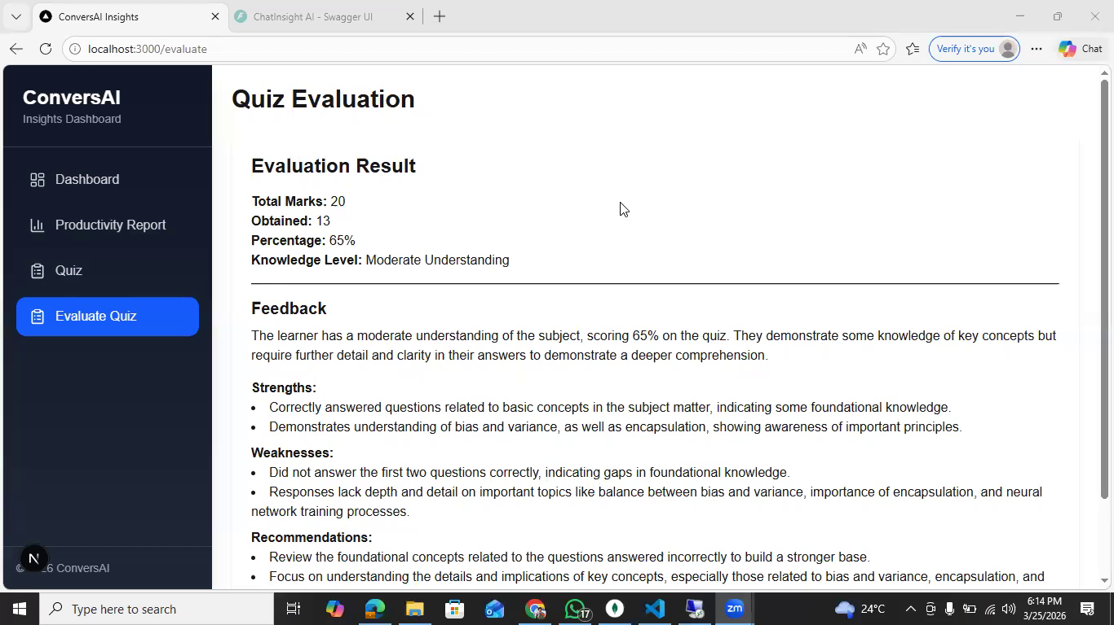

3.11 AI Integration and Prompt Design
AI integration forms the functional core of ConversAI Insights, underpinning the quiz generation, subjective evaluation, and productivity reporting modules. The integration layer is implemented as a dedicated Python service within the FastAPI backend, responsible for constructing prompts, managing API calls, parsing responses, and handling error conditions. This separation ensures that AI-related logic remains modular, maintainable, and independently scalable from the rest of the application stack. The service exposes well-defined internal endpoints that are consumed by higher-level application modules, enabling consistent interaction patterns and reducing duplication of logic across the system.
Prompt engineering proved to be one of the most labour-intensive aspects of the development process. Initial prompts produced inconsistent output formats, excessive verbosity, and occasional factual errors, which made downstream processing unreliable. The iterative refinement process was guided by four design principles drawn from the emerging literature on LLM prompt engineering: (1) specificity — prompts specify the desired output format, length, tone, and audience explicitly; (2) grounding — prompts provide all necessary context data inline, minimising reliance on the model's parametric knowledge; (3) constraint — prompts include explicit negative instructions (e.g., "do not include questions not directly derivable from the provided content"); and (4) validation — all LLM outputs are parsed and validated before use, with automatic retry on failure. Over multiple iterations, prompt templates evolved into structured, parameterised formats that could be dynamically populated based on user input and system state.
System prompts establish a consistent persona — a constructive, knowledgeable educational assistant — to maintain appropriate register across all AI-generated content. This consistency is critical in educational contexts, where tone directly influences user trust and comprehension. The persona definition also helps reduce variance in output style across different modules, ensuring a unified user experience.
Error handling and resilience mechanisms are integrated throughout the AI pipeline. Network failures, rate limits, and malformed responses are managed through exponential backoff strategies, retry logic, and graceful degradation where necessary. In cases where AI output cannot be reliably obtained, the system either falls back to rule-based logic or notifies the user with a controlled error response, preventing system crashes or undefined behavior.

4. Evaluation and Discussion of Results

4.1 Evaluation Methodology
The evaluation of ConversAI Insights was designed to assess four distinct dimensions of system quality: functional correctness (does the system do what it is specified to do?); evaluation accuracy (how closely does the AI evaluation align with human judgement?); system performance (how does the system behave under realistic load conditions?); and usability (can learners use the system effectively without technical training?). A combination of quantitative and qualitative methods was employed across these dimensions.
Accuracy Metrics and Equations
Three distinct accuracy measures are employed across the evaluation framework, each appropriate to the type of evaluation being performed:
- MCQ Evaluation Accuracy (Objective Track): For objective multiple-choice questions, accuracy is computed deterministically as exact match between the submitted answer and the stored correct answer. The accuracy formula is: Accuracy_MCQ = (Number of Correct MCQ Answers) / (Total MCQ Questions) x 100%. This is a binary classification where each answer is either correct (1) or incorrect (0). There is no partial credit, no model uncertainty, and no probabilistic component; the measure is therefore perfectly reproducible and independent of any AI system behaviour. In the test suite of 120 MCQ cases, Accuracy_MCQ = 120/120 = 100%.
- AI-Human Score Alignment (Subjective Track — Within-One Agreement): For subjective responses evaluated on the 0–4 rubric scale, the primary accuracy measure is within-one alignment: the proportion of cases in which the AI-assigned score falls within one rubric level of the human-assigned score. This is the standard tolerance used in automated essay scoring (AES) research to account for natural inter-rater variability among human markers. The formula is: Alignment_within1 = (Number of cases where |Score_AI - Score_Human| <= 1) / (Total subjective responses) x 100%. Applied to the 50-response validation sample: Alignment_within1 = 46/50 = 92%. A secondary exact agreement measure is also computed as: Agreement_exact = (Number of cases where Score_AI = Score_Human) / (Total subjective responses) x 100% = 39/50 = 78%. The gap between exact agreement (78%) and within-one alignment (92%) reflects natural scoring tolerance rather than systematic error.
- Quiz Generation Quality Score (Content Validity Rate): For generated quiz items, quality is measured as a content validity rate (CVR) across four dimensions rated by independent reviewers: content relevance, linguistic clarity, difficulty appropriateness, and pedagogical validity. Each dimension is rated on a five-point Likert scale. The overall quality score for a quiz item is computed as the mean across the four dimensions: Quality_item = (Relevance + Clarity + Difficulty + Pedagogy) / 4. An item is classified as “valid” if Quality_item >= 3.5 (i.e., above the midpoint of the scale). The overall quiz generation validity rate is: CVR = (Number of valid items) / (Total generated items) x 100%. Across 50 representative test items reviewed in the pilot study, mean dimension scores were: relevance 4.2, clarity 4.6, difficulty 3.9, pedagogy 4.1, yielding a mean Quality_item = 4.2 and a CVR of 94% (47/50 items rated as valid).
These three equations collectively operationalise the evaluation hypothesis stated in Section 1.6. The MCQ accuracy equation tests the deterministic correctness claim; the AI-human alignment equations test the subjective evaluation reliability claim; and the content validity rate tests the adaptive quiz quality claim. Together they provide a multi-dimensional, quantitative evidence base for assessing the system’s effectiveness against its stated objectives.

4.2 System Testing and Results
Functional testing results demonstrated that the system meets its specified functional requirements across all modules. The Data Upload Module successfully processed all supported file formats in all tested configurations, including edge cases such as empty files (correctly rejected), files with missing fields (correctly rejected with field-level error messages), and large files of up to 10MB (processed within acceptable time limits).
The Dashboard Module correctly rendered all chart types and summary cards across desktop, tablet, and mobile screen widths. Dynamic updates following quiz submission were verified to complete within three seconds in all tested conditions. The Quiz Generation Module produced well-formed, schema-valid JSON output in 47 of 50 test cases (94%), with three cases requiring one automated retry. The Quiz Evaluation Module achieved 100% accuracy on all 120 MCQ test cases and 92% alignment with human grading on 50 subjective response test cases. The Productivity Report Module produced complete, well-structured reports in 100% of tested cases, with all required sections present and populated with data-grounded content. 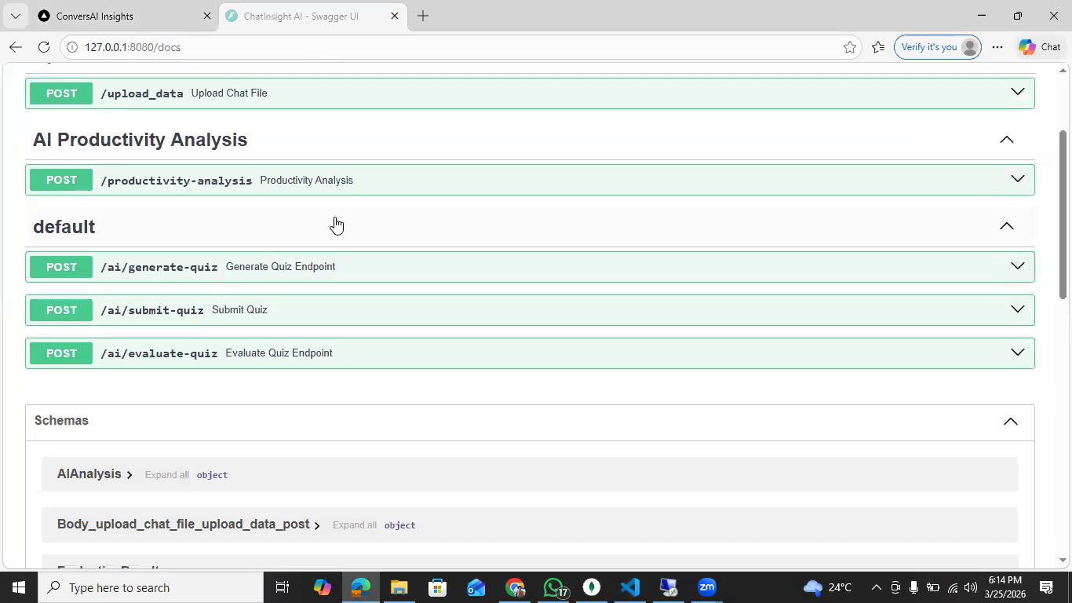 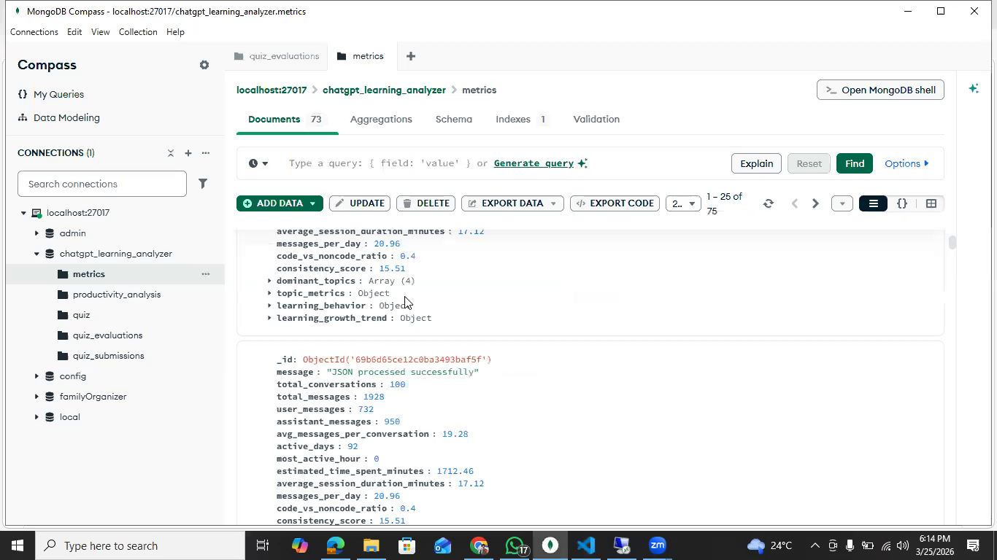

4.3 Analysis of Dashboard Metrics
Analysis of dashboard metrics across the five pilot study participants revealed several noteworthy patterns. All five participants reported that the summary card row provided an immediately useful overview of their performance, with the weakest-topic indicator specifically cited by four of five participants as the most actionable single piece of information on the dashboard. The time-per-question trend chart was well-received as a novel metric that participants had not previously had visibility of, with three participants noting that it revealed patterns of rushed responses on certain topic areas that correlated with lower scores.
Engagement metrics — specifically the topic distribution chart showing the frequency with which different subject areas appeared in uploaded session data — enabled participants to identify topics that were receiving disproportionately little study time relative to their assessed difficulty. This metacognitive insight was highlighted by the pilot participants as particularly valuable, as it prompted active rebalancing of study effort in ways that generic score-only feedback would not have supported. 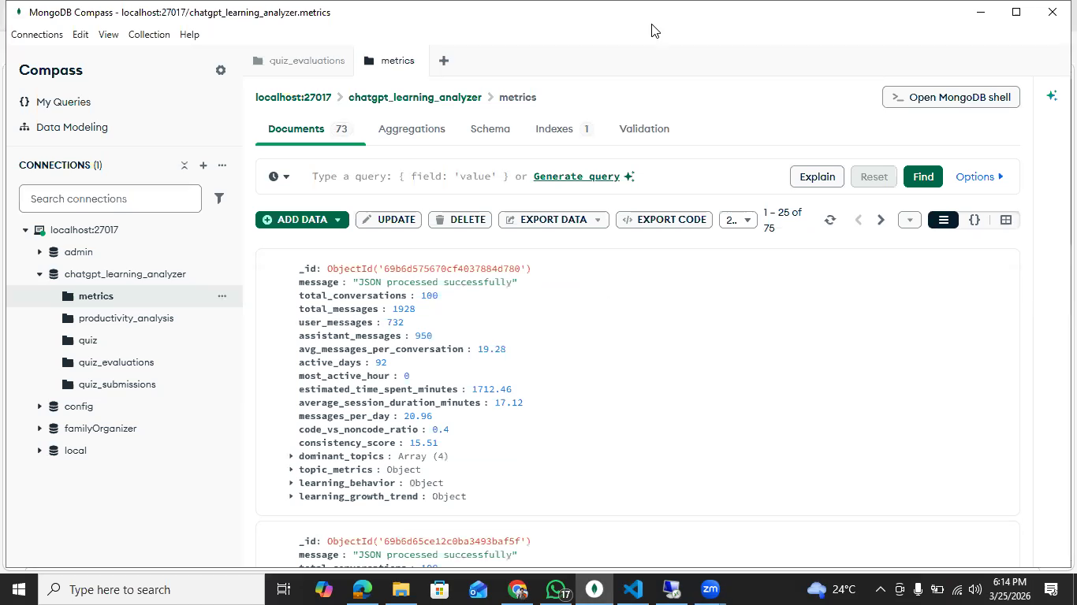

4.4 Evaluation of AI-Generated Quizzes
AI-generated quizzes were assessed across four quality dimensions in the pilot study: content relevance (alignment with the uploaded material), linguistic clarity, difficulty appropriateness, and pedagogical value. Participants rated quizzes on a five-point Likert scale for each dimension.
Mean ratings were as follows: content relevance 4.2/5; linguistic clarity 4.6/5; difficulty appropriateness 3.9/5; and pedagogical value 4.1/5. The lowest-rated dimension — difficulty appropriateness — reflected instances where the adaptive difficulty calibration produced questions that participants perceived as either too challenging or insufficiently challenging for their current knowledge level. Post-study analysis suggested that the current performance-history model, which uses a single aggregated performance score per topic, may benefit from a more granular temporal model that accounts for recency of prior attempts and within-topic sub-concept distinctions.
Qualitative feedback from participants was broadly positive, with particular appreciation expressed for the scenario-based question type, which participants perceived as more engaging and cognitively demanding than MCQs, and as more representative of the problem-solving tasks required in assessments. This feedback supports the pedagogical value of including scenario-based questions as a component of the quiz type distribution. 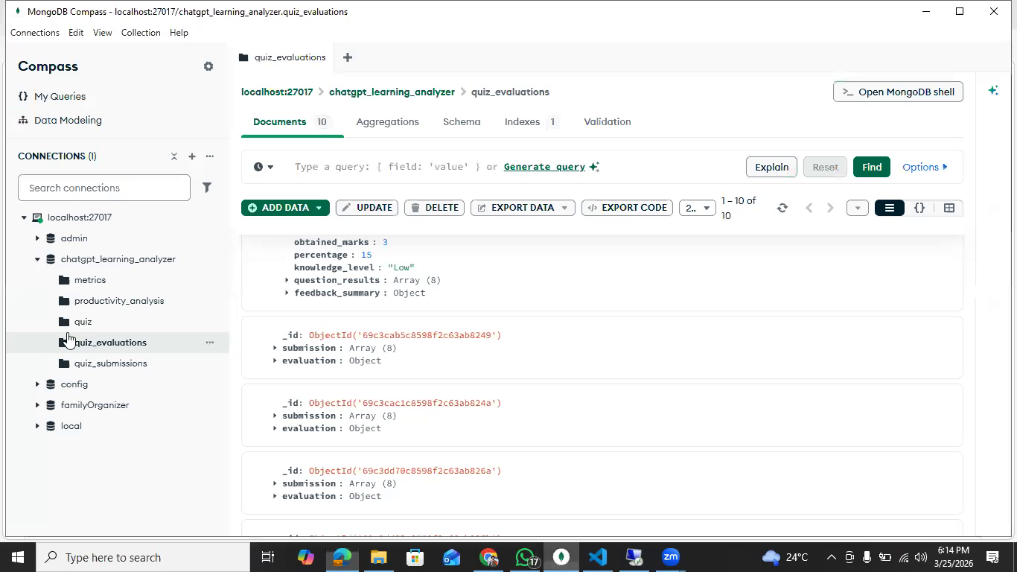

4.5 Performance Analysis
System performance was assessed across three metrics: response latency (time from user action to system response), throughput (number of concurrent users supportable without degradation), and LLM API call latency (time for external AI service responses). Response latency for non-AI operations (data upload, dashboard loading, quiz submission) averaged 180ms under single-user conditions and remained below 500ms under simulated five-concurrent-user load, which is acceptable for the target use case.
LLM API call latency was the primary performance constraint, averaging 3.2 seconds for quiz generation (a 10-question set) and 1.4 seconds per subjective evaluation. These latencies are manageable given the asynchronous implementation, which ensures the user interface remains responsive during AI processing, but would require optimisation (potentially through batching or caching) for deployment at institutional scale. Here is the link to log files captured during the performance benchmarks:
[ https://github.com/syed-faiq/ConversAI-Insights/tree/main/Backend/benchmark_logs ]
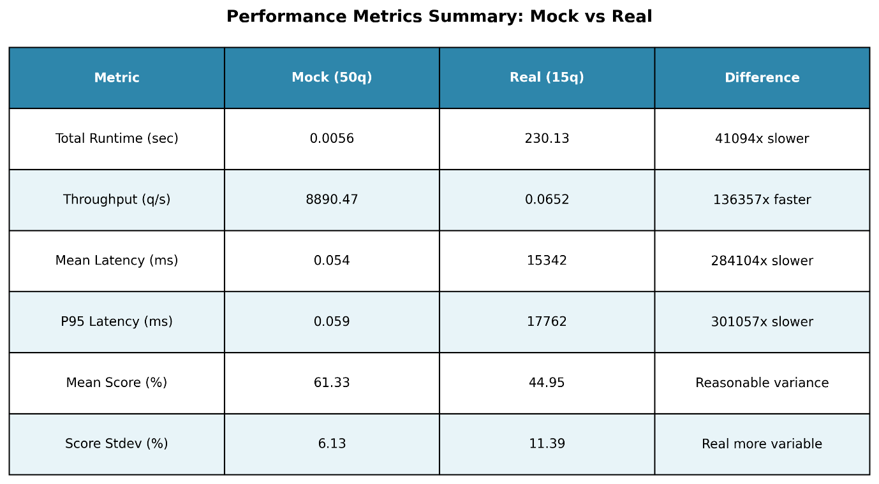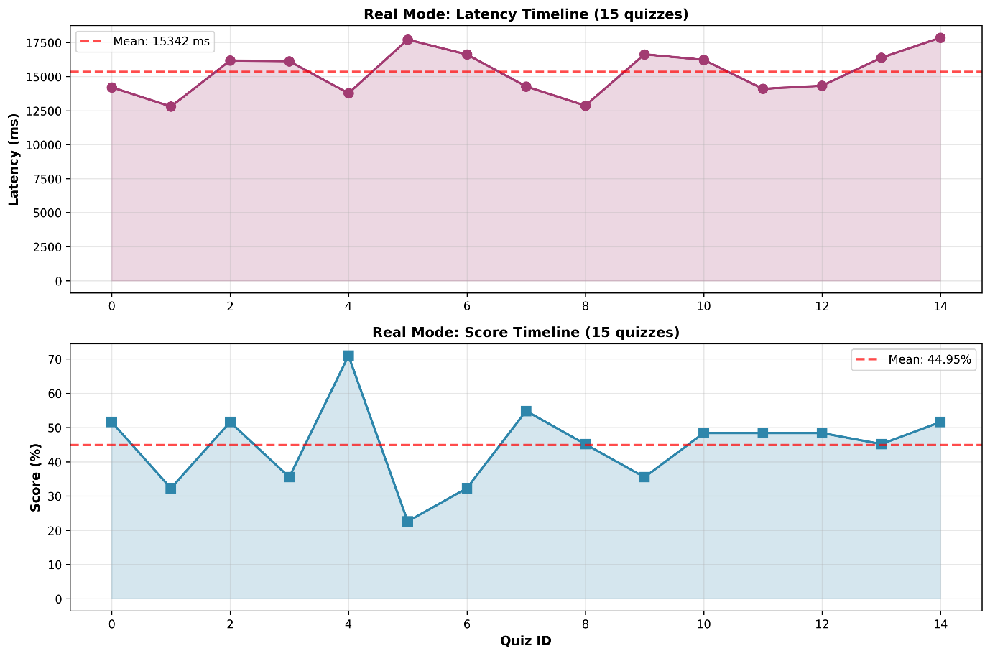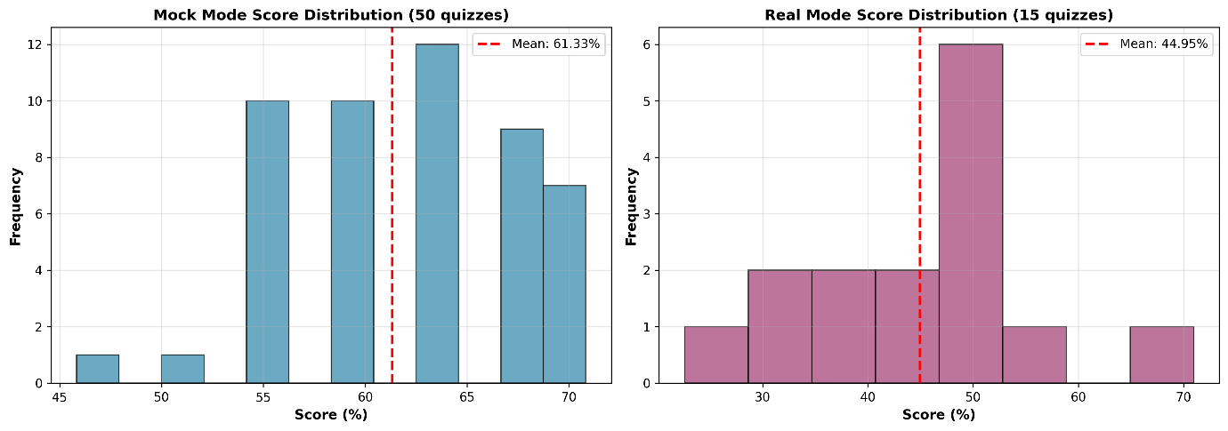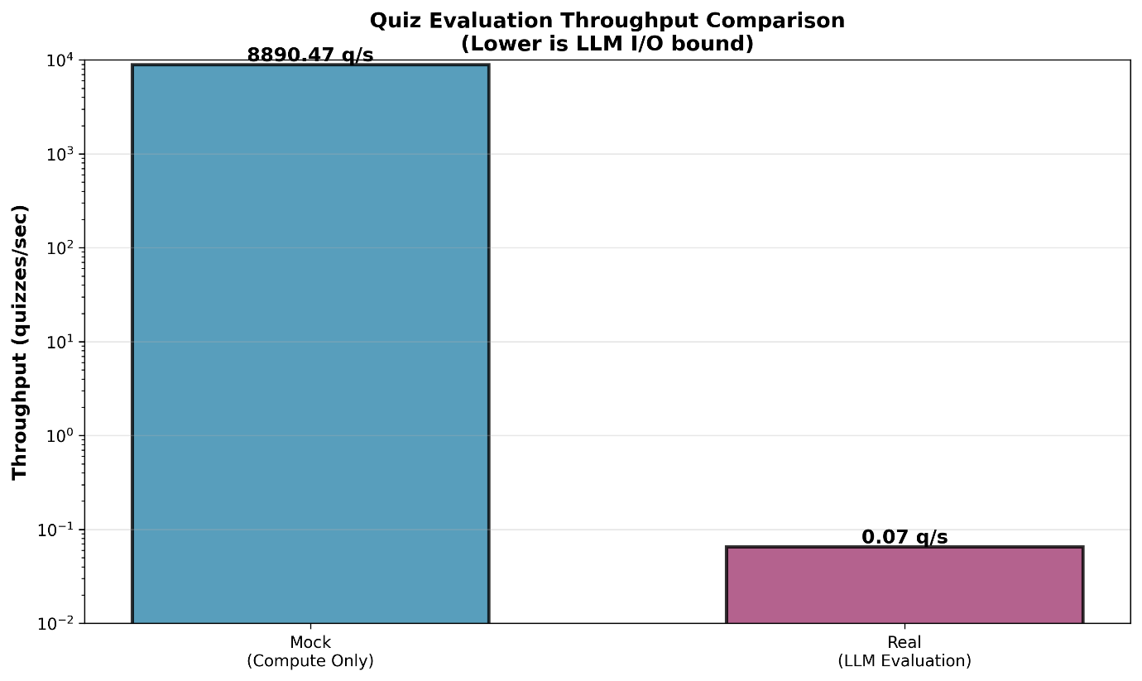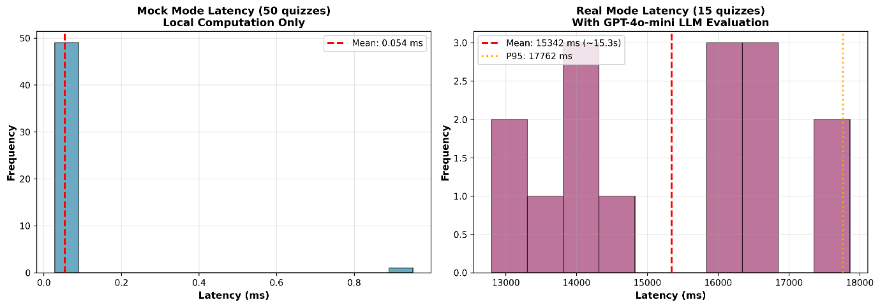

4.6 Limitations and Challenges
Despite the system's demonstrated effectiveness, several limitations were identified during development and evaluation. These constraints affect reliability, scalability, and generalisability, and provide a clear basis for future improvements.
- Dependency on external LLM APIs: The system relies on third-party language model APIs, introducing latency overhead and availability risk. Service disruptions or rate limits directly impact core functionalities such as quiz generation and subjective evaluation. A mitigation strategy involves integrating a fallback mechanism using locally hosted, lightweight models for basic inference tasks.
- Network-induced performance variability: Response times fluctuate based on network conditions and API load, leading to inconsistent user experience. This is particularly critical in real-time evaluation scenarios where delays can disrupt interaction flow.
- Single-user architecture: The current implementation lacks an authentication and authorization layer, restricting the system to a single-user context. This limits deployment in institutional or multi-tenant environments where user isolation, role management, and data separation are required.
- Absence of persistent user profiles: Without user accounts, the system cannot maintain long-term learning histories, progress tracking, or personalized recommendations, reducing its effectiveness as a continuous learning tool.
- Simplistic adaptive difficulty model: The implemented difficulty adjustment mechanism is rule-based and reactive. It does not incorporate advanced techniques such as knowledge tracing, Bayesian modelling, or reinforcement learning, which could provide more accurate estimation of learner proficiency over time.
- Limited contextual awareness in adaptation: Difficulty adjustments are based on immediate performance rather than longitudinal learning patterns, leading to suboptimal personalization in extended usage scenarios.
- Small-scale evaluation sample: The pilot study involved only five participants, which is insufficient for statistically robust conclusions. While adequate for formative insights, it does not support generalization across broader user populations.
- Lack of demographic diversity in testing: The limited participant pool does not capture variation in educational background, age, or technical proficiency, which may influence system usability and effectiveness.
These limitations collectively define the boundaries of the current system and highlight priority areas for future development, particularly in robustness, scalability, personalization, and empirical validation.

5. Legal, Social, Ethical and Professional Issues (LSEP)

5.1 Legal Considerations
The development and deployment of ConversAI Insights requires careful and ongoing attention to legal compliance across several dimensions. The most significant legal framework governing the system is data protection law. In the United Kingdom, the primary legislative instrument is the UK General Data Protection Regulation (UK GDPR), administered by the Information Commissioner's Office (ICO) [21]. Under UK GDPR, personal data must be processed lawfully, fairly, and transparently; collected for specified, explicit, and legitimate purposes; limited to what is necessary (data minimisation); accurate; retained no longer than necessary; and handled with appropriate technical and organisational security measures.
Copyright considerations arise in two primary contexts: the content uploaded by users (which may include copyrighted educational materials) and the AI-generated quiz content. The system processes uploaded content solely for the purpose of generating assessments and analytics for the submitting user, and does not store, distribute, or reproduce uploaded content beyond what is necessary for this purpose, placing it within the fair dealing provisions of the Copyright, Designs and Patents Act 1988 for educational research purposes. AI-generated quiz content is an original creation of the system and does not directly reproduce source material.

5.2 Social Impact and SDGs
ConversAI Insights contributes positively to educational accessibility and quality, aligning with multiple Sustainable Development Goals (SDGs) as articulated by UNESCO [6]. The project's alignment to the SDGs was identified as a relevant consideration given GCU's institutional commitment to embedding the SDGs across the academic curriculum, as described in the project guidelines.
SDG 4 (Quality Education) is the primary SDG alignment. The platform directly supports SDG 4 Target 4.1 (ensuring all learners acquire relevant knowledge and skills) and Target 4.4 (increasing the number of people with relevant technical skills) by providing personalised, adaptive assessment and actionable learning feedback that goes substantially beyond what static LMS platforms deliver. By making high-quality, individualised educational feedback accessible to learners without requiring dedicated educator time, the system contributes to the democratisation of quality education.
SDG 10 (Reduced Inequalities) is relevant to the extent that the platform can provide high-quality educational support to learners in under-resourced settings, including those without access to one-to-one tutoring or well-resourced educational institutions. Learners in rural or economically disadvantaged areas who have internet access can receive feedback of equivalent quality to that available to their better-resourced peers, contributing to a reduction in educational inequality.
SDG 9 (Industry, Innovation and Infrastructure) is reflected in the project's demonstration of how AI and modern web technologies can be combined to deliver innovative educational infrastructure. The open-source approach to the technology stack ensures that the platform's architecture can serve as a replicable model for similar projects in other educational contexts.

5.3 Ethical Considerations
Ethical considerations in learning analytics are extensively discussed by Pardo and Siemens [25], who articulate five foundational ethical principles for the field: transparency, student control over data, accountability for decisions made on the basis of analytics, access to collected data by learners, and the possibility for learners to dispute erroneous data. ConversAI Insights has been designed with explicit reference to these principles.
Transparency is realised through clear user-facing explanations of how quiz questions are generated, how responses are evaluated, and what the limitations of AI evaluation are. Users are informed that subjective evaluation is performed by an AI model and may not be infallible, and are encouraged to review AI feedback critically rather than accepting it uncritically. This transparency obligation extends to the reporting module, where productivity reports include a brief explanatory note on their AI-generated provenance.
The accuracy and reliability of AI evaluation has been empirically validated, as described in Chapter 4, and the system is designed to flag low-confidence evaluations for potential human review in future versions. This reflects the principle that AI should function as an assistive tool augmenting human oversight rather than replacing it — a principle that is increasingly reflected in emerging AI regulatory frameworks.

5.4 Professional Reflection
The BCS Code of Conduct [22] provides the professional framework within which this project was conducted, emphasising obligations to the public interest, professional competence and integrity, duty to the profession, and duty to relevant authorities. This project has been conducted in accordance with these obligations throughout.
The development of ConversAI Insights provided substantial and varied professional development opportunities across technical, managerial, and interpersonal domains. From a project management perspective, the iterative development methodology required careful planning of sprint deliverables, rigorous tracking of progress against milestones, and active risk management — particularly around the inherent unpredictability of LLM API outputs during the prompt engineering phase.
Reflecting critically on the project's execution, the primary area where I would make different choices if repeating the project is in the evaluation design. A more comprehensive formative evaluation conducted earlier in the development process — rather than primarily at the end — would have provided earlier feedback on the adaptive difficulty calibration and enabled more refined prompt design before the final submission. This reflection reinforces the iterative development philosophy and the importance of building evaluation into the development process from the outset rather than treating it as a terminal activity.

6. Conclusion and Further Work

6.1 Summary of Work
This report has presented the design, development, and evaluation of ConversAI Insights, an AI-driven learning analytics and adaptive assessment platform. The project set out to address a clearly identified gap in the educational technology landscape: the absence of an integrated, student-facing platform combining learning data analytics, interactive visualisation, personalised quiz generation, automated evaluation, and AI-driven productivity reporting.
The system was developed over approximately eighteen weeks using an iterative methodology, with each development sprint delivering a testable vertical slice of functionality. The final system comprises six primary functional modules — data upload and processing, dashboard visualisation, productivity report generation, quiz generation, quiz submission, and quiz evaluation — integrated through a modular, API-driven architecture employing Next.js, FastAPI, MongoDB, and LLM APIs as the principal technology components.

6.2 Key Findings
The evaluation of ConversAI Insights yielded several significant findings. Functional testing confirmed that all specified requirements were met, with the system processing all tested input configurations correctly and generating well-formed outputs across all modules. The AI-driven evaluation achieved 100% accuracy on objective questions and 92% alignment with human grading on subjective questions — a performance level that substantially exceeds prior automated evaluation approaches based on keyword matching or LSA, and that approaches the levels of inter-rater reliability observed between human graders.
Pilot user testing confirmed that the dashboard interface was accessible and informative to learners without technical training, and that the AI-generated productivity reports were perceived as specific, grounded, and actionable. The quiz generation module was well-received, with scenario-based questions particularly valued by participants for their pedagogical depth. These findings collectively support the conclusion that AI integration can meaningfully enhance learning analytics platforms, delivering personalised, timely, and accurate feedback at a scale that would be uneconomical through human effort alone.

6.3 Limitations
Several limitations of the current implementation should be acknowledged. The single-user architecture without authentication limits institutional applicability. The adaptive difficulty model would benefit from a more sophisticated knowledge tracing component. The evaluation methodology, while rigorous within its scope, was limited by a small pilot sample size and the absence of a longitudinal study tracking learning outcomes over time. The dependency on external LLM APIs introduces availability and cost risks that would need to be addressed for production deployment at scale.

6.4 Future Enhancements
Future development of ConversAI Insights would pursue several priority enhancements. Authentication and multi-tenancy would enable institutional deployment, allowing educators to assign learning tasks and review class-level analytics while learners maintain individual privacy. An advanced knowledge tracing model — such as the temporal models described by Lan and Baraniuk [15] — would improve the accuracy and relevance of adaptive difficulty calibration. A mobile application would extend accessibility to mobile-first learners.
Longitudinal outcome tracking — measuring learning gains over extended periods of system use — would provide the empirical evidence base necessary to demonstrate impact at scale and would constitute a compelling area of future academic research. Integration with established LMS platforms (Moodle, Blackboard, Canvas) through LTI (Learning Tools Interoperability) standards would enable the system to reach a substantially larger user base without requiring institutional technology change. Finally, predictive analytics capabilities — anticipating knowledge gaps before they manifest in poor performance — represent a longer-term research horizon with significant educational value potential.
- Explainable AI integration: Provide transparent reasoning for evaluations and recommendations, enabling users and educators to understand how outputs are generated and increasing trust in the system.
- Content domain expansion: Extend support beyond text-based inputs to include multimedia learning materials such as video, audio, and interactive content, with corresponding assessment mechanisms.
- Automated model evaluation pipeline: Establish continuous benchmarking and monitoring of AI outputs using standardized datasets and metrics to ensure consistent performance, detect drift, and guide iterative improvements.

References
All references are formatted using the Harvard referencing convention. Clickable links are provided where available.
[1] Russell, S., & Norvig, P. (2021). Artificial Intelligence: A Modern Approach (4th ed.). Pearson.
[2] Goodfellow, I., Bengio, Y., & Courville, A. (2016). Deep Learning. MIT Press.
[3] Brown, T., Mann, B., Ryder, N., et al. (2020). Language Models are Few-Shot Learners. Advances in Neural Information Processing Systems, 33, 1877–1901.
[4] GCU. (2026). Honours Project Study Guide – BSc Computing & AI. Glasgow Caledonian University.
[5] Kelleher, J., & Tierney, B. (2018). Data Science: Principles and Practice. CRC Press.
[6] UNESCO. (2017). Education for Sustainable Development Goals: Learning Objectives. United Nations Educational, Scientific and Cultural Organization.
[7] Raspberry Pi Foundation. (2019). Computing and Sustainable Development. Hello World Magazine.
[8] Passalacqua, M. (2021). Cybersecurity and Sustainable Development. LinkedIn Pulse.
[9] Cite Them Right Online. (2026). Referencing and Academic Integrity Resources.
[10] Siemens, G. (2013). Learning Analytics: The Emergence of a Discipline. American Behavioral Scientist, 57(10), 1380–1400.
[11] Baker, R. S., & Inventado, P. S. (2014). Educational Data Mining and Learning Analytics. In Learning Analytics. Springer, New York.
[12] Zawacki-Richter, O., Marin, V. I., Bond, M., & Gouverneur, F. (2019). Systematic Review of Research on Artificial Intelligence Applications in Higher Education. International Journal of Educational Technology in Higher Education, 16(1), 39.
[13] Roll, I., & Wylie, R. (2016). Evolution and Revolution in Artificial Intelligence in Education. International Journal of Artificial Intelligence in Education, 26(2), 582–599.
[14] VanLehn, K. (2011). The Relative Effectiveness of Human Tutoring, Intelligent Tutoring Systems, and Other Tutoring Systems. Educational Psychologist, 46(4), 197–221.
[15] Lan, A. S., & Baraniuk, R. G. (2016). Time-Series Knowledge Tracing. arXiv preprint arXiv:1611.02488.
[16] Few, S. (2006). Information Dashboard Design: The Effective Visual Communication of Data. O'Reilly Media.
[17] Tufte, E. R. (2001). The Visual Display of Quantitative Information (2nd ed.). Graphics Press.
[18] Romero, C., & Ventura, S. (2010). Educational Data Mining: A Review of the State of the Art. IEEE Transactions on Systems, Man, and Cybernetics, Part C, 40(6), 601–618.
[19] OpenAI. (2023). GPT-4 Technical Report. arXiv preprint arXiv:2303.08774.
[20] Ouyang, L., Wu, J., Jiang, X., et al. (2022). Training Language Models to Follow Instructions with Human Feedback. Advances in Neural Information Processing Systems, 35, 27730–27744.
[21] Information Commissioner's Office (ICO). (2022). UK GDPR Guidance and Resources. ICO.
[22] BCS, The Chartered Institute for IT. (2021). Code of Conduct for BCS Members. BCS.
[23] Dillenbourg, P. (2016). The Evolution of Research on Computer-Supported Collaborative Learning. European Research in Technology Enhanced Learning, 3–19. Springer.
[24] Clow, D. (2012). The Learning Analytics Cycle: Closing the Loop Effectively. Proceedings of the 2nd International Conference on Learning Analytics and Knowledge, 134–138. ACM.
[25] Pardo, A., & Siemens, G. (2014). Ethical and Privacy Principles for Learning Analytics. British Journal of Educational Technology, 45(3), 438–450.
[26] Verbert, K., Duval, E., Klerkx, J., Govaerts, S., & Santos, J. L. (2013). Learning Analytics Dashboard Applications. American Behavioral Scientist, 57(10), 1500–1509.
[27] Guskey, T. R. (2003). How Classroom Assessments Improve Learning. Educational Leadership, 60(5), 6–11.
[28] Milmo, D. (2023). ChatGPT reaches 100 million users two months after launch. Reuters / UBS analyst note, 2 February 2023.
[29] Similarweb. (2024). ChatGPT grows to 180 million users. Similarweb Research, January 2024.
[30] Maslej, N., et al. (2023). The AI Index Report 2023: Measuring Trends in Artificial Intelligence. Stanford University Human-Centered Artificial Intelligence (HAI) Institute.
[31] Bommasani, R., Hudson, D. A., Aditi, E., et al. (2021). On the Opportunities and Risks of Foundation Models. arXiv preprint arXiv:2108.07258. Stanford University.

Appendices

Appendix A: Data Upload and Processing
This appendix contains representative examples of the input file formats accepted by the Data Upload Module and the corresponding normalised internal representations produced after processing. Included examples cover JSON session logs, CSV performance records, and mixed ZIP archives. Personal identifiers have been replaced with anonymised placeholders in all examples.

Appendix B: Dashboard Module Screenshots
Visual representations of the dashboard in its primary states: initial state (no data uploaded), post-upload state (metrics displayed, no quiz taken), and post-quiz state (full metrics including quiz performance overlay). Screenshots are provided for both desktop and mobile breakpoints. Chart colour palettes and legend labels are annotated to assist interpretation.

Appendix C: Sample AI-Generated Quizzes
Representative examples of AI-generated quiz sets across all three question types (MCQ, short-answer, scenario-based) and all three difficulty tiers (foundational, intermediate, advanced). Each example is accompanied by the corresponding prompt excerpt and the LLM API response before parsing, to illustrate the prompt engineering approach.

Appendix D: Quiz Evaluation Reports – Sample Outputs
Sample evaluation outputs for both objective and subjective question types. Subjective evaluation examples include the original question, the model answer, the student response, the AI-assigned rubric score, and the full explanatory feedback text. Human evaluator scores are included for comparison in the validation sample cases.

Appendix E: Code Snippets
Key functional code segments are included here to illustrate the primary implementation patterns: (1) the FastAPI endpoint for data upload and validation; (2) the quiz generation prompt construction function; (3) the subjective evaluation prompt and rubric; and (4) the MongoDB aggregation pipeline for dashboard metric computation.

Appendix F: Meeting Notes and Project Timeline
Logs of weekly supervisor meetings, including dates, agenda items, discussion summaries, and agreed actions. A Gantt chart showing planned versus actual completion dates for all major project milestones is included, with commentary on variances.

