Computer-assisted analysis of sperm concentration and motility from Makler chamber videos: technical report (53 samples)
Data for preparing a publication: recording conditions, processing parameters, classifier validation and per-sample results. Generated automatically.
Alikhan Magauiya · orda.ezhenid@gmail.com · 2026-10-08
1. Material
– 53 videos of native semen preparations were analysed (samples 1–53); identical duplicate files were excluded.
– Recordings are anonymised: samples are identified by sequential numbers, and no patient information was processed.
2. Equipment and recording

Parameter | Value
Counting chamber | Makler (Sperm Processor, India): 10 µm deep, 10 × 10 grid of 100 µm squares
Microscope | Olympus CX43 (Olympus Corporation, Japan)
Camera | ToupCam XCAM1080PHB (China)
Objective / magnification | [fill in]
Stage temperature | [fill in; unknown — see section 8]
Video resolution | 1920 × 1080, H.264
Frame rate | actual (frames / duration) ≈ 25 fps, while the container states 29.97 (variable frame rate). The actual rate was used.
Recording length | 30–83 s (51 median)
Scale | 0.3270 µm/px (range 0.3270–0.3300), from the grid pitch

3. Rationale of the method
Purpose and overall approach
Manual assessment of concentration and motility remains the basis of semen analysis but depends on the technician’s experience and a short observation time; the 6th edition of the WHO manual calls for standardization and quality control of exactly these steps [1, 2]. Computer-assisted sperm analysis (CASA) measures the trajectory of every cell and is therefore more objective, but its results depend on chamber type, frame rate and settings, and agreement with manual analysis decreases at high concentration and in the presence of debris and non-sperm cells [3, 4]. The software addresses the same task using ordinary microscope camera video, without dedicated hardware, and reports results in WHO 5th and 6th edition terms.
Counting chamber
A Makler chamber with a nominal depth of 10 µm was used, which allows concentration to be measured without dilution and motility to be assessed in the same preparation. The known layer depth converts the number of cells in the visible frame area into concentration (C = ΣN / (ΣS · h)). The actual depth of Makler chambers may exceed the nominal value (mean 11.1 µm for new and 12.7 µm for used chambers) [5]; in that case calculation with h = 10 µm overestimates concentration in proportion to the depth deviation. The 100 × 100 µm grid on the cover glass serves both as a scale reference and as a fixed landmark for compensating stage motion.
Stage-motion compensation
The operator moved the stage between fields during recording, so frame displacement had to be subtracted from cell coordinates; otherwise immotile objects would acquire spurious velocity. The shift between consecutive frames was estimated by phase correlation with sub-pixel refinement of the peak. The dark grid lines produce a strong, unambiguous peak even with many motile cells in view. Frames shifted by more than 6 pixels were excluded from tracking (motion blur), and only frames shifted by less than 1.5 pixels were used for counting.
Head detection and trajectory linking
In bright field a sperm head appears as a high-contrast oval of about 15 pixels. It was enhanced by the sum of black-hat and top-hat morphological transforms, which emphasize dark and bright objects of a given size regardless of uneven background; position was taken as the contrast-weighted centroid, giving sub-pixel accuracy. Bands along the grid lines and the frame border were excluded because heads are only partly visible there, and their area was subtracted from the counting area. Detections in consecutive frames were linked by solving an assignment problem (Hungarian algorithm) with position prediction from the last velocity. Automatic multi-sperm tracking in human image sequences followed by kinematic analysis is an established approach, and its main sources of error — crossing trajectories and lost objects — have been described [6].
Kinematics and motility classes
Standard CASA parameters — VCL, VSL, VAP, LIN, STR, WOB, ALH and BCF — were computed for every track. Curvilinear velocity and related measures depend strongly on frame rate [4], so classification used progression speed: the median displacement of the smoothed track over 1 s. It is closest to the WHO definition (“distance covered per second”) and depends little on frame rate. The 6th edition of the WHO manual again splits progressive motility into rapid (a, ≥ 25 µm/s) and slow (b, 5–25 µm/s) [1, 7]; WHO 5th classes were obtained by merging: PR = a + b, NP = c, IM = d. Class proportions were weighted by the observation time of each track: fast cells leave the field and are lost more often, so a plain track count would underestimate motility.
Debris rejection
Debris, round cells and aggregates are the main source of systematic error in CASA of human semen [3, 4]. Simple morphometric features did not separate heads from debris, so an appearance-based classifier was trained: histogram-based gradient-boosted decision trees (HistGradientBoostingClassifier, following the LightGBM approach) [8] on 110 rotation-invariant features. Performance was assessed only on videos not used for training, to avoid fitting to the peculiarities of a particular recording. Machine-learning methods for semen analysis are developing rapidly [9, 10], including on open annotated video datasets [11]; clinical use of such models nevertheless requires external validation and a transparent description of the training data [10].
Concentration and its precision
Concentration was calculated from every third still frame over the whole visible area rather than individual grid squares. This increases the number of cells counted, which primarily determines the random counting error [1, 12]. Consecutive frames of one field are not independent, so the 95% confidence interval was derived from the variation in concentration between fields.
Interpretation by percentiles
Each parameter was compared with the WHO 2021 distribution for men whose partners conceived within 12 months [1, 13]. The lower reference limit is the 5th percentile of this distribution. A percentile shows where a sample lies among fertile men and is not a probability of conception: the distribution contains no data on infertile couples [13].
Validation plan
Assessing the accuracy of the software requires comparison with manual analysis of the same samples performed to WHO counting-quality requirements [1, 12]. Agreement is to be evaluated by Bland–Altman analysis — bias and 95% limits of agreement [14] — together with the intraclass correlation coefficient [15] and agreement on normal / below-normal categories, as in CASA validity studies [3].
4. Processing parameters

Parameter | Value
Stage-motion compensation | phase correlation on a 4× downscaled frame; tracking breaks at shift > 6 px; counting frames — shift < 1.5 px
Calibration | from the Makler grid pitch (100 µm), autocorrelation of the line mask
Head detection | black-hat + 0.7·top-hat, 21 px ellipse, Gaussian σ = 1.5, threshold 25, area 40–700 px; bands along grid lines and a 12 px border excluded
Tracking | Hungarian assignment; 7.5 µm/frame gate; up to 2 missed frames; track ≥ 0.5 s
Progression speed | median displacement of the smoothed track over 1 s
WHO 6th classes | a ≥ 25 µm/s; b 5–25 µm/s; c < 5 µm/s with head movement; d — the rest
Immotility VCL threshold | max(8 µm/s; 1.8 × median VCL of tracks with progression speed < 2 µm/s), per video
Class proportions | weighted by the number of frames each track was observed
Concentration | every 3rd still frame; C = ΣN / (ΣS · 10 µm); 95% CI from between-field variation (new field after cumulative shift > 150 px)
Classifier | HistGradientBoosting: 200 iterations, learning rate 0.05, ≤ 15 leaves, L2 = 1.0; 110 rotation-invariant features; probability threshold 0.5; 8 rotation/flip augmentations

5. Head-versus-debris classifier
578 objects from all 53 videos were labelled: 203 sperm heads, 278 debris objects, 97 unclear (excluded). Objects were sampled at random among slow tracks (classes c/d) and detections in counting frames — exactly where the classifier makes decisions.
Labelling was done by a single annotator on enlarged frame crops (48 × 48 px). It should be re-checked by a specialist before publication; the label file is attached.
Performance was estimated by video-wise cross-validation: 11 folds; objects from one video were never in training and test at the same time.
Table 1 – Head-versus-debris classifier performance on videos not used for training
Model and set | Objects / videos | Accuracy, % | AUC | Sensitivity, % | Specificity, % | Head-fraction error, pp
Video-wise cross-validation, 53 videos | 481 / 53 | 87.3 | 0.952 | 86.7 | 87.8 | 8.0
Note – “Head-fraction error” is the mean per-video absolute difference between true and predicted head fraction among labelled objects; with 6–7 objects per video the estimate is coarse.

6. Results
Concentration below 16 million/mL: 7 of 53 samples; PR below 30%: 14; total motility below 42%: 9.
Debris rejection lowered the concentration estimate by a median of 37% (range 8–92%), most strongly in low-concentration samples (Figure 5).
Half-width of the 95% CI of concentration: median 11% of the estimate (samples with ≥ 2 fields).
Table 2 – Summary of 53 samples
Parameter | Median | Q1–Q3 | Min–max | Below WHO 6th lower limit, n (%)
Concentration, million/mL | 57.0 | 24.5–105.4 | 4.0–226.2 | 7 (13)
Progressive motility (a + b), % | 49.5 | 28.9–67.4 | 3.7–92.5 | 14 (26)
Total motility, % | 84.2 | 52.5–94.4 | 12.5–99.7 | 9 (17)
a, % | 13.6 | 1.6–30.3 | 0.0–59.9 | —
b, % | 31.5 | 20.6–40.3 | 3.2–65.6 | —
c, % | 21.8 | 13.7–36.3 | 3.8–58.5 | —
d, % | 15.8 | 5.6–47.5 | 0.3–87.5 | —
VCL of motile cells, µm/s | 34.6 | 24.3–44.4 | 10.6–60.2 | —
VSL of motile cells, µm/s | 18.3 | 11.9–21.3 | 5.0–30.4 | —
LIN | 0.48 | 0.44–0.56 | 0.28–0.81 | —
Change in concentration after debris rejection, % | -37 | -58–-19 | -92–-8 | —

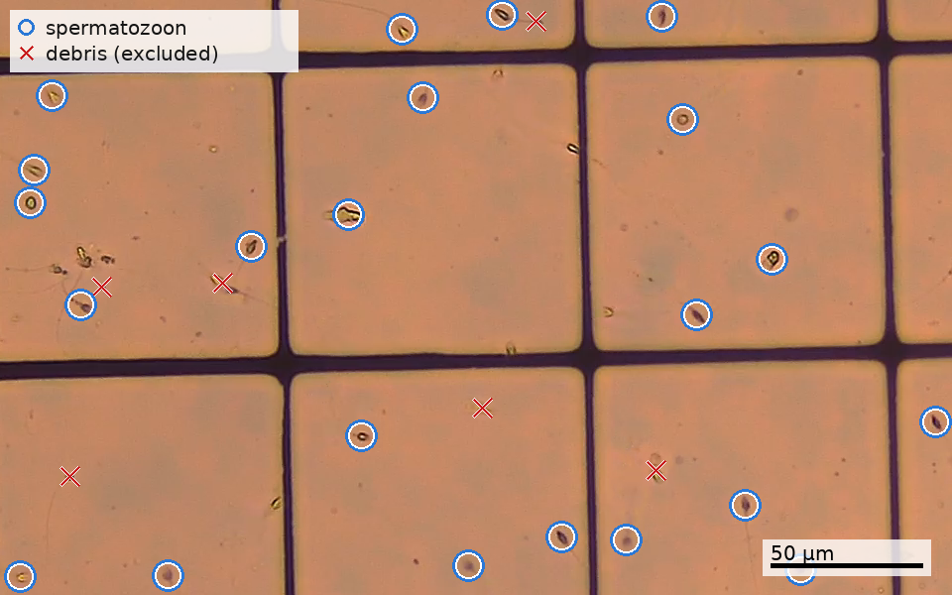
Figure 1 – Crop of a counting frame from sample 28: blue circles — objects accepted as spermatozoa; red crosses — objects classified as debris by the classifier. Objects near grid lines and the frame border are excluded from counting and not marked
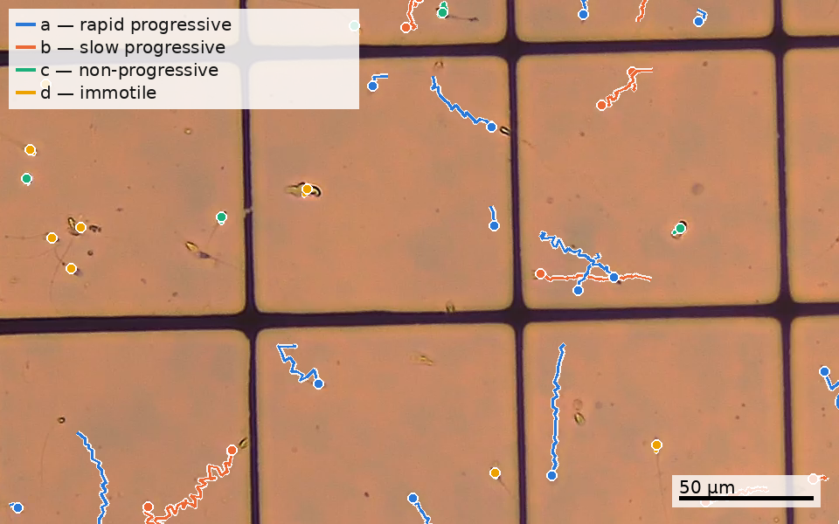
Figure 2 – Sperm trajectories over 2 s ending at the same frame (sample 28); colour — WHO 6th class, dot — head position in the frame shown
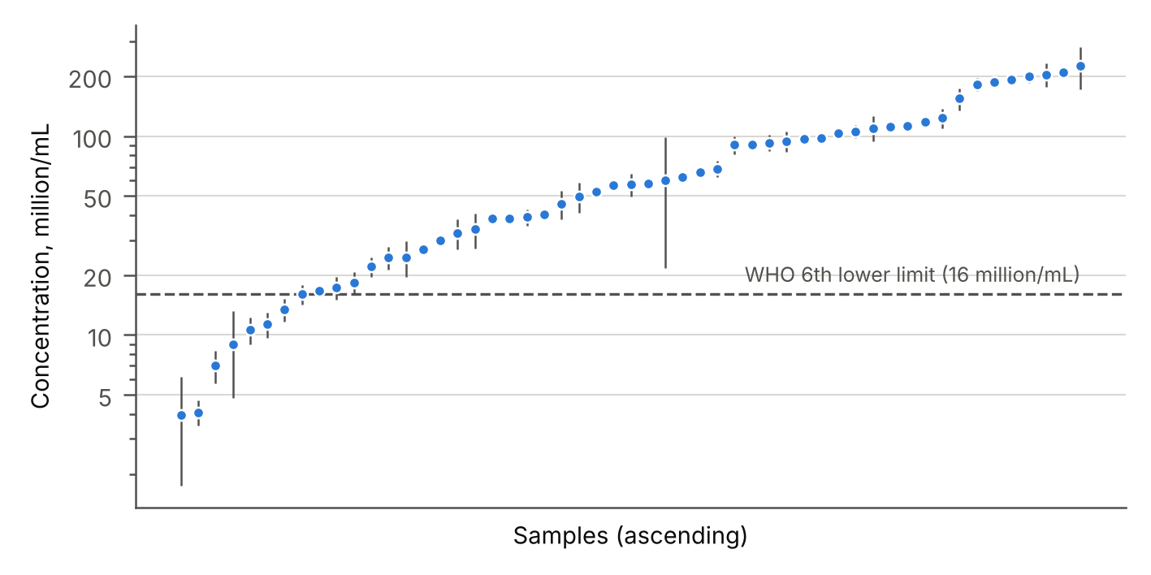
Figure 3 – Sperm concentration in 53 samples (95% CI; dashed line — WHO 6th lower limit, 16 million/mL)
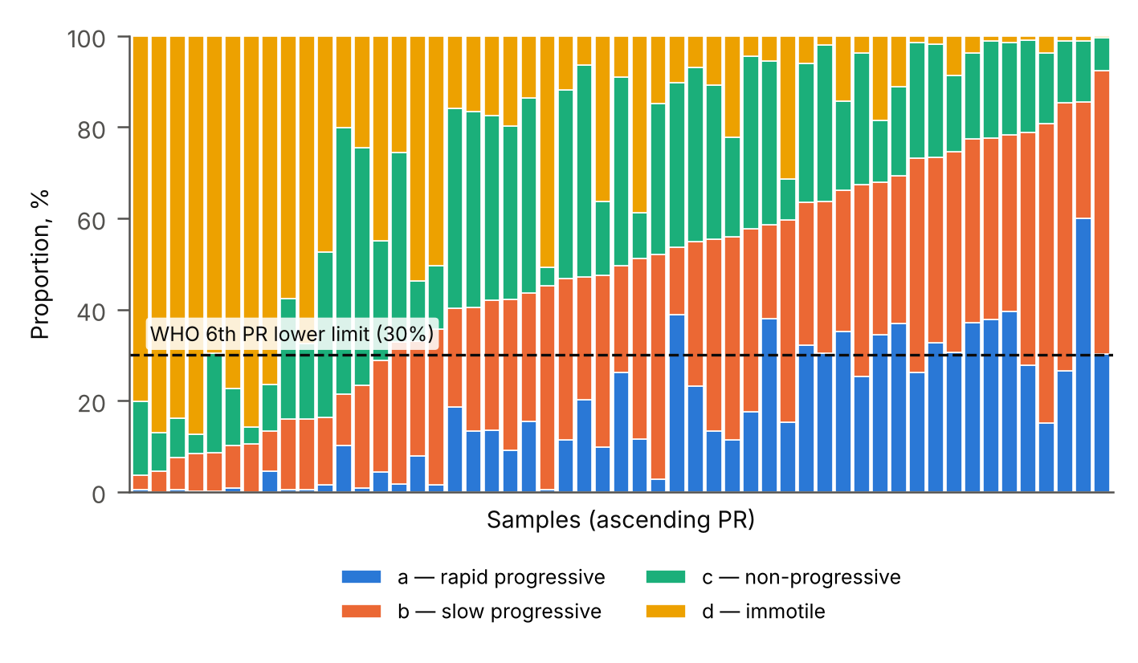
Figure 4 – WHO 6th motility classes (samples ordered by PR; dashed line — PR lower limit, 30%)
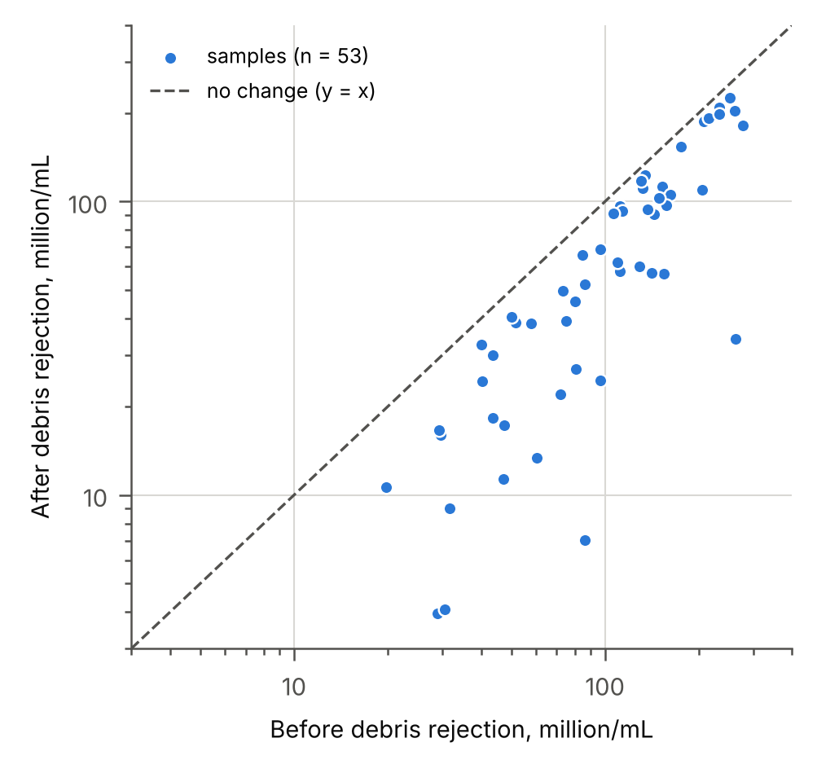
Figure 5 – Concentration before and after debris rejection by the classifier

Table 3 – Results per sample
Sample | fps | Fields | Conc., M/mL (95% CI) | Pctl | a | b | c | d | PR | PR pctl | Total | VCL | VSL | LIN | Debris, %
1 | 25.0 | 15 | 38.6 (36.3–41.0) | 27 | 34 | 33 | 14 | 19 | 68 | 84 | 81 | 44.4 | 22.2 | 0.49 | -25
2 | 25.0 | 19 | 112.8 (107.1–118.5) | 76 | 11 | 45 | 22 | 22 | 56 | 53 | 78 | 29.7 | 15.8 | 0.50 | -26
3 | 25.0 | 16 | 24.5 (21.2–27.7) | 13 | 0 | 9 | 22 | 70 | 9 | <2.5 | 30 | 20.9 | 5.0 | 0.28 | -39
4 | 25.0 | 18 | 52.4 (49.5–55.2) | 39 | 10 | 38 | 16 | 36 | 48 | 31 | 64 | 31.0 | 16.5 | 0.52 | -39
5 | 25.0 | 16 | 29.9 (27.9–31.8) | 18 | 15 | 44 | 9 | 31 | 60 | 65 | 69 | 40.1 | 19.0 | 0.48 | -32
6 | 25.0 | 22 | 187.8 (177.8–197.9) | 93 | 15 | 66 | 16 | 4 | 81 | 97 | 96 | 43.8 | 17.8 | 0.41 | -10
7 | 25.0 | 16 | 96.8 (92.3–101.3) | 68 | 31 | 44 | 17 | 9 | 75 | 93 | 91 | 42.0 | 20.6 | 0.49 | -13
8 | 25.0 | 4 | 182.2 (168.6–195.8) | 92 | 15 | 28 | 43 | 14 | 44 | 23 | 86 | 31.2 | 16.9 | 0.48 | -34
9 | 25.0 | 12 | 9.0 (4.8–13.2) | <2.5 | 0 | 45 | 4 | 51 | 45 | 25 | 49 | 10.6 | 7.5 | 0.81 | -72
10 | 25.0 | 2 | 4.0 (1.8–6.2) | <2.5 | 0 | 10 | 4 | 86 | 10 | <2.5 | 14 | 15.1 | 8.4 | 0.58 | -86
11 | 25.0 | 2 | 105.4 (97.6–113.2) | 72 | 20 | 27 | 47 | 6 | 47 | 30 | 94 | 35.3 | 20.3 | 0.53 | -35
12 | 24.4 | 2 | 38.5 (37.5–39.5) | 27 | 14 | 28 | 41 | 17 | 42 | 20 | 83 | 38.4 | 18.3 | 0.45 | -34
13 | 22.6 | 9 | 7.0 (5.7–8.3) | <2.5 | 1 | 7 | 9 | 84 | 8 | <2.5 | 16 | 16.8 | 8.9 | 0.58 | -92
14 | 25.0 | 4 | 204.4 (177.1–231.6) | 95 | 28 | 51 | 20 | 1 | 79 | 96 | 99 | 52.7 | 21.0 | 0.38 | -22
15 | 25.0 | 4 | 226.2 (171.7–280.7) | 96 | 26 | 59 | 14 | 1 | 85 | >97.5 | 99 | 43.9 | 20.0 | 0.45 | -10
16 | 25.0 | 3 | 123.4 (109.3–137.4) | 79 | 60 | 26 | 13 | 1 | 86 | >97.5 | 99 | 48.5 | 30.4 | 0.62 | -8
17 | 25.0 | 3 | 92.7 (84.1–101.2) | 65 | 11 | 36 | 41 | 12 | 47 | 30 | 88 | 30.6 | 17.2 | 0.54 | -18
18 | 25.0 | 2 | 111.0 (108.2–113.9) | 75 | 32 | 32 | 30 | 6 | 64 | 76 | 94 | 28.9 | 21.3 | 0.70 | -16
19 | 23.8 | 5 | 90.6 (81.1–100.1) | 64 | 23 | 32 | 38 | 7 | 55 | 50 | 93 | 43.1 | 20.5 | 0.45 | -37
20 | 23.7 | 6 | 10.6 (9.0–12.2) | <2.5 | 0 | 8 | 4 | 87 | 8 | <2.5 | 13 | 19.4 | 12.3 | 0.62 | -47
21 | 24.1 | 8 | 34.0 (27.2–40.7) | 23 | 4 | 25 | 26 | 45 | 29 | 5 | 55 | 20.4 | 11.6 | 0.54 | -87
22 | 25.0 | 4 | 154.4 (135.1–173.6) | 87 | 40 | 39 | 20 | 1 | 78 | 96 | 99 | 50.2 | 24.7 | 0.47 | -12
23 | 25.0 | 7 | 13.4 (11.7–15.1) | 4 | 8 | 25 | 13 | 54 | 33 | 8 | 46 | 37.6 | 15.7 | 0.43 | -78
24 | 25.0 | 11 | 11.3 (9.7–13.0) | 3 | 0 | 5 | 8 | 87 | 5 | <2.5 | 13 | 15.1 | 10.2 | 0.59 | -76
25 | 25.0 | 5 | 94.3 (83.6–105.0) | 66 | 13 | 27 | 43 | 17 | 41 | 18 | 83 | 27.0 | 17.2 | 0.58 | -31
26 | 25.0 | 5 | 27.0 (25.3–28.6) | 15 | 0 | 3 | 16 | 80 | 4 | <2.5 | 20 | 13.5 | 6.9 | 0.42 | -67
27 | 25.0 | 1 | 97.4 | 68 | 18 | 40 | 38 | 4 | 58 | 59 | 96 | 34.5 | 18.3 | 0.51 | -38
28 | 25.0 | 5 | 40.4 (38.1–42.7) | 29 | 35 | 31 | 20 | 14 | 66 | 81 | 86 | 42.8 | 25.1 | 0.59 | -19
29 | 25.0 | 4 | 39.1 (35.2–42.9) | 28 | 9 | 33 | 38 | 20 | 42 | 20 | 80 | 35.2 | 15.8 | 0.43 | -48
30 | 25.0 | 7 | 16.0 (14.2–17.8) | 5 | 12 | 40 | 10 | 39 | 51 | 41 | 61 | 45.7 | 18.4 | 0.42 | -46
31 | 25.0 | 2 | 103.2 (102.5–103.9) | 71 | 1 | 23 | 52 | 25 | 23 | <2.5 | 75 | 20.8 | 10.6 | 0.46 | -31
32 | 25.0 | 1 | 65.8 | 50 | 26 | 47 | 25 | 2 | 73 | 92 | 98 | 50.0 | 21.1 | 0.42 | -22
33 | 25.0 | 5 | 49.7 (41.3–58.1) | 36 | 39 | 15 | 36 | 10 | 54 | 47 | 90 | 48.6 | 28.5 | 0.56 | -32
34 | 25.0 | 3 | 57.9 (54.0–61.7) | 43 | 19 | 22 | 44 | 16 | 40 | 17 | 84 | 34.6 | 20.5 | 0.55 | -48
35 | 25.0 | 3 | 18.4 (16.1–20.6) | 7 | 26 | 23 | 42 | 9 | 50 | 36 | 91 | 55.7 | 24.9 | 0.44 | -58
36 | 24.3 | 14 | 56.7 (53.2–60.2) | 42 | 1 | 9 | 13 | 77 | 10 | <2.5 | 23 | 21.5 | 8.7 | 0.39 | -63
37 | 25.0 | 3 | 209.1 (205.2–213.0) | 95 | 30 | 62 | 7 | 0 | 92 | >97.5 | 100 | 53.2 | 21.5 | 0.41 | -11
38 | 25.0 | 1 | 62.1 | 47 | 2 | 15 | 36 | 47 | 16 | <2.5 | 53 | 22.6 | 11.5 | 0.46 | -43
39 | 12.6 | 3 | 60.1 (21.8–98.4) | 45 | 3 | 49 | 33 | 15 | 52 | 43 | 85 | 19.8 | 11.5 | 0.56 | -53
40 | 25.0 | 2 | 109.9 (94.1–125.7) | 75 | 10 | 11 | 58 | 20 | 22 | <2.5 | 80 | 29.7 | 16.7 | 0.47 | -46
41 | 25.0 | 2 | 45.6 (38.3–52.8) | 33 | 13 | 42 | 34 | 11 | 55 | 51 | 89 | 35.3 | 18.3 | 0.52 | -43
42 | 25.0 | 2 | 193.0 (192.0–194.1) | 93 | 33 | 41 | 25 | 2 | 73 | 92 | 98 | 49.3 | 22.9 | 0.44 | -11
43 | 25.0 | 6 | 32.6 (26.8–38.3) | 21 | 37 | 33 | 19 | 11 | 69 | 87 | 89 | 45.7 | 23.1 | 0.49 | -19
44 | 25.0 | 4 | 4.1 (3.5–4.7) | <2.5 | 5 | 9 | 10 | 77 | 13 | <2.5 | 23 | 30.0 | 13.8 | 0.48 | -87
45 | 25.0 | 3 | 24.5 (19.6–29.5) | 13 | 1 | 34 | 14 | 50 | 36 | 10 | 50 | 19.2 | 11.9 | 0.58 | -75
46 | 25.0 | 5 | 91.1 (87.6–94.6) | 64 | 37 | 40 | 19 | 4 | 77 | 95 | 96 | 54.3 | 24.9 | 0.45 | -15
47 | 25.0 | 10 | 17.3 (15.1–19.5) | 6 | 0 | 16 | 16 | 68 | 16 | <2.5 | 32 | 25.5 | 10.5 | 0.44 | -63
48 | 25.0 | 3 | 199.3 (186.1–212.4) | 94 | 25 | 42 | 29 | 4 | 67 | 83 | 96 | 33.9 | 20.1 | 0.56 | -14
49 | 25.0 | 3 | 57.0 (49.6–64.3) | 42 | 2 | 31 | 41 | 26 | 33 | 7 | 74 | 24.3 | 12.5 | 0.48 | -60
50 | 25.0 | 7 | 22.0 (19.6–24.5) | 10 | 0 | 16 | 26 | 58 | 16 | <2.5 | 42 | 24.4 | 10.1 | 0.40 | -69
51 | 25.0 | 1 | 117.7 | 77 | 38 | 40 | 21 | 1 | 78 | 95 | 99 | 60.2 | 24.5 | 0.40 | -10
52 | 25.0 | 3 | 68.7 (62.5–74.8) | 52 | 38 | 21 | 36 | 6 | 59 | 61 | 94 | 53.0 | 25.9 | 0.47 | -29
53 | 25.0 | 1 | 16.7 | 6 | 30 | 33 | 34 | 2 | 64 | 76 | 98 | 39.6 | 23.2 | 0.59 | -43
Note – a, b, c, d, PR and total motility in %; VCL and VSL in µm/s. “Pctl” — percentile of the WHO 2021 distribution (Campbell et al., 2021) for men whose partners conceived within 12 months; a percentile is not a probability of conception. “Debris” — change in concentration after debris rejection.

7. Quality flags
– Sample 39: actual frame rate about 12.5 fps — interpret kinematics and a/b classes with caution.
– Single field of view (no 95% CI): samples 27, 32, 38, 51, 53.
– The non-progressive fraction (class c) varies widely: median 22%, range 4–58%; above 40% in samples 8, 11, 12, 17, 25, 31, 34, 35, 40, 49. Without manual assessment it is impossible to tell whether this reflects the samples or tracking errors (e.g., jumps between neighbouring cells); these samples should be checked first.
8. Limitations and what is needed for validation
– There is no comparison with manual counts, so the accuracy of concentration and motility has not been measured. A publication needs manual analysis of the same samples — concentration and a/b/c/d, ideally by two technicians — followed by Bland–Altman analysis, the intraclass correlation coefficient and agreement on normal / below-normal categories.
– Head/debris labels come from a single annotator and need review by a specialist.
– ≈ 25 fps is below the 50–60 fps recommended for CASA: VCL, ALH and BCF are underestimated.
– Recording temperature was not recorded; the 25 µm/s boundary between classes a and b is defined by WHO at 37 °C.
– The actual depth of the Makler chamber was not measured; any deviation from the nominal 10 µm biases concentration proportionally (published measurements report 11–13 µm).
– Morphology and vitality cannot be assessed from native video.
9. Software
Python 3.13.16; OpenCV 5.0.0; NumPy 2.5.3; SciPy 1.18.1; scikit-learn 1.9.1; pandas 3.0.5.
Attached files: all_samples.csv (all parameters per sample), labeled_patches.npz (labels), classifier_eval.json (metrics), figures at 300 dpi.
References
1. World Health Organization. WHO laboratory manual for the examination and processing of human semen. 6th ed. Geneva: World Health Organization; 2021.
2. Björndahl L, Kirkman Brown J; Editorial Board Members of the WHO Laboratory Manual for the Examination and Processing of Human Semen. The sixth edition of the WHO Laboratory Manual for the Examination and Processing of Human Semen: ensuring quality and standardization in basic examination of human ejaculates. Fertil Steril. 2022;117(2):246-251.
doi:10.1016/j.fertnstert.2021.12.012
3. Finelli R, Leisegang K, Tumallapalli S, Henkel R, Agarwal A. The validity and reliability of computer-aided semen analyzers in performing semen analysis: a systematic review. Transl Androl Urol. 2021;10(7):3069-3079.
doi:10.21037/tau-21-276
4. Mortimer ST, van der Horst G, Mortimer D. The future of computer-aided sperm analysis. Asian J Androl. 2015;17(4):545-553.
doi:10.4103/1008-682X.154312
5. Lu JC, Yue RQ, Feng RX, Kong LZ, Xu YC. Accuracy evaluation of the depth of six kinds of sperm counting chambers for both manual and computer-aided semen analyses. Int J Fertil Steril. 2015;9(4):527-533.
doi:10.22074/ijfs.2015.4612
6. Urbano LF, Masson P, VerMilyea M, Kam M. Automatic tracking and motility analysis of human sperm in time-lapse images. IEEE Trans Med Imaging. 2017;36(3):792-801.
doi:10.1109/TMI.2016.2630720
7. Boitrelle F, Shah R, Saleh R, Henkel R, Kandil H, Chung E, Vogiatzi P, Zini A, Arafa M, Agarwal A. The sixth edition of the WHO manual for human semen analysis: a critical review and SWOT analysis. Life (Basel). 2021;11(12):1368.
doi:10.3390/life11121368
8. Ke G, Meng Q, Finley T, Wang T, Chen W, Ma W, Ye Q, Liu TY. LightGBM: a highly efficient gradient boosting decision tree. In: Advances in Neural Information Processing Systems 30 (NIPS 2017). Long Beach; 2017. p. 3146-3154.
9. Panner Selvam MK, Moharana AK, Baskaran S, Finelli R, Hudnall MC, Sikka SC. Current updates on involvement of artificial intelligence and machine learning in semen analysis. Medicina (Kaunas). 2024;60(2):279.
doi:10.3390/medicina60020279
10. Riegler MA, Stensen MH, Witczak O, Andersen JM, Hicks SA, Hammer HL, Delbarre E, Halvorsen P, Yazidi A, Holst N, Haugen TB. Artificial intelligence in the fertility clinic: status, pitfalls and possibilities. Hum Reprod. 2021;36(9):2429-2442.
doi:10.1093/humrep/deab168
11. Thambawita V, Hicks SA, Storås AM, Nguyen T, Andersen JM, Witczak O, Haugen TB, Hammer HL, Halvorsen P, Riegler MA. VISEM-Tracking, a human spermatozoa tracking dataset. Sci Data. 2023;10(1):260.
doi:10.1038/s41597-023-02173-4
12. Björndahl L, Barratt CLR, Mortimer D, Jouannet P. ‘How to count sperm properly’: checklist for acceptability of studies based on human semen analysis. Hum Reprod. 2016;31(2):227-232.
doi:10.1093/humrep/dev305
13. Campbell MJ, Lotti F, Baldi E, Schlatt S, Festin MPR, Björndahl L, Toskin I, Barratt CLR. Distribution of semen examination results 2020 – a follow up of data collated for the WHO semen analysis manual 2010. Andrology. 2021;9(3):817-822.
doi:10.1111/andr.12983
14. Giavarina D. Understanding Bland Altman analysis. Biochem Med (Zagreb). 2015;25(2):141-151.
doi:10.11613/BM.2015.015
15. Koo TK, Li MY. A guideline of selecting and reporting intraclass correlation coefficients for reliability research. J Chiropr Med. 2016;15(2):155-163.
doi:10.1016/j.jcm.2016.02.012

