1.

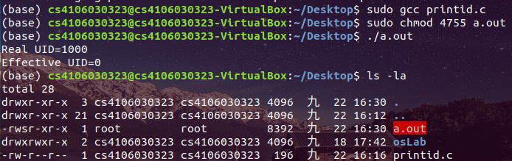

2.

Setup files

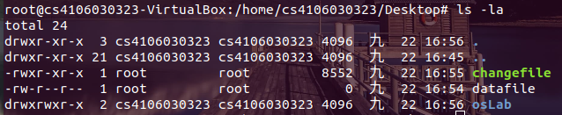

Example - root

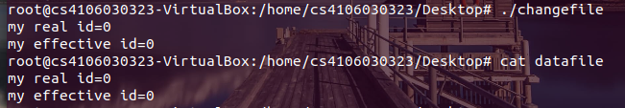

Example – NOT root

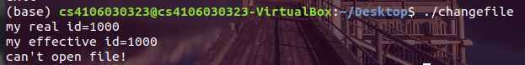

Test 01 - Set changefile SUID attribute

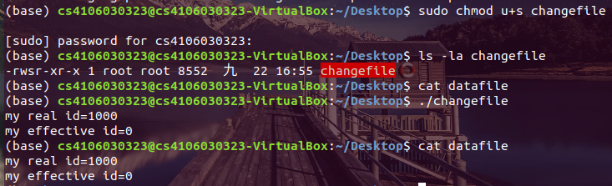

Test 02 – Change Code to change EUID

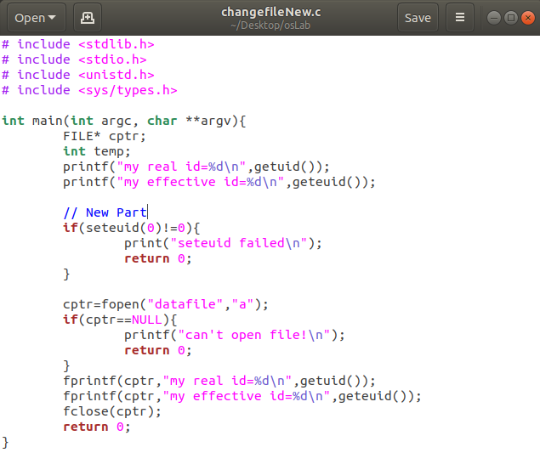

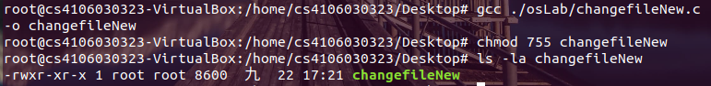

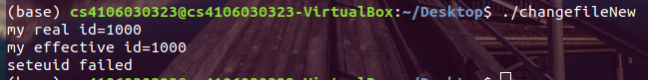

Only set changefile SUID attribute work.

只有 root 可以利用 seteuid 指令，更改 Effective uid。