Name______Jenner_Higgins____________ Mark _____________________/50

[**Instructions**: Remove everything that is not a heading below and fill in with your own diagrams, etc.]

## Brief introduction __/3

The feature I am in charge of are player related combat movement/actions which consists of the different weapon attack mechanics and special skills that the player character can use to interact/attack enemies.

## Use case diagram with scenario __14

### Use Case Diagrams

### Scenarios

**Name:** Attack

**Summary:** Player will attack any nearby enemies

**Actors:** Player of game

**Preconditions:** Player Character is spawned and alive, Player Character has weapon

**Basic sequence:**

**Step 1:** I/O receives attack input

**Step 2:** Attack animation occurs depending on type of weapon used

**Step 3:** Attack animation will register damage if enemy is hit with the collision

**Exceptions:**

**Step 1:** No damage will register if no enemies are within range (animation will still occur)

**Post conditions:** Decrease in enemies health points

**Priority:** 1*

**ID:** J03

**Name:** Skill

**Summary:** Player will use special skill

**Actors:** Player of game

**Preconditions:** Player Character is spawned, Skill is activated and not on cool-down

**Basic sequence:**

**Step 1:** I/O receives skill input

**Step 2:** Animation occurs depending on skill activated

**Step 3:** Skill animation will give player character buff if used

**Step 4:** Calculate and show result.

**Exceptions:**

**Step 1:** Skill will not register if skill is not activated or skill is on cool-down

**Post conditions:** Potential buff given to player character

**Priority:** 3*

**ID:** J08

## Data Flow diagram(s) from Level 0 to process description for your feature _______14

### Data Flow Diagrams

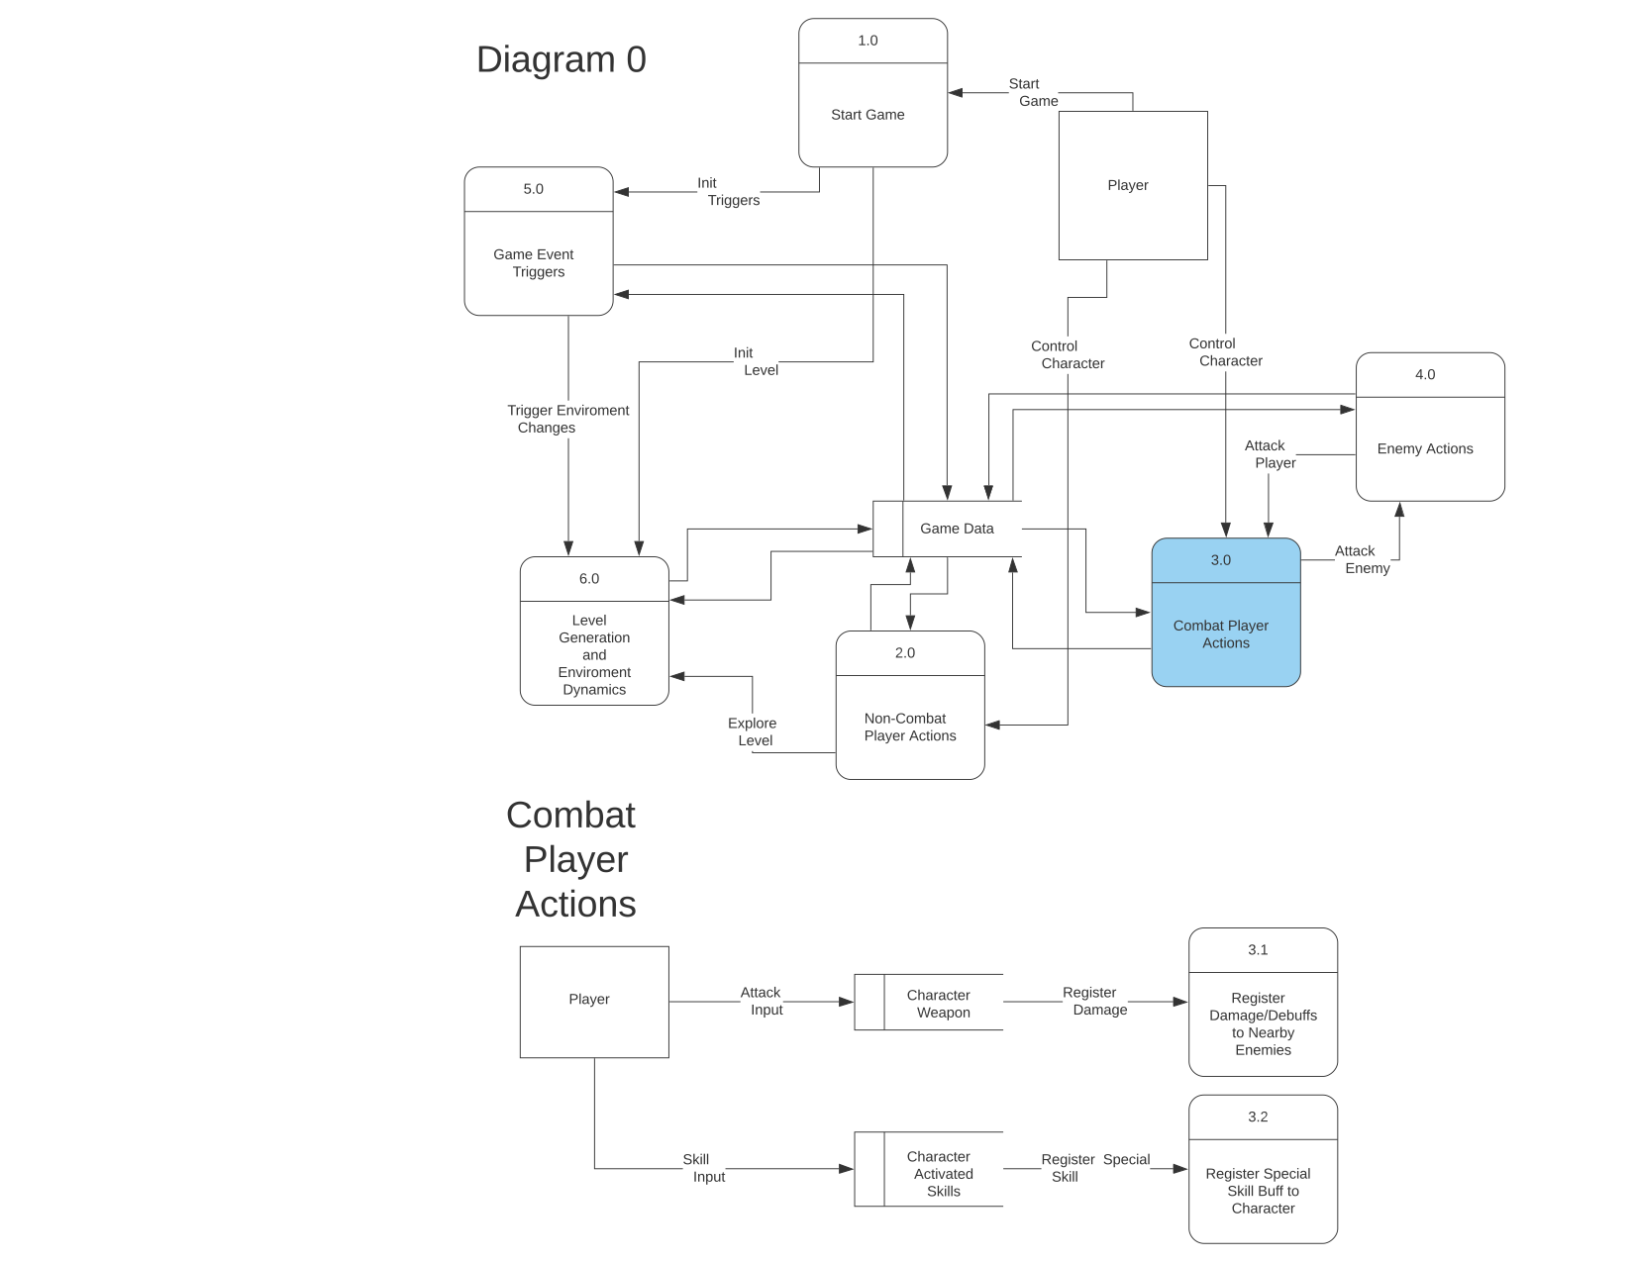

### Process Descriptions

Register Damage/Debuffs to Nearby Enemies:

WHILE attack input is pressed

DO attack animation for current character weapon

IF enemy is hit by attack animation

THEN register damage/debuff to enemy

END IF

END WHILE

Register Special Skill Buff to Character:

IF character has skill unlocked AND skill is not on cool-down

THEN register special skill buff to character

END IF

## Acceptance Tests ________9

**Player Attack & Player Special Skills**

* Player character must respond to input for attack and special skills
* Skills and attack must be able to damage and effect enemies if present
* Skills and attack must stay within boundaries of the map as well as the camera

**Player Taking Damage & Death**

* Player character must be able to receive and register damage from enemies by reducing player characters health points when not in BC mode
* When player character health points <= player character must register as dead and no longer be allowed to accept user input until respawned

## Timeline _________/10

### Work items

|  |  |  |
| --- | --- | --- |
| Task | Duration (PWks) | Predecessor Task(s) |
| 1. Weapon Design | 8 | - |
| 2. Player Attack Animation/Mechanics | 12 | 1 |
| 3. Player Attack Testing | 6 | 2 |
| 4. Player Taking Damage | 6 | - |
| 5. Player Death | 6 | 4 |
| 6. Player Damage/Death Testing | 3 | 5 |
| 7. Special Skill Design | 6 | 2 |
| 8. Player Special Skills | 14 | 7 |
| 9. Player Special Skills Testing | 14 | 8 |