Name: Paul Shannon Mark _____________________/50

## Brief introduction __/3

The feature that I am championing in the enemies of the game. This feature will include at least three different designs of enemies and different attack strategies. This feature will also include enemy interaction between the environment, enemy movement, enemy tracking, and enemy death animations.

## Use case diagram with scenario __14

### Use Case Diagrams

### Scenarios

**[You will need a scenario for each use case]**

**Name:** Attacks Player

**Summary:** The enemy locates and attacks the player.

**Actors:** Player

**Preconditions:** Rooms have been generated

**Basic sequence:**

**Step 1:** Player enters room

**Step 2:** Spawn Enemy

**Step 3:** Locates Player

**Step 4:** Attacks Player

**Exceptions:**

**Step 1:** Player is behind a wall, move, then attack.

**Step 2:** Player Damages Enemy, retaliate, then take cover.

**Post conditions:** Player is damaged

**Priority:** 1

**ID:** PS01

## Data Flow diagram(s) from Level 0 to process description for your feature _______14

### Data Flow Diagrams

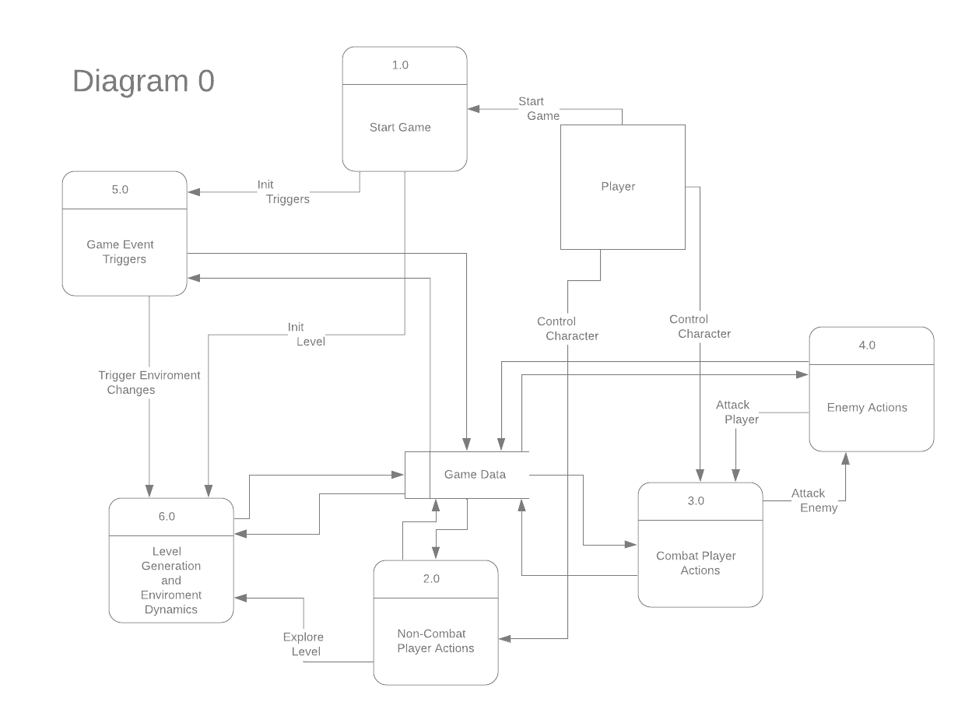



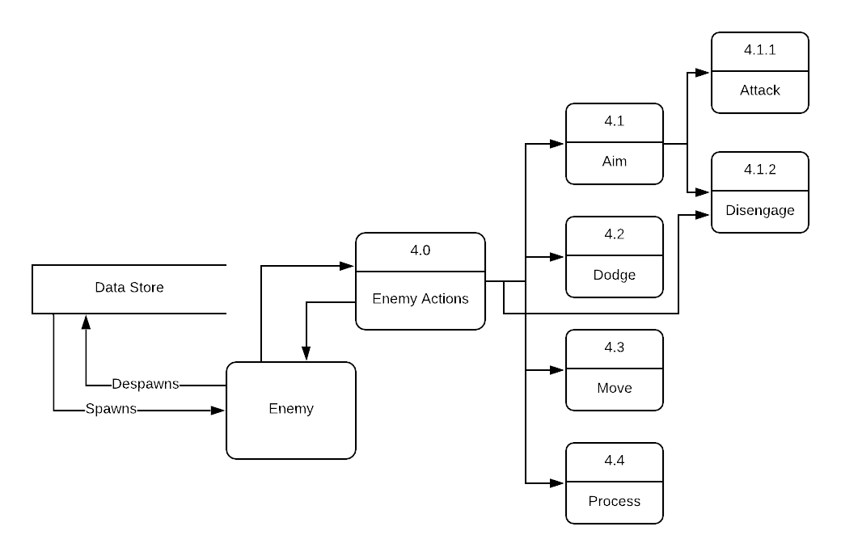



### Process Descriptions

Enemy Spawns

Enemy Sees Player

Attacks Player

Melee

Ranged

Move

Forward

Backward

Left

Right

Jump

Disengage

Enemy Attacked

Dodge

Take Cover

while

## Timeline _________/10

### Work items

|  |  |  |
| --- | --- | --- |
| Task | Duration (PHr) | Predecessor Task(s) |
| 1. Enemy Designs | 5 | - |
| 2. Enemy Animations | 6 | 1 |
| 3. Enemy Movement | 5 | 2 |
| 4. Enemy Attack | 5 | 3 |
| 5. Enemy Taking Damage | 4 | 2 |
| 6. Enemy Death Actions | 5 | 5 |
| 7. Testing | 4 | 4,6 |
| 8. Installation | 3 | 7 |

### Pert diagram

### Gantt timeline

|  |  |  |  |  |  |  |  |  |  |  |  |  |  |  |  |  |  |  |  |  |  |  |  |  |  |  |  |  |  |  |  |
| --- | --- | --- | --- | --- | --- | --- | --- | --- | --- | --- | --- | --- | --- | --- | --- | --- | --- | --- | --- | --- | --- | --- | --- | --- | --- | --- | --- | --- | --- | --- | --- |
| Enemy Design | 5 | 0 | Planned |  |  |  |  |  |  |  |  |  |  |  |  |  |  |  |  |  |  |  |  |  |  |  |  |  |  |  |  |
| Enemy Animations | 6 | 0 | Planned |  |  |  |  |  | 1 |  |  |  |  |  |  |  |  |  |  |  |  |  |  |  |  |  |  |  |  |  |  |
| Enemy Movement | 5 | 0 | Planned |  |  |  |  |  |  |  |  |  |  |  | 2 |  |  |  |  |  |  |  |  |  |  |  |  |  |  |  |  |
| Enemy Attacks | 5 | 0 | Planned |  |  |  |  |  |  |  |  |  |  |  |  |  |  |  |  | 3 |  |  |  |  |  |  |  |  |  |  |  |
| Enemy Taking Damage | 4 | 0 | Planned |  |  |  |  |  |  |  |  |  |  |  | 2 |  |  |  |  |  |  |  |  |  |  |  |  |  |  |  |  |
| Enemy Death | 5 | 0 | Planned |  |  |  |  |  |  |  |  |  |  |  |  |  |  |  | 5 |  |  |  |  |  |  |  |  |  |  |  |  |
| Testing | 4 | 0 | Planned |  |  |  |  |  |  |  |  |  |  |  |  |  |  |  |  |  |  |  |  |  | 4, 6 |  |  |  |  |  |  |
| Installation | 3 | 0 | Planned |  |  |  |  |  |  |  |  |  |  |  |  |  |  |  |  |  |  |  |  |  |  |  |  |  | 7 |  |  |