Name: Will Johnson Mark _____________________/50

## Brief introduction __/3

My feature is the movement of the player, along with movement related abilities.

## Use case diagram with scenario __14

### Use Case Diagrams

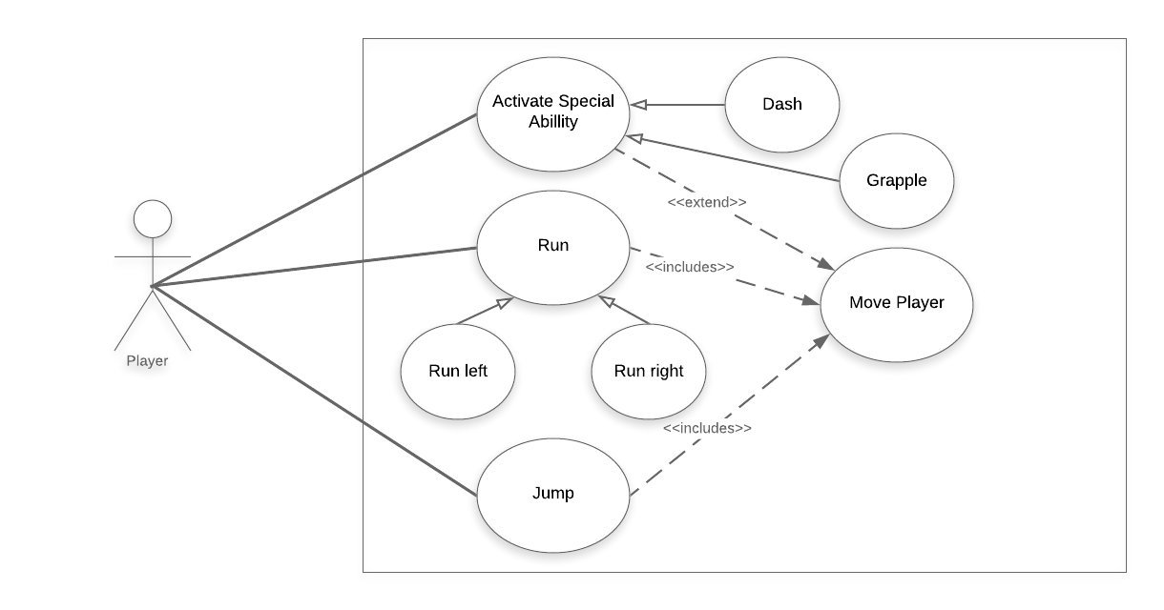

### Scenarios

**Name: Run**

**Summary:** Basic player movement left, right

**Actors:** Player

**Preconditions:** Game started and currently not paused

**Basic sequence:**

**Step 1:** Get player direction input

**Step 2:** Change player velocity

**Exceptions:** None

**Post conditions:** Player moving with different velocity

**Priority:** 1*

**Name: Activate Special Ability**

**Summary:** Advanced player movement options

**Actors:** Player

**Preconditions:** Game started and currently not paused, special ability unlocked and not on cool down

**Basic sequence:**

**Step 1:** Get player input

**Step 2:** Change movement mode to match special ability

**Step 3:** Change player position based on ability

**Step 4:** Change mode back to normal

**Exceptions:** None

**Post conditions:** Player in special ability movement mode

**Priority:** 2*

**Name: Move Player**

**Summary:** Player movement

**Actors:** Player

**Preconditions:** Game started and currently not paused

**Basic sequence:**

**Step 1:** Check player velocity

**Step 2:** Change player position

**Exceptions:** Player activates special ability

**Step 1:** Get player input

**Step 2:** Change movement mode to match special ability

**Step 3:** Change player position based on ability

**Step 4:** Change mode back to normal

**Post conditions:** Player in different location

**Priority:** 1*

**Name: Jump**

**Summary:** Basic player movement up

**Actors:** Player

**Preconditions:** Game started and currently not paused, player on ground

**Basic sequence:**

**Step 1:** Get player jump input

**Step 2:** Change player velocity

**Exceptions:** None

**Post conditions:** Player moving with different velocity

**Priority:** 1*

*The priorities are 1 = must have, 2 = essential, 3 = nice to have.

## Data Flow diagram(s) from Level 0 to process description for your feature _______14

### Data Flow Diagrams

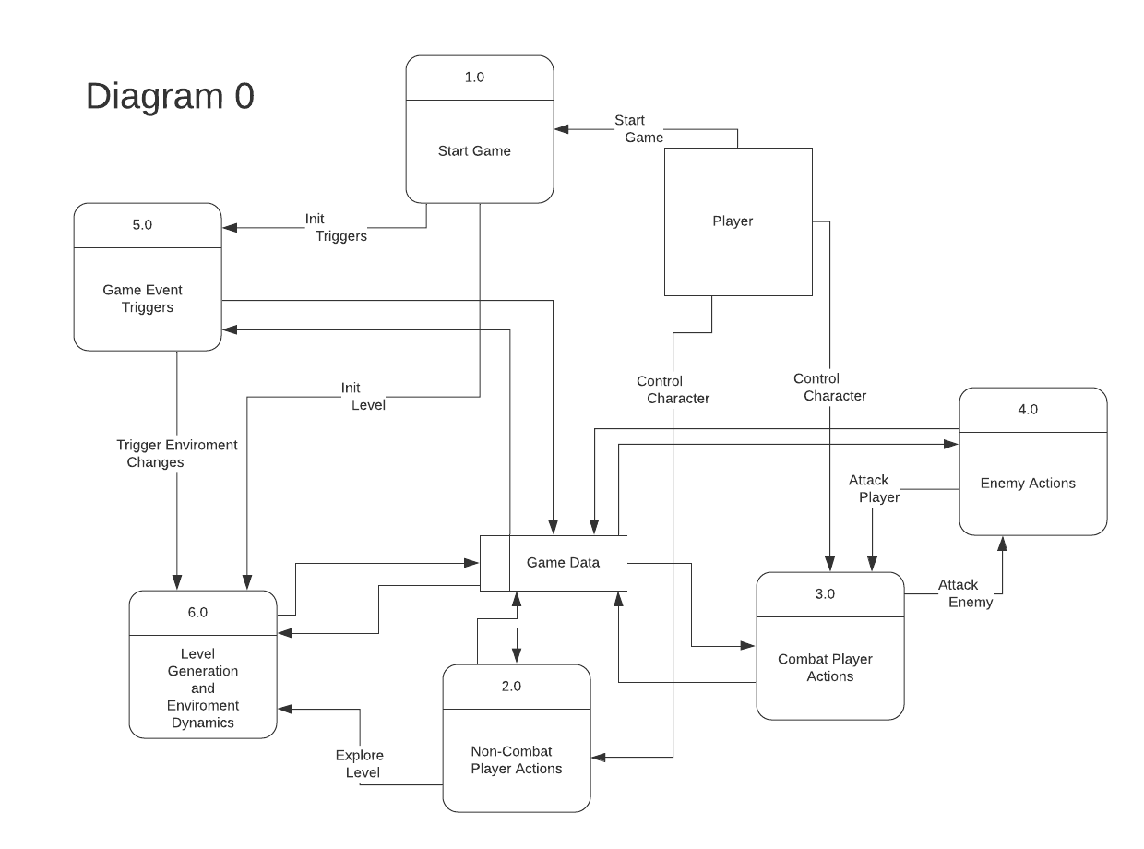

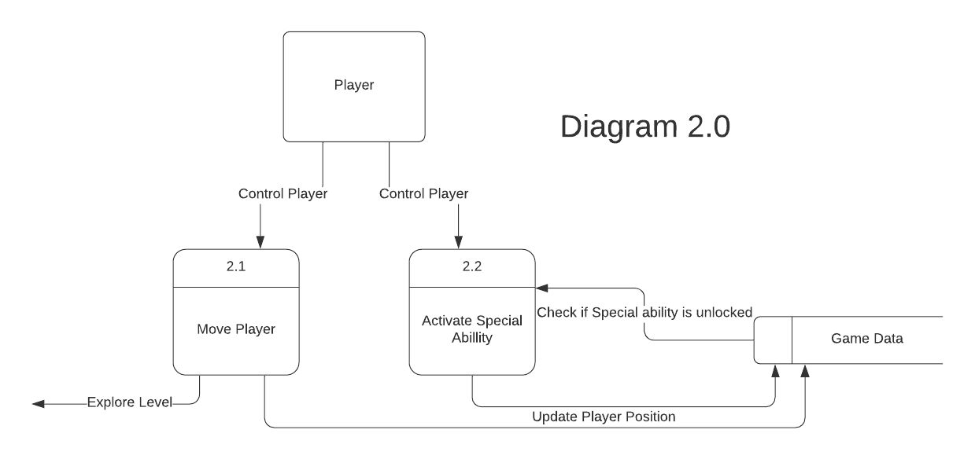

### Process Descriptions

Activate Special Ability:

WHILE player enters special ability input AND special ability is unlocked

Check which ability is selected

Change to the correct mode and perform the actions associated with the ability

END WHILE

Move Player:

WHILE player enters a basic movement input

Check which direction is being inputted

IF input is jump AND player is on ground

increase player y velocity

ELSE IF input is not jump

increase player x velocity in direction specified by input

END IF

END WHILE

## Acceptance Tests ________9

Basic movement:

Left, Right, Jump on flat surface

Inputs will be set left for 2 seconds then right for 2 seconds then will jump then jump while moving

Player will move in specified direction and be able to jump and jump while moving

With obstacles, check movement feel

Player will be placed in a room with a few small obstacles, the inputs will be set to move and jump, then a manual test of the movement will be made

The player will successfully pass over the obstacles, the tester will state that the movement has good feel

Special abilities, dash, grapple, other abilities TBD:

Flat surface test

Input for special ability will be set

Input for special ability triggers and ability is activated

Test in prototype level design

Player will be placed in a room with an obstacle that cannot be traversed with basic movement, some inputs will be set to traverse it using a special ability

The player will successfully pass to the other side of the obstacles

Advanced movement:

Interacts with enemies, doge enemy fire

Player will be placed in a room with an enemy, a tester will manualy attempt to avoid the enemy fire

Player can successfully doge some enemy fire

Traverse finalized level design

The player will be placed in a fully built section of the game, a set pattern of inputs will be run to traverse the level

Player will traverse finalized level

## Timeline _________/10

### Work items

|  |  |  |
| --- | --- | --- |
| Task | Duration (HRs) | Predecessor Task(s) |
| 1. Design Movement | 2 | - |
| 2. Implement Basic Movement | 4 | 1 |
| 3. Test and debug Basic Movement | 5 | 2 |
| 4. Implement ability activation | 2 | 1 |
| 5. Implement dash | 4 | 3,4 |
| 6. Test and debug Dash | 5 | 5 |
| 7. Implement Grapple | 4 | 3,4 |
| 8. Test and debug Grapple | 5 | 7 |
| 9. Implement other special abilities | 8 | 3,4 |
| 10.Test and debug other special abilities | 10 | 9 |
| 11.Final tests and debug | 6 | 5,8,10 |

### Pert diagram

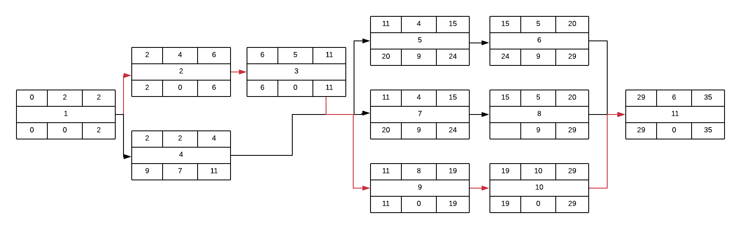

### Gantt timeline

|  |  |  |  |  |  |  |  |  |  |  |  |  |  |  |  |  |  |  |  |  |  |  |  |  |  |  |  |  |  |  |  |  |  |  |  |  |  |
| --- | --- | --- | --- | --- | --- | --- | --- | --- | --- | --- | --- | --- | --- | --- | --- | --- | --- | --- | --- | --- | --- | --- | --- | --- | --- | --- | --- | --- | --- | --- | --- | --- | --- | --- | --- | --- | --- |
| # | Name | Hours |  | | | | | | | | | | | | | | | | | | | | | | | | | | | | | | | | | | |
| 1 | Movement Design | 2 |  |  |  |  |  |  |  |  |  |  |  |  |  |  |  |  |  |  |  |  |  |  |  |  |  |  |  |  |  |  |  |  |  |  |  |
| 2 | Basic Movement | 4 |  |  | 1 |  |  |  |  |  |  |  |  |  |  |  |  |  |  |  |  |  |  |  |  |  |  |  |  |  |  |  |  |  |  |  |  |
| 3 | Basic Movement Testing | 5 |  |  |  |  |  |  | 2 |  |  |  |  |  |  |  |  |  |  |  |  |  |  |  |  |  |  |  |  |  |  |  |  |  |  |  |  |
| 4 | Ability Activation | 2 |  |  | 1 |  |  |  |  |  |  |  |  |  |  |  |  |  |  |  |  |  |  |  |  |  |  |  |  |  |  |  |  |  |  |  |  |
| 5 | Dash Ability | 4 |  |  |  |  |  |  |  |  |  |  |  | 3,4 |  |  |  |  |  |  |  |  |  |  |  |  |  |  |  |  |  |  |  |  |  |  |  |
| 6 | Dash Testing | 5 |  |  |  |  |  |  |  |  |  |  |  |  |  |  |  | 5 |  |  |  |  |  |  |  |  |  |  |  |  |  |  |  |  |  |  |  |
| 7 | Grapple Ability | 4 |  |  |  |  |  |  |  |  |  |  |  | 3,4 |  |  |  |  |  |  |  |  |  |  |  |  |  |  |  |  |  |  |  |  |  |  |  |
| 8 | Grapple Testing | 5 |  |  |  |  |  |  |  |  |  |  |  |  |  |  |  | 7 |  |  |  |  |  |  |  |  |  |  |  |  |  |  |  |  |  |  |  |
| 9 | Other Abilities | 8 |  |  |  |  |  |  |  |  |  |  |  | 3,4 |  |  |  |  |  |  |  |  |  |  |  |  |  |  |  |  |  |  |  |  |  |  |  |
| 10 | Other Ability Testing | 10 |  |  |  |  |  |  |  |  |  |  |  |  |  |  |  |  |  |  |  | 10 |  |  |  |  |  |  |  |  |  |  |  |  |  |  |  |
| 11 | Final Movement Testing | 6 |  |  |  |  |  |  |  |  |  |  |  |  |  |  |  |  |  |  |  |  |  |  |  |  |  |  |  |  |  | 6,8,10 |  |  |  |  |  |