User Manual

FENCE Monitoring System

Advance Communications Sdn. Bhd.
VERSION 2.0

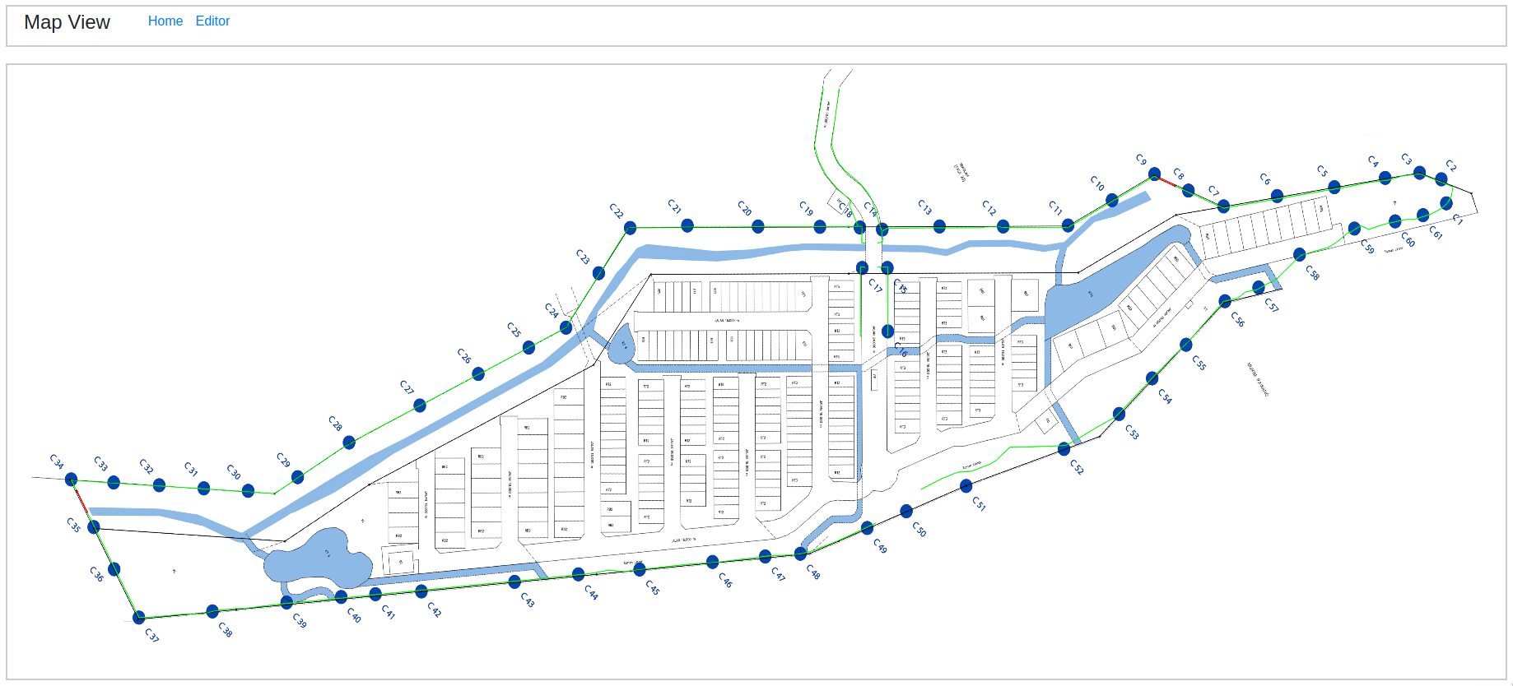

Table of Contents
FENCE Monitoring System 1
Overview 3
Basic Manual 4
Login and Navigation 4
As Administrator 4
As Security Operator 5
Admin Section 7
Users 7
FENCE Elements 8

Overview
FENCE monitoring system is a web application used together with the FENCE hardware provided by Advance Communications Sdn. Bhd. The monitoring system can be viewed via a web browser and function with existing CCTV monitoring applications as well as a standalone application.
This product is currently version 2, inheriting some of the previous version’s design. User’s familiar with version 1 of the FENCE monitoring system may find the interface slightly similar albeit improved.
The manual is divided into 2 major section, one feature configuration know hows and one feature the operational manual.

Basic Manual
This is a preface section describing basic operations that one should know in order to use the system.

Login and Navigation

As Administrator
To login as an administrator, first open up a web-browser and navigate to the IP address in which the system is installed on. In our example, the server is installed on the same machine as the web viewer, and we use the loopback IP address (127.0.0.1 or localhost). For installations on DIFFERENT machines, navigate to the following page :
http://<SERVER_IP>:1337/admin/auth/login
where one would replace <SERVER_IP> with the IP address of the machine with the system installed. The administrator port is by default bound to port number 1337. A sample login from the web-browser is shown in figure 1. The URL used in the example is framed in a blue rectangle.
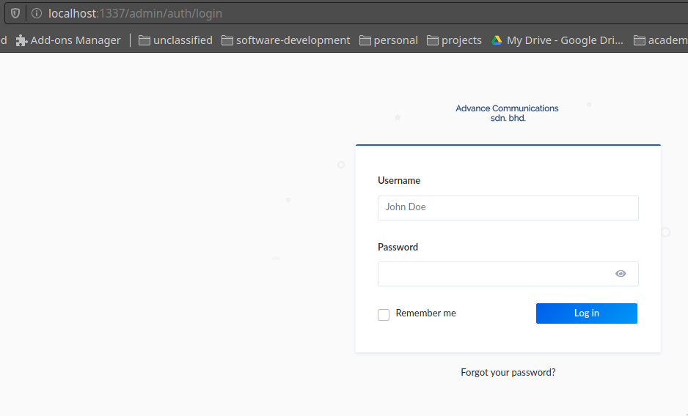
Figure 1
The default login and password is provided by the technician installing the software. Once login, the admin will be greeted by the following page shown in figure 2.
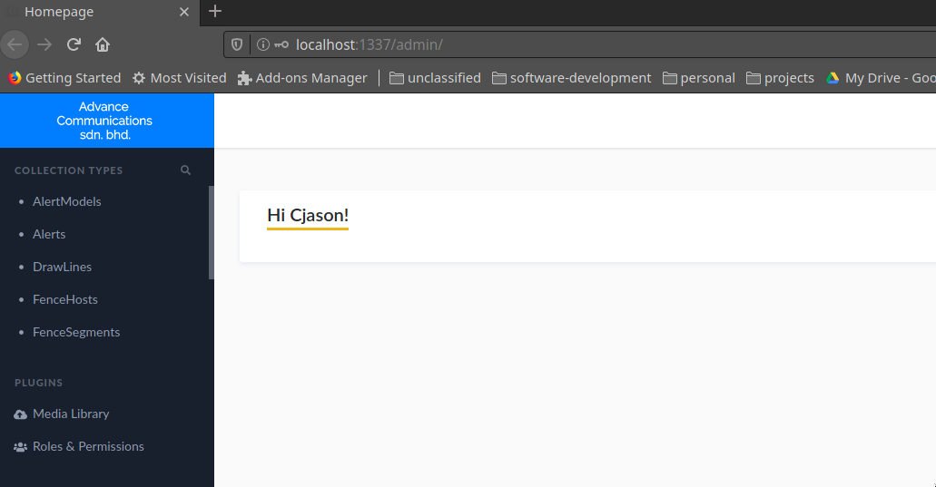
Figure 2
From here, the administrator can perform various actions such as adding new fence segments, IP cameras and view the alerts.

The administrator may click on the menu items on the left (i.e., AlertModels, Alerts etc.) to view them and/or modify them. Additionally, the administrator may also add new users as viewers or admins to the systems through “Collection Types” → “Users”. Different Roles and Permissions may be assigned accordingly from the “Roles & Permissions” menu item.

As Security Operator
The security operator logins on a separate portal. The url to login is as follows :
http://<SERVER_IP>:4000/login
An example of the login page is shown in figure 3. On successful login, the operator will be greeted by a page shown in figure 4.

From figure 4, the operator may choose to navigate into various links (i.e., Profile, Map, Focus, Host Status etc.) Each of this link has its own use and should be viewed by a separate monitor if possible. The uses are described in detail in the “Operator” section found in further sections of this manual.
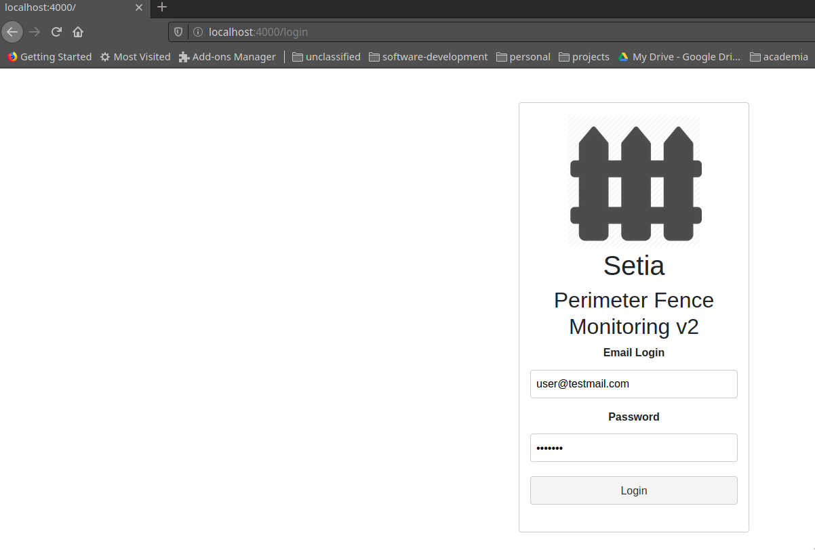
Figure 3.

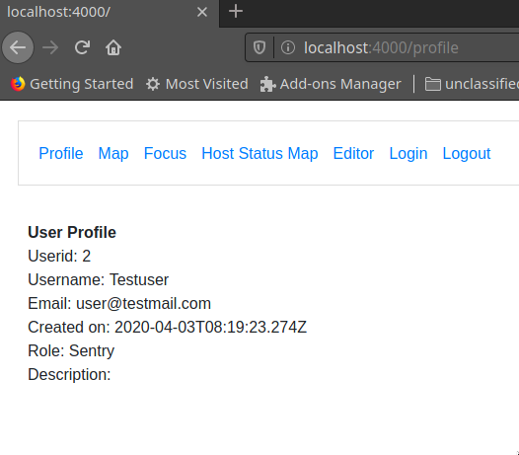
Figure 4.

Admin Section

Users
The password provided by the technician can be changed in the “User” menu under the page shown in figure 2 (Type in “User” in the search bar under “Collection Types”). Users can be added or modified from this page as shown in figure 5.
To add a new user, click on “Add New user” on the top right side of the screen and key in the details accordingly. To modify a user attribute (such as passwords), the admin may click on the user to be modified, which will bring up a page shown in figure 6.
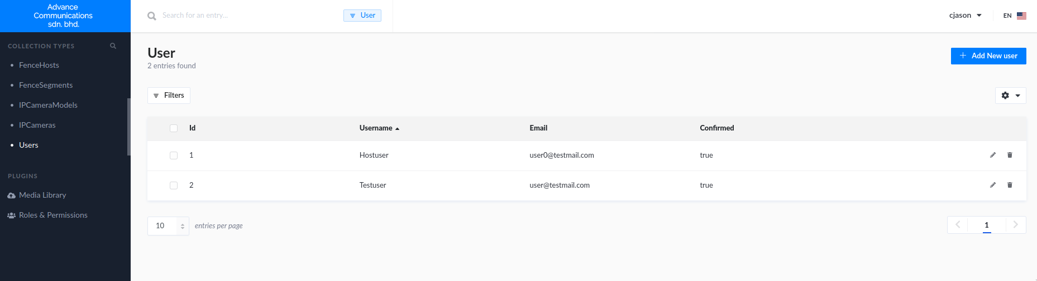
Figure 5.
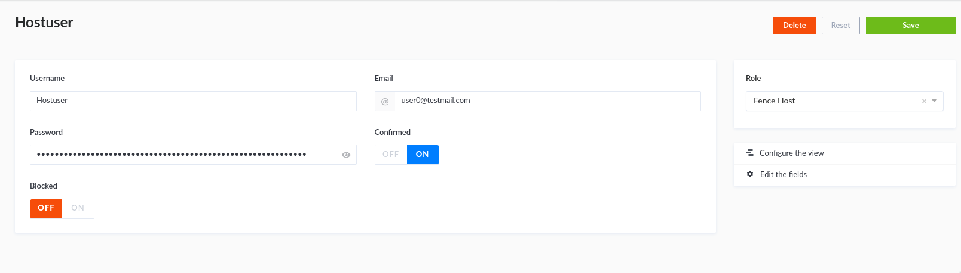
Figure 6.

Users may also be assigned different roles (Selected from the right side) as shown in figure 6. However, the role and its permissions must be first configured (Please refer to the installing technician on whether a permission is safe to be enabled or not).

FENCE Elements
FENCE elements may be added/modified through a few data types. Typically, a FENCE monitoring host controller requires its own record in the database as well as a well defined FENCE segments and AlertModels in order for the system to work. The end-user is strictly advised against performing this setup themselves and should seek help from a technician during installation. This manual will detail how to modify FENCE elements should there be a need to do so.

FENCE HOST
A FENCE host is the central controller combining multiple segments together. Figure 7 shows a sample configuration with 1 host. A host serves as a logical unit to join up multiple segment. The host is responsible for pushing any alert from any of its segments to the server. The only attribute that can be configured without risk of breaking the system is the HostName. This is the name that will be displayed when an alert arises, indicating which host is responsible for triggering the alert and thus allowing the operator to identity the corresponding region and segment.
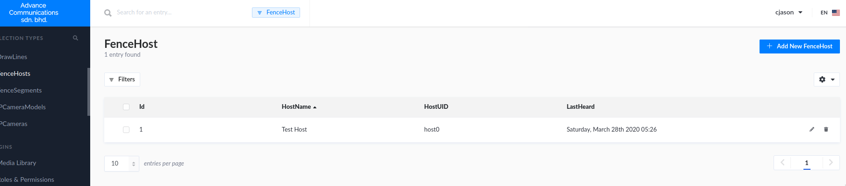
Figure 7.
One may also observed that a “LastHeard” field is present to indicate when does the host last replied to the server’s heartbeat queries. All segment under a host that has failed to reply to the hearbeat will be drawn BLACK in the operator’s “Host Status Map” to indicate an unresponsive host, which should then be checked for malfunctions or damage.

FENCE SEGMENT
A FENCE segment is a logical unit combining several sensors together. Every alert triggered by a host will have an “Origin” segment, which means that the host detected a sensor on the “Origin” segment has been disturbed. A segment need not be a straightline and can be multiple line segments which can account for a curved fencing area. Figure 8 shows the table with one sample segments. Similarly to a FENCE host, the only attribute that can be configured without risk of breaking the system is the SegmentName. This name will be displayed when an alert arises, and could be used to indicate which parts of the area that the user is trying to guard is being infiltrated.
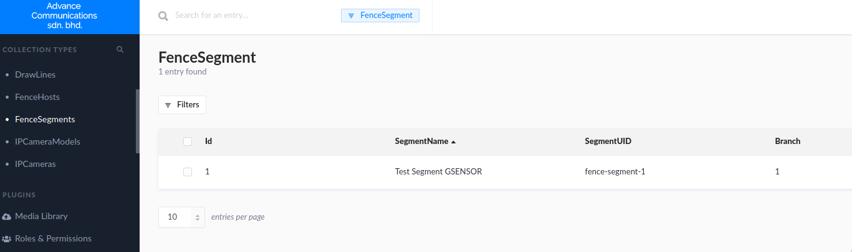
Figure 8.

A Segment must belong to a Host element. An orphaned segment cannot trigger alerts. Please be mindful when editing the configuration as it might cause some segments to not trigger. This manual advise only an experienced admin or technician should modify the configurations for FENCE Host, Segment and IP Cameras.

IPCameras
IPCameras can be configured through the menu “IPCamera” and “IPCameraModels”.

