## Test DOCXOPT

|  |  |
| --- | --- |
| FOO | BAR |
| foo | asd |
| baz | ghi |

Another table comes after, with its own column width definitions

|  |  |
| --- | --- |
| FOO2 | BAR2 |
| foo | asd |
| baz | ghi |

# Images

This image uses default (black border, img default width)

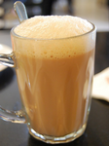

This image uses overriden formatting (no border, 2 inch width)

