# Figures Tests

A picture of my favourite drink

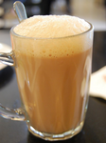

Captions



Figure : a teh tarik kurang manis

With alignment. Alignment tag must be preceeded with an empty line.



Figure : test caption

Fixed width



Figure : test caption

More attributes



Figure : test caption

All together



Figure : test caption



Figure : test caption