**PROJECT 10**

TITLE : TRAFFIC MANAGEMENT SYSTEM

IR Based Traffic Density Detection and Signal Adjustment

* The project is a traffic signal controller system that reacts to the density of traffic. The time required on changing signals adjusts automatically depending on the density of traffic. Well traffic problems contribute a major problem in many cities and also increase fuel consumption as well as pollution.
* Traffic signals operating on fixed signal timing delays do not adjust to the changing traffic density. When the traffic density increases more than a limit at one particular side, it needs longer green light duration to ease traffic flow.
* Our system uses a microcontroller of the 8051 family that is interfaced with IR sensors. These IR sensors are used for line of sight object detection using which the system gets an input of the traffic density. Traffic density is measured as “low, medium and high”.
* Based on this density reading the system adjusts and varies the traffic signal duration for that particular way.  
  This system can also be further enhanced by using multiple such systems across the city and synchronizing them through a network.

**Hardware Specifications**

* 8051 series Microcontroller
* Diodes
* Voltage Regulator
* IR-LED & Photodiode
* Transistor
* Transformer

**Software Specifications**

* Keil µVision IDE
* MC Programming Language: Embedded C

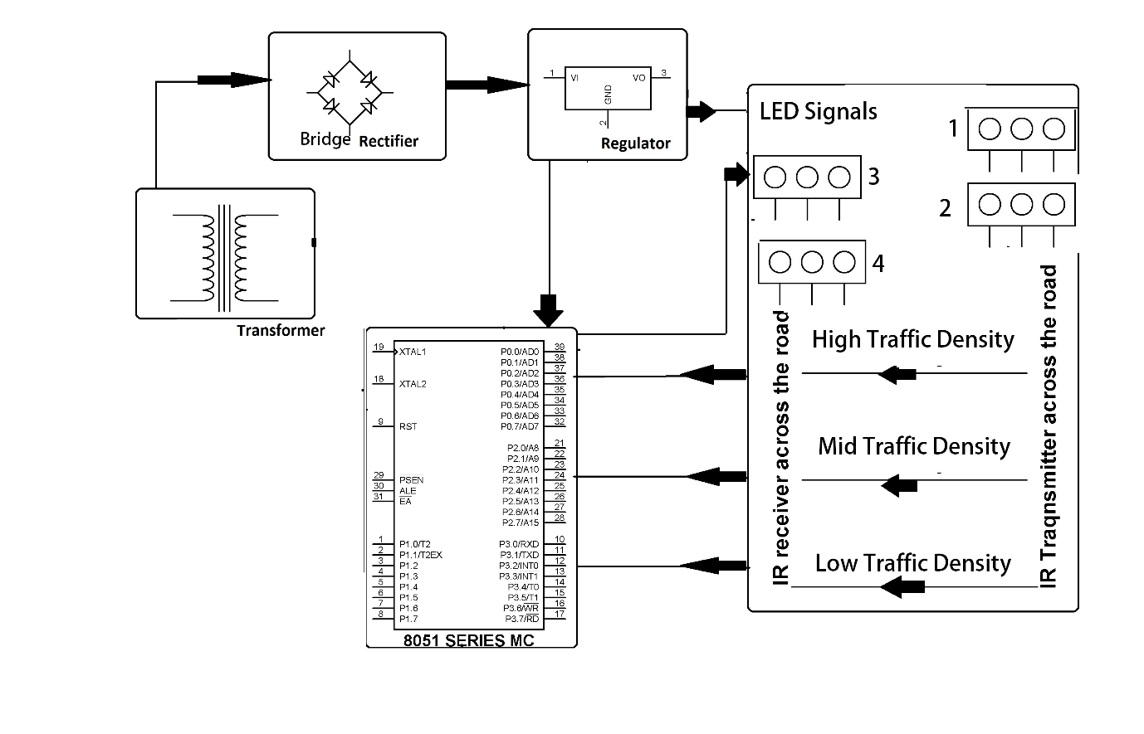**8051 Series Microcontroller:**

* In this circuit, We have used three traffic light. signal 1(P2.0 to P2.2) and signal 2 (P2.3 to P2.5) are connected to port2 and signal3(P3.0 to P3.2) is connected to port 3. Traffic light gets turned on as per the sequence provided.
* The Interfacing Traffic Light Control with 8051 program is very simple and straight forward, which controls Traffic Light in certain time period.
* The C program is written in Keil software. This system uses 8051 microcontroller (AT89C52), 7-segments and LED’s for indication.
* The LED’s which was used as lights was connected to the Microcontroller by means of common Anode configuration.
* In this configuration the Microcontroller was used to sink the current from the LED to its ports.

* That means logic 0 signal in the Microcontroller switches the LED ON and logic 1 signal switches the LED off. Here we are using 6 MHz crystal for the 8051 Microcontroller operation and you can use upto 12MHz crystal with this controller.

**Common cathode 7-segment:**

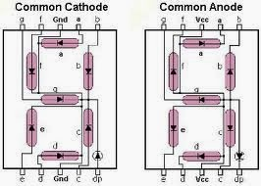

**Diodes:**

* 4 Diodes are connected together to form a bridge rectifier.
* A bridge rectifier is an electrical circuit that converts alternating current (AC) into direct current (DC). It is commonly used in traffic management systems for various purposes.
* A bridge rectifier is used in traffic management to convert AC power from the grid into DC power for various components such as traffic lights, sensors, controllers, and backup battery systems. This conversion ensures that the traffic management system operates reliably and efficiently.

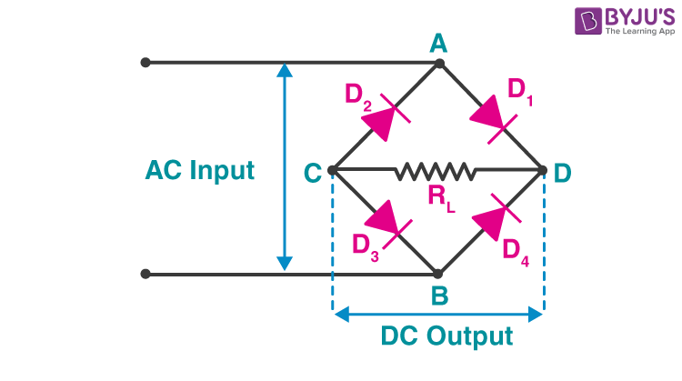

**Voltage Regulators**:

* Voltage regulators are important components in traffic management systems to maintain a stable and consistent voltage level, especially for sensitive electronic equipment.
* voltage regulators are essential in traffic management systems to ensure the stability and reliability of the power supply to critical components. They play a crucial role in preventing equipment malfunctions, improving accuracy, and extending the lifespan of electronic devices used in traffic control and monitoring.

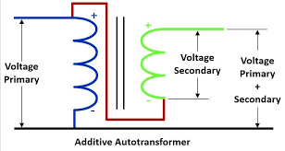

**IR-LED and Photodiodes:**

* In traffic management systems, infrared (IR) LEDs (Light Emitting Diodes) and photodiodes are commonly used for various purposes, including vehicle detection and communication**.**
* IR LEDs and photodiodes are versatile components used in traffic management for vehicle detection, traffic light control, pedestrian crosswalks, and traffic monitoring. They play a crucial role in enhancing the efficiency, safety, and responsiveness of traffic management systems.

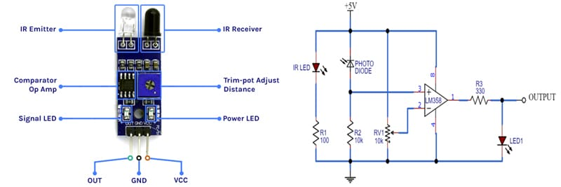

**Transistors:**

* Transistors are used in traffic management systems for various purposes, primarily as amplifiers and switches to control the flow of electrical signals and power.
* Transistors play a crucial role in traffic management systems by serving as switches and amplifiers in various components, from traffic lights and sensors to communication equipment and control systems.
* They help ensure the efficient and safe operation of traffic control and monitoring infrastructure.

**Transformer:**

* Transformers are essential components in traffic management systems, primarily used for voltage conversion, isolation, and distribution of electrical power.
* Transformers are crucial in traffic management systems for voltage conversion, power distribution, safety, and signal processing.
* They play a vital role in ensuring the reliable and efficient operation of various traffic control and monitoring components, contributing to safe and efficient traffic flow.

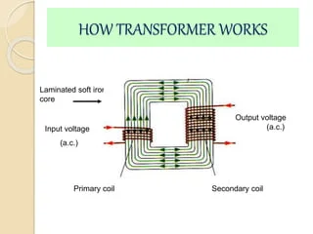

**Keil µVision IDE:**

* Keil µVision IDE (Integrated Development Environment) is a software development tool commonly used for programming microcontrollers and embedded systems.
* While it is not typically used directly in traffic management systems, it can be an essential part of the development process for traffic management controllers and related embedded systems.
* Keil µVision IDE is a powerful tool used in the development of embedded software and firmware for microcontrollers and embedded systems in traffic management. It plays a crucial role in designing, testing, and maintaining the software that controls traffic lights, sensors, and other critical components in traffic management systems.

**MC Programming Language: Embedded C:**

* Embedded C programming language is widely used in traffic management systems to develop software for microcontrollers and embedded systems.
* Embedded C programming is central to the development of the software that controls the various components in traffic management systems.
* It enables the creation of reliable, efficient, and real-time systems that help manage traffic flow, improve safety, and enhance transportation infrastructure.