Reset adaptor

2016-06-07

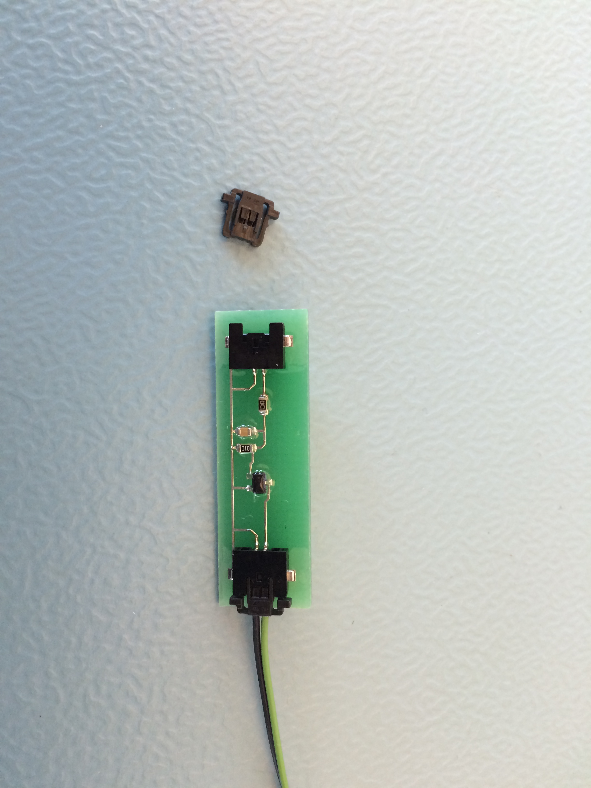

1. Connect black/green two-pin cable to right side of the reset adaptor (shipped pre-connected) and the other end of the wire to the NanoPower Dock P1 connector.
2. The left side of the reset adaptor should be connected to the Y-cable from the TFM (black/yellow).
   1. NOTE: ground must be connected to the bottom pin, and the GPIO active high to the top pin. To do this you must swap the two pins in the connector. First remove the existing plastic housing from the wire crimp by bending the plastic close to the crimp lock. Throw away that housing (never re-use housings) and insert the already crimps into the included empty housing.
3. Take a picture of the connected board and send to GomSpace before testing the system.
4. Power on the satellite to test the functionality.

