**Лабораторна робота №2**

з курсу «**Проектування інформаційних систем**»

на тему: «**Складення опису передпроектної документації (Software Requirement Specifications)**»

Виконала:

студентка групи ДА-61

Онищенко Єлизавета

**Мета роботи:** вивчити основні етапи створення передпроектної документації (SRS).

**Задача:** використати приклад SRS для створення передпроектної документації згідно індивідуальної темі для виконання лабораторних робіт.

**Завдання:**

1. Вивчити вимоги до передпроектної документації.

2. Скласти опис передпроектної документації для об'єкта проектування.

3. Скласти 5-7 приймальних тестів для ПО об'єкта проектування.

4. Оформити технічне завдання згідно опис передпроектної документації

(використовувати рекомендації IEEE 830).

**Зміст звіту:**

1. Мета роботи.

2. Завдання роботи.

3. Оформлення результатів роботи.

4. Перевірити цілістність .

5. Висновки.

**Хід роботи:**

Software Requirements Specification

for

Smart Swimming Coach

Version 1.0

Prepared by Yelyzaveta Onyshchenko

Date : September 30, 2019

**Table of contents**

1. Introduction 5

1.1 Purpose 5

1.2 Document Conventions 5

1.3 Intended Audience and Reading Suggestions 5

1.4 Product Scope 5

1.5 References 5

2. Overall Description 6

2.1 Product Perspective 6

2.2 Product Functions 6

2.3 User Interfaces 6

2.4 User Classes and Characteristics 10

2.5 Operating Environment 10

2.6 Design and Implementation Constraints 10

2.7 User Documentation 11

2.8 Assumptions and Dependencies 11

3. External Interface Requirements 12

3.1 User Interfaces 12

3.2 Hardware Interfaces 12

3.3 Software Interfaces 12

4. Other Nonfunctional Requirements 13

4.1 Performance Requirements 13

4.2 Safety Requirements 13

4.3 Security Requirements 13

4.4 Software Quality Attributes 13

Revision History

|  |  |  |  |
| --- | --- | --- | --- |
| **Name** | **Date** | **Reason For Changes** | **Version** |
|  |  |  |  |
|  |  |  |  |

# Introduction

## Purpose

The purpose of this document is to provide a detailed description of the “Smart Swimming Coach” (SSC) system. As well as this SRS covers requirements to the functionality of this app, it also describes user’s personal interface and necessary system testing.

## Document Conventions

This document is structured to follow IEEE – 830 - 1998 standards.

## Intended Audience and Reading Suggestions

The audiences for this document include both system developers and users. System developers use this document as modeling and designing instructions. Users review the document to ensure the documentation completely describes the app’s functionality.

## Product Scope

The whole SSC systems consist of two main components:

* Server – side component
* Client – side component – will run on Android devices

The SSC system will provide next services:

* Creating new trainings
* Keeping user’s training data, results
* Editing existing sets
* Deleting workouts
* Notification system that will remind user about the swimming session
* Calories counting

## References

Software requirements specification

<http://en.wikipedia.org/wiki/Software_requirements_specification>

SRS – Software requirements specification IEEE 830

<http://www.math.uaa.alaska.edu/~afkjm/cs401/IEEE830.pdf>

Marvel - design platform

<https://marvelapp.com/>

# Overall Description

## Product Perspective

This system is intended to be a usable app, which stores information about user’s swimming trainings, keeps data about user’s achievements such as results. The main aim of this product is to be comfortable for user and replace all sportsman’s paper recordings.

## Product Functions

A list of main required system functions:

* User can create a new training.
* Existing trainings can be edited or deleted.
* User is allowed to add and modify his/her results.
* It is possible to set a reminder to a future swimming session.

## User Interfaces

The next figures show exemplary models of interface design:

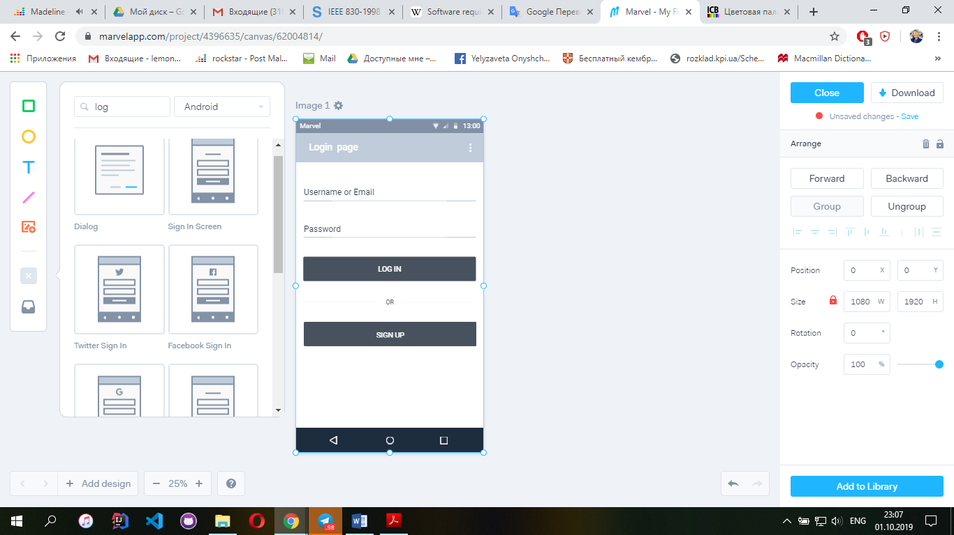

Figure 1. Log in page

-“Username or Email” and “Password” : default input fields

- Button “Log In”: Redirects user to his personal profile, if authentication is successful. Otherwise, user will receive a warning and will be asked to fill in the fields again.

- Button “Sign up” : Redirects user to the Sign Up Page.

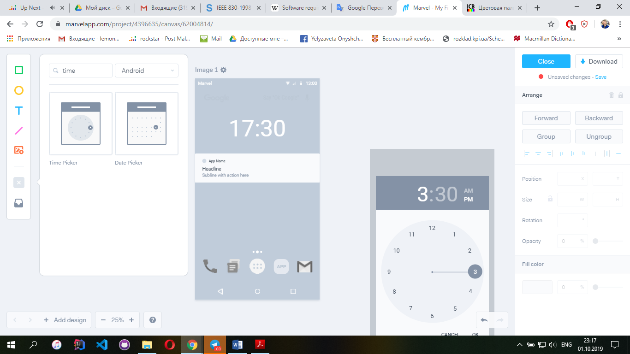

Figure 2. App notifications

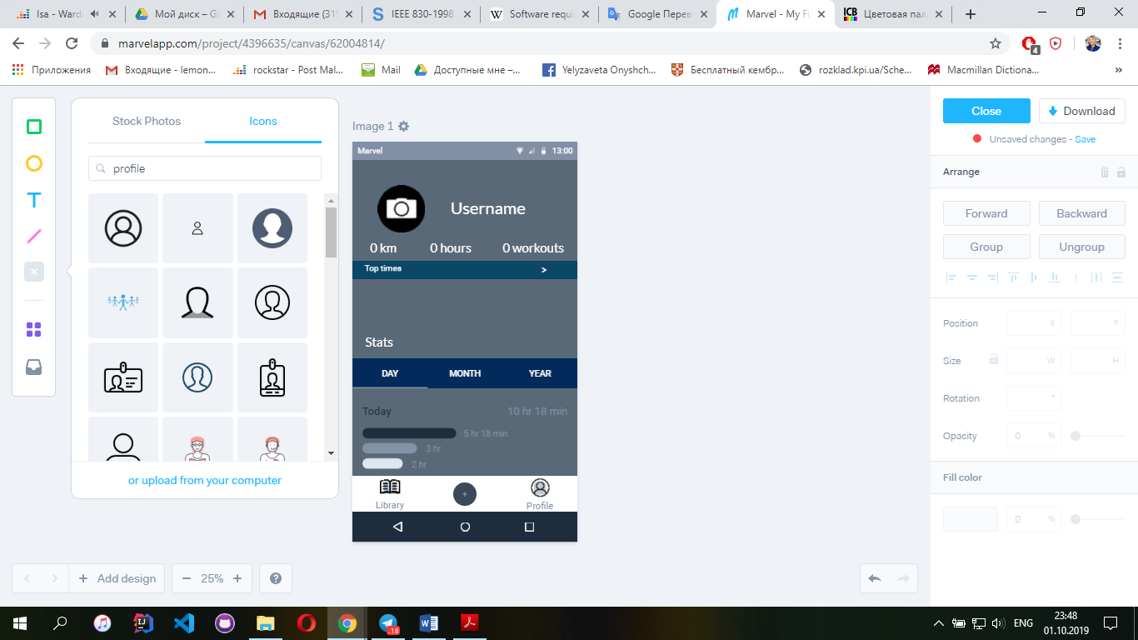

Figure 3. Personal profile

-“Top times” button : Opens default list where user can add/edit information.

- “Stats” tab: Default tab, that shows information to the user about his achievements.

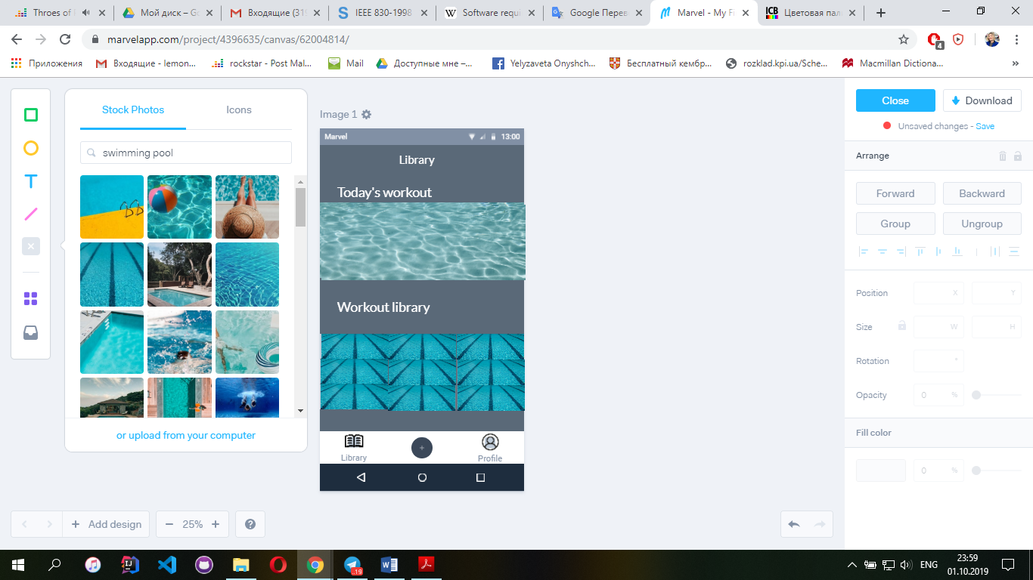

Figure 4. Workout library

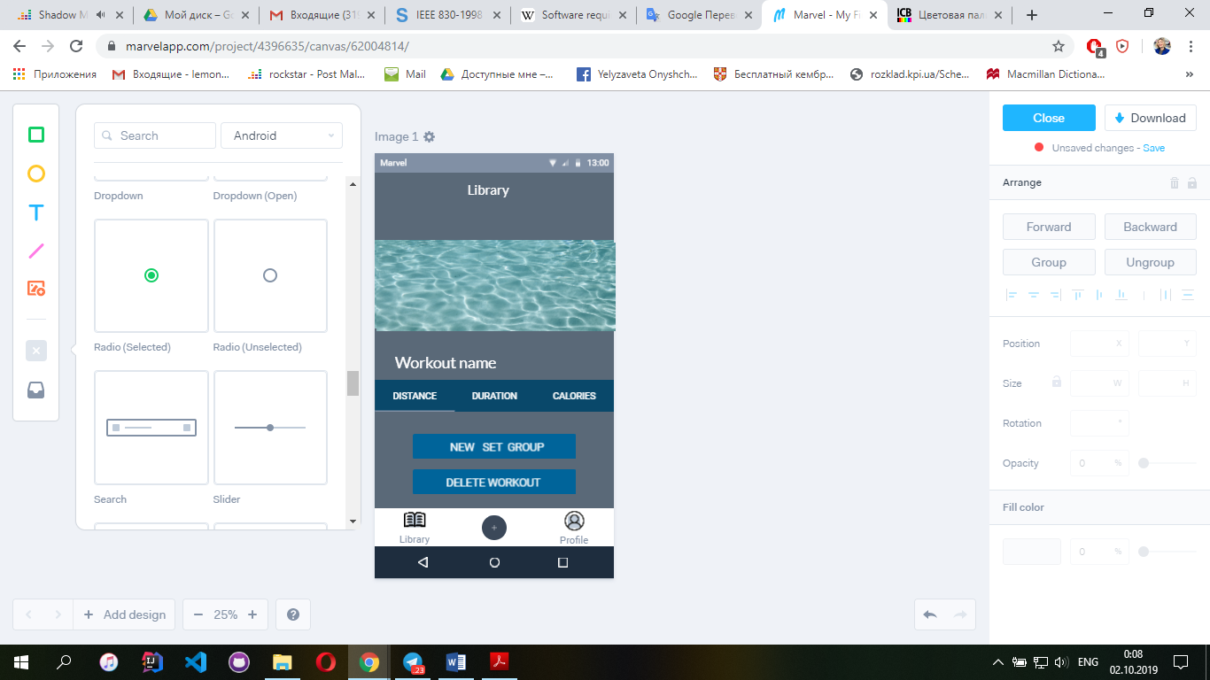

Figure 5. Approximate example of creating a training

-“Workout name” input : default input field

- “Stats” tab: default tab, which keeps track of training characteristics

## User Classes and Characteristics

UCC-1: Users, who want to get service provided by the SCC system.

UCC-2: Developers of the SCC system, who are responsible for maintaining excitable code and briefing system usability.

## Operating Environment

The system shall operate on Android client application with minimum Android version 4.0.

## Design and Implementation Constraints

CO-1: The system shall use the current corporate MySQL Server engine.

CO-2: The system shall be in compliance with all Accessibility and Security Policies applicable.

CO-3: User must have access to his data anytime.

## User Documentation

User documentation will consist of the several components usually expected of a modern web

based software application, including a tutorial, help pages, FAQ’s with an online request form, and

a complete user’s manual

User documentation will consist of two main components:

UD-1: User’s manual, which will include help pages and FAQ.

UD-2: Interactive tutorial, which will help user, who opens the app for the first time to learn how to use it.

## Assumptions and Dependencies

The users have sufficient knowledge of Android devices.

The users of the system know English because the interface will be provided in English.

# External Interface Requirements

## User Interfaces

The system will have simple and coherent user interface. User testing will be held in order to ensure that the user interface is simple, clear and complete (users can perform all the stated functions from the interface).

## Hardware Interfaces

The system will use standard hardware so no extra hardware interfaces are needed.

## Software Interfaces

The system will use standard software resources, which are available in the Internet. This includes, but is not limited to, MySQL – open-source relational database management system, Intellij IDEA – Java integrated development environment, Jetty – Java HTTP server.

# Other Nonfunctional Requirements

## Performance Requirements

PR-1: Requirement for number of users

The system must support no less than 1000 concurrent connections from any combination of Android devices.

## Safety Requirements

SFR-1: System recovery

In case of any system failure, the system must be capable to restore itself to the previous state.

## Security Requirements

The application security system corresponds to the minimum security requirements.

SR-1: Authentication

The system must have an authentication system in order to protect users’ personal information. In order to protect the intended audience, every user must register in the app and, as result, have personal ID(e-mail) and password.

SR-2: Availability

The system must be available for users anytime. In this particular case, availability is regarding reliability of the network and the software.

## Software Quality Attributes

SQ-1: Adaptability

Implementation of the application software and design of the system should be flexible enough for the necessary change in the later phase.

SQ -2: Usability

The system shall allow users to access the system from the Internet, using Android platform as an interface.

The system is user – friendly.

**Висновок :** В ході даної лабораторної роботи було вивчено основні етапи створення передпроектної документації та за допомогою прикладу SRS було розроблено передпроектну документацію за власною темою (інформаційна система для плавання).