Software Requirements Specification

for

VisitIt

Version 1.0

Prepared by Sofiia Materynska

NTUU Igor Sikorsky KPI

7.10.2019

Table of Contents

1. Introduction
   1. Purpose(Intended audience and reading suggestions)
   2. Scope
   3. Definitions, acronyms, and abbreviations
   4. References
   5. Overwiev
2. Overall description
   1. Product perspective
   2. Product functions
   3. User characteristics
   4. Constraints
   5. Assumptions and dependencies
3. Specific requirements

Appendixes

Index

1. **Introduction**

This section gives a scope description and overview of everything included in this SRS document. Also, the purpose for this document is described and a list of abbreviations and definitions is provided.

* 1. **Purpose**

The purpose of this document is to present a detailed description of the requirements for the “VisitIt” software. It will explain the purpose and features of the system, the interfaces of the system, what the system will do, the constraints under which it must operate and how the system will react to external stimuli. This document is intended for both the stakeholders and the developers of the system.

* 1. **Scope**

The “VisitIt” is a mobile application which helps travelers to build a unique personalized tourist route by adding desirable places in a particular city they are visiting. The system will be designed to simplify traveling as users will be able to add, change and delete different places, cross out locations they have already visited, sort them in a sequence.

The application should be free to download from either a mobile phone application store or similar services.

* 1. **Definitions, acronyms, and abbreviations**

|  |  |
| --- | --- |
| **Term** | **Definition** |
| User | Someone who interacts with the mobile phone application |
| Stakeholder | Any person who has interaction with the system who is not a developer. |
| DB | Database |
| DESC | Description |
| RAT | Rational |

* 1. **References**

IEEE. IEEE Std 830-1998 IEEE Recommended Practice for Software Requirements Specifications. IEEE Computer Society, 1998. <http://www.math.uaa.alaska.edu/~afkjm/cs401/IEEE830.pdf>

* 1. **Overwiev**

The remainder of this document includes two chapters and appendixes. The second one provides an overview of the system functionality and system interaction with other systems. This chapter also introduces stakeholders and their interaction with the system. Further, the chapter also mentions the system constraints and assumptions about the product.

The third chapter provides the requirements specification in detailed terms and a description of the different system interfaces. Different specification techniques are used in order to specify the requirements more precisely for different audiences.

1. **Overall description**

This section will give an overview of the whole system. The system will be explained in its context to introduce the basic functionality of it. It will also describe stakeholders that will use the system. At last, the constraints and assumptions for the system will be presented.

* 1. **Product perspective**

This project is independent and self-contained system for Android. It is intended to help tourists to create routs through unknown cities in a convenient way including their own preferences by adding places to visit. The software will be a grate application for those who loves total planning and has a limited amount of time so they can build the best way to discover new cities.

Since this is a data-centric product it will need somewhere to store the data. For that, a database will be used.

* 1. **Product functions**

With the mobile application users will have an opportunity to create a list of locations they want to visit in a particular city and then place them in desirable sequence. It will be possible to add a place, edit it, delete and cross out(tick as visited).

* 1. **User characteristics**

The program is designed for travelers. Every Android user will be able to use this application as no special skills are required.

* 1. **Constraints**

The mobile application will be constrained by the capacity of the database.

The system should be in compliance with Accessibility and Security policy.

* 1. **Assumptions and dependencies**

One assumption about the product is that it will always be used on mobile phones that have enough performance. If the phone does not have enough hardware resources available for the application, for example the users might have allocated them with other applications, there may be scenarios where the application does not work as intended or even at all.

1. **Specific requirements**

*This section contains all of the functional and quality requirements of the system. It gives a detailed description of the system and all its features.*

* 1. **External interfaces**
     1. ***User interfaces***

Every user after opening an application is on the main page – see Figure 1. User can add a new country or choose one of previous.

After choosing a country it is possible to do the same sequence of choices with cities.

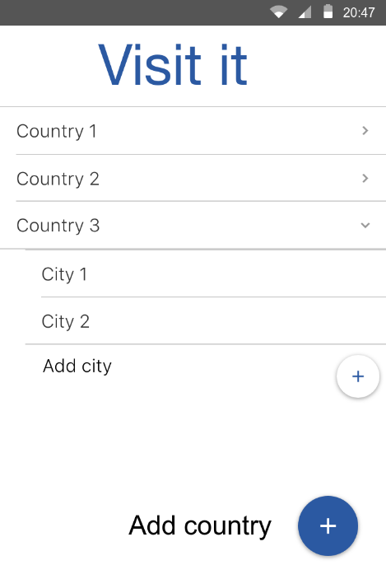After a city is chosen you can add new place – see Figure 2 - or edit the one that already exists – see Figure 3.

Figure 1

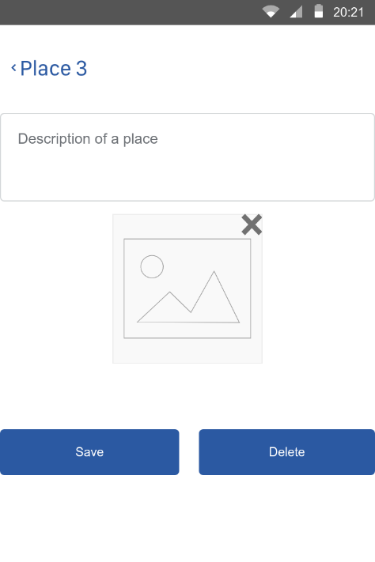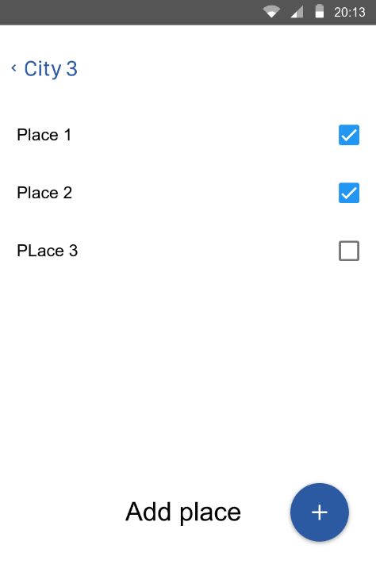

Figure 3

Figure 2

* + 1. ***Hardware interfaces***

It does not have any direct hardware interfaces***.***

* + 1. ***Software interfaces***

Operating system on the mobile device should be Android 5.1 or higher.

* + 1. ***Communication interfaces***

The communication between the different parts of the system is important since they depend on each other. However, in what way the communication is achieved is not important for the system and is therefore handled by the underlying operating systems.

* 1. **Functional requirements**

*This section includes the requirements that specify all the fundamental actions of the software system.*

* + 1. ***Functional requirement 1***

ID: FR1

TITLE: Download mobile application

DESC: A user should be able to download the mobile application through either an application store or similar service on the mobile phone. The application should be free to download.

RAT: In order for a user to download the mobile application.

* + 1. ***Functional requirement 2***

ID: FR2

TITLE: Add new country

DESC: A user should be able to add a new country that was not mentioned before. Needed input – country name. It should be checked if this country is already in the list.

RAT: In order for a user to add a new country.

* + 1. ***Functional requirement 3***

ID: FR3

TITLE: Add new city

DESC: A user should be able to add a new city that was not mentioned before in the border of particular country. Needed input – city name. It should be checked if this city is already in the list.

RAT: In order for a user to add a new city.

* + 1. ***Functional requirement 4***

ID: FR4

TITLE: Add new place

DESC: A user should be able to add a new place that was not mentioned before in the border of particular city. Needed input – place name, optional: description and photo. It should be checked if this place is already in the list.

RAT: In order for a user to add a new place.

* + 1. ***Functional requirement 5***

ID: FR5

TITLE: Edit chosen place

DESC: A user should be able to change information about current. Needed input – optional. Place can be deleted. Or changes can be saved.

RAT: In order for a user to edit mentioned places.

* 1. **Performance requirements**

*The requirements in this section provide a detailed specification of the user interaction with the software and measurements placed on the system performance.*

N/A

* 1. **Design constraints**

*This section includes the design constraints on the software caused by the hardware.*

N/A

* 1. **Software system attributes**

*The requirements in this section specify the required reliability, availability, security and maintainability of the software system.*

* + 1. ***Reliability***

ID: QR1

TAG: SystemReliability

GIST: The reliability of the system.

SCALE: The reliability that the system update information correctly.

METER: Measurements obtained from 1000 cases of updating/creating new information about places.

MUST: More than 99% of cases.

PLAN: 100% of cases.

WISH: 100% of the cases.

* + 1. ***Availability***

ID: QR2

TAG: SystemAvailability

GIST: The availability of the system when it is used.

SCALE: The average system availability.

METER: Measurements obtained from 1000 hours of usage during testing.

MUST: More than 98% of the time.

PLAN: More than 99% of the time.

WISH: 100% of the time.

* + 1. ***Security***

N/A

* + 1. ***Maintainability***

ID: QR3

TITLE: Application extendibility

DESC: The application should be easy to extend. The code should be written in a way that it favors implementation of new functions.

RAT: In order for future functions to be implemented easily to the application.

ID: QR4

TITLE: Application testability

DESC: Test environments should be built for the application to allow testing of the applications different functions.

RAT: In order to test the application.

* + 1. ***Portability***

ID: QR5

TITLE: Application portability

DESC: The application should be portable with Android.

RAT: The adaptable platform for the application to run on.

* 1. **Other requirements**

**Appendixes**

**Index**