Comparison of ordinary crossrun joint distributions and joint distributions withg empirical median.

n=64:
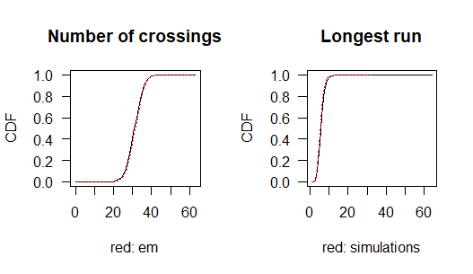
cmeancr cmeanem lmeancr lmeanem csdcr
31.500000 32.000000 6.334041 5.961919 3.968627
csdem lsdcr lsdem clmeancr clmeanem
3.968127 1.757241 1.536792 196.036457 187.624634
Here, cmeancr is mean of C with ordinary crossrun, cmeanem with empirical median. lmeancr and lmeanem similarly for L, sd: Standard deviations. Clmeancr and clmeanem similarly for means of C*L.

n=32:
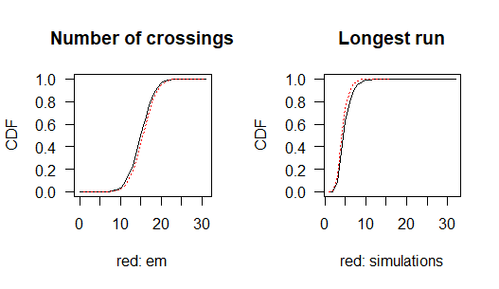
cmeancr cmeanem lmeancr lmeanem csdcr csdem
15.500000 16.000000 5.335215 4.814632 2.783882 2.782433
lsdcr lsdem clmeancr clmeanem
1.670450 1.333190 79.930712 74.702560
n=16:
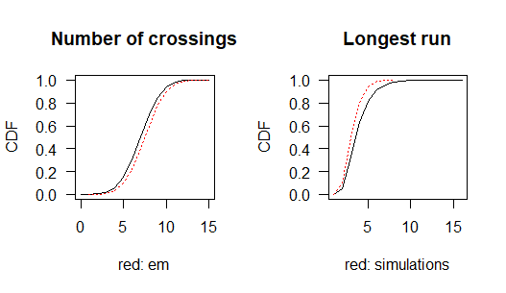
cmeancr cmeanem lmeancr lmeanem csdcr csdem
7.500000 8.000000 4.338043 3.670396 1.936492 1.932184
lsdcr lsdem clmeancr clmeanem
1.518004 1.057177 30.490662 27.819114

